A
PROJECT REPORT
ON
NEXUS ROUTE
AI Dynamic Routing Algorithm Selector



Academic Year
2026-2027

Under the Guidance of

Dr. VARSHA NEMADE

Submitted by
Aditya Karnawat C246
Harshal Sonawane C300
Rohit Badgujar C301

Sub:Computer Networks 2026-2027

Department of AIML
SVKM’s NMIMS (Deemed-to-be-University)
Mukesh Patel School of Technology Management & Engineering, Shirpur Campus

Index

Page No.
- Introduction 3

- Methods and Material 4

- Block Diagram 6

- Component List 7

- Working Model 8

- Project Execution Steps 10

- Results 11

- Applications 11

- Conclusion & Future Scope 12

- References 13

Acknowledgement
- Introduction
About Project:
NEXUS ROUTE is an interactive, laboratory-grade web platform and telemetry simulator developed for the Computer Networks course. It evaluates real-time network conditions across 10 telemetry features and dynamically chooses the best routing algorithm using a trained Random Forest classifier. Users can build a network in six topology formats, watch packets flow across it, inspect every hop, and compare four classic and dynamic routing strategies (Dijkstra, Alternate Path, Load Balancing and Fault Tolerant) against an AI Autonomous selector.
Objective of the Work:
The objective of this project is to replace static routing decisions with an adaptive, AI-driven routing selector that reacts to live network conditions. Specifically, the system aims to:
- provide an interactive topology canvas with draggable routers, live latency and load indicators, animated packet flows and a wire/connect tool;
- implement four routing strategies, each with its own link cost function, so that their behaviour can be compared under the same conditions;
- simulate network telemetry (link load, queue delay, packet loss and cut links) and show per-hop delay, loss, bandwidth and cost;
- train a Random Forest classifier on 1,000 synthetic scenarios using 10 telemetry features, so that the best routing algorithm is selected automatically; and
- support six topology formats, editable through connection syntax (edge lists) and an interactive N × N adjacency matrix.
Origin of the Proposal:
In traditional networks, routing decisions are made with static link metrics such as geographic distance or rated port speed [1], [2]. Real networks, however, are dynamic and non-linear. The path with the lowest physical distance may be filled to 90% capacity, causing latency spikes (bufferbloat) and dropped packets [3], while an alternative cable with only 2 ms higher base latency sits idle at 10% load. A static protocol keeps sending packets into the congested bottleneck until sessions time out.
This observation led to the proposal of an adaptive selector that monitors telemetry (link load, queue latency, packet loss and cut cables) and assigns the right algorithm for the right moment. The project is also motivated by the wish to build a hands-on environment in
- Methods and Material
The system combines a network simulation with machine-learning-based algorithm selection. A topology is modelled as a weighted graph whose links carry base latency, load, packet loss and failure state. Each routing algorithm is a shortest-path search [4] that differs only in the cost function applied to each link, and the Random Forest classifier [5] decides which of them to run for the current conditions.
The following methods were used:
- Shortest-path search finds the least-cost route between two nodes, and the K-shortest-path idea is used by the Alternate Path strategy to find a detour around a congested link [6].
- Congestion-aware cost functions change the weight of a link according to its load, loss and failure state. They are listed in Table 1.
- Effective latency model estimates queueing delay as L_eff = L_base × (1 + 3 × (load/100)²), so that delay rises sharply as a link approaches saturation.
- Random Forest classification uses an ensemble of decision trees on 10 telemetry features, trained on 1,000 synthetic scenarios, and gives feature-importance rankings.
- Topology models include Watts-Strogatz small world [7], full mesh, ring lattice, star, 2D grid matrix and data-centre spine-leaf (Clos) [8].
Table 1: Routing strategies and their link cost functions
Algorithm | Strategy | Ideal network condition | Link cost function
Dijkstra | Static shortest path | Low traffic, minimal congestion | Cost = BaseLatency
Alternate Path | Congestion detour (K-shortest) | Localised choke points (load > 70%) | Cost = BaseLatency + (Load > 70 ? 300 + 10 × (Load − 70) : 0)
Load Balancing | Throughput and capacity distribution | High global traffic across all links | Cost = BaseLatency × (1 + 5 × (Load/100)²)
Fault Tolerant | Resilient failure isolation | Physical link cuts and packet loss | Cost = ∞ if the link has failed; otherwise EffLatency + 10 × Loss
AI Autonomous | Random Forest classifier | Dynamic, unpredictable traffic | Evaluates 10 network features and selects the winning strategy

The materials used (hardware and software) are listed in Section 4.
- Block Diagram
Figure 1 shows the flow of NEXUS ROUTE from start to end, and Figure 2 shows the overall system architecture. The blocks of the flow chart are described first.
Description of the blocks:
- Start: The process begins.
- Build / select network topology: The user chooses one of the six topology formats, edits the connections, and sets the traffic and failure conditions.
- Collect link telemetry: Load, queue latency, packet loss and failed links are collected for every link.
- Extract the 10 network features: The telemetry is summarised into the 10 features used by the classifier.
- Routing mode?: The user chooses between AI Autonomous mode and manual selection of an algorithm.
- Random Forest classifier predicts the best algorithm: In AI mode, the trained classifier selects the winning strategy.
- User selects one of the 4 routing algorithms: In manual mode, the user deploys Dijkstra, Alternate Path, Load Balancing or Fault Tolerant routing.
- Compute per-link cost and find the route: The selected cost function is applied and a shortest-path search finds the route.
- Display route, per-hop telemetry and animated packet flow: The result is drawn on the topology canvas and the hop-by-hop details are shown.
- Conditions changed?: If the network conditions change, telemetry is collected again; otherwise the process ends.
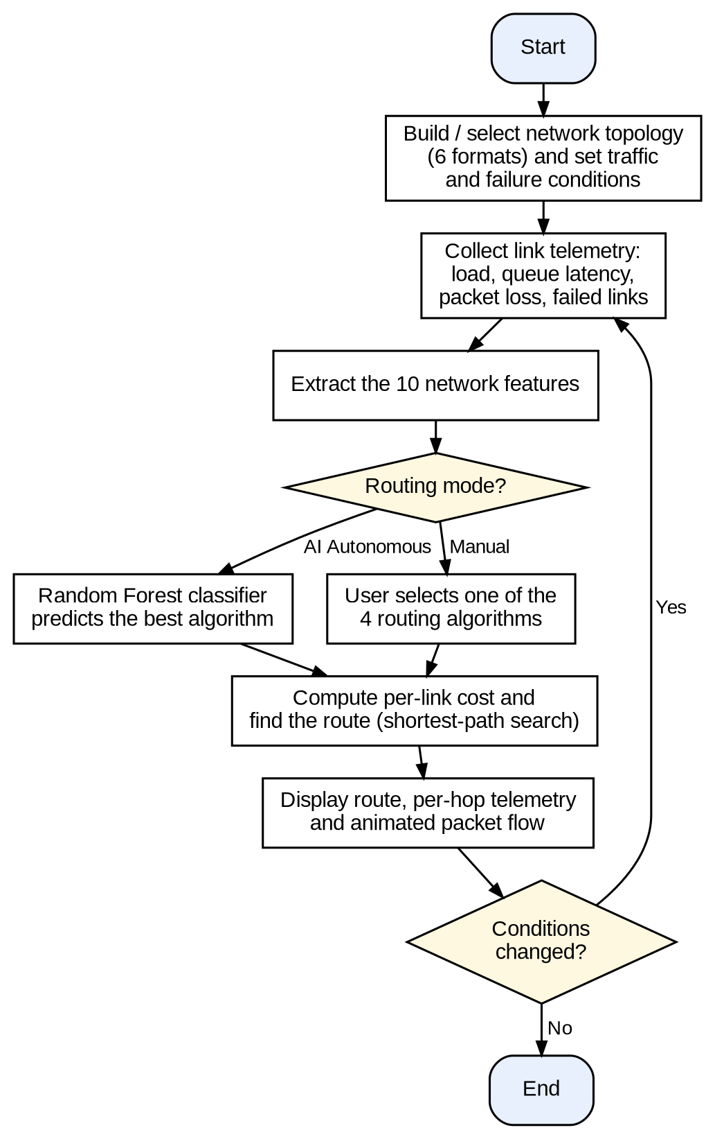
Figure 1: Block diagram / flow chart used for NEXUS ROUTE
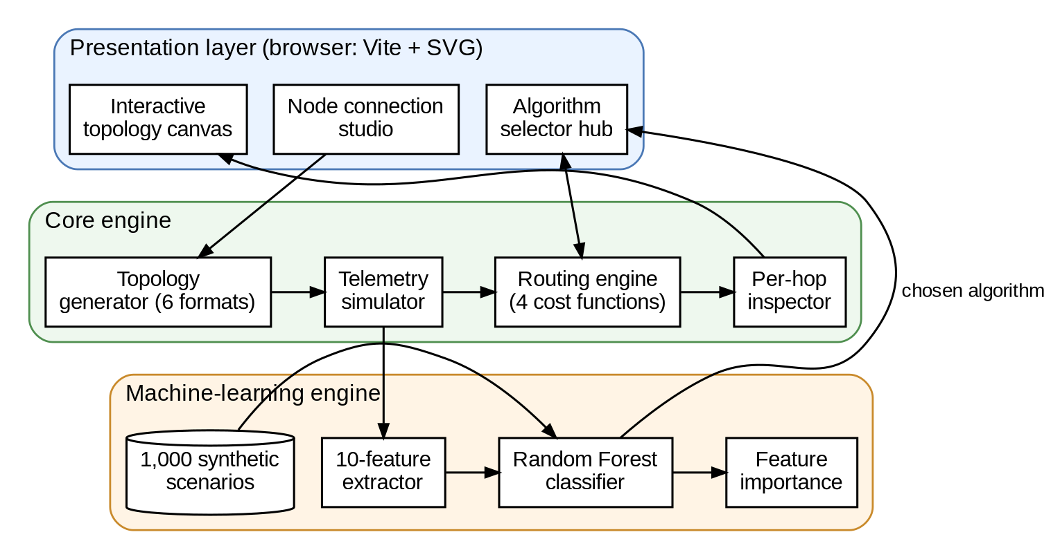
Figure 2: System architecture of NEXUS ROUTE
The architecture has three layers. The presentation layer, which runs in the web browser, contains the interactive topology canvas, the algorithm selector hub and the node connection studio. The core engine contains the topology generator, the telemetry simulator, the routing engine with its four cost functions, and the per-hop inspector. The machine-learning engine extracts the 10 features, runs the Random Forest classifier (trained on 1,000 synthetic scenarios) and reports feature importance; its choice is passed back to the algorithm selector hub.
- Component List
The hardware, software and tools used in the project are listed below.
Sr. No. | Name of Algorithm/Dataset/Tool | Source
1 | Computer (laptop / desktop) | Existing hardware
2 | Web browser | Any modern browser
3 | Node.js (v18 or later) and npm | nodejs.org (open source)
4 | Vite (development server and build tool) | vite.dev (open source)
5 | Random Forest classifier (10 features) | Trained within the project
6 | Synthetic training dataset (1,000 scenarios) | Generated within the project
7 | SVG topology visualiser and routing engine | Project source code

- Working Model
The working model is the NEXUS ROUTE web application itself. It is installed with Node.js [9] and npm, served locally by the Vite development server [10] at http://localhost:3000, and runs entirely in the browser. Figure 3 shows how the telemetry conditions are mapped to the routing strategies.
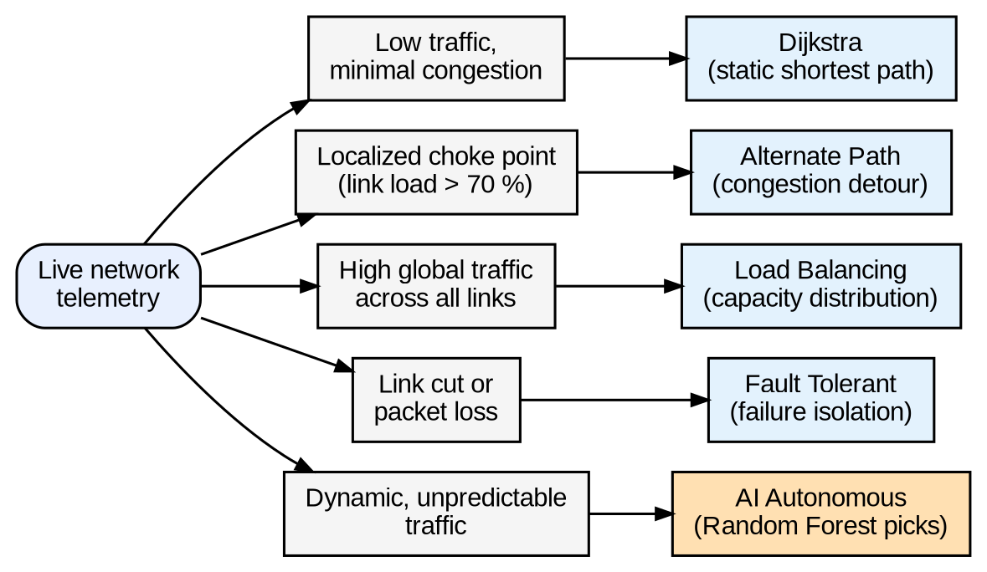
Figure 3: Mapping of network conditions to routing algorithms in NEXUS ROUTE
Main modules:
- Interactive Topology Canvas: a real-time SVG network visualiser with animated packet flows, draggable router nodes, live latency/load pills and a wire/connect tool.
- Algorithm Selector Hub: lets the user test, compare and deploy the four routing strategies and the AI Autonomous selector.
- Node Connection and Architecture Studio: switches between six topology formats (Watts-Strogatz small world, full mesh, ring lattice, star, 2D grid matrix and data-centre spine-leaf), edits the connection syntax (edge list), or connects nodes by clicking on an N × N adjacency matrix.
- Per-Hop Telemetry and Cost Functions: shows, hop by hop, the effective queue delay, packet loss, bandwidth and cost formula of each link on the chosen route.
- Machine Learning Engine: a 10-feature real-time classifier with feature-importance ranking, trained on 1,000 synthetic scenarios.
How the system works:
The simulator assigns each link a base latency, a load, a packet-loss rate and a failure state. The effective latency of a link is calculated as L_eff = L_base × (1 + 3 × (load/100)²), so a link at 90% load is much slower than the same link at 10% load. The selected algorithm turns these values into a link cost (Table 1) and finds the least-cost route. In AI Autonomous mode, the Random Forest classifier reads the 10 telemetry features and selects the algorithm before the route is computed.
The effect of the cost functions is shown by a worked example. Route A has a base latency of 10 ms but is congested at 90% load. Route B has a base latency of 12 ms and is idle at 10% load. Table 2 gives the cost of each route according to the formulas in Table 1 (assuming no packet loss and no failed links).
Table 2: Worked example of route cost (calculated from the cost functions)
Algorithm | Route A (10 ms, 90% load) | Route B (12 ms, 10% load) | Route chosen
Dijkstra | 10 | 12 | A
Alternate Path | 10 + 300 + 10 × 20 = 510 | 12 | B
Load Balancing | 10 × (1 + 5 × 0.81) = 50.5 | 12 × (1 + 5 × 0.01) = 12.6 | B
Fault Tolerant | 10 × (1 + 3 × 0.81) = 34.3 | 12 × (1 + 3 × 0.01) = 12.4 | B

Dijkstra, which uses only the base latency, sends traffic into the congested Route A, whereas the three adaptive strategies move traffic to the idle Route B. These values are calculated from the formulas and are meant as an illustration, not as measured results.
Team roles:
The project was carried out as a team under the guidance of the faculty supervisor.
- Project Execution Steps
Step 1: Set up the environment. Install Node.js (v18 or later) and npm on the computer, and obtain the NEXUS ROUTE project folder.
Step 2: Install the dependencies. Open a terminal in the project folder and run npm install --legacy-peer-deps.
Step 3: Launch the application. Run npm run dev to start the Vite development server, and open http://localhost:3000 in the browser. A production build can be created with npm run build.
Step 4: Build the network. Choose one of the six topology formats in the Node Connection Studio, then edit the edge list, click cells of the adjacency matrix, or use the wire tool on the canvas to add or remove links.
Step 5: Set the network conditions. Vary the link loads, packet loss and failed links to create low-traffic, congested, high-traffic or link-cut situations.
Step 6: Select the routing algorithm. In the Algorithm Selector Hub, deploy Dijkstra, Alternate Path, Load Balancing or Fault Tolerant routing, or switch on the AI Autonomous mode.
Step 7: Inspect the route. Watch the animated packet flow and read the hop-by-hop delay, loss, bandwidth and cost values.
Step 8: Test and evaluate. Repeat the experiment on different topologies and conditions, compare the strategies with each other and with the AI selector, and review the feature-importance ranking.
- Results
The project produced a working AI-assisted routing platform in which routing strategies can be compared on the same network and under the same conditions. The results are:
- Networks can be created in six topology formats and edited through an edge list, an adjacency matrix or the wire tool.
- Packets are routed and animated on the canvas, with live latency and load shown for every link.
- The four strategies behave differently under the same conditions. For example, Dijkstra keeps using a congested shortest path, while Alternate Path, Load Balancing and Fault Tolerant routing move traffic to less loaded or surviving links (Table 2).
- Cut links are given an infinite cost by the Fault Tolerant strategy, so the route is rebuilt around them without waiting for slow protocol re-convergence.
- Per-hop telemetry shows the effective delay, loss, bandwidth and cost on the chosen route.
- The Random Forest classifier selects the strategy from 10 telemetry features, and its feature-importance ranking shows which features influence the choice most.
- Applications
1. Internet service providers and content delivery networks: during peak-hour surges the system detects link utilisation above 70% and switches to Alternate Path or Load Balancing, diverting non-priority traffic over under-used links to keep latency steady.
2. Cloud data centres: in tiered spine-leaf networks, dynamic load balancing shifts traffic away from links hit by hash collisions or microbursts, which keeps maximum link loads low and reduces tail latency.
3. Mission-critical and emergency networks (5G, autonomous driving, remote surgery): the Fault Tolerant module isolates severed links with an infinite penalty and re-routes packets along redundant paths.
4. Financial trading networks: routing on effective latency steers packets around queuing switches before bufferbloat occurs, which reduces jitter.
5. Education and network laboratories: students can experiment with topologies, failures and routing strategies and see the effect of each decision immediately.
- Conclusion & Future Scope
Conclusion:
NEXUS ROUTE shows that routing can adapt to network conditions instead of relying on static link metrics. By combining a telemetry simulator, four congestion- and failure-aware cost functions and a Random Forest classifier that selects among them, the platform lets users see why a static shortest path fails under congestion and how adaptive strategies recover. The interactive canvas, topology studio and per-hop inspector also make it a useful learning tool for Computer Networks.
Limitations:
The platform is a simulator. The classifier is trained on synthetic scenarios, so its accuracy on real network traffic has not been validated, and the routes are calculated centrally without real routers or routing protocols.
Future Scope:
- Train and test the classifier on traffic traces and measurements from real networks.
- Integrate the selector with a software-defined networking controller or real routers.
- Add more strategies (for example equal-cost multipath), quality-of-service classes and reinforcement-learning-based selection.
- Add export of experiment results and comparison reports.
- References
[1] J. Moy, "OSPF Version 2," Internet Engineering Task Force, RFC 2328, Apr. 1998.
[2] J. F. Kurose and K. W. Ross, Computer Networking: A Top-Down Approach, 8th ed. Harlow, U.K.: Pearson, 2021.
[3] J. Gettys and K. Nichols, "Bufferbloat: Dark buffers in the Internet," Communications of the ACM, vol. 55, no. 1, pp. 57–65, Jan. 2012.
[4] E. W. Dijkstra, "A note on two problems in connexion with graphs," Numerische Mathematik, vol. 1, no. 1, pp. 269–271, Dec. 1959.
[5] L. Breiman, "Random forests," Machine Learning, vol. 45, no. 1, pp. 5–32, Oct. 2001.
[6] J. Y. Yen, "Finding the K shortest loopless paths in a network," Management Science, vol. 17, no. 11, pp. 712–716, Jul. 1971.
[7] D. J. Watts and S. H. Strogatz, "Collective dynamics of 'small-world' networks," Nature, vol. 393, no. 6684, pp. 440–442, Jun. 1998.
[8] C. Clos, "A study of non-blocking switching networks," Bell System Technical Journal, vol. 32, no. 2, pp. 406–424, Mar. 1953.
[9] OpenJS Foundation, "Node.js JavaScript runtime." [Online]. Available: https://nodejs.org/
[10] Vite Contributors, "Vite: Next generation frontend tooling." [Online]. Available: https://vite.dev/
Acknowledgement
We sincerely thank Dr. Varsha Nemade for her invaluable guidance and support throughout this project. Her expertise and feedback were crucial to its successful completion.
Proof of Concept:

Poster Presentation:

