LIBRARY MANAGEMENT SYSTEM

A Project Report Submitted
by

Sriveda Raghavi (AP24110011513)
Divya jyothi Bonam (AP241100011717)
Likhita Reddy .R(AP24110011721)
K.Sritha (AP24110011082)
M.Ramita(AP24110011286)
H.V.N Harshitha (AP24110010898)

Under the Supervision of
Mr. Prakash
Department of Computer Science and
Engineering

SRM University-AP

In partial fulfilment for the requirements of the
Coding skills

BACHELOR OF TECHNOLOGY
IN
COMPUTER SCIENCE AND ENGINEERING



DEPARTMENT OF COMPUTER SCIENCE AND ENGINEERING
SRM UNIVERSITY-AP

CERTIFICATE

This is to certify that the project work entitled “Library management system”.
It is a Bonafide record of project work carried out by the following students:

● Ms.Manyam Sriveda Raghavi (AP24110011513)
● Ms.Divya jyothi Bonam (AP241100011717)
● Ms.Likhita Reddy .R(AP24110011721)
● Ms.K.Sritha (AP24110011082)
● Ms.M.Ramita(AP24110011286)
● Ms.H.V.N Harshitha (AP24110010898)

from the Department of Computer Science and Engineering, SRM University-AP.
The students conducted this project work under my supervision during the period August 2025 to December 2025.It is further certified that, to the best of my knowledge, this project has not
previously formed the basis for the award of any degree or any similar title to this or any other
candidate.
This is also to certify that the project work represents the teamwork of the candidates.

Station: Mangalagiri
Date: 10-12-2025

ACKNOWLEDGEMENT

I would like to express my sincere gratitude to my project guide and faculty members for giving me the opportunity to work on the project titled “Library Management System.” Their continuous guidance, valuable suggestions, and encouragement greatly helped me understand the concepts of database management, record organization, and software development. This project has enhanced my understanding of how real-world systems function, and I am truly grateful for the support I received throughout the process.
I am also thankful to my institution for providing the necessary resources and a supportive learning environment, which played an important role in the successful completion of this project. The availability of reference materials, lab facilities, and academic support helped me explore various aspects of library management such as book cataloguing, user management, transaction handling, and system efficiency. I sincerely appreciate the contributions of my teachers and classmates who guided me whenever I faced challenges during the development of this system.
Lastly, I would like to thank my parents and friends for their constant motivation, understanding, and encouragement during the course of this project. Their support helped me stay focused and determined to complete my work with dedication. This project has been a great learning experience for me, and I believe the knowledge gained through it will be highly useful for my future academic and professional endeavour’s.

ABSTRACT

The Library Management System is designed to simplify and automate the process of managing a library's daily operations. Traditional library systems often involve manual work, which can lead to errors, delays, and difficulty in maintaining accurate records. This project aims to provide an efficient digital solution that helps librarians and users quickly access information about books, members, and transactions. By incorporating structured data handling, the system ensures that all records are organized, secure, and easy to retrieve.
The system focuses on core features such as book entry, member registration, book issue and return, fine calculation, and search functionality. These features not only speed up the work of library staff but also provide users with a smooth and convenient experience. The Library Management System reduces paperwork, minimizes the chances of data loss, and improves the accuracy and reliability of library operations. With clear menus, simplified workflows, and systematic record storage, this project highlights the advantages of implementing automation in educational and institutional environments.
Overall, this project demonstrates how the use of technology can enhance traditional library management by making processes faster, more accurate, and more user-friendly. The system serves as a practical example of applying programming and database concepts to solve real-world problems. Through this project, valuable insights were gained into designing software solutions, building user interfaces, and managing data efficiently. The Library Management System thus reflects both academic learning and practical application.

INTRODUCTION

The Library Management System (LMS), branded as "Book Verse," is a sophisticated web-based application developed to transform the way libraries operate, organize resources, and serve readers. Libraries—ranging from small community libraries to large academic or digital libraries—play a crucial role in supporting education, research, and lifelong learning. However, traditional library management methods often rely on manual record-keeping or outdated digital tools, resulting in inefficiencies, data errors, and poor user experiences. The LMS addresses these challenges by offering a centralized, user-friendly platform that caters to both librarians and readers, streamlining tasks such as book cataloguing, issuing, returning, fine management, and digital resource access.
This project was developed as part of the Web Technology (CSE210) course at SRM University-AP, with the objective of applying modern web development techniques to a real-world problem. The system uses a robust technology stack, including PHP for backend processing, MySQL for database management, and HTML, CSS, and JavaScript for a responsive and interactive frontend. The LMS includes a wide range of features such as category-based book browsing, student/faculty login, automated fine calculation, inventory management, and real-time availability tracking. These functionalities ensure efficient library operations while providing readers with a smooth and engaging experience.
The LMS is built to meet the rising need for digital and efficient library services. It manages books, users, and transactions smoothly with features like search, issuing/returning, and fine tracking. The system is secure, scalable, and accessible on all devices. Future upgrades may include digital library integration, a mobile app, and AI-based recommendations.

PROBLEM STATEMENT

Library management is a complex process that involves handling several tasks, including book cataloguing, user registration, book issuing/returning, fine management, and inventory tracking. Traditional methods—like manual registers or paper-based records—are slow, error-prone, and lack scalability. Even existing digital tools often have limitations such as outdated interfaces, limited automation, and poor integration with modern library needs. The Library Management System (LMS) was developed to overcome these challenges by providing a centralized, efficient, and user-friendly platform.
One major problem with traditional library systems is the absence of a unified platform. Librarians frequently rely on separate tools for cataloguing books, recording transactions, tracking users, and sending notifications. This leads to data inconsistency, repeated work, and overall inefficiency. For readers, the lack of a single system makes it hard to search books, check availability, or receive timely reminders. The LMS solves these issues by offering one platform where all library-related activities can be managed smoothly.
Manual book issuing/returning and fine calculation often lead to errors like missing entries or incorrect return dates. Traditional systems also lack security for user data and book records. The LMS simplifies these tasks by automating issuing/returning, accurately calculating fines, and providing secure access for users, making library work faster and error-free.
Scalability is another issue for libraries with large collections. Manual systems cannot efficiently handle thousands of books or users. The LMS is designed to manage growing inventories smoothly by organizing books, users, and transactions in a structured and efficient way.

OBJECTIVES

The Library Management System (LMS) aims to simplify and modernize basic library operations. The key objectives are:
- To automate routine library functions such as book cataloguing, searching, issuing, returning, and tracking.

- To reduce manual paperwork, human errors, and repetitive tasks performed by librarians.

- To provide quick and accurate access to information on book availability, member status, due dates, and transaction history.

- To improve operational efficiency by speeding up circulation processes and ensuring smoother workflow.

- To maintain centralized and well-organized records, enabling easy data retrieval, updates, and long-term storage.

- To enhance user satisfaction by offering a simple, intuitive interface for both librarians and library members.

- To ensure data accuracy and security, protecting user information and preventing unauthorized access or data loss.

- To support timely reminders and notifications, such as due date alerts and overdue book warnings

- To provide analytical insights through reports on book usage, popular titles, member activity, and library performance.

SYSTEM ARCHITECTURE

The LMS follows a Three-Tier architecture:

Presentation Layer:
HTML, CSS (and optional JavaScript) used to create the user interface for students, members, and librarians.
The Library Management System is designed to simplify and automate the process of managing a library's daily operations. Traditional library systems often involve manual work, which can lead to errors, delays, and difficulty in maintaining accurate records. This project aims to provide an efficient digital solution that helps librarians and users quickly access information about books, members, and transactions. By incorporating structured data handling, the system ensures that all records are organized, secure, and easy to retrieve.
The system focuses on core features such as book entry, member registration, book issue and return, fine calculation, and search functionality. These features not only speed up the work of library staff but also provide users with a smooth and convenient experience. Overall, this project demonstrates how the use of technology can enhance traditional library management by making processes faster, more accurate, and more user-friendly. The system serves as a practical example of applying programming and database concepts to solve real-world problems. Through this project, valuable insights were gained into designing software solutions, building user interfaces, and managing data efficiently. The Library Management System thus reflects both academic learning and practical application.

DESIGN (DFD DIAGRAM)

The design of the Library Management System (LMS) is represented through Data Flow Diagrams (DFDs) and an Entity-Relationship Diagram (ERD) to illustrate system processes, data flows, and database relationships.
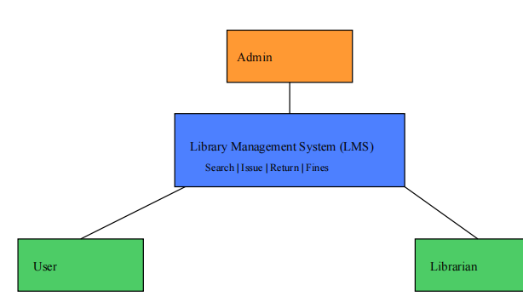
The Context Diagram shows the interaction between external entities such as Users (Students/Members), Librarian, and Admin with the LMS. It highlights how users log in, search books, issue or return books, and view their records, while the librarian and admin manage book inventory, user accounts, and system operations.

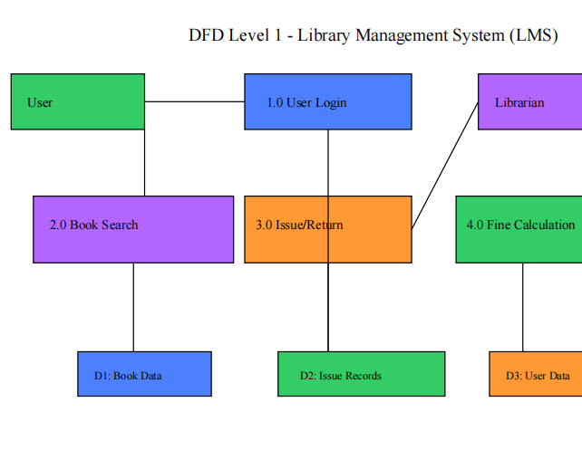

DATABASE INTERACTION

Entities: Books, Users, Issue Records
Data Flow: User inputs (book search, issue/return requests) are stored in the database and retrieved when needed. Book details, user data, and issuing records are updated and accessed for display or further processing.

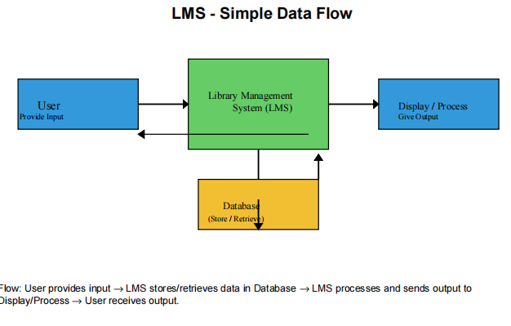

IMPLEMENTATION

The EMS is implemented using a client-server architecture with PHP for backend logic, MySQL for data
storage, and HTML/CSS/JavaScript for the frontend. Key components include:
Frontend
● HTML/CSS: Structured layouts with responsive design using CSS variables for consistent
theming (e.g., --primary: #4361ee).
● JavaScript: Handles dynamic interactions, such as form validation and search functionality.
● External Libraries:
○ Font Awesome for icons (e.g., <i class="fas fa-calendar-alt"></i>).
○ Google Fonts (Poppins) for typography.
Backend
● PHP: Manages server-side logic, including event creation (Create-events.php), registration
(register.php), payment processing (payment.php), and confirmation (confirmation.php).
● MySQL: Stores event details, user registrations, and reviews in a relational database.
● PDO: Used for secure database interactions with prepared statements to prevent SQL
injection.

Key Features
● User Login: Secure login to access personal library account.
● Book Search: Find books by title, author, or category and check availability.
● Borrow/Return: Track issued books, return dates, and update stock automatically.
● Fines & Alerts: Auto-calculate fines and send due-date reminders.
● Librarian Tools: Manage books, users, and inventory.
● Reports: View borrowing trends, overdue books, and library activity.
DATABASE DESIGN

The LMS uses a MySQL database (library dB) with the following key tables:

1) Books
- id: Primary Key, Auto-increment
- title: VARCHAR(255)
- author: VARCHAR(255)
- category: VARCHAR(100)
- isbn: VARCHAR(50)
- publisher: VARCHAR(255)
- published_year: YEAR
- available_copies: INT
- total_copies: INT

2) Members
- id: Primary Key, Auto-increment
- full_name: VARCHAR(255)
- membership_date: DATE

3) Borrowings
- id: Primary Key, Auto-increment
- book_id: Foreign Key (references Books.id)
- due_date: DATE
- return_date: DATE (NULL if not returned)
- status: ENUM('borrowed', 'returned', 'overdue')

4) Reviews
- id: Primary Key, Auto-increment
- book_id: Foreign Key (references Books.id)
- user_name: VARCHAR(255)
- review_text: TEXT
- created_at: DATETIME
SCREENSHOTS:

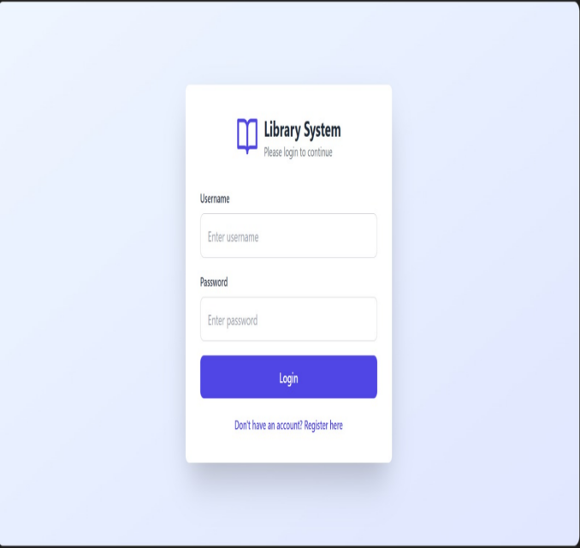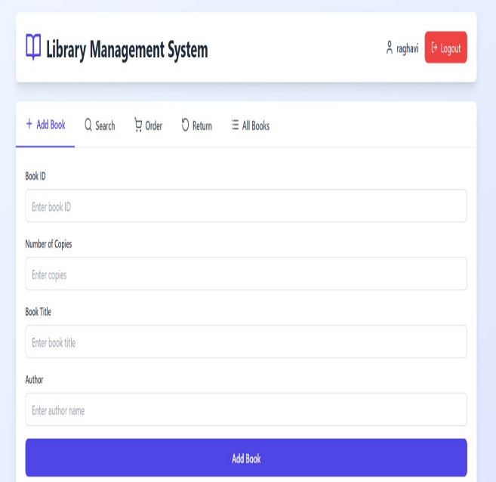

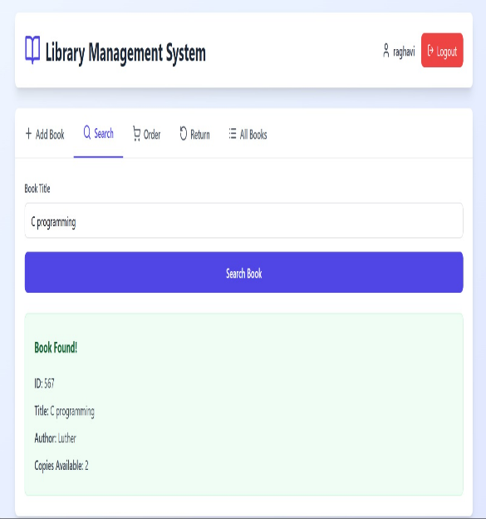
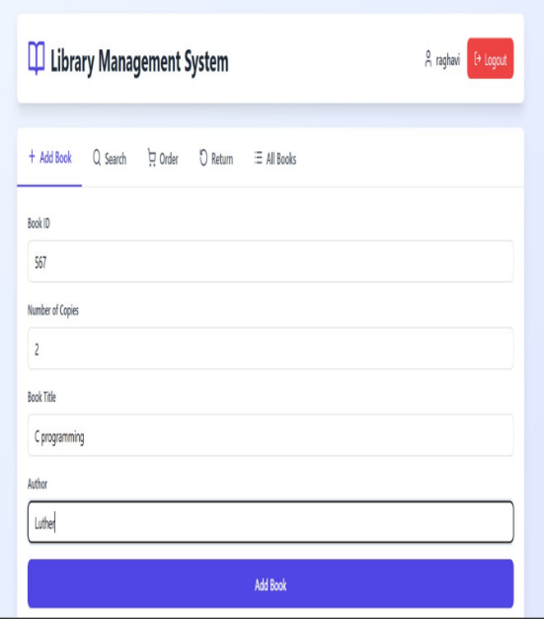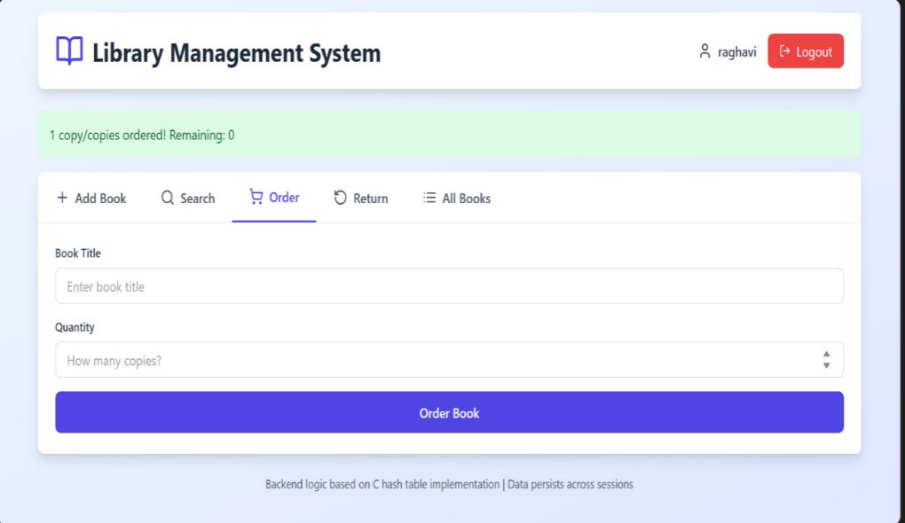

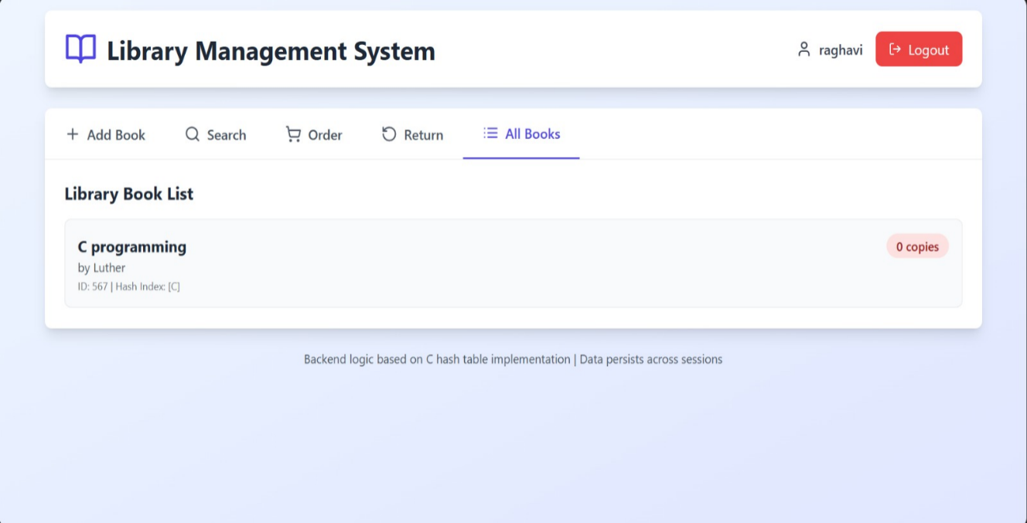
CONCLUSION

The Library Management System developed in this project successfully fulfills the objective of simplifying and automating the core functions of a traditional library. Through this system, tasks such as maintaining book records, managing user details, issuing and returning books, and tracking availability have become more efficient and accurate. By reducing manual work and minimizing human errors, the system provides a reliable and user-friendly platform that enhances the overall functioning of a library.
This project has demonstrated how technology can effectively replace outdated manual processes and introduce a structured, time-saving workflow. The implementation of features like search options, systematic cataloguing, and fine calculation ensures that both librarians and users benefit from faster access to information. The system is designed to handle data securely, maintain accuracy, and provide easy navigation, making it suitable for educational institutions and small libraries. The positive outcomes of this project highlight the importance of automation and digital transformation in modern information management.
Overall, the development of the Library Management System has been a valuable learning experience, allowing the application of programming concepts, problem-solving skills, and database management techniques. The project provided insights into real-world system design and improved understanding of how software can be used to solve practical problems. With further enhancements such as online access, advanced search filters, and integration with mobile platforms, this system has strong potential for future development. This project concludes with confidence that the Library Management System is a meaningful contribution toward improving library operations and user experience.

FUTURE ENHANCEMENTS

Although the current Library Management System meets the essential requirements of managing books, users, and transactions, several improvements can be implemented to make the system more advanced, efficient, and user-friendly. One potential enhancement is the development of an online access module, where users can log in from anywhere to search for books, reserve titles, check due dates, and renew books. This would greatly improve convenience and reduce the workload of library staff by minimizing manual inquiries.
Another important enhancement could be the integration of barcode or QR code scanning for book issue and return processes. This would significantly speed up transactions, reduce errors, and improve accuracy in tracking inventory. Additionally, implementing automatic fine calculation and online payment systems would make the system smoother and eliminate the need for manual handling of fees. Introducing features like email or SMS notifications for due dates, overdue reminders, and reservation alerts would further enhance communication with users and improve overall library management efficiency.
To make the system more robust, future versions could include data analytics and reporting features, allowing librarians to view statistics on most-issued books, user activity, inventory shortages, and budget planning. Integration with cloud storage can ensure secure data backup and remote access for administrators. Finally, developing a mobile application for both users and librarians would make the system more accessible and modern, enabling real-time updates and faster interaction. These enhancements would transform the current system into a comprehensive, smart, and fully automated library management solution.

REFERENCES

1)Books & Text Materials
Silberschatz, A., Korth, H.F., & Sudarshan, S. Database System Concepts. McGraw-Hill Education.
Balagurusamy, E. Object-Oriented Programming with C++. Tata McGraw-Hill.
Pressman, R.S. Software Engineering: A Practitioner’s Approach. McGraw-Hill.
2) Online Resource
TutorialsPoint – Database Management Systems, SQL, and C++ programming concepts.
GeeksforGeeks – Articles on file handling, data structures, and library system examples.
W3Schools – Basic programming and system design references.
3) Research & Documentation
IEEE Papers on library automation and information retrieval systems.
Academic notes and classroom materials provided by the faculty.
4) Software & Tools Used
C++ / Java / Python (whichever language you used) documentation.
MySQL / SQL Server / Any database tool documentation.
Visual Studio Code / CodeBlocks / IDE references.

