Second-Hand Student Marketplace

Project Report Submitted to the
SRM University-AP, Andhra Pradesh
For the partial fulfilment of the requirement to award the degree of

Bachelor of Technology in
Computer Science & Engineering
School of Engineering & Sciences

Submitted by
M Ramita Saraswati (AP24110011286)

Under the Guidance of
Dr. Anusha Nalajala

Department of Computer Science & Engineering

SRM University-AP
Neerukonda, Mangalagiri, Guntur
Amaravati, Andhra Pradesh – 522240

April 21, 2026

Acknowledgement

I would like to express my sincere and heartfelt gratitude to Dr. Anusha Nalajala for her constant guidance, valuable suggestions, and continuous encouragement throughout the development of this DBMS project titled “UniThrift: Peer-to-Peer Campus Marketplace System.” Her expertise in the subject and insightful feedback helped me understand the core concepts of database design, normalization, and implementation more effectively. Her support played a crucial role in successfully completing this project in a structured and meaningful manner.
I would also like to extend my sincere thanks to the faculty members of the department for providing a strong academic foundation and for creating an environment that encouraged learning and innovation. The knowledge and concepts taught during the course greatly contributed to the successful design and development of this project.
I am equally thankful to my institution for providing the necessary infrastructure, resources, and support required to carry out this work efficiently. The availability of lab facilities, software tools, and learning resources made it possible to implement the project smoothly.
I would also like to acknowledge my friends and classmates for their support, discussions, and encouragement during the course of this project. Their suggestions and collaborative spirit helped me overcome challenges and improve my work.
Finally, I would like to express my gratitude to my family for their constant motivation, patience, and moral support. Their encouragement helped me stay focused and complete this project successfully.
This project has been a valuable learning experience, enhancing both my technical knowledge and practical understanding of Database Management Systems.

CONTEXT

- Project Identification 04
- Project Background and Motivation 05
- Description and System Overview 06-07
- Entity-Relationship (ER) Diagram 08
- Explanation of ER Diagram 09-10
- Relational Schema Design (Table Creation) 10-13
- Detailed Description of Tables 14-16
- Database Normalization 17-18
- Data Population 19
- SQL Queries Implementation 20-21
- Creation and Usage of Views 22-23
- Triggers and Transaction Management 24-25
- Execution Proof 26-31
- Conclusion 32

- Project Identification

The title of the project is “UniThrift: Peer-to-Peer Campus Second-Hand Marketplace System.” This project is a database-driven web application developed to facilitate the buying and selling of second-hand items within university campuses in a secure and organized manner.

UniThrift focuses on creating a university-specific marketplace, where students can interact only with users belonging to the same institution. This ensures trust, relevance, and ease of transactions within a controlled environment. The system allows users to act as both buyers and sellers, enabling them to list products, browse available items, and participate in transactions seamlessly.

From a Database Management System (DBMS) perspective, the project emphasizes the practical implementation of key concepts such as:
- Relational database design using multiple interconnected tables
- Primary and Foreign Key constraints to maintain referential integrity
- Normalization up to Third Normal Form (3NF) to eliminate redundancy
- Triggers for automating critical operations like updating product status
- Views for simplified and secure data access

Overall, this project demonstrates how DBMS concepts can be effectively applied to build a real-world application that is scalable, efficient, and reliable.

- Project Background and Motivation

The rapid advancement of digital technology and online platforms has significantly transformed the way people interact, communicate, and conduct transactions. E-commerce and online marketplaces have become an integral part of modern life, enabling users to buy and sell products conveniently from anywhere. However, despite this growth, there is still a noticeable gap when it comes to university-specific marketplaces that cater exclusively to student communities.

In a typical university environment, students frequently require various second-hand items such as textbooks, laboratory equipment, calculators, electronics, furniture, and other daily-use products. Purchasing brand-new items can often be expensive for students, especially those who are managing limited budgets. As a result, there is a strong demand for affordable alternatives through second-hand exchanges.

Currently, students rely on general-purpose platforms such as OLX, Facebook Marketplace, or informal communication channels like WhatsApp groups. These methods present several challenges:
- Lack of trust due to unknown sellers
- Presence of irrelevant or geographically distant listings
- No verification of users or authenticity of products
- Difficulty in filtering items specific to a university
- Absence of structured transaction tracking

These limitations highlight the need for a dedicated, secure, and structured platform that is tailored specifically for university students.
The motivation behind developing UniThrift is to address these issues by creating a closed and controlled marketplace ecosystem that operates within university boundaries

- Description and System Overview

UniThrift is a comprehensive Peer-to-Peer (P2P) campus marketplace system designed to facilitate the buying and selling of second-hand items within university environments. The primary goal of the system is to provide a secure, structured, and user-friendly platform where students can interact with peers from their own institution and exchange goods efficiently.

The system is developed using a full-stack architecture, which integrates the frontend, backend, and database layers to ensure smooth functionality and seamless user interaction. The frontend is responsible for providing an intuitive and responsive user interface, the backend handles business logic and request processing, and the database manages data storage, retrieval, and integrity.

UniThrift enables users to register using their university-specific details, ensuring that all participants belong to a verified academic community. Once registered, users can perform multiple operations such as listing products for sale, browsing available items, sending purchase requests, and completing transactions. The system is designed to allow users to act as both buyers and sellers, making it flexible and user-centric.

A key feature of the platform is the seller approval mechanism, which introduces an additional layer of control in the transaction process. When a buyer expresses interest in a product, a request is generated and sent to the seller. The seller then has the authority to either accept or reject the request. This ensures that transactions are not automatic and provides sellers with full control over their listed items. Once a request is accepted, the transaction proceeds, and the system updates the product status accordingly.

Another important aspect of the system is the implementation of university-based filtering, which ensures that users can only view and interact with products listed by students from their own university. This feature enhances trust, reduces irrelevant data, and creates a localized marketplace experience.

The major functionalities of the system include:
- User Authentication and Role-Based Access:
Secure login and registration system with roles such as Buyer, Seller, and Admin to control access and functionality.
- Product Listing Module:
Sellers can add products with detailed attributes such as title, price, condition, description, and category.
- University-Based Filtering:
Displays only those products that belong to the same university as the logged-in user.
- Order Management and Tracking:
Handles buyer requests, seller approvals, and tracks the status of transactions (Pending, Completed, Cancelled).
- Review and Rating System:
Allows buyers to provide feedback after successful transactions, improving transparency and trust.
- Cart and Wishlist Functionality:
Enables users to save items for future reference or purchase.

The backend of the system is powered by a robust relational database management system (MySQL), which ensures data consistency, integrity, and efficient query processing. The use of structured tables, foreign key constraints, triggers, and views enables the system to maintain reliable and accurate data at all times.

- ER Diagram

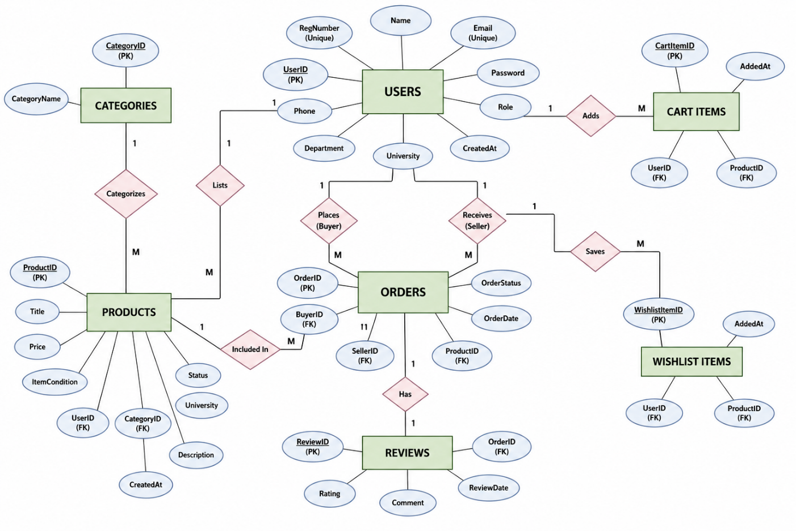

- Explanation of ER Diagram
The Entity-Relationship (ER) diagram of the UniThrift system represents the logical structure of the database and illustrates how different entities are connected to each other within the marketplace. It provides a clear understanding of how data flows between users, products, and transactions.
The diagram consists of key entities such as User, Product, Category, Order, Review, CartItem, and WishlistItem, each representing a real-world component of the system. Every entity is defined with its attributes and a primary key to uniquely identify records. The relationships between these entities are established using connectors, which indicate how they interact with one another.

At the core of the diagram is the User entity, which plays a central role in the system. A user can act as a buyer, seller, or both. Users can list products, place orders, and manage their cart and wishlist. This creates multiple one-to-many relationships between the User entity and other entities such as Product, Order, CartItem, and WishlistItem.

- The Product entity represents items listed for sale and is directly associated with both Users and Categories. Each product is listed by a single user (seller) and belongs to one category, while a category can contain multiple products. This establishes a one-to-many relationship between Category and Product.
- The Order entity models the transaction process between buyers and sellers. A user acting as a buyer can place multiple orders, while another user acting as a seller receives those requests. Each order is associated with a specific product, forming a relationship between Product and Order. This structure supports the complete purchase workflow in the system.
- The Review entity is linked to the Order entity and is used to store feedback after a transaction is completed. Each order can have one corresponding review, ensuring that only valid transactions are reviewed.

- The CartItem and WishlistItem entities represent user interactions before making a purchase. A user can add multiple products to their cart or wishlist, and each of these entries is linked to both the user and the product. These relationships help in tracking user preferences and temporary selections.

Overall, the ER diagram establishes several important relationships, including one-to-many relationships between users and products, products and orders, and categories and products, as well as a one-to-one relationship between orders and reviews. This structured design ensures data consistency, minimizes redundancy, and supports efficient database operations.
The ER diagram serves as the foundation for designing the relational schema and plays a crucial role in implementing a scalable and well-organized database system for the UniThrift platform.

- Relational Schema Design (Table Creation)

The relational schema for the UniThrift system has been carefully designed by converting the ER diagram into structured relational tables. Each entity in the system is mapped into a corresponding table with appropriate attributes, data types, and constraints to ensure efficient data management and integrity.

The database consists of seven main tables: Users, Products, Categories, Orders, Reviews, CartItems, and WishlistItems, each representing a specific component of the marketplace system.

- The Users table stores all registered user details such as UserID, Name, Registration Number, Email, Phone number, Password, Department, University, Role, and CreatedAt. The use of UNIQUE constraints on fields like Email and Registration Number ensures that duplicate entries are avoided. The Role attribute allows users to act as Buyer, Seller, Both, or Admin, enabling flexible participation in the system.

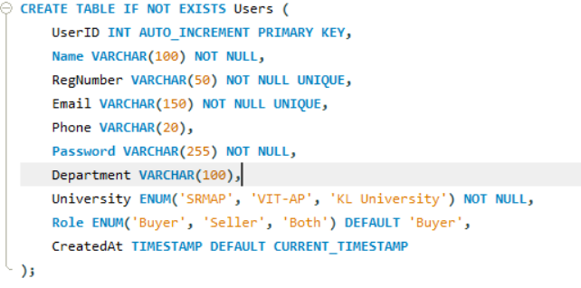

- The Products table contains information about items listed for sale. It includes attributes such as ProductID, UserID, CategoryID, Title, Price, ItemCondition, Status, University, Description, and CreatedAt. The UserID acts as a foreign key linking each product to its seller, while CategoryID connects the product to its category. The Status field (Available/Sold) helps track the lifecycle of a product.
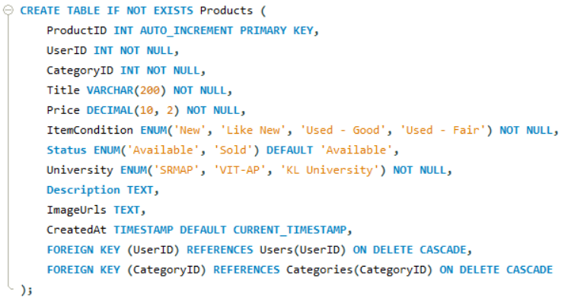

- The Categories table is used to classify products into groups such as Books, Electronics, Furniture, and Accessories. It consists of CategoryID and CategoryName, ensuring proper organization and easy filtering of products.
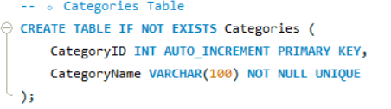

- The Orders table represents the transaction process between buyers and sellers. It includes OrderID, ProductID, BuyerID, SellerID, OrderStatus, and OrderDate. The foreign keys establish relationships with both the Users and Products tables. The OrderStatus attribute (Pending, Completed, Cancelled) helps in tracking the progress of each transaction.
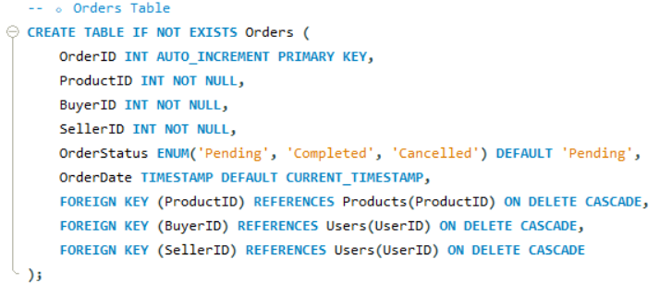

- The Reviews table stores feedback provided by buyers after successful transactions. It contains ReviewID, OrderID, Rating, Comment, and ReviewDate. The OrderID is a foreign key ensuring that reviews are linked only to valid orders.
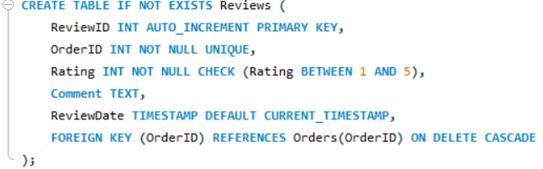

- The CartItems table manages temporary selections made by users before purchasing. It includes CartItemID, UserID, ProductID, and AddedAt. This table establishes a relationship between users and products, allowing users to add multiple items to their cart.
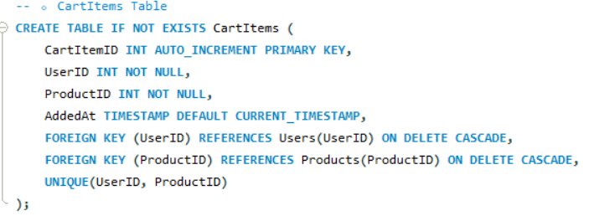
- Similarly, the WishlistItems table allows users to save products for future interest. It includes WishlistItemID, UserID, ProductID, and AddedAt. This helps users keep track of desired items.
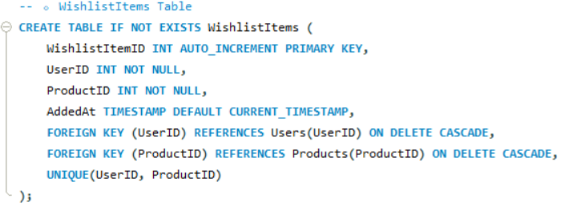
To maintain data integrity, foreign key constraints with cascading rules (ON DELETE CASCADE) are implemented. This ensures that when a parent record is deleted, all related child records are automatically removed, preventing inconsistencies.
Additionally, ENUM data types are used for controlled attributes such as:
- Role (Buyer, Seller, Both, Admin)
- Product Status (Available, Sold)
- Order Status (Pending, Completed, Cancelled)
- University (SRMAP, VIT-AP, KL University)
This structured relational schema ensures that the database is efficient, consistent, and scalable, supporting all functionalities of the UniThrift marketplace system.

- Detailed Description of Tables
The UniThrift database consists of multiple tables, each designed to perform a specific function within the system. These tables work together to support the overall marketplace operations.
  - The Users table stores information about all registered users in the system. It plays a central role as it is connected to multiple other tables. It is used for authentication, role management, and identifying buyers and sellers during transactions.
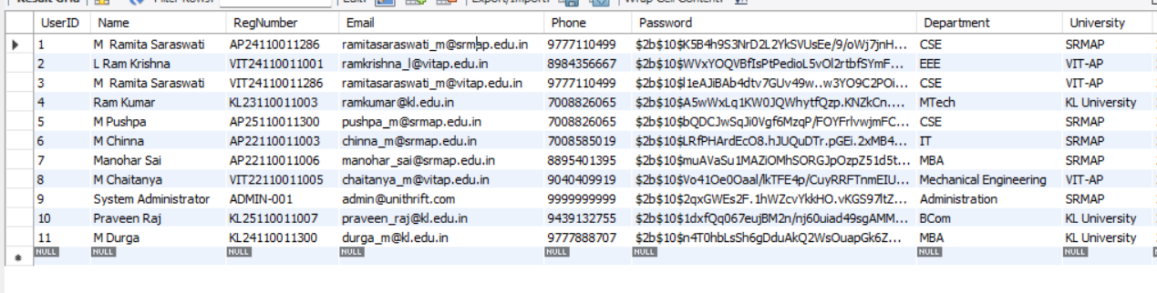
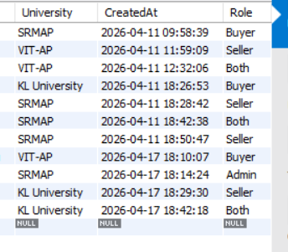
Figure 1: Users Table displaying registered users from different universities.

  - The Products table contains all items listed for sale by users. It is one of the most important tables in the system, as it connects users, categories, and orders. It helps in managing product details, availability status, and university-based filtering.

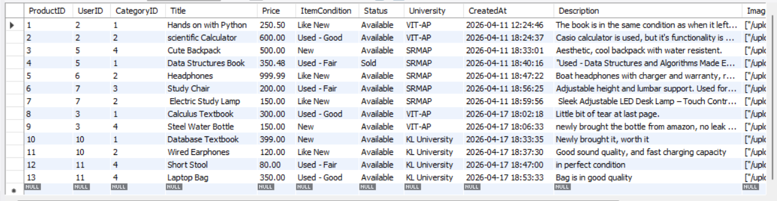
Figure 2: Products Table showing items listed with price, condition, and status.

  - The Categories table is used to organize products into different groups such as books, electronics, and furniture. This improves search efficiency and helps users easily browse items.
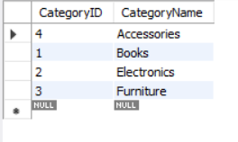
Figure 3: Categories Table showing different product categories available in the system.

  - The Orders table manages the transaction process between buyers and sellers. It tracks the status of each order, whether it is pending, completed, or cancelled, and plays a key role in handling purchase requests.
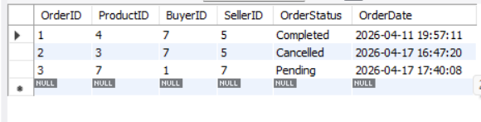
Figure 4: Orders Table showing transactions with buyer, seller, and order status.

  - The Reviews table stores feedback given by buyers after completing a transaction. It helps in maintaining trust and improving transparency within the system.
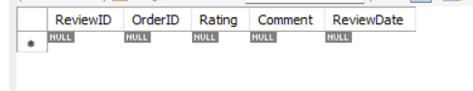
Figure 5: Reviews Table showing ratings and feedback for completed orders.

  - The CartItems table allows users to temporarily store products before making a purchase. It improves user convenience by enabling them to manage multiple items.
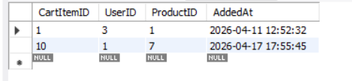
Figure 6: CartItems Table showing products added to cart by users.

  - Similarly, The WishlistItems table helps users save products for future reference. It enhances user experience by allowing users to keep track of items they are interested in
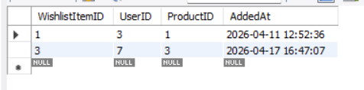
Figure 6: WishlistItems Table showing products saved for future reference.

Overall, each table in the database is designed with a specific purpose, and together they ensure smooth functioning of the UniThrift marketplace system.

- Database Normalization
Database normalization is a systematic process used to organize data in a relational database in order to reduce redundancy, eliminate anomalies, and improve data integrity. It ensures that the database structure is efficient and that each piece of data is stored in an appropriate location.
In the UniThrift system, normalization has been applied up to the Third Normal Form (3NF) to ensure that the database remains consistent, scalable, and easy to maintain.

a. First Normal Form (1NF)
A table is said to be in First Normal Form if:
- All attributes contain atomic (indivisible) values
- There are no repeating groups or multi-valued attributes
In this project:
- Each table stores data in a structured format where each field contains only a single value.
- For example, in the Users table, attributes like Name, Email, and Phone are stored as individual values, and there are no multiple values in a single column.

b. Second Normal Form (2NF)
A table is in Second Normal Form if:
- It is already in 1NF
- All non-key attributes are fully dependent on the primary key
In the UniThrift database:
- Each table has a clearly defined primary key (e.g., UserID, ProductID, OrderID)
- All other attributes depend entirely on that key
For example:
- In the Products table, attributes like Title, Price, and Condition depend on ProductID and not on any partial key.

c. Third Normal Form (3NF)
A table is in Third Normal Form if:
- It is already in 2NF
- There are no transitive dependencies (i.e., non-key attributes should not depend on other non-key attributes) .
In this project:
- Related data is separated into different tables to avoid duplication
- For example:
  - User-related details such as University and Department are stored only in the Users table
  - Product-related data is stored in the Products table
  - Category information is stored separately in the Categories table
This ensures that data is not unnecessarily repeated across multiple tables.

Benefits of Normalization in This Project
The normalization applied in the UniThrift database provides several advantages:
- Reduces data redundancy: Avoids storing duplicate data in multiple places
- Improves data consistency: Ensures accurate and reliable data across tables
- Prevents anomalies: Eliminates insertion, deletion, and update anomalies
- Enhances query efficiency: Structured tables improve data retrieval performance
- Simplifies maintenance: Changes in one table do not affect unrelated data

- Data Population
To demonstrate the functionality and effectiveness of the UniThrift system, sample data has been inserted into all the tables of the database. This data simulates real-world usage of the platform by including multiple users, product listings, and transaction records.
The dataset includes users from different universities such as SRMAP, VIT-AP, and KL University, with different roles like Buyer, Seller, and Both. Various products have been listed under different categories such as Books, Electronics, Furniture, and Accessories. Additionally, orders have been created to represent transactions between buyers and sellers, along with corresponding cart and wishlist entries.

This sample data plays a crucial role in verifying the correctness and functionality of the system. It helps in:
- Testing relationships:
Ensures that foreign key relationships between tables (Users, Products, Orders, etc.) are correctly established and functioning.
- Validating constraints:
Confirms that constraints such as primary keys, foreign keys, UNIQUE constraints, and ENUM values are properly enforced.
- Demonstrating query outputs:
Allows execution of SQL queries such as joins, subqueries, and aggregate functions to produce meaningful results.
- Simulating real-world scenarios:
Represents actual marketplace activities like product listing, purchase requests, and order completion.
- Verifying data integrity:
Ensures that data remains consistent across all tables during insertion and updates.

Overall, the populated data provides a practical demonstration of how the UniThrift system operates and supports all major functionalities of the application.

- SQL Queries Implementation

In the UniThrift system, various SQL queries are used to efficiently retrieve and manipulate data from multiple tables. These queries play a crucial role in implementing core functionalities of the application and demonstrate the practical use of DBMS concepts.

- Join Queries
  - Join operations are extensively used in the project to combine data from multiple tables. Since the database is normalized, related data such as user details and category names are not stored redundantly in the Products table. Instead, they are retrieved dynamically using joins.
  - For example, when displaying products, the system joins the Products, Categories, and Users tables to fetch additional information such as the category name and seller name. This ensures that data remains consistent and avoids duplication.
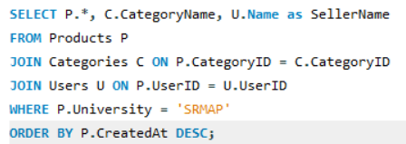
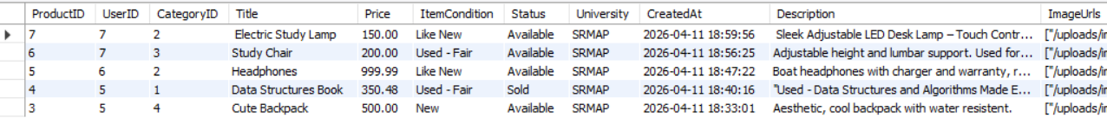

- Aggregate Functions
  - Aggregate functions are used to perform calculations on data and generate summary information. In this project, functions like COUNT() are used to calculate the total number of users, products, and orders in the system.
  - These queries are particularly useful in the Admin Dashboard, where overall system statistics are displayed. For instance, the total number of registered users or total products listed can be obtained using aggregate functions.

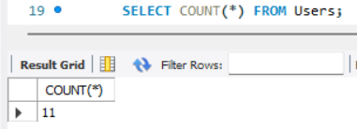
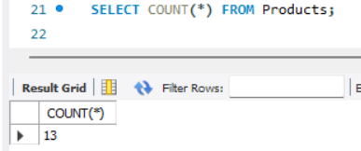
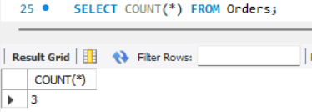

- Subqueries (Nested Queries)
  - Subqueries are used to execute nested queries within a single SQL statement. In the UniThrift system, subqueries are used to retrieve multiple aggregated values in one query.
  - For example, the system uses a single query containing multiple subqueries to fetch:
- Total number of users
- Total number of products
- Total number of orders
  - This approach improves efficiency by reducing the number of database calls and ensures faster data retrieval.
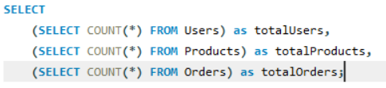
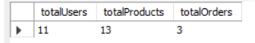

- Creation and Usage of Views

In the UniThrift system, views are created to simplify complex queries and provide a structured way to access data from multiple tables. A view is a virtual table that is derived from one or more base tables using SQL queries. It does not store data physically but presents data in a user-friendly format.
In this project, two important views are created:
- Buyer_View
- Seller_View
- Both Buyer and Seller

The Buyer_View displays transaction details from the buyer’s perspective. It includes information such as OrderID, BuyerID, Product Title, Order Status, Order Date, and Price. This view is created by joining the Orders and Products tables, allowing easy access to buyer-related transactions without writing complex join queries each time.
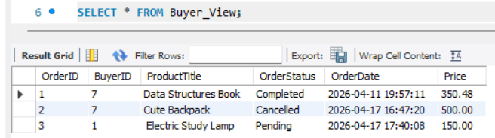

Similarly, the Seller_View displays transaction details from the seller’s perspective. It includes SellerID along with product and order details. This helps sellers track the status of products they have sold.
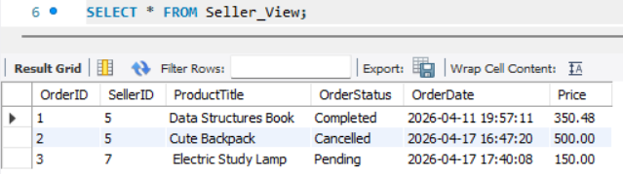

These views improve the overall system design by:
- Simplifying complex queries: Users can retrieve combined data without writing JOIN statements repeatedly
- Improving security: Sensitive data can be restricted by exposing only required fields through views
- Enhancing data organization: Provides separate logical representations for buyers and sellers

Additionally, the system utilizes database queries along with views to support the Admin Dashboard, where the administrator can monitor platform activity. The admin can view summary information such as:
- Total number of users
- Number of buyers and sellers
- Total products and orders

This helps in analyzing system usage and managing the platform effectively.
Overall, the use of views in the UniThrift system improves data accessibility, reduces query complexity, and enhances the overall efficiency of database operations.

- Triggers and Transaction Management

In the UniThrift system, triggers and transactions are used to automate important database operations and ensure data consistency during critical processes such as order completion.

A. Triggers
A trigger is a database mechanism that automatically executes a predefined action when a specific event occurs. In this project, a trigger named After_Order_Completed is implemented on the Orders table.
When the status of an order is updated to “Completed”, the trigger is automatically activated. It performs the following actions:
- Updates the corresponding product’s status to “Sold” in the Products table
- Ensures that the product is no longer available for other buyers
- Removes the product from CartItems and WishlistItems tables to avoid duplicate or invalid selections
This automation eliminates the need for manual updates and ensures that the database remains consistent and synchronized across all related tables.

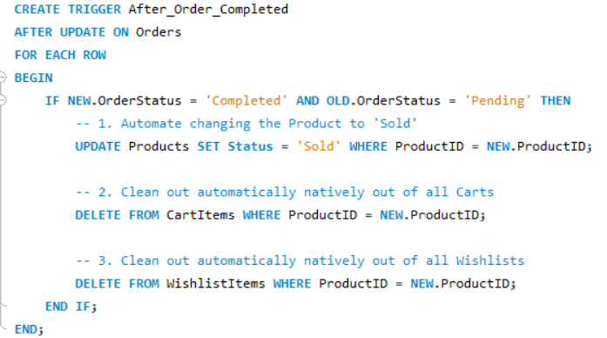

B. Transactions
Transactions are used to execute a group of database operations as a single unit. They ensure that all operations are completed successfully, or none are applied in case of failure.
In this project, transactions are used during order processing:
- When a seller accepts a request, the system updates the order status
- The trigger is executed, and related updates are applied
- All operations are performed within a transaction to maintain consistency
Transactions follow key properties such as:
- Atomicity: All operations are completed fully or not at all
- Consistency: The database remains in a valid state
- Rollback support: In case of failure, changes can be undone

The use of triggers and transactions in the UniThrift system ensures automated, reliable, and consistent database operations. These features enhance the robustness of the system and demonstrate the practical implementation of advanced DBMS concepts.

- Execution Proof
- Homepage Based on University-
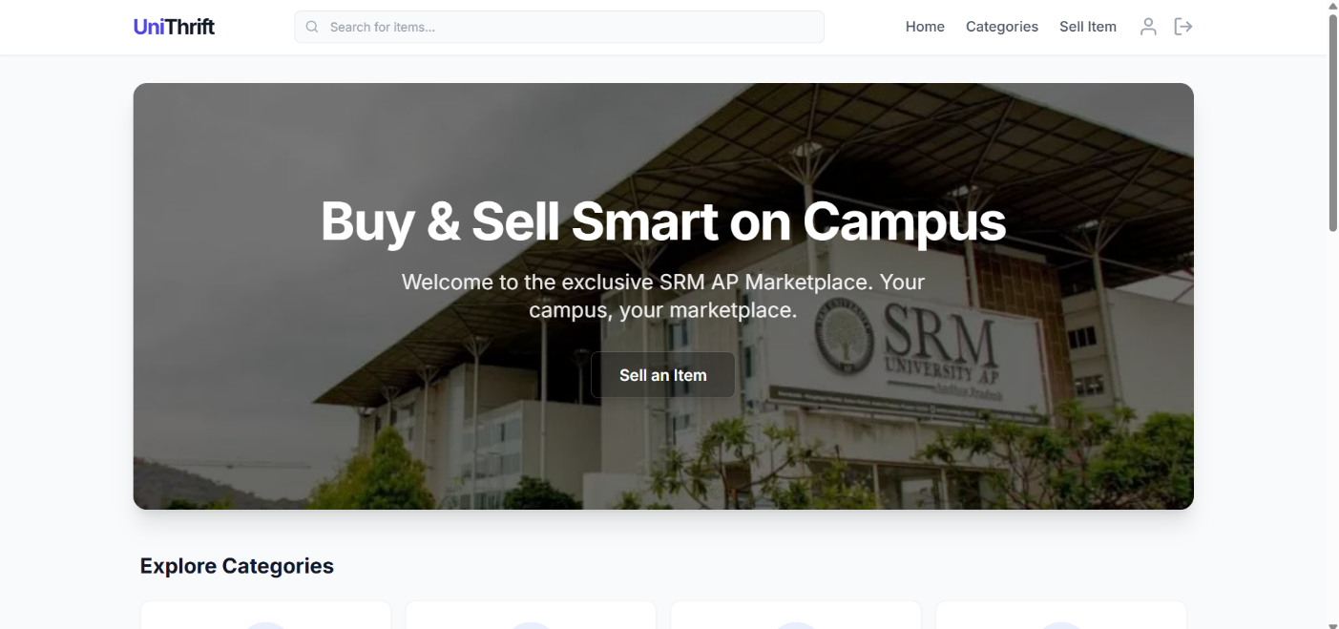
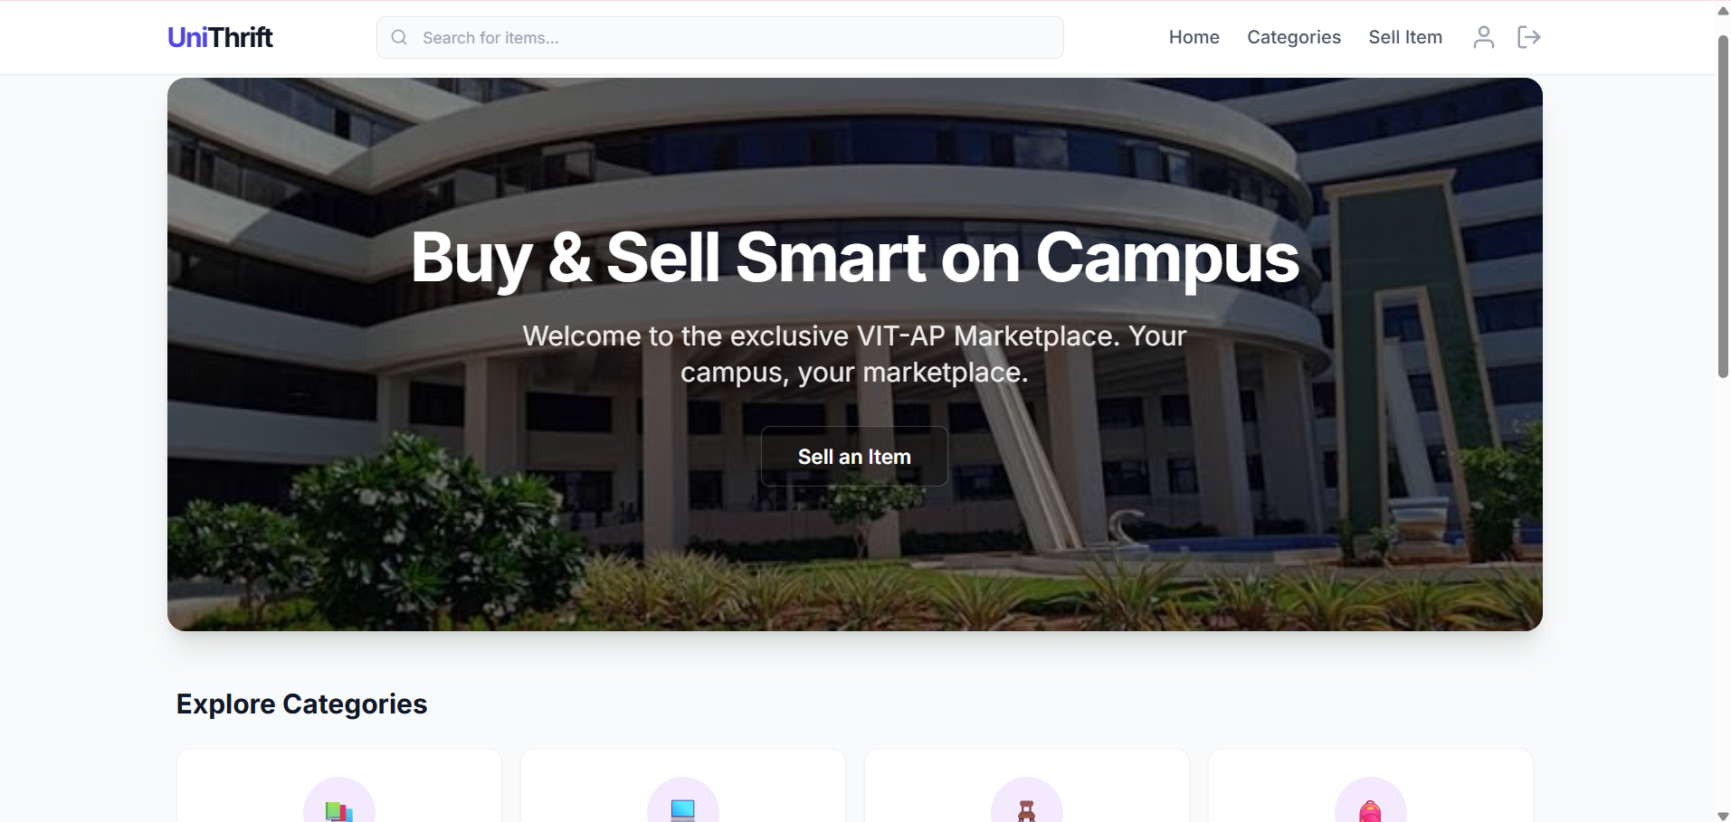
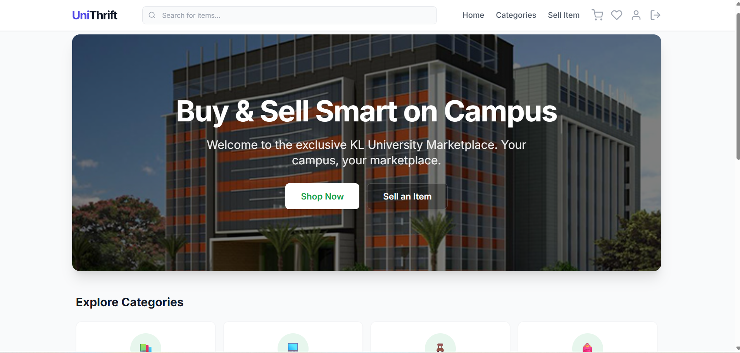

- User Registration Page-
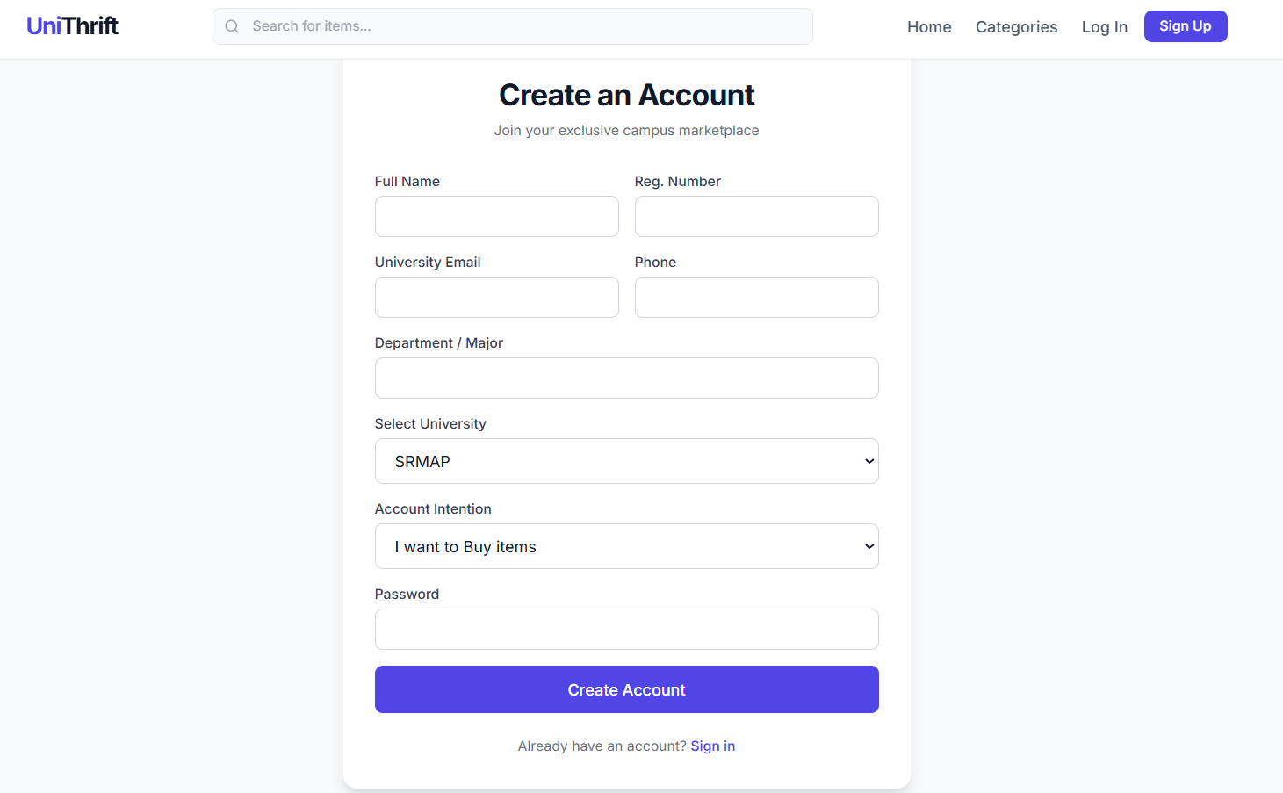

- Admin Page-

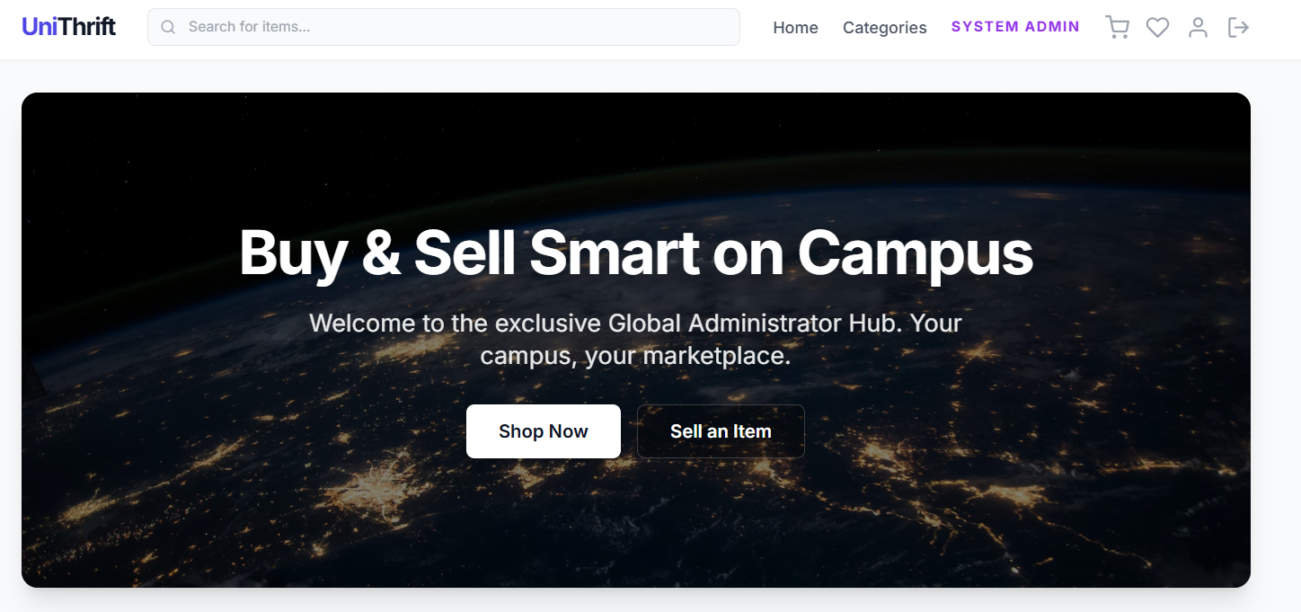
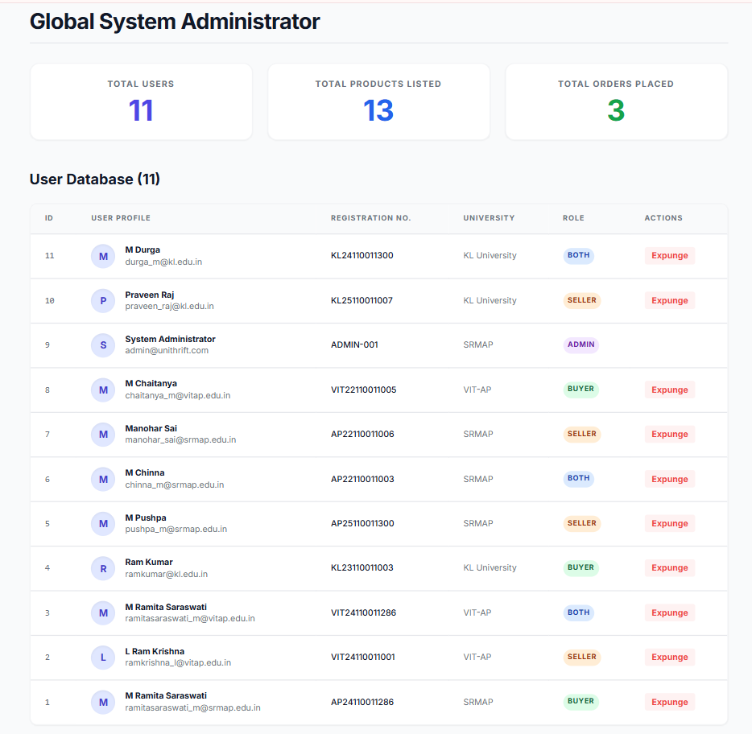
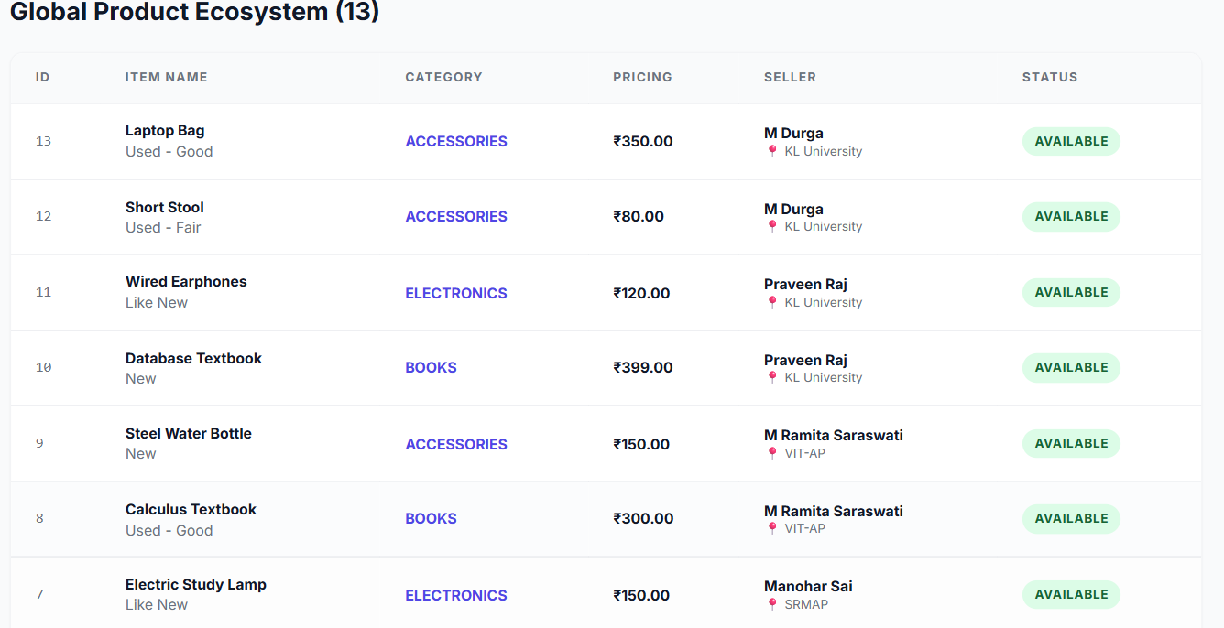

- Global Store-

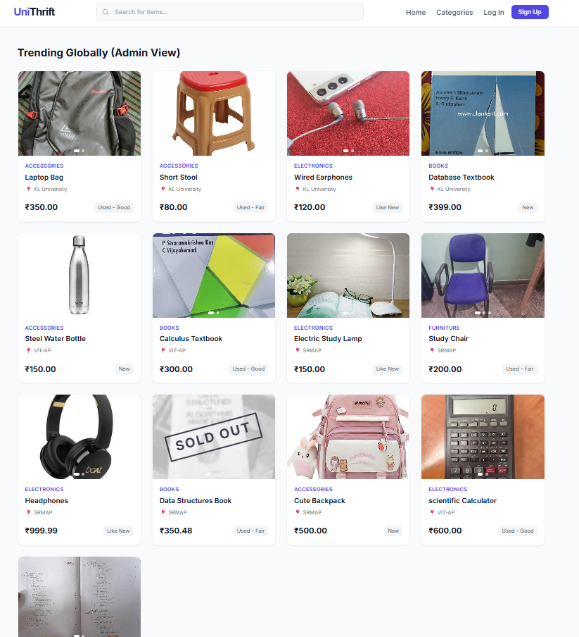

- Product View and Cart-
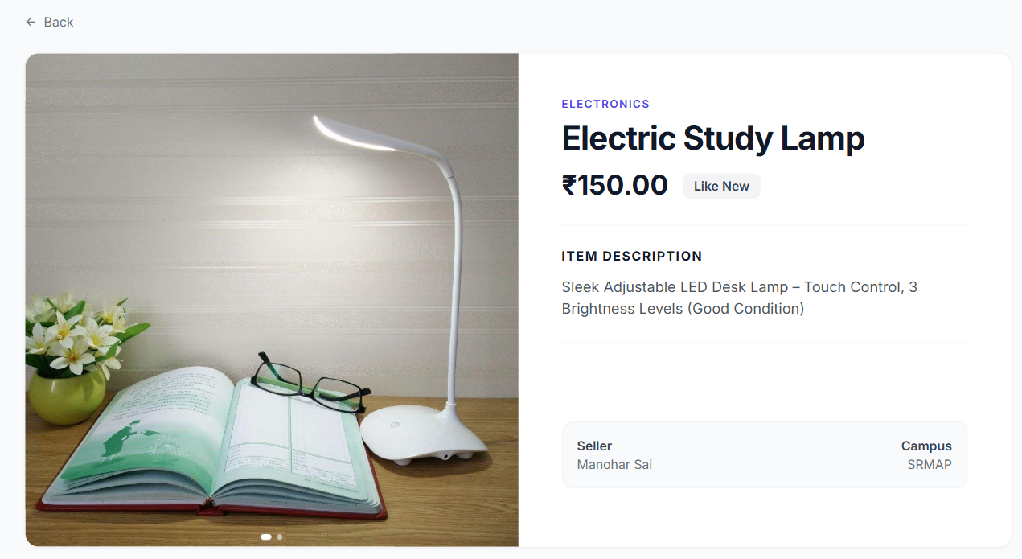
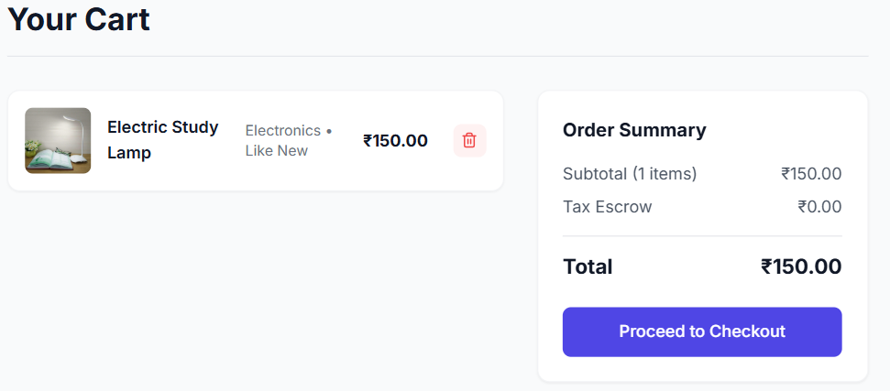
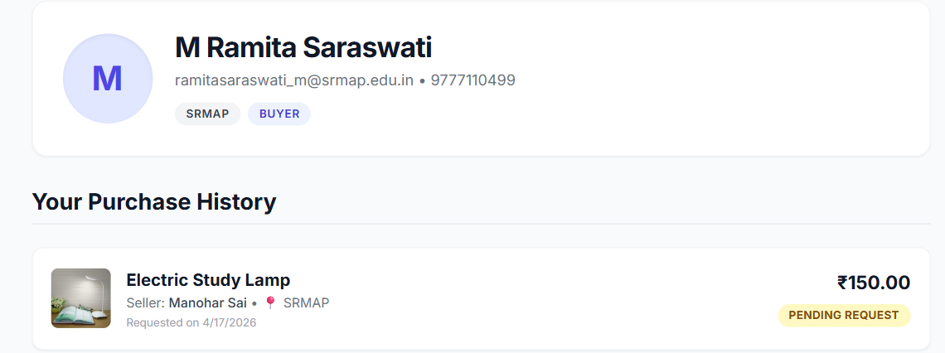

- Order Request-

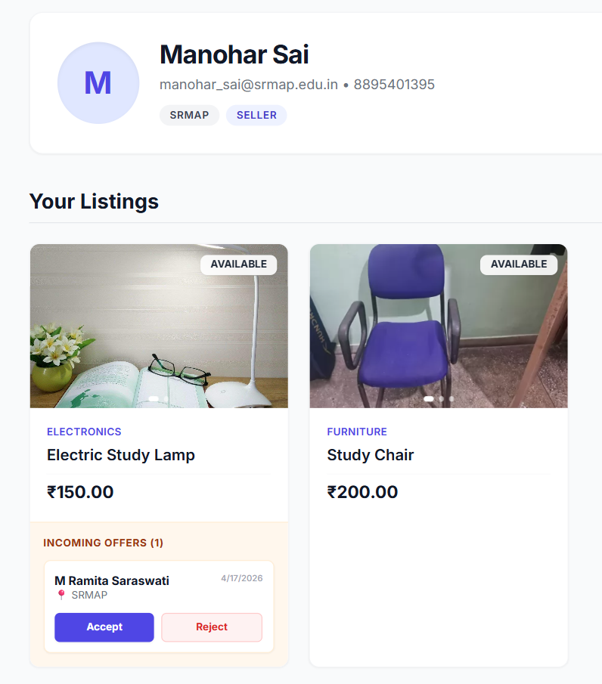

- Conclusion
The UniThrift system successfully demonstrates the practical implementation of Database Management System (DBMS) concepts through the development of a real-world, full-stack application. The project provides a structured and secure platform for students to buy and sell second-hand items within their respective universities.
Through this project, key DBMS concepts such as relational schema design, normalization, primary and foreign key constraints, views, triggers, and transactions have been effectively applied. The database is designed to ensure data consistency, integrity, and efficient retrieval, while minimizing redundancy.
The system also integrates frontend and backend technologies to deliver a seamless user experience. Features such as role-based access (Buyer/Seller/Both), university-based filtering, seller approval mechanism, and admin dashboard enhance the usability and functionality of the platform. The use of triggers ensures automation of critical operations like updating product status, while transactions guarantee safe and reliable database operations.
Overall, the UniThrift project not only addresses a practical problem faced by students but also showcases how DBMS concepts can be utilized to build scalable, efficient, and real-world applications. It serves as a comprehensive learning experience and highlights the importance of database systems in modern application development.

