Rohit Chitte

ineuron  | Income Prediction Web App

Income Prediction (HLD)

# Contents

## Abstract

## General Description

### Product Perspective

### Problem Statement

### Proposed Solution

### Further Potential Improvements

### Technical Requirements

### Data Requirements

### Hardware Requirements

### Constraints

### Assumptions

## Design Details

### Proposed Methodology

### Training Methodology

## Event Log

## Error handling

## Performance

## Reusability

## Application Compatibility

## Resource Utilization

## Deployment

## Conclusion

## Reference

## Abstract

Factors like covid 19, necessity of passive income streams, huge and easy availability of information about stock market, Technical and fundamental analysis. Awareness about investment options. There is huge surge in demat accounts all over the world specially in India. Stock market is a place where many new beginner traders are nowadays extremely interested to learn and earn money. But often due to greedy approach of trading they lose money. Traders usually rely on indicators, news and historical prices of stocks. Most fundamental approach is predicting future trends of stock prices using historic prices. This project involves a small effort of predicting trends in stock prices based on price data of last 100 trading sessions to support the analysis of amateur traders.

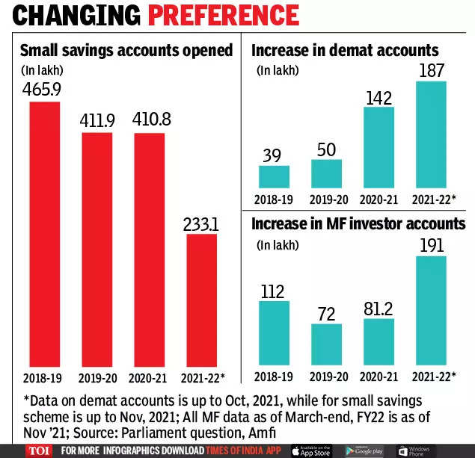

# General Description

## Product Perspective

Income Prediction Application is tool developed for intention to support traders in decision making before placing final order in the stock market. Income Prediction application predicts the trend of particular stock based on past 100 trading session prices.

## Problem Statement

Creating Application to predict trend of stock price based on historic prices.

## Proposed Solution

Developing application that asks symbol to detect the trend of particular stock prices from user, scrape data from trusted website and predict trend based on Machine learning/Deep Learning approach.

## Further Potential Improvements

Using State-of-Art time series algorithms to detect trend.

## Technical Requirements

Laptop of Desktop with Windows 11 operating system. Internet connection

## Data Requirements

Price data of last 5 years to predict trend.

## Tools Used

* Python (Programming Language)
* Pandas (Data Manipulation and preprocessing)
* Selenium (Browser Automation and Web Scraping)
* Logging (Debugging, Maintenance)
* Cassandrea (Database to store scraped data)
* Keras (training and predictions using LSTM model time series analysis)
* PyCharm (IDE for development of application)
* GitHub & Git (Version Control System)

## Hardware Requirements

* Laptop/Desktop
* Working Internet Connection

## Constraints

* Application must accept stock Ticker(symbol) input from user.
* Scrap data from trusted website(Yahoo Finance)
* Using Machine Learning/Deep Learning algorithm for prediction
* Proper Logging to be implemented.
* Data scraped to be uploaded on DB automatically.
* Total Execution time to be recorded and optimized.
* Application must provide consistent results.

## Assumptions

Stock price trends is function of historical stock prices.

# Design Details

## Proposed Methodology

Checking user input is valid/invalid.

Pre-Processing User input

Accept User Input

Stock Ticker

Data Scraping

Data is stored on device

Passing input to driver code

Passing Data to testing Pipeline

Saving Image on disk

Starting thread to upload data on remote DB.

Application Ready to predict next trend

Image output on UI

## Training Methodology

Splitting in Train / Test

Pre-Processing Data

Scrape Data for Nifty 50 index

Changing Form of data suitable to train time series model.

Dump pickle file for scaler object

Scaling Data

Saving model file in .h5 format

Passing Data to training function

Defining Model Architecture

## Event Log

As Modular Codding standards have been followed, code is written with functions, try except block has been included proper logging has been done, Logger object logs the entry exit of code control in log.txt file. Once can clearly know the code flow from log file without debugging the project.

## Error handling

To ensure that code flow is not interrupted due to unexpected errors and exceptions, all lines of code are included under try and except blocks

## Performance

As project includes many different modules to take care of different functionalities. Execution time is major concern specially for DB module as connection and uploading data to remote DB is time consuming. Hence to reduce overall Execution time, Concept of multi-threading has been used.

**Average execution time before multi-threading 7 minutes**

**Average Execution time after multi-threading 2 minutes.**

## Reusability

Project is run multiple times on multiple test cases. Every time expected results are produced. Here taste case means different stocks names E.g INFY, TATAMOTORS, LUPIN,ABB

## Application Compatibility

Project can be run on any system. Windows 11 and edge browsers are recommended.

## Resource Utilization

As DB operations are time consuming. To save time and utilize resources to optimal extent. Multi-Threading has been implemented using threading module in python.

## Deployment

Deployment of Application is not possible at current stage due to use of selenium web driver and web scraping

## Conclusion

Income Prediction Web App is designed with a view to predict stock prices trends based on historical data of prices. This will be useful aid for amateur traders in decision making and stock selection.

## Reference

Image link

<https://www.google.com/url?sa=i&url=https%3A%2F%2Fm.timesofindia.com%2Fbusiness%2Findia-business%2Fno-of-new-small-savings-a%2Fcs-shrinks-demat-spikes-in-3-yrs%2Farticleshow%2F88266728.cms&psig=AOvVaw18e_gt22AEZJOFF5BZLNHT&ust=1676969723980000&source=images&cd=vfe&ved=0CBAQjRxqFwoTCKj34p_po_0CFQAAAAAdAAAAABAD>