OZ
AI Agent Orchestration Platform

"Control your entire infrastructure with plain English"

Company | AIT GLOBAL INC
Contact | rohit.darekar@aitglobalinc.com
Version | 1.0 — June 2026
Category | AI · DevOps · Infrastructure Automation

📋 Executive Summary
Oz is an AI-powered infrastructure management platform that lets any engineer manage servers, containers, deployments, and cloud resources using plain English — no memorising commands, no SSH fatigue, no tool-switching.
Example queries users ask Oz today:
- "How many Docker containers are running on production?"
- "Deploy the latest build on the web server and restart the service."
- "Show me the last 50 error logs from the API container."
- "Check the health of AITLP-371."
- "List all VMs on the Proxmox cluster and show me which are offline."

What makes Oz different: It combines a natural-language chat interface (Leon AI), a backend orchestration engine, Cloudflare Edge AI agents (zero cold-start, globally distributed), and an encrypted secrets vault into a single deployable platform that any DevOps team can self-host today — or consume as a SaaS.

🚨 The Problem
▸ The Knowledge Gap: Every infrastructure operation requires specialised CLI knowledge. New engineers spend weeks learning SSH flags and Docker commands. Senior engineers waste hours on repetitive, low-value operational tasks.
▸ The Context-Switching Tax: A typical DevOps workflow requires switching between: terminal, Docker CLI, Grafana, log aggregators, CI/CD dashboards, DNS panels, and ticketing systems. Each context switch costs 20–25 minutes of productive focus.
▸ The Automation Ceiling: Existing tools (Ansible, Terraform, Bash) are powerful but brittle — they require upfront authoring, break when infrastructure changes, and cannot handle free-form operational queries. AI coding assistants help with code but cannot execute live infrastructure operations.

The result: Engineering teams spend 30–40% of their time on operational toil that should be automated.

✅ Our Solution
Oz solves all three problems with a single, cohesive platform. Instead of building yet another fixed automation script or another AI chatbot that only answers questions, Oz connects a natural-language understanding layer (Leon AI) to a fleet of specialised AI agents that have direct, authenticated access to your infrastructure.
Problem | Oz Solution
Knowledge gap | Natural-language interface — ask in plain English, Oz handles the syntax
Context switching | One chat for all infra — containers, servers, databases, DNS, CI/CD
Automation ceiling | AI agents that reason, adapt, and execute multi-step tasks live against real infra

🏗️ System Architecture
The diagram below shows how the four layers of Oz work together:
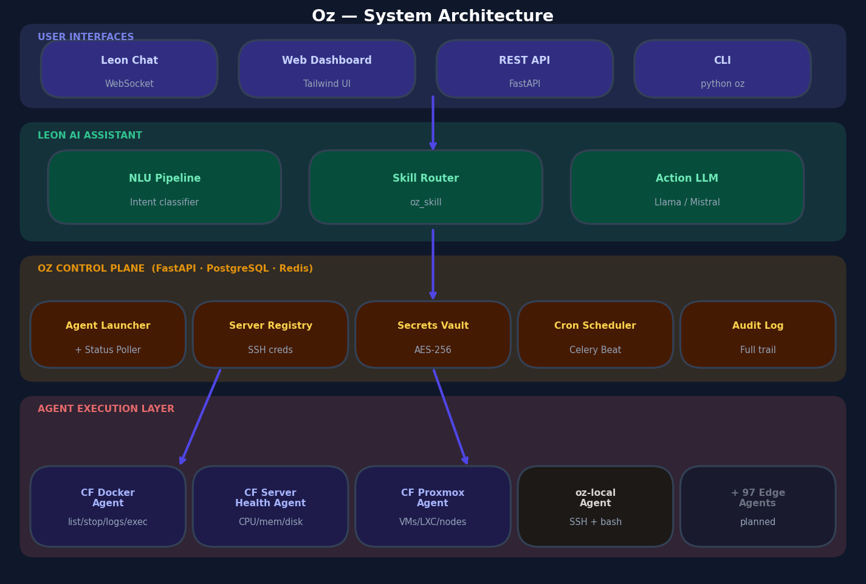
Layer 1 — User Interfaces: Leon Chat (WebSocket), Web Dashboard, REST API, CLI. Layer 2 — Leon AI: NLU pipeline, skill router, action LLM. Layer 3 — Oz Control Plane: agent launcher, server registry, secrets vault, cron scheduler, audit log. Layer 4 — Agent Execution: Cloudflare Edge Workers (sub-100ms) and oz-local Docker sandboxes (for SSH tasks).

🔄 Request Flow — How It Works
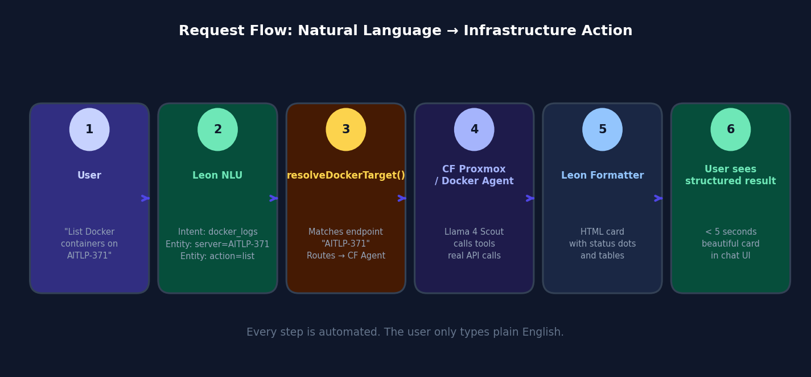
Step 1: User types plain English in Leon chat. Step 2: Leon NLU pipeline identifies the intent and extracts entities (server name, container name, etc.). Step 3: resolveDockerTarget() / resolveProxmoxTarget() matches the server name to a registered endpoint. Step 4: Cloudflare Edge Worker receives the task, runs Llama 4 Scout 17B, calls real API tools. Step 5: Leon formats the output as a structured HTML card. Step 6: User sees a clean, readable result in under 5 seconds.

⚡ Key Features
✦ Natural Language Interface: No commands to memorise. Ask in plain English — Oz handles the syntax, the SSH, and the execution.
✦ Multi-Agent Support: OpenCode (free, default), Claude Code, Codex, Gemini CLI, CommandCode, oz-local, and Cloudflare edge agents. Agent-agnostic architecture.
✦ Cloudflare Edge AI Agents: Purpose-built Workers running Llama 4 Scout 17B at Cloudflare's global edge. Zero cold start. Sub-100ms from anywhere in the world.
✦ Encrypted Secrets Vault: SSH keys, passwords, API tokens, Proxmox tokens — all stored AES-256 encrypted. Decrypted only at agent launch time, injected as env vars, never logged.
✦ Server & Endpoint Registry: Register SSH servers and Docker/Proxmox API endpoints. Oz resolves them by name from your natural language queries.
✦ Cron Scheduling: Schedule any agent on a cron schedule. Run health checks every morning, SSL audits every week, DB backups nightly — all automatic.
✦ Real-time Log Streaming: Every agent run streams logs via WebSocket. Watch deployments unfold live in the chat UI.
✦ Full Audit Trail: Every action logged: who triggered it, which agent ran, what prompt was used, when it started and finished.
✦ Skills Library: Save reusable agent configurations as named Skills. Share best-practice setups across your team.
✦ Structured HTML Responses: Output is formatted into clean HTML cards — tables with status dots, dark log blocks, key-value metric cards — not raw text dumps.

🤖 Agents Built Today (4 of 101)
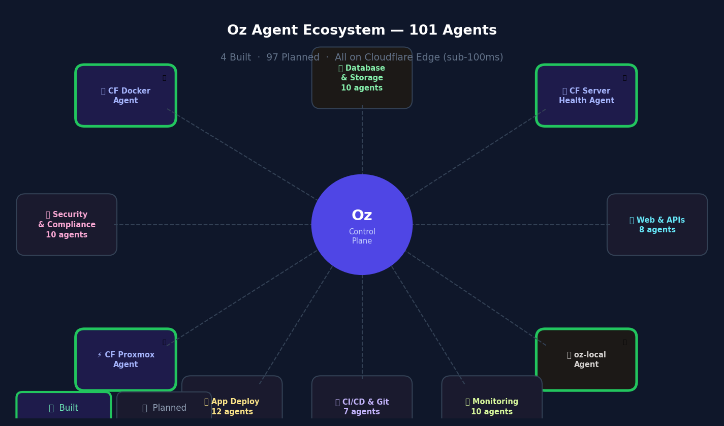
🐳 Docker Container Management [cloudflare_docker_agent]
Endpoint: https://cf-docker-agent.rohit-darekar.workers.dev
Tools: 10 tools: list_containers, inspect_container, get_container_logs, container_stats, run_container, stop_container, remove_container, list_images, exec_in_container, docker_system_info
List containers, fetch logs, get CPU/memory stats, exec commands, start/stop/remove containers.

🖥️ Server Health Monitoring [cloudflare_server_health_agent]
Endpoint: https://cf-server-health-agent.rohit-darekar.workers.dev
Tools: 5 tools: system_info, disk_usage, list_containers, get_resource_usage, exec_in_container
Full health report: OS, CPU, RAM, disk, per-container resource usage, load average, HEALTHY/WARNING/CRITICAL status.

⚡ Proxmox VE Hypervisor Management [cloudflare_proxmox_agent]
Endpoint: https://cf-proxmox-agent.rohit-darekar.workers.dev
Tools: 13 tools: get_cluster_status, list_nodes, get_node_status, list_vms, get_vm_status, vm_action (start/stop/shutdown/reboot/reset), list_containers, get_container_status, container_action, list_storage, get_node_tasks, list_vm_snapshots, get_vm_config
Manage VMs and LXC containers on Proxmox clusters. Check node health, storage, and task history. Start/stop VMs by name.

🔧 SSH + Shell Agent (Local) [oz-local]
Endpoint: Docker sandbox on Oz host
Tools: Runs any AI agent (OpenCode, Claude Code, Codex, Gemini CLI) inside an isolated Docker container
Handles any task requiring SSH access to servers: deployments, bash commands, app logs, server health on SSH servers.

🗺️ Planned Agent Roadmap — 101 Agents Total
Each new Cloudflare edge agent takes 2–4 hours to build using our standardised template. The architecture is fully templated — CF Worker + backend runner + Leon action + locale. Below is the full 10-category roadmap.
Category | Agents | Built | Key Agents
🖥️ Infrastructure & Ops | 15 | ✅ ✅ | Server health ✅, Process management, Disk analysis, Memory monitoring +5 more
🐳 Docker & Containers | 10 | ✅ | Container management ✅, Docker Compose, Image management, Volume cleanup +4 more
⚡ Proxmox VE | 1 | ✅ | VM & LXC management ✅ (13 tools: cluster, nodes, VMs, containers, storage, snapshots)
🚀 Application & Deployment | 12 | 📋 | Deploy pipeline, Rollback, n8n workflows, App logs +4 more
🗄️ Database & Storage | 10 | 📋 | PostgreSQL, MySQL, Redis, MongoDB +4 more
🔒 Security & Compliance | 10 | 📋 | SSL audit, Firewall check, CVE scanning, SSH hardening +3 more
🌐 Networking & DNS | 8 | 📋 | DNS lookup, Ping / latency, Port scanning, Traceroute +3 more
📊 Monitoring & Alerting | 10 | 📋 | Grafana queries, Prometheus PromQL, Sentry errors, Uptime monitoring +3 more
🧠 AI & Productivity | 10 | 📋 | RAG over docs, Code review, Summarisation, Translation +2 more
🔗 Web & APIs | 8 | 📋 | Website checks, API testing, Screenshots, PageSpeed +2 more
🔀 CI/CD & Git | 7 | 📋 | GitHub/GitLab status, PR review, Dependency audit, Release tagging +1 more

📈 Market Opportunity
Market Segment | Size (2025) | Source
DevOps & Platform Engineering Tools | $8.7B | MarketsandMarkets
AIOps & IT Operations AI | $11.9B | IDC
Cloud Infrastructure Management | $29.4B | Gartner

Combined Total Addressable Market: ~$50 Billion

💰 Business Model
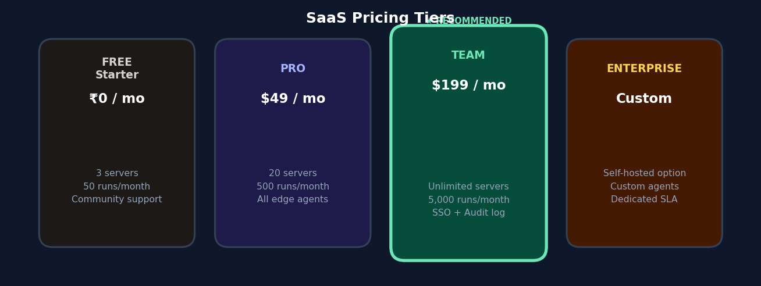
Revenue Streams:
- SaaS subscriptions — Starter (free), Pro ($49/mo), Team ($199/mo), Enterprise (custom)
- Agent run consumption — each run consumes compute; charged above free tier limits
- Custom agent development — enterprise clients pay for bespoke agents for their stack
- Managed hosting — we run and maintain Oz for teams that prefer not to self-host
- Agent marketplace — community-built premium agents sold as add-ons

Unit Economics:
Cloudflare Workers AI cost per edge agent run: ~$0.001–0.003
Gross margin at Pro tier: ~75–80%
Estimated LTV:CAC ratio: ~3:1

⚔️ Competitive Landscape
Competitor | What They Do | Oz Advantage
Ansible / Terraform | Infrastructure-as-code automation | Requires upfront authoring and breaks on infra changes. Oz works on existing infra via natural language.
GitHub Copilot | AI code assistant in the IDE | Suggests code but cannot execute live infrastructure operations. Oz takes real actions.
Datadog / New Relic | Observability dashboards | Shows metrics but requires manual analysis. Oz acts — ask a question, get an action taken.
RunBook / Airplane | Internal tooling platforms | Require workflow authoring. Oz is AI-first with no pre-built workflows needed.
AWS Systems Manager | Cloud-native server management | AWS-only, no AI reasoning, no natural language. Oz works on any server anywhere, open-source.

🛠️ Tech Stack
Layer | Technology | Why
Backend API | FastAPI (Python 3.12) | Async, auto OpenAPI docs, JWT auth
Database | PostgreSQL 16 | Relational store for users, agents, servers, secrets
Cache / Queue | Redis 7 + Celery | Async agent execution, cron scheduling
AI Assistant | Leon (open-source) | Production NLU pipeline, WebSocket chat, skill system
NLU / LLM | Llama 3.1 / Mistral via OpenRouter | Intent classification and entity extraction
Edge AI | Cloudflare Workers AI — Llama 4 Scout 17B | Sub-100ms AI inference at global edge, free tier available
Edge Runtime | Cloudflare Workers (TypeScript) | Serverless, zero idle cost, 300+ global PoPs
Container Runtime | Docker + Docker Compose | Reproducible deployment, agent sandboxing
Reverse Proxy | nginx | TLS termination, Docker/Proxmox API proxying
Security | JWT + bcrypt + Fernet AES | Stateless auth, encrypted secrets vault

🤝 The Ask
We are raising a seed round to accelerate the 101-agent roadmap and go-to-market.
Use of Funds | Allocation
Engineering (2 senior engineers) | 45%
Complete 101-agent roadmap | 20%
Go-to-market & sales | 25%
Infrastructure & ops | 10%

📅 12-Month Milestones
Period | Milestone
M1–M3 | Complete 25 more Cloudflare edge agents, launch public beta, first 50 customers
M3–M6 | Pro tier live, Stripe integration, 100 paying customers, $60K ARR
M6–M9 | Team tier + SSO, agent marketplace beta, 500 paying customers, $300K ARR
M9–M12 | Enterprise pilots, custom agent service, $1M ARR target

👥 Team
Rohit Darekar — Founder & CTO, AIT GLOBAL INC
Full-stack engineer with deep expertise in AI systems, infrastructure automation, and product development. Built Oz end-to-end — architecture, FastAPI backend, React/Tailwind frontend, Cloudflare edge workers, Leon NLU integration, and all 4 production AI agents. Contact: rohit.darekar@aitglobalinc.com

The DevOps AI tooling market is being claimed right now.
The first platform to build a comprehensive, production-ready,
self-hostable AI infrastructure agent fleet will own the category.
Oz has the architecture, the working product, and the roadmap to be that platform.

AIT GLOBAL INC · rohit.darekar@aitglobalinc.com

