|  |
| --- |
| **PROCESS DOCUMENT** |

|  |
| --- |
|  |

#@#

Create New IAM User --- this IAM use will be used to create and upload packages within EC2 – which can then be further used for the LAMBDA functions as LAYERS . This IAM role will not be used for writing the actual LAMBDA functions for that we create another IAM role as seen below .

Attach permissions policies --->> Choose from Existing policies --->> **AmazonS3FullAccess**

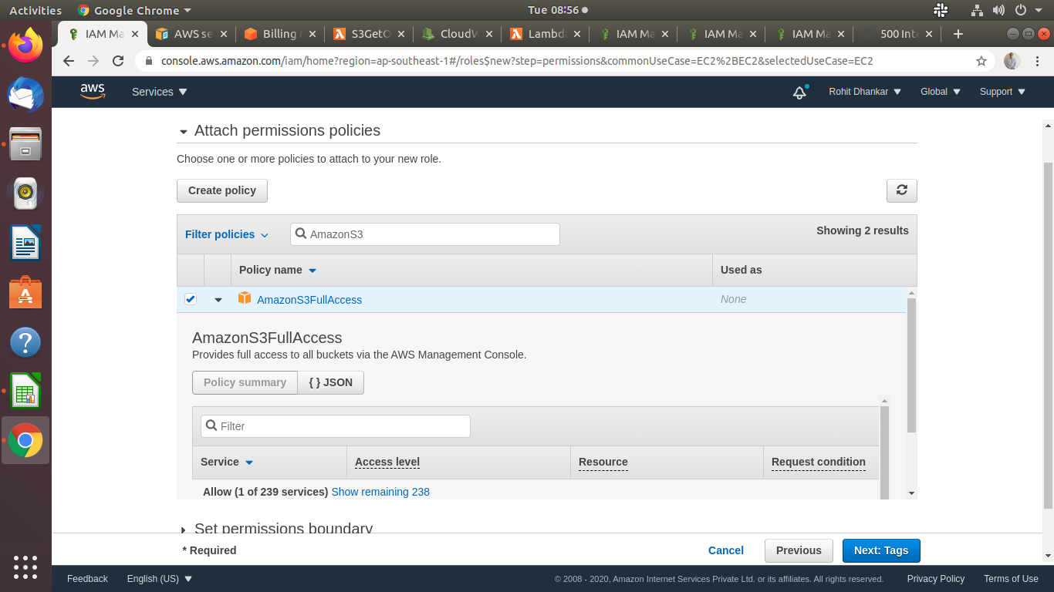

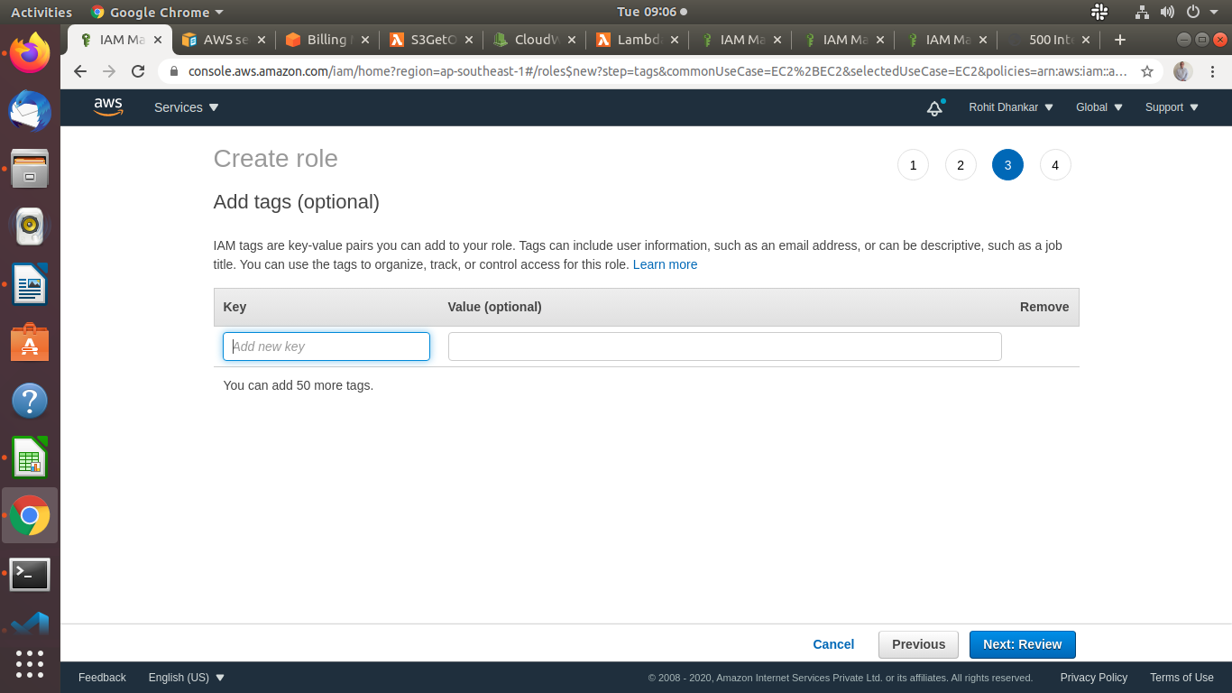

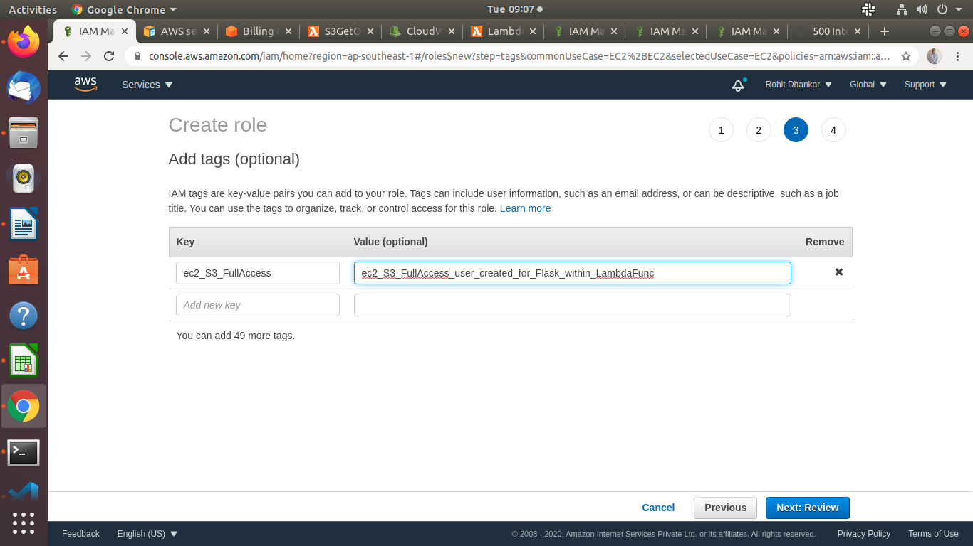

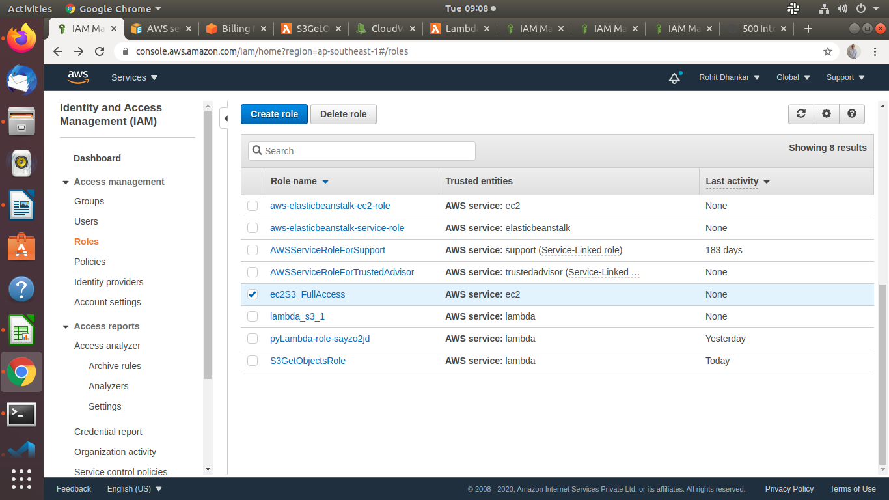

#@# Create another LAMBDA role with