few keywords, such as "a haunted house," "an unexpected visitor," create a story

Once upon a time, there was a large, old house on the outskirts of town. Rumors circulated that it was haunted, and people avoided it at all costs. But one day, a young woman named Emily was out for a walk and found herself drawn to the eerie house. She couldn't resist the urge to explore it, even though she knew it was a risky decision.

As Emily entered the house, she felt a chill run down her spine. It was dark and musty, and she couldn't shake the feeling that she wasn't alone. Suddenly, she heard a noise, and her heart skipped a beat. Was someone else in the house with her?

As she crept around the house, she found herself in a room she hadn't noticed before. Suddenly, she heard footsteps coming towards her, and she panicked. But to her surprise, it was not a ghostly figure, but a young man named Alex, who had come to the house to investigate the rumors.

Emily and Alex were relieved to find that they were not alone, and they quickly struck up a conversation. As they talked, they discovered that they had a lot in common and enjoyed each other's company.

Just as they were about to leave, they heard a loud noise coming from upstairs. Emily and Alex went to investigate and found a hidden room. Inside was a trunk full of old letters and journals, detailing the tragic history of the house and the people who had lived there.

As they read through the journals, they were suddenly interrupted by the appearance of a ghostly figure. But instead of being afraid, Emily and Alex realized that the ghost was not malevolent but was simply trying to protect the house's secrets. They thanked the ghost for the opportunity to learn about the house's history and promised to keep its secrets safe.

Emily and Alex left the house feeling enriched by their unexpected adventure. From that day on, they became good friends and often visited the house together, always respectful of its history and the ghostly figure that still watched over it.

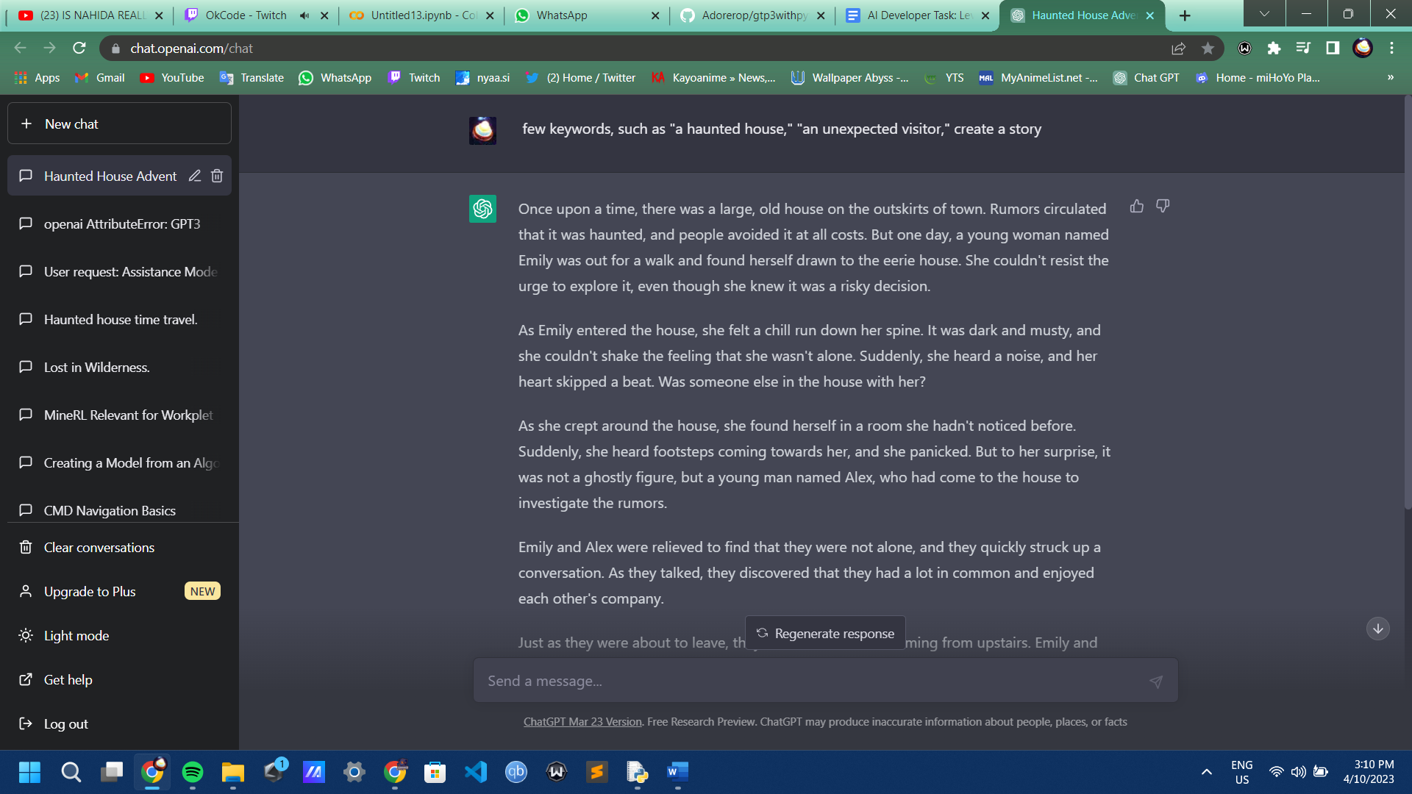Top of Form