A Micro Project report on

#### The Book Spot

Submitted to the CMR Institute of Technology in partial fulfillment of the requirement of the

**Web Technologies** **Lab**

**of**

**III-B.Tech. I-Semester**

**in**

#### Computer Science and Engineering Department

Submitted by

**Ch.Harshini (19R01A0507)**

**K. Architha (19R01A0520)**

**K. Anusha (19R01A0526)**

**P. Neha Reddy (19R01A0540)**

Under the Guidance Of

##### Mr. N. Suresh

##### (Assistant professor, CSE Dept)

##### 

##### CMR INSTITUTE OF TECHNOLOGY

**(UGC AUTONOMUS)**

**(Approved by AICTE,Affiliated to JNTU,Kukatpally,Hyderabad)**

**Kandlakoya,Medchal Road,Hyderabad**

#### 2021-2022

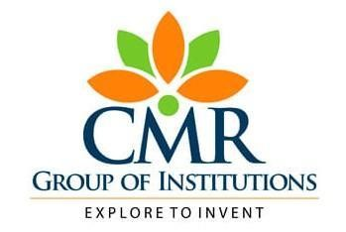

#### CMR INSTITUTE OF TECHNOLOGY

**(UGC AUTONOMUS)**

**(Approved by AICTE, Affiliated to JNTU, Kukatpally, Hyderabad) Kandlakoya, Medchal Road, Hyderabad.**

##### Department of Computer Science and Engineering

**CERTIFICATE**

This is to certify that a **Micro Project** entitled with **The Book Spot** , is being submitted by

**Ch.Harshini (19R01A0507)**

**K. Architha (19R01A0520)**

**K. Anusha (19R01A0526)**

**P. Neha Reddy (19R01A0540)**

in partial fulfillment of the requirement for completion of the Web Technologies Lab of III-B.Tech I- Semester .

**Signature of Faculty Signature of HOD**

**ACKNOWLEDGEMENT**

I am extremely grateful to **Dr. M. Janga Reddy**, **Director**, **Dr. B. Satyanarayana**,

**Principal** and  **Mr. A. Prakash**, **Head of Department**, **Department of Computer Science and Engineering**, CMR Institute of Technology for their inspiration and valuable guidance during entire duration.

I am extremely thankful to **Mrs. N. Suresh** , **Assistant professor**, Computer

Science and Engineering department, CMR Institute of Technology for his constant guidance, encouragement and moral support throughout the project.

**Ch**. **Harshini (19R01A0507)**

**K. Architha (19R01A0520)**

**K. Anusha (19R01A0526)**

**P. Neha Reddy (19R01A0540)**

###### 