**Software Requirement Specification (SRS) for**

**THE BOOK SPOT.**

**Introduction:**

Online Book store is an online web application where the customer can purchase books online. Through a web browser the customers can search for a book by its title or author, later can add to the shopping cart and finally purchase using credit card transaction.

Shopping for books online helps you find the best possible price for just about any book you want. If customers in the market are for rare, collectible or autographed books, it’s much cheaper and faster to search online than it would be to call up local used and independent bookstores that carry these types of items.

The project deals with creating an online platform for selling a variety of books. It is a web page for attracting customers interested in reading books. It goals to attracts readers and non-readers of various ages, and also helps them in choosing their favourite book in various price ranges.

**Purpose of SRS:**

* Frontend: HTML, CSS, JAVA SCRIPT.
* Backend: PHP, Java.
* Database: MySQL

**Purpose of Project:**

The sole purpose of the project is to give a platform for readers and non-readers to choose books of their choice for satisfying their reading cravings. This project allows customer to buy books online from seller’s website in real time system.

* To manage the details of books.
* To give a good and consistent transaction facility online.
* To portray products in an indulging manner.
* To grab the customer’s attention.
* To provide economical copy of book.

**Scope:**

The software system being produced is called Online Bookstore. It is being produced for a customer interested in selling books via the Internet. This system is designed to “provide automation support” for the process of placing books for sale on the Internet and facilitating the actual sale. This system is largely cross-platform and is available to anyone using the internet. The system will be run on a central server with each user having a remote user interface through a web browser to interact with it. The Online Bookstore will allow any user to create an account to become a customer. The customer, through the process of account creation, will have the option to become a member of the site. The system will allow customers to browse, search, select, and add books to a shopping cart. Then, provided they have books in their shopping cart, check out books in shopping cart and decrement the stock that the inventory the system maintains. The Online Bookstore also allows a manager to manage the inventory with full create, retrieve, update and delete (CRUD) functionality with regards to books in the system.

**Modules:**

This project has the following Modules:

**1) Home Page:**

A Home page with product catalog. This is the page where the user will be navigated after a successful login. It will display all the book categories and you can shop by selecting your favourite categories .The categories included in our project are crime and thriller, fiction, Health, Fitness and Nutrition, Humor, Sports, Technology and engineering, Travel & Tourism.

**2) Book Description:**

When user click on the categories the books available in the selected category will be displayed along with the title of book, Author and overview of the book. Book Description If the user would like to know details about a book he can click on the title and know the details of the book.

**3) Shopping Cart:**

The user can manage a shopping cart which will include all the books he selected. The user can edit, delete and update his shopping cart. A final shopping cart summary is displayed which includes all the items the user selected and the final total cost.

**4) Managing user accounts:**

Each user should have an account to access all the functionalities of website. User can login using login page and logout using the logout page. All the user sessions will be saved in the database.

**5) Administration :**

The Administrator will be provided with special functionalities like

* Add or delete a book category.
* Add or delete a member.
* Manage member orders.

**6) Registration page:**

If user does not have an account then he has to create a account by clicking registration option. In this user has to enter details like username, mail, password, confirm password, mobile number etc.

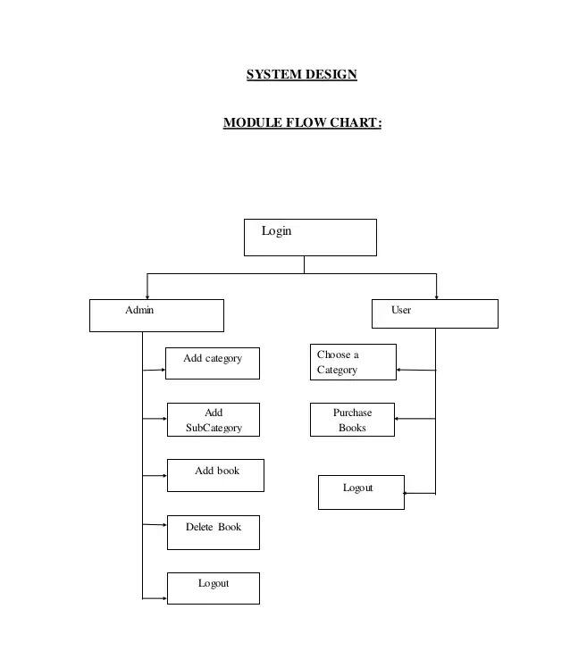

**Client Requirements:**

* A personalized feed page where user can visualization is of his choice.
* A secure transaction portal.
* Attractive and neutral appearance.
* Decreasing complexity in design.
* Stability.
* Easier review and verification of transactions.
* Facilitates architectural and code reuse.

**Developer Responsibilities:**

* To execute the explicit requirements of the clients.
* Make sure all the discussed requirements of the customer are fulfilled.
* Ensure security for the transactions.