PALADINMEDIA
Architecture Specification
Foundation MVP 0 → Progressive Architecture Evolution
Energy-Efficient Post-Quantum Media Steganography System

Field | Value
Document status | Draft — Architecture Specification
Current baseline | PaladinMedia Foundation MVP 0
Target architecture | PaladinMedia v6 (progressively reached through Phases 1–6)
Current MVP | 512×512 RGB image-to-image secure concealment and recovery
Primary architecture goal | Prove and preserve a modular end-to-end data path
Document role | Defines HOW the system is structured and how modules evolve
Important: MVP 0 is a functional foundation. Later-phase security, robustness, performance, and deployment properties remain subject to implementation and experiment.

1. Document Control
Item | Definition
Product | PaladinMedia
Architecture document version | 0.1
Architecture baseline | MVP 0
Forward target | v6 architecture baseline after progressive upgrades
Related document — Product Vision | Defines WHY / WHO / WHAT
Related document — System & Research | Defines WHY THIS DESIGN / hypotheses / evidence / evolution rationale
Source of current technical truth | This document for architecture; System & Research for rationale and experiment history

1.1 Scope of this document
This document defines the structural architecture of PaladinMedia from the smallest working foundation through the planned Phase 1–6 evolution. It specifies modules, responsibilities, inputs/outputs, boundaries, data flow, interfaces, architectural invariants, and upgrade points. It intentionally avoids turning research hypotheses into guaranteed outcomes.

2. Architecture Stance
PaladinMedia is treated as an evolving modular system. MVP 0 is not a disposable demonstration; it is the first architecture baseline whose module boundaries are preserved as later implementations become stronger. The product therefore evolves mainly by replacing or hardening modules behind stable contracts rather than by repeatedly rewriting the entire pipeline.

2.1 Architectural strategy
Stable product pipeline
↓
Stable module contracts
↓
MVP 0 implementations
↓
Phase-specific replacements / upgrades
↓
Integrated target architecture

2.2 Design priority
1. First prove the end-to-end data path.
2. Then harden cryptographic session establishment.
3. Then formalize deterministic carrier processing.
4. Then introduce and train the proposed ACS-Sub-INN research component.
5. Then optimize inference and productize the research pipeline.

3. Architecture Objectives
- Provide a complete sender-to-receiver path for protected secret media.
- Separate cryptographic protection from concealment mechanics.
- Provide explicit interfaces between serialization, crypto, ECC, header, mask, transform and embedding stages.
- Make exact payload recovery experimentally testable.
- Keep raw capacity separate from usable payload capacity.
- Allow the MVP 0 crypto and embedding implementations to be upgraded without changing the entire application.
- Provide a clean path to the intended PQC + ACS-Sub-INN architecture.
- Keep deployment optimization and sustainability telemetry outside the security boundary.

4. Architecture Principles
Principle | Architectural meaning
Layer separation | Each subsystem has one primary responsibility.
Replaceable implementations | Interfaces remain stable while internal implementations can evolve.
Receiver symmetry | Every sender transformation has a defined extraction, inverse or verification counterpart.
No silent information loss | The system must not intentionally discard information required for recovery.
Explicit capacity accounting | Header, encryption and ECC overhead are included when reporting usable capacity.
Authenticated control metadata | Metadata required to interpret a protected payload should be integrity-bound in the hardened architecture.
Evidence before claim | Architecture specifies requirements and mechanisms; experiments establish performance.
Security/optimization separation | ONNX, INT8 and QAT are deployment concerns, not cryptographic security mechanisms.

5. System Context
At the product level, PaladinMedia consists of a sender, a media carrier, a communication/storage boundary, and a receiver. The sender converts a secret media object into a protected payload and conceals it inside a cover image. The receiver reverses the carrier processing and validates the protected payload before reconstruction.
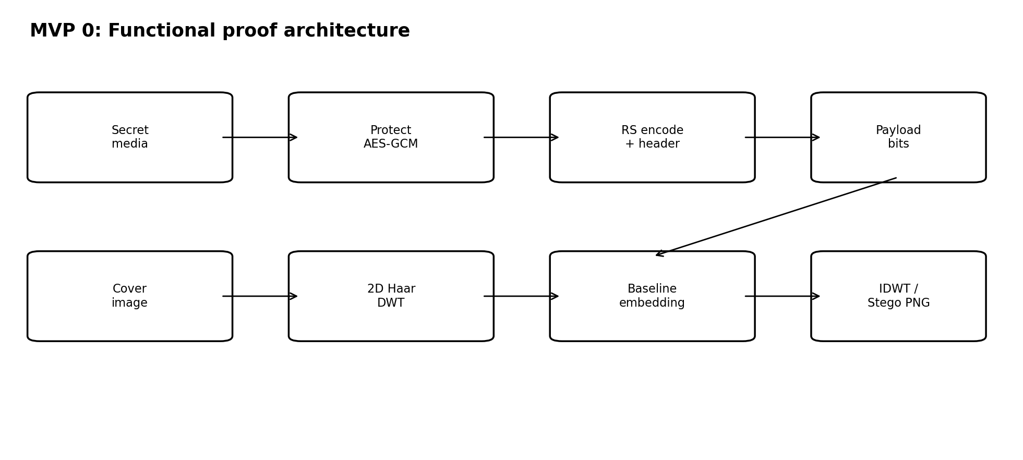
Figure 1. MVP 0 sender-side functional architecture (conceptual).

5.1 External entities and dependencies
Entity | Interaction
Secret media source | Provides the sensitive input object to be protected and concealed.
Cover media source | Provides the benign-looking carrier image.
Communication / storage medium | Carries or stores the resulting stego image; the current architecture does not assume a specific network.
Receiver | Performs extraction, error correction, integrity verification and decryption.
ML / signal processing runtime | Provides the numerical environment for DWT/IDWT and later neural inference.
Cryptographic library | Provides standard cryptographic primitives and, from Phase 1 onward, PQC bindings.
Dataset / evaluation harness | Provides controlled training and validation data, initially DIV2K for Phase 4.
Telemetry | Measures computational cost in Phase 6; it is not part of the transformation path.

6. Architecture Boundaries
Boundary | Inside | Outside
Security boundary | Key/session handling, AEAD protection, integrity verification | GUI presentation and telemetry
Payload boundary | Serialization through AES-GCM, RS, header and payload placement | Cover image content itself
Media-processing boundary | DWT, embedding engine, IDWT, PNG container | Cryptographic key establishment
Research boundary | ACS-Sub-INN training and experimental parameters | Operational security certification
Deployment boundary | Inference model and runtime | Cryptographic semantics

7. Architecture Evolution Roadmap
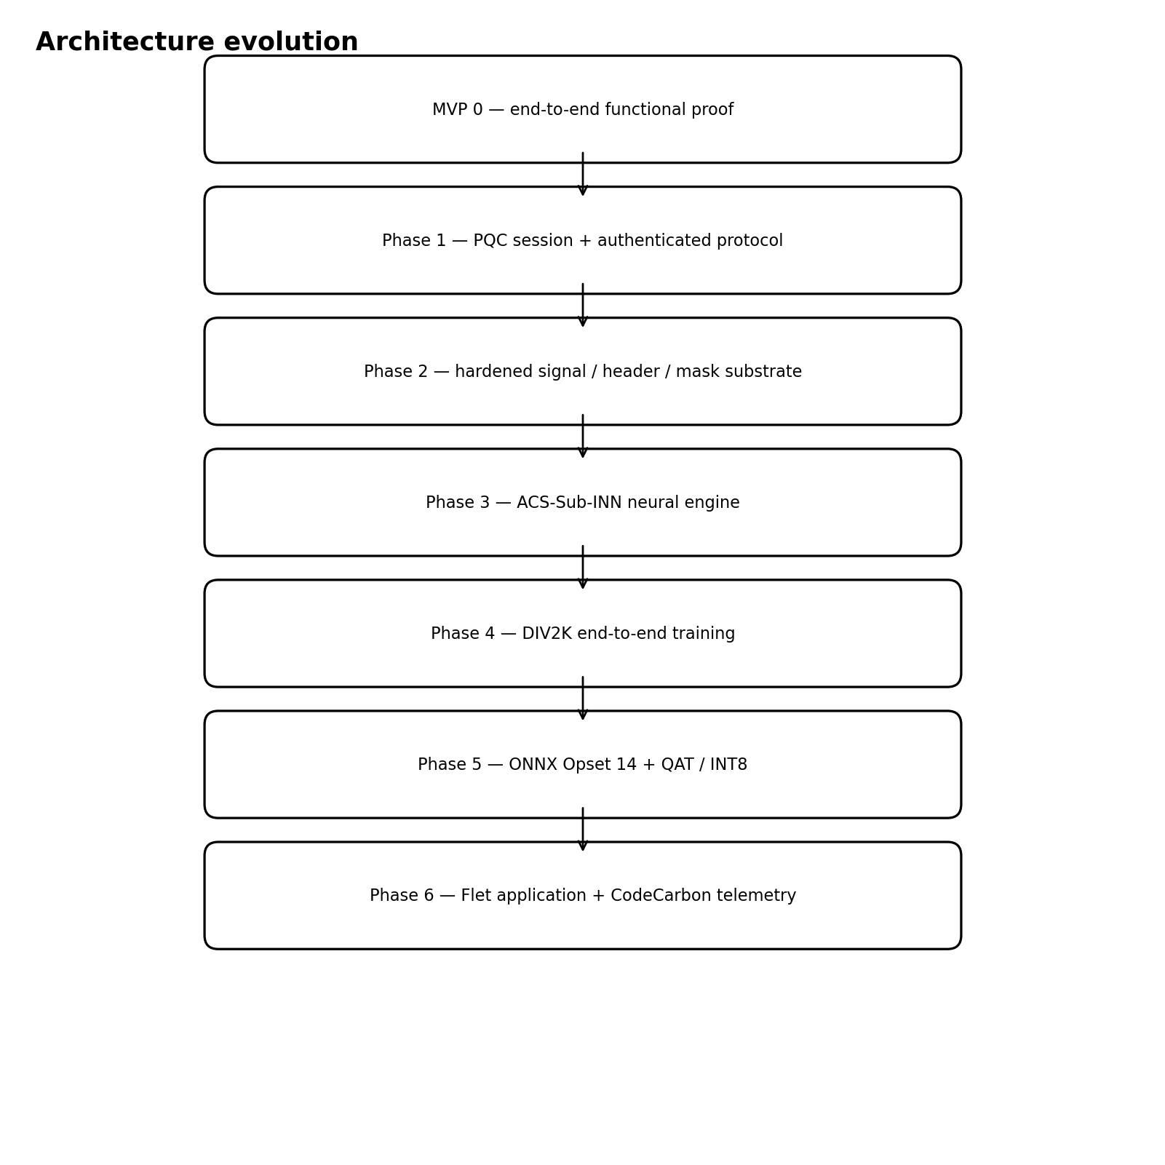
Figure 2. Progressive evolution from the foundation MVP to the full planned system.
The roadmap is deliberately incremental. Each phase should produce an artifact that is testable before the next phase is treated as complete. A later phase may change an implementation, but it should not silently invalidate earlier module contracts without an explicit version change.
Stage | Architectural role | Primary additions | Exit condition
MVP 0 | Functional foundation | AES-GCM, RS, fixed header, deterministic test mask, Haar DWT/IDWT, baseline embedding | Protected payload can traverse the system and recovery is measurable
Phase 1 | Cryptographic hardening | ML-KEM/ML-DSA bindings, transcript hashing, HKDF, AES-GCM AAD integration, RS validation | Session setup and authenticated payload path pass protocol tests
Phase 2 | Carrier infrastructure | Formal 2D Haar pipeline, fixed header packing, production deterministic mask generator | Sender and receiver deterministically agree on carrier interpretation
Phase 3 | Neural research engine | Context Predictor CNN, Adaptive Gain CNN, ACS-Sub-INN, STE quantization | Model can be evaluated as an integrated embedding/extraction module
Phase 4 | Learning at scale | DIV2K training/validation pipeline, reproducible experiments | Training and validation produce reproducible metrics
Phase 5 | Deployment optimization | ONNX Opset 14, QAT, INT8 evaluation | Deployable model variant is measured against the reference model
Phase 6 | Productization | Flet GUI, Python backend integration, CodeCarbon telemetry | Usable research application with measurable runtime/resource profile

8. MVP 0 — Foundation Architecture
MVP 0 is the smallest meaningful version of PaladinMedia. Its purpose is not to establish the final cryptographic protocol or final neural model. Its purpose is to prove the existence of a complete, testable path from secret media to stego media and back to recovered secret bytes.
Figure 3. MVP 0 end-to-end architecture.

8.1 MVP 0 sender flow
Secret media
→ serialize
→ AES-256-GCM protection
→ Reed-Solomon encoding
→ fixed header + payload packing
→ deterministic test mask
→ cover image DWT
→ baseline embedding
→ IDWT
→ 8-bit RGB stego image
→ PNG output

8.2 MVP 0 receiver flow
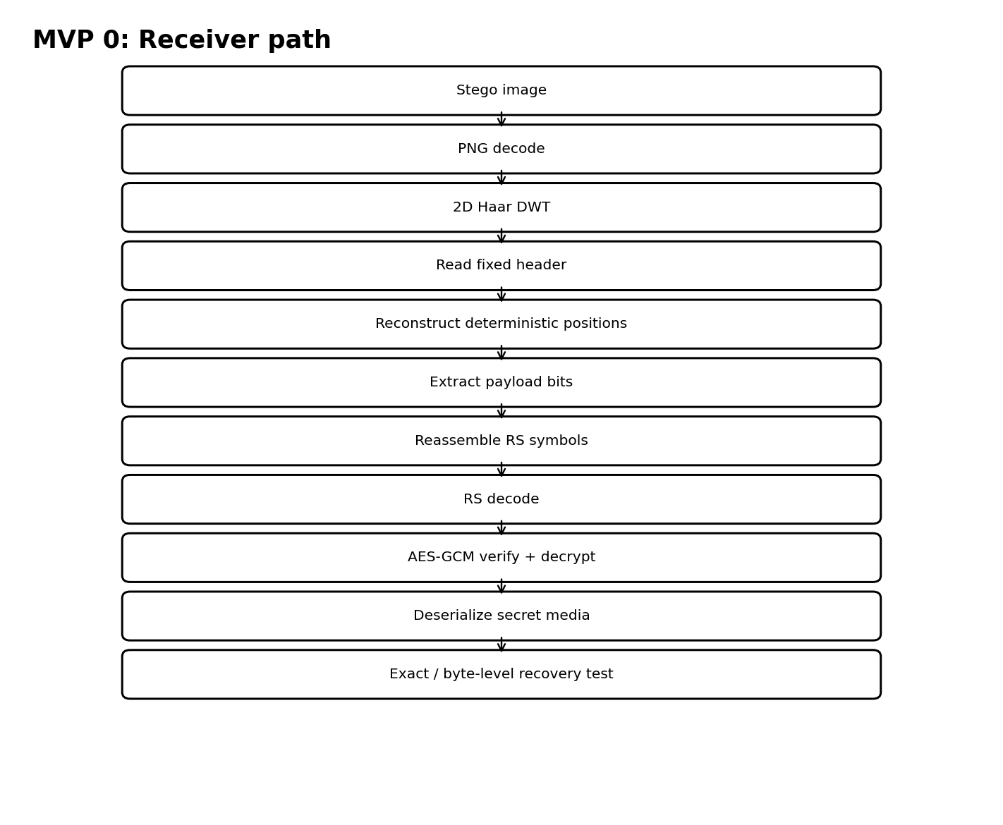
Figure 4. MVP 0 receiver-side recovery flow.
The receiver must not attempt full decryption before integrity and structural checks succeed. Recovery therefore follows an ordered path: parse the media container, obtain transform coefficients, interpret the fixed header, regenerate the selection, extract the encoded payload, RS-decode it, verify/decrypt the protected bytes, and reconstruct the secret.

8.3 MVP 0 module inventory
Module | Responsibility | MVP 0 implementation role
SecretSerializer | Convert secret media to deterministic bytes and reconstruct it | Required
CryptoProvider | Encrypt/decrypt protected payload | AES-GCM test/session implementation
ECCEncoder | Add redundancy and decode symbols | Reed-Solomon
HeaderCodec | Encode/decode fixed metadata | Minimal fixed header
MaskGenerator | Select embedding positions reproducibly | Controlled deterministic seed / generator
TransformEngine | DWT and inverse DWT | 1-level 2D Haar
EmbeddingEngine | Map payload representation into the carrier representation | Baseline embedding implementation
CarrierCodec | Represent final carrier as 8-bit PNG | Required
RecoveryEngine | Coordinate receiver-side extraction and reconstruction | Required
EvaluationHarness | Measure recovery and carrier changes | Required

9. Module Contracts
SecretSerializer
Input: secret media object
Output: byte string + media metadata
Must be deterministic for a given input and metadata.
CryptoProvider
Input: plaintext bytes + crypto context
Output: ciphertext + authentication tag
MVP 0 may use a controlled development provider; Phase 1 replaces it with a PQC-backed session provider.
ECCEncoder
Input: protected bytes
Output: encoded RS symbols
ECC must be applied after encryption so the protected representation remains the recoverable transport object.
HeaderCodec
Input: version + payload length + file/session metadata
Output: fixed-size header bytes
Header format is versioned; Phase 1+ binds relevant header fields to authenticated encryption.
MaskGenerator
Input: authenticated context + payload length + carrier dimensions
Output: deterministic index set
Receiver must reproduce the same selection without transmitting the full mask.
TransformEngine
Input: RGB image
Output: LL/LH/HL/HH coefficients
Current architecture uses one-level 2D Haar DWT/IDWT.
EmbeddingEngine
Input: transform representation + payload + context
Output: modified transform representation
Implementation is replaceable; ACS-Sub-INN becomes the target research implementation in Phase 3.
CarrierCodec
Input: reconstructed RGB array
Output: PNG byte stream / image
PNG is lossless for stored 8-bit pixel values; this does not by itself guarantee zero error through the full floating-point transform round trip.
RecoveryEngine
Input: stego image + receiver context
Output: recovered secret media
Must surface structural, ECC and authentication failures rather than silently returning corrupted plaintext.

10. Payload and Data Model
The protected payload should be treated as a binary object with explicit framing. The exact binary serialization is an implementation detail that should be versioned, but the architectural sequence is fixed.
Secret media
│
├── media metadata
└── raw/serialized bytes
│
▼
AES-256-GCM
│
├── ciphertext
└── authentication tag
│
▼
Reed-Solomon encoding
│
▼
encoded payload
+
fixed header
│
▼
embedding bitstream

10.1 Header responsibilities
- Identify the PaladinMedia framing/version.
- Carry payload length or enough information to reconstruct it.
- Carry the file/session counter or identifier needed by deterministic placement and nonce handling.
- Carry only metadata necessary for bootstrap; sensitive payload data is not placed in the header.
- From Phase 1 onward, relevant header values are integrity-bound as authenticated data (AAD).

10.2 Capacity accounting
Raw capacity
− fixed header
− encryption overhead (e.g., authentication tag)
− ECC overhead
= usable protected-payload capacity
usable protected-payload capacity
− serialization / format overhead
= usable secret-media capacity

11. Signal-Processing Architecture
The carrier-processing path uses a one-level 2D Haar wavelet transform. The current 512×512 RGB MVP produces LL, LH, HL and HH sub-bands at half spatial resolution per dimension. The transform-domain architecture is preserved from MVP 0 so that the later ACS-Sub-INN engine can be introduced without redesigning the entire carrier path.
RGB cover
↓
1-level 2D Haar DWT
├── LL → retain
├── LH → retain
├── HL → retain
└── HH → embedding representation
↓
EmbeddingEngine
↓
HH'
↓
combine with retained bands
↓
inverse Haar DWT
↓
RGB carrier

11.1 Current MVP capacity implication
For a 512×512 RGB image, a one-level DWT yields an HH representation of 3 × 256 × 256 coefficients. The eventual ACS-Sub-INN architecture retains a context subset and modifies an embedding subset. A design that consumes all three HH channels as drop channels would eliminate the retained context required by the current context-conditioned formulation; therefore the commonly cited 0.75 bpp figure is not compatible with the present ACS-Sub-INN context design. Capacity must be reported from the actual embedding configuration rather than from theoretical HH size alone.

12. MVP 0 Embedding Architecture
MVP 0 deliberately uses a simpler embedding implementation so that failures in the neural research component do not obscure whether the surrounding system works. The embedding engine is therefore treated as a replaceable contract.
EmbeddingEngine
├── MVP 0: BaselineEmbeddingEngine
└── Phase 3+: ACSSubINNEmbeddingEngine

12.1 MVP 0 requirement
The MVP 0 embedding implementation only needs to establish controlled extraction and recovery. It is not used to make final claims about the research novelty or the final perceptual-quality trade-off.

12.2 Phase 3 target
Phase 3 replaces the baseline implementation with the context-conditioned ACS-Sub-INN architecture. The rest of the carrier and payload contracts remain unchanged.

13. Target Cryptographic Architecture (Phase 1 onward)
Phase 1 hardens MVP 0 by establishing a post-quantum session and authenticating the protocol context. The target is not to claim absolute quantum security, but to use standardized post-quantum mechanisms as part of the session establishment and authentication design.
Peer/session context
│
├── ML-KEM-768 → shared secret establishment
└── ML-DSA-65 → authentication / signatures
│
▼
Transcript hash
│
▼
HKDF-SHA256
│
┌───────┼───────────┐
▼ ▼ ▼
AES key nonce context mask context
│
▼
AES-256-GCM
│
├── ciphertext
└── tag
│
▼
Reed-Solomon

13.1 Cryptographic responsibilities
- ML-KEM-768 establishes shared session material between authorized parties.
- ML-DSA-65 provides authentication/signature support for the protocol transcript.
- Transcript-bound HKDF derives independent context-specific material from the session transcript and shared secret.
- AES-256-GCM provides payload confidentiality and authenticated integrity.
- The fixed steganographic header is treated as authenticated associated data in the hardened architecture.
- Reed-Solomon is applied to the protected payload representation after encryption.

13.2 Nonce and counter rule
Nonce uniqueness is an operational invariant of the protocol, not a rhetorical guarantee. The implementation must ensure that a given AES-GCM key is never reused with the same nonce. The file/session counter mechanism must therefore be maintained consistently and tested for reuse, rollback and multi-file behavior.

14. Deterministic Mask Architecture
Payload placement must be reproducible by both sender and receiver. The full mask is therefore derived rather than transmitted.
Authenticated session/file context
+
payload length
+
carrier dimensions
↓
deterministic PRNG
↓
shuffled candidate
↓
first N positions
↓
embedding mask

14.1 Bootstrap rule
The receiver cannot depend on a payload value that it has not yet extracted to reconstruct the mask. The bootstrap header therefore contains the minimum information required to establish payload length/file context, and the hardened Phase 1 protocol binds that metadata to the authenticated session.

15. ACS-Sub-INN Architecture (Phase 3 target)
The target neural engine uses a context-conditioned substitution formulation. The high-level idea is to retain part of the HH representation as context and modify a selected subset using a predictor-derived baseline plus an adaptive payload gain.
HH = [HH_keep, HH_drop]
context = ContextPredictorCNN(HH_keep)
gamma = Softplus(AdaptiveGainCNN(HH_keep)) + gamma_min
HH_drop' = context + gamma ⊙ P
masked form:
HH_drop' = (1-M) ⊙ HH_drop
+ M ⊙ [context + gamma ⊙ P]

15.1 Neural modules
Module | Responsibility
Context Predictor CNN | Estimate a context-dependent reference for the embedding region from retained HH context.
Adaptive Gain CNN | Estimate a positive, spatially varying embedding gain.
Mask controller | Restrict modifications to selected coefficient positions.
STE quantization layer | Approximate the 8-bit conversion effect during training so the model is trained against a more realistic deployment path.

15.2 Invertibility distinction
The algebraic transform may be invertible under its mathematical assumptions, but end-to-end exact recovery still depends on the complete pipeline, including neural approximation, IDWT, 8-bit conversion, PNG serialization, image decode and receiver-side numerical behavior. Therefore, the architecture defines a reversible transform design, while the System & Research document must establish practical end-to-end recovery experimentally.

16. Training Architecture (Phase 4)
DIV2K
├── train split
├── validation split
└── held-out evaluation
│
▼
cover preprocessing
│
▼
ACS-Sub-INN
│
┌──────┼────────┐
▼ ▼ ▼
carrier payload recovery
loss loss loss
└──────┬────────┘
▼
checkpoint
▼
evaluation suite
Training configuration, loss formulations, ablations, dataset split policy, random seeds and result interpretation belong in the System & Research document. The architecture document only fixes the component boundaries and the dataflow.

17. Deployment Architecture (Phase 5)
Reference model (PyTorch)
↓
export / validation
↓
ONNX Opset 14
↓
quantization-aware training
↓
INT8 variant
↓
latency / memory / recovery tests
The ONNX/INT8 path creates a deployment model variant. The reference floating-point model remains the research comparison point. Quantization can change numerical behavior, so the INT8 model must be tested for recovery, distortion and runtime rather than assumed to be equivalent to the reference model.

18. Application and Telemetry Architecture (Phase 6)
Flet GUI
│
▼
Python application services
├── crypto service
├── encode/decode service
├── model inference service
└── file/media service
│
▼
Core PaladinMedia pipeline
│
└── CodeCarbon telemetry
CodeCarbon is telemetry only. It measures/estimates computational energy/carbon associated with executions; it does not change the protected payload or the security properties of the cryptographic pipeline. Any metric such as energy per MB is a derived measurement and must be defined explicitly.

19. Integrated Sender / Receiver Architecture
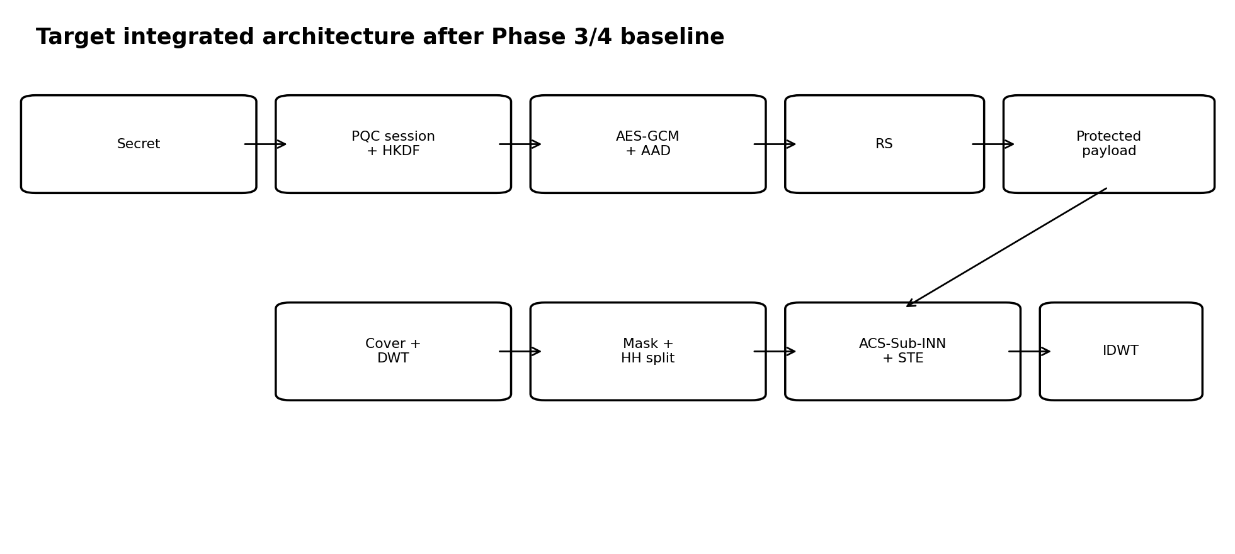
Figure 5. Target integrated architecture after cryptographic hardening and neural integration.

19.1 Sender sequence
1. Load and serialize secret media.
2. Establish/obtain an authorized session context.
3. Encrypt the secret using AES-256-GCM and prepare authenticated metadata.
4. Apply Reed-Solomon encoding to the protected payload.
5. Construct the fixed header.
6. Derive the deterministic embedding positions.
7. Load the cover image and perform one-level Haar DWT.
8. Split the embedding representation into retained context and modifiable positions.
9. Run the configured EmbeddingEngine (baseline in MVP 0; ACS-Sub-INN in Phase 3+).
10. Perform IDWT and encode the resulting 8-bit RGB image as PNG.
11. Emit the stego media plus non-secret session artifacts required by the protocol.

19.2 Receiver sequence
1. Decode the stego image from the media container.
2. Perform the corresponding one-level Haar DWT.
3. Read the fixed header and validate framing.
4. Reconstruct the deterministic embedding positions.
5. Extract the encoded payload from the selected representation.
6. RS-decode the payload.
7. Verify AES-GCM authentication and decrypt.
8. Deserialize the secret media.
9. Compare the recovered object against the original reference during evaluation.

20. Failure and Recovery Paths
Failure point | Required behavior
Invalid / unsupported header | Reject payload before attempting normal extraction.
Mask reconstruction mismatch | Reject extraction attempt or mark as structural failure.
RS decode failure | Report ECC failure; do not treat output as valid plaintext.
AES-GCM authentication failure | Reject decrypted output; do not return unauthenticated plaintext as valid.
Unsupported media dimensions / mode | Fail fast with a structured error.
Model inference failure | Return model/runtime error and preserve source artifacts for diagnosis.
Quantization/deployment mismatch | Report model-variant incompatibility rather than silently falling back to incorrect recovery.
The architecture must distinguish between successful recovery, recoverable transport errors, and security verification failure. A visually plausible but unauthenticated secret reconstruction is not a successful result.

21. Security Boundaries and Trust Assumptions
The architecture assumes an authorized sender and receiver who possess or establish the required cryptographic context. The stego image is treated as potentially exposed to an untrusted storage or transport environment.
Component / artifact | Trust expectation
Secret plaintext | Trusted only at authorized endpoints; should not be exposed outside the protected processing path.
Session keys / derived crypto material | Sensitive; must remain in protected runtime scope.
Header | May be visible for bootstrap; relevant fields are integrity-bound in the hardened protocol.
Stego image | Potentially observable by an adversary; concealment is intended to reduce obvious payload exposure, not to assume secrecy of the carrier.
Model weights | Not inherently secret under the product threat model unless explicitly configured otherwise.
Telemetry | Should avoid logging plaintext payloads or sensitive keys.

22. Architectural Invariants
- Secret content is protected before embedding.
- Error correction operates on the protected payload representation.
- The embedding engine receives a cover-derived representation and a payload representation through a defined interface.
- The receiver can deterministically reconstruct the payload placement from the allowed authenticated context.
- No unrecoverable latent variable is silently discarded as part of the current architecture.
- The security layer and embedding layer remain independently replaceable.
- Raw capacity is never reported as usable plaintext capacity without overhead accounting.
- Algebraic invertibility is not equated with end-to-end lossless recovery.
- PNG losslessness is not interpreted as proof of zero numerical error through the entire DWT/INN/IDWT path.
- Optimization layers cannot modify the semantics of authentication, integrity or key establishment.
- Experimental results override untested assumptions; documented targets are not presented as achievements.

23. Architecture Version / Change History
Version | Role | Key architectural change | Status
MVP 0 | Foundation | Modular sender/receiver pipeline; AES-GCM + RS + header + mask + Haar DWT/IDWT + baseline embedding | Planned foundation baseline
Phase 1 | Security upgrade | ML-KEM-768, ML-DSA-65, transcript-bound HKDF, authenticated header/AAD | Planned
Phase 2 | Carrier upgrade | Formal fixed header bit-packing and deterministic PRNG mask generation; signal path stabilization | Planned
Phase 3 | Neural upgrade | ACS-Sub-INN with retained HH context, predictor CNN, adaptive gain CNN and STE quantization | Planned research architecture
Phase 4 | Training upgrade | DIV2K end-to-end training and evaluation | Planned
Phase 5 | Deployment upgrade | ONNX Opset 14, QAT, INT8 variants | Planned
Phase 6 | Product upgrade | Flet GUI, Python integration and CodeCarbon telemetry | Planned
v6 | Target integrated baseline | Hardened full architecture after progressive upgrades | Target baseline; not an achieved implementation claim

24. Implementation Sequencing Guidance
1. Build and unit-test each MVP 0 module independently.
2. Build a deterministic sender/receiver round-trip test before introducing neural training.
3. Add negative tests for header corruption, mask mismatch, RS failure and AES-GCM authentication failure.
4. Replace the development crypto provider with the Phase 1 provider only after the basic data path is understood.
5. Introduce ACS-Sub-INN behind the EmbeddingEngine contract rather than rewriting the application pipeline.
6. Train on controlled examples before scaling to DIV2K.
7. Only export to ONNX/INT8 after the floating-point reference path is stable and measured.
8. Integrate Flet and CodeCarbon last so GUI and telemetry issues cannot obscure core pipeline failures.

25. Validation Strategy
Validation layer | Examples of tests
Unit validation | Serializer round-trip; AES-GCM encrypt/decrypt; RS encode/decode; header pack/unpack; DWT/IDWT numerical consistency
Component validation | Mask reproducibility; embedding/extraction inverse behavior; model tensor shape and range checks
System validation | Secret → stego → secret round-trip; exact byte comparison
Security validation | Wrong key; modified header; modified ciphertext; replay/counter misuse; malformed protocol inputs
Numerical validation | Floating-point versus 8-bit round-trip error; quantization effects
Capacity validation | Raw coefficient positions versus usable plaintext capacity after overhead
Perceptual validation | PSNR, SSIM and direct pixel-difference statistics
Deployment validation | PyTorch vs ONNX outputs; FP32 vs INT8 recovery and quality comparison
Energy validation | Repeated controlled runs with defined hardware/software conditions and telemetry settings
No numeric threshold in this architecture document is treated as achieved merely because it is desirable. Final acceptance thresholds should be set in the research plan and validated experimentally.

26. Current Architecture Status
Area | Current status
Product architecture | Defined conceptually
MVP 0 module boundaries | Defined
MVP 0 implementation | Not yet claimed as complete
PQC integration | Planned Phase 1
Deterministic production mask | Planned Phase 2
ACS-Sub-INN | Planned Phase 3
DIV2K training | Planned Phase 4
ONNX / QAT / INT8 | Planned Phase 5
Flet / CodeCarbon | Planned Phase 6
Measured end-to-end zero-loss recovery | Not established until experiments are run
Operational deployment / certification | Out of scope for this academic architecture baseline

27. Key Architectural Decisions Recorded
ID | Decision | Reason
D-01 | Use an MVP-first architecture | Reduce debugging coupling and prove the core data path before adding advanced components.
D-02 | Keep CryptoProvider replaceable | Allows MVP 0 to use a development session mechanism while Phase 1 introduces the PQC protocol.
D-03 | Keep EmbeddingEngine replaceable | Allows baseline embedding to prove the pipeline before ACS-Sub-INN is introduced.
D-04 | Use transform-domain carrier processing from the beginning | Avoids a later redesign when the neural engine is introduced.
D-05 | Treat fixed metadata as a separate codec | Enables deterministic receiver bootstrap and explicit protocol versioning.
D-06 | Derive mask instead of transmitting it | Avoids unnecessary payload overhead and sender/receiver mismatch from ad-hoc placement.
D-07 | Keep optimization outside the security boundary | Prevents deployment tools from being confused with the cryptographic architecture.

28. Relationship to Product Vision and System & Research
Document | Primary question | What belongs there
Product Vision | WHY / WHO / WHAT | Vision, users, use cases, value proposition, scope, product requirements, success criteria, roadmap
Architecture Specification | HOW | Modules, interfaces, current dataflows, security boundaries, architecture invariants, deployment structure
System & Research | WHY THIS DESIGN / WHAT THE EVIDENCE SHOWS | Research gap, hypotheses, mathematical rationale, alternative designs, failures, experiments, ablations, results, limitations
When a design choice changes, this Architecture Specification should be updated to show the new current structure, while the System & Research document records the reason for the change and the evidence that caused it.

Appendix A — Recommended Repository Mapping
Architecture module | Suggested package boundary
SecretSerializer | src/core/serialization
CryptoProvider | src/security/crypto
PQC session provider | src/security/pqc
ECCEncoder | src/security/ecc
HeaderCodec | src/protocol/header
MaskGenerator | src/protocol/mask
TransformEngine | src/media/dwt
EmbeddingEngine | src/steganography
ACS-Sub-INN | src/models/acs_sub_inn
Training pipeline | src/training
Evaluation | src/evaluation
ONNX / quantization | src/deployment
Flet application | src/app
Telemetry | src/telemetry
The exact directory structure can change during implementation; the table is a suggested mapping intended to preserve the architectural separation.

Appendix B — MVP 0 Definition of Done
- A cover image can be loaded and transformed with one-level Haar DWT.
- A small secret can be serialized and protected using AES-GCM.
- The protected payload can be Reed-Solomon encoded and framed by a fixed header.
- Sender and receiver independently derive identical deterministic embedding positions.
- The embedding engine produces a valid carrier image.
- The receiver extracts the payload and successfully performs RS decoding and AES-GCM verification.
- Recovered secret bytes can be compared directly against the source bytes.
- Failure cases are surfaced explicitly rather than producing silent corrupted output.
- A reproducible test command can run the complete sender/receiver round trip.

Appendix C — Future Research Extensions
- Robustness under resizing, recompression and other channel perturbations.
- Steganalysis benchmarking using appropriate public datasets.
- Cover-selection strategies that increase usable capacity without unacceptable distortion.
- Model-depth and gain-function ablations.
- Alternative PQC / protocol profiles if standards or libraries evolve.
- Audio/video extensions only after modality-specific capacity and recovery studies.

