**PROJECT TOPIC: Network congestion analysis**

**Group No. : 13**

**Project Group Members:**

* Rohit Gupta(C-51/181500590)

**Project Supervisor:** Mr. Ashutosh Shankhdhar

**About the Project:**

In this Digital Era everyone is connected through network so it is possible that the huge amount of data in the network channel can create the congestion in the network. So, it is important to analyse the network congestion factors that we can use to reduce the congestion in the network. After this we will analyse the factors to reduce the congestion in the network so that it will minimize the effect on a network. Then we will work on the security aspects of the network so that we can reduce the packet loss, drop calls and network failures.

**Motivation:**  Network Congestion Analysis in which we will analyse the different factors of congestion, how to reduce the congestion in the network as well as analyse the security aspects of the network so that we can enhance the security to protect the data packets**.**

**Project Planning:**

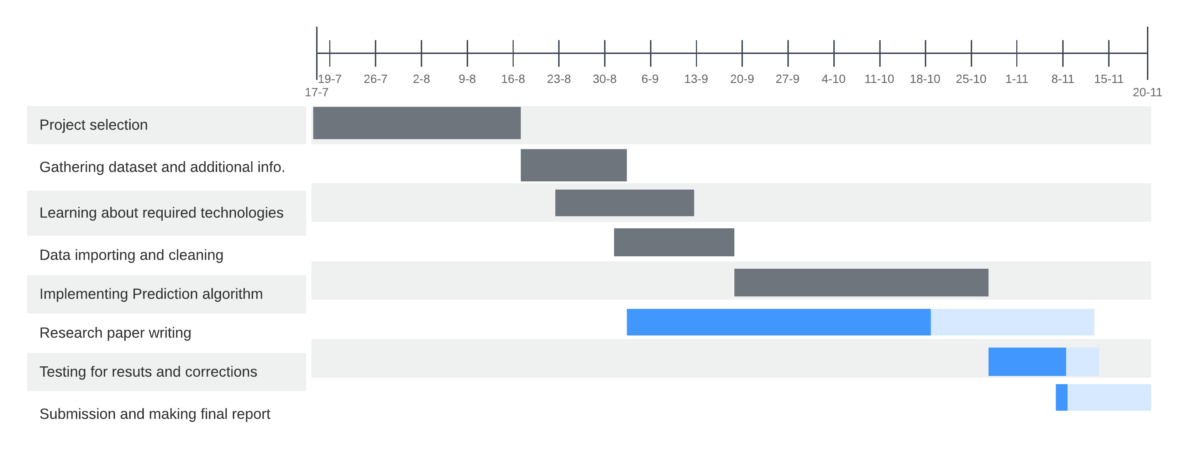

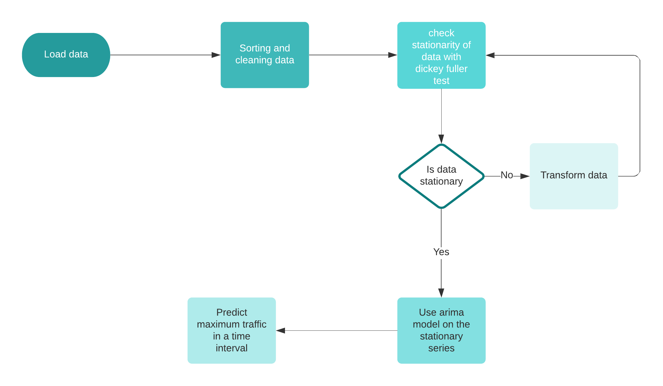

**Tools required:**

* **Hardware Requirements:**

Computer System with minimum 8GB of RAM

* **Software Requirements:**

i) Windows OS

ii) Jupyter Notebook

iii) Python 3

iv) MongoDB

**Signature of Project Supervisor: _____________________**

**Project GitHub -** [**https://github.com/RohitGupta1605/Network-Congestion-Analysis**](https://github.com/RohitGupta1605/Network-Congestion-Analysis)

**How to use:**

* Store a traffic database in MongoDB in your system
* A sample dataset is given : Network_Congestion_Analysis_Dataset
* Run .py file in your Python idle
* Check prediction by prediction_ARIMA_log