**PATENT**

**Title**

A Decentralized AI Trip Generator Using Blockchain for personalized travel planning solutions.

# Field of the Invention

# [0001] The present invention pertains to the fields of artificial intelligence, decentralized systems, and blockchain technology. It specifically addresses the need for a transparent, secure, and personalized trip planning system that integrates user preferences, real-time data, and trust less transactions.

# Background

[0002] Traditional trip planning systems are often centralized, which limits transparency, raises data privacy concerns, and sometimes fails to meet personalized user preferences. Users often struggle to find trustworthy platforms that seamlessly integrate travel recommendations, booking services, and data security.

# [0003] Decentralized technologies, combined with AI, provide a unique opportunity to overcome these limitations. Blockchain ensures data integrity and transparency, while AI enhances user experience through intelligent recommendations and adaptive planning.

# [0004] Existing solutions either focus on AI-powered recommendations or blockchain-driven transparency but fail to integrate these two technologies into a cohesive platform. This gap highlights the need for a decentralized, AI-driven trip generator that offers both personalization and trust less operation.

# Objectives of the Invention

[0005] The primary objective is to develop a decentralized trip generator platform that:

1. Utilizes blockchain technology to ensure secure, transparent, and tamper-proof transactions and data management.
2. Leverages AI to analyse user preferences and provide adaptive, personalized travel recommendations.
3. Integrates real-time data sources, such as weather, pricing, and local events, for dynamic trip planning.

[0006] Additional objectives include enabling peer-to-peer booking services, offering secure payment gateways, and fostering a community-driven review system for enhanced trust.

# Figures/Models/Flow diagram

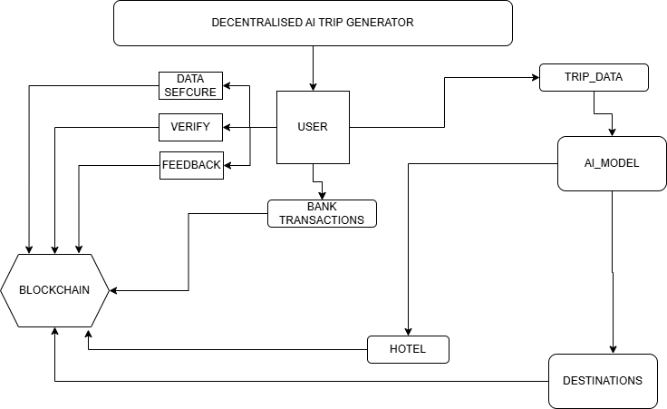

# Claims

1. A decentralized platform leveraging blockchain for secure, tamper-proof management of travel data and transactions.
2. An AI-driven recommendation system that uses machine learning models to analyse user preferences, travel history, and real-time data for personalized trip planning.
3. Integration of smart contracts to automate and ensure transparency in bookings and payments.
4. A peer-to-peer system for users to share reviews and ratings directly, enhancing platform trustworthiness.

# Technologies Used

**1. Frontend:** React.js (Version 18.x) for a responsive user interface with interactive trip customization options.

**2. Backend:** Node.js (Version 20.x) with a decentralized architecture powered by blockchain (e.g., Ethereum or Polygon).

**3. AI Models:** TensorFlow and OpenAI APIs for recommendation engines and adaptive trip planning.

**4. Database:** Fire Base for decentralized storage of travel itineraries and user data.

**5. Smart Contracts:** Solidity for managing transactions, bookings, and peer-to-peer payments securely.

# Hardware

# The platform operates on decentralized blockchain nodes, ensuring reliability and security. User devices include smartphones, tablets, and computers with internet connectivity for seamless platform access.

# End-User Devices

# The platform supports all modern browsers (Chrome, Firefox, Safari) and operating systems (Windows, macOS, Android, iOS).

# Environment

The platform is entirely browser-based, supporting cross-platform access on Windows, macOS, Android, and iOS. This allows both individuals and businesses to find their best trip plan easily, regardless of their operating system.

# Abstract

# The Decentralized AI-Powered Trip Generator is an innovative platform combining AI and blockchain to deliver secure, personalized, and transparent travel planning. By integrating decentralized storage and smart contracts, it provides users with trustworthy recommendations, dynamic trip updates, and peer-to-peer engagement. Unlike traditional systems, it ensures data privacy and eliminates intermediaries, promoting cost-effective and efficient travel planning.

# End Users

1. The platform assists individuals and families to generate best trip plan for their journey and gives them tokens to check in easily.

# Advantages

# Ensures data security and transparency with blockchain technology.

# Offers real-time, AI-powered recommendations tailored to user preferences.

# Promotes user trust through decentralized reviews and tamper-proof records.

# Eliminates intermediaries, reducing costs and enhancing booking efficiency.

# Conclusion

The Decentralized AI Trip Generator revolutionizes the travel planning industry by seamlessly integrating blockchain and AI technologies. It empowers users with a personalized, transparent, and secure platform, fostering trust and efficiency in the travel ecosystem.