Game Design Document

Fill up the following document

1. Write the title of your project.

* A fighter plane save the Earth from alien

1. What is the goal of the game?

* To defeat all the alien attacking Earth

1. Write a brief story of your game.

One day aliens attacked the earth all the fighter plane trying to fight

them were defeated except one plane which in the end defeated all

the alien and saved the earth

1. Which are the playing characters of this game?

* Playing characters are the ones who respond to the user based on the input from the user.
* Cars, monkeys, dinos, wizards, etc., are the playing characters in the game.

|  |  |  |
| --- | --- | --- |
| Number | Character Name | What can this character do? |
| 1 | The fighter plane | It can shoot down the  Alien planes |
| 2 |  |  |
| 3 |  |  |

1. Which are the Non-Playing Characters of this game?

* Non-Playing characters are the ones that don't have an action or behavior when the user interacts with the game.
* Hurdles, stones, bananas, coins, etc., are non-playing characters in the game.

|  |  |  |
| --- | --- | --- |
| Number | Character Name | What can this character do? |
| 1 | Alien planes | They will try to shoot  Down the fighter plane |
| 2 |  |  |
| 3 |  |  |

Draw your imagination of this game. What does this game look like?

* Draw the game either on your computer or on paper.
* Add images of the game scenes to show each of the playing and non-playing characters at least once.

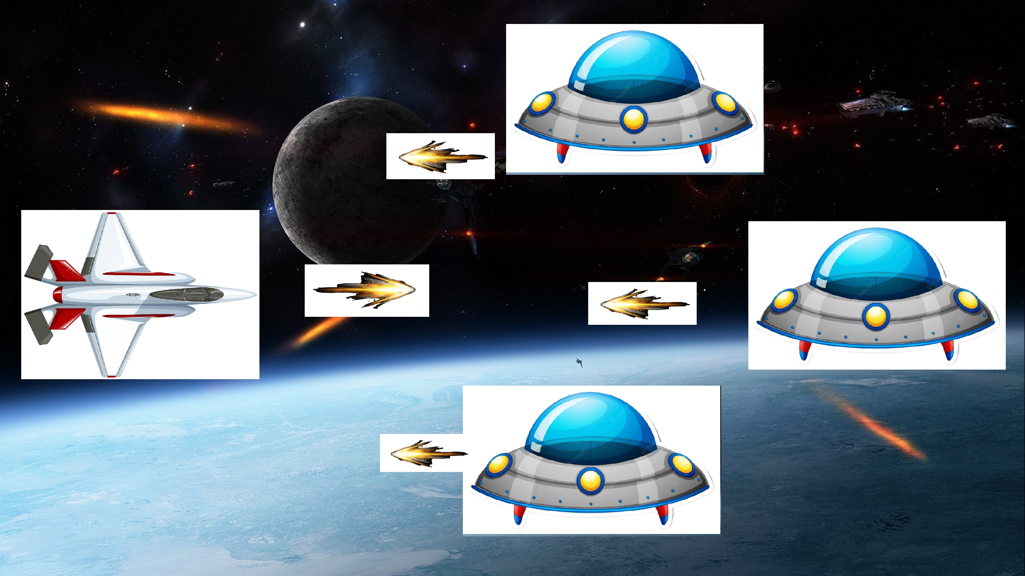

This is what I can from image on google

How do you plan to make your game engaging?

1. We can add power for the fighter plane so that it can dodge the enemy bullets

2. we can add upgrade for our plane so that it can become powerfull after each upgrade

3. after some time we can add a boss of the alien which when we defeat we get a reward