Project Title

Olympic Dashboard

Problem Statement

Many businesses, including ours, collect a lot of data from different sources like databases, Excel files and online systems. While this data is valuable, it’s often scattered and hard to make sense of. As a result, it takes too much time to find important information or understand what the data is telling us. This makes decision-making slow and less effective.
Businesses today, including ours, gather vast amounts of data from a variety of sources like databases, Excel spreadsheets, cloud platforms, and online systems. While this data has the potential to provide valuable insights, it is often unorganized, scattered across multiple locations, and difficult to interpret. As a result, identifying key information or making sense of trends becomes a time-consuming and challenging task.
This lack of clear, accessible data creates delays in decision-making, which in turn impacts our ability to respond quickly to business needs or opportunities.

Project Description

Scope of the Work
The project titled “Olympic Player Performance Analysis for the 2024 Olympics” This analysis will provide insights into the names of Olympic athletes and the medals they have won across different sports categories. Key aspects include tracking the total number of medals (Gold, Silver, Bronze) earned by each player and categorizing them based on the specific sport. This will allow for the identification of top-performing athletes in various Olympic events, showcasing who excelled in their respective categories.
In addition to analyzing individual achievements, the project will provide an overview of medal distribution across different sports, highlighting which sports categories had the most successful athletes and identifying trends in medal wins by country or athlete. By including this Olympic analysis, the project will offer a holistic view making it a comprehensive tool for sports performance analysis.

Project Modules

Data Sources and Connections
  - Understanding Data Sources
  - Connecting to Data
  - Data Integration

Data Cleaning and Transformation
  - Power Query Basics
  - Data Transformation Techniques
  - Advanced Features

Data Modeling
  - Understanding Data Models
  - Creating Relationships
  - Using DAX (Data Analysis Expressions)

Data Visualization
  - Creating Reports and Dashboards
  - Customizing Visualizations
  - Advanced Visualization Techniques

Project and Case Studies
  - Hands-On Project
  - Real-World Case Studies

Context Diagram

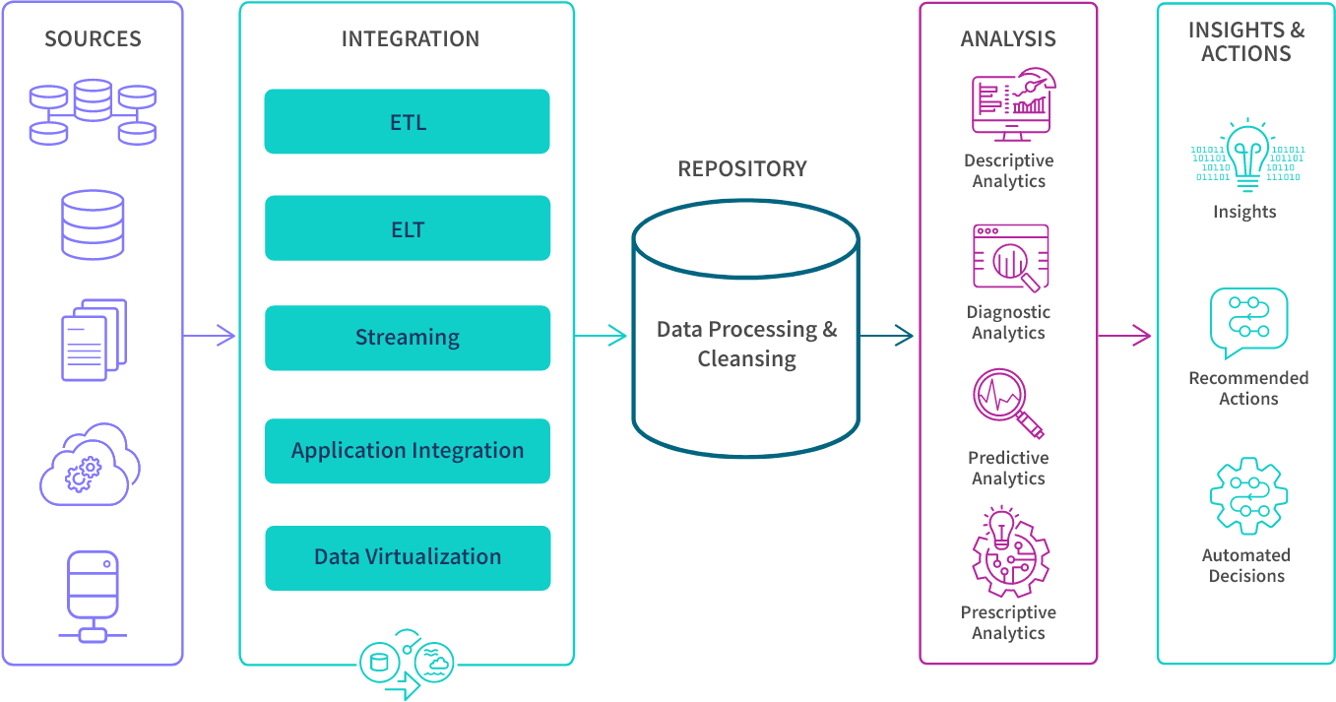

Steps for Effective Data Analytics and Visualization:
- Define Business Objectives: Set clear goals, like identifying new markets or optimizing production processes.
- Identify Data Sources: Gather data from systems like CRM, supply chain, social media, or real-time streams.
- Integrate Data: Use ETL/ELT pipelines, streaming, APIs, or virtualization to unify data in a cloud-based repository.
- Analyze Data: Explore patterns, trends, and insights to answer questions and uncover new opportunities.
- Actionable Insights: Embed analytics into applications, trigger real-time alerts and automate actions for faster decision-making.

Implementation Methodology
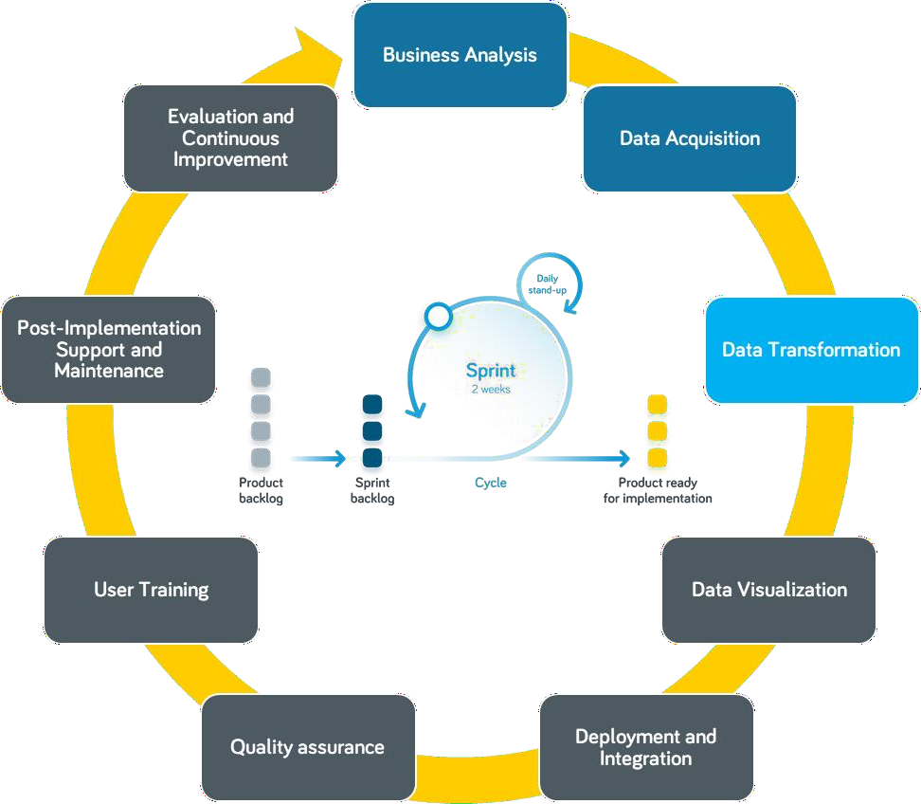

Technologies to be used

Software Platform
    - Power BI Desktop
    - Power Query

Hardware Platform
    - Standard laptop or desktop computer
    - Internet connection for cloud collaboration

Tools
    - Power BI
    - Microsoft Excel
    - SQL
    - Jupyter Notebook

Advantages of this Project
- Real-Time Insights: Instantly track metrics and respond quickly to changes.
- Predictive Analytics: Forecast future trends using AI and machine learning.
- Automation and Integration: Streamline workflows and connect with other tools seamlessly.
- Custom AI-Powered Insights: Uncover hidden patterns with advanced AI features.
- Scalable for Big Data: Efficiently manage large datasets with cloud-based solutions.
- Enhanced Security and Compliance: Protect sensitive data with role-based access and compliance tools.

Future Scope and further enhancement of the Project

The future of this data analytics and visualization project holds immense potential for innovation, scalability, and enhanced decision-making capabilities. Central to its progression is the integration of advanced analytics techniques, including predictive modeling, machine learning (ML), and artificial intelligence (AI). Predictive modeling enables businesses to anticipate future trends, such as customer churn, inventory needs, or market shifts, based on historical data patterns. Machine learning algorithms can further enhance insights by identifying complex relationships within data, automating the detection of anomalies, and improving decision-making processes through continuous learning. AI-driven tools, like automated insights and smart narratives, will elevate data interpretation, making it easier for organizations to identify key influencers and derive actionable recommendations from raw data

Conclusion
This project exemplifies the profound impact of data analytics and visualization using Power BI in transforming how businesses leverage their data. In a world where organizations generate enormous volumes of data from various sources, such as transactional systems, social media, CRM tools, and IoT devices, making sense of this data is crucial for success. Power BI bridges this gap by turning raw, complex datasets into visually engaging, easily interpretable dashboards and reports. These visualizations empower businesses to gain a comprehensive understanding of their operations, market trends, and customer behavior, enabling strategic and well-informed decision-making at every level.
One of the core strengths of Power BI is its interactivity, which allows users to explore data dynamically. Instead of static reports, users can drill down into specific metrics, filter data in real-time, and compare trends across different time periods or dimensions. This flexibility ensures that key insights are always accessible and relevant to current business contexts. Real-time data integration further enhances this capability, allowing businesses to monitor operations and respond swiftly to emerging opportunities or challenges.

References

- https://link.springer.com/book/10.1007/978-3-031-15266-5

- https://link.springer.com/referencework/10.1007/978-981-19-9438-8

- https://www.geeksforgeeks.org/data-analysis-tutorial/

- https://www.youtube.com/@The-Developer-BI

- https://www.microsoft.com/en-us/power-platform/products/power-bi

Screenshots



