What is Cache?

A cache is a storage mechanism that temporarily holds data to improve data retrieval times for future requests. By keeping frequently accessed data in a faster storage medium, cache reduces the need to fetch data from slower, more permanent storage solutions (like databases or external APIs). Caching improves performance, reduces latency, and diminishes the load on backend systems.

What is Caching in Spring Boot?

Caching in Spring Boot refers to the capability of the framework to store the result of method calls or data retrievals for future reference. It allows applications to save the output of expensive operations (such as database queries) to reduce response time in subsequent invocations. Spring Boot provides an abstraction over various caching solutions, allowing developers to easily enable and use caching without worrying about the underlying technology.

What are the Types of Caching?

There are several types of caching, including:

1. In-Memory Caching: Data is stored in the memory of the application server (e.g., using `ConcurrentHashMap`).
2. Distributed Caching: Data is cached across multiple servers or nodes (e.g., using Redis, Memcached) to improve scalability and reliability.
3. HTTP Caching: Web pages or specific HTTP responses are cached to reduce load times for clients (e.g., browser caching).
4. Application-Level Caching: Caching at the application logic level, often used in microservices for inter-service calls.

Annotations Used in Caching

1. @EnableCaching:
- This annotation is placed on a configuration class to enable Spring's caching support. It allows the Spring context to process caching annotations in the application.

2. @Cacheable:
- This annotation is applied to methods whose results should be cached. When the method is invoked, Spring checks the cache first before executing the method. If the result is present in the cache, it is returned immediately; otherwise, the method is executed, and the result is stored in the cache.

3. @CachePut:
- Unlike `@Cacheable`, `@CachePut` is used to update the cache with the result of a method execution every time the method is called. This ensures that the cache stays up to date with the latest data.

4. @CacheEvict:
- This annotation is used to indicate that a cache entry should be removed (evicted) when a particular method is executed. It is often used to invalidate entries when data is modified, ensuring cached data is current.

5. @Caching:
- This annotation allows combining multiple caching annotations on a single method. It enables complex caching strategies by grouping `@Cacheable`, `@CachePut`, and `@CacheEvict` in a single declaration.

Below is the example of IN Memory Cache

Controller

package com.Caching.Weather_Service.controller;

import com.Caching.Weather_Service.entity.Weather;
import com.Caching.Weather_Service.repository.WeatherRepository;
import com.Caching.Weather_Service.service.CacheInspectionService;
import com.Caching.Weather_Service.service.WeatherService;
import lombok.RequiredArgsConstructor;
import org.springframework.web.bind.annotation.*;

import java.util.List;

@RestController
@RequestMapping("/weather")
@RequiredArgsConstructor
public class WeatherController {

private final WeatherService weatherService;
private final WeatherRepository weatherRepository;
private final CacheInspectionService cacheInspectionService;

@GetMapping
public String getWeatherByCity(@RequestParam String city){
String weatherCity = weatherService.getWeatherByCity(city);
return weatherCity;
}

@PostMapping
public Weather addWeather(@RequestBody Weather weather){
return weatherRepository.save(weather);
}

@GetMapping("/all")
public List<Weather> getALlWeather(){
return weatherRepository.findAll();
}

@GetMapping("/cacheData")
public void getCacheData(){
cacheInspectionService.printCacheContents("weather");
}

@PutMapping("/{city}")
public String updateWeather(@PathVariable String city, @RequestParam String weatherUpdate){
return weatherService.updateWeather(city, weatherUpdate);
}

@DeleteMapping("/{city}")
public String deleteWeather(@PathVariable String city){
weatherService.deleteWeather(city);
return "Weather data for " + city + " has been deleted and cache envicted.";
}

}

Service

package com.Caching.Weather_Service.service;

import com.Caching.Weather_Service.entity.Weather;
import com.Caching.Weather_Service.repository.WeatherRepository;
import jakarta.transaction.Transactional;
import lombok.RequiredArgsConstructor;
import org.springframework.cache.annotation.CacheEvict;
import org.springframework.cache.annotation.CachePut;
import org.springframework.cache.annotation.Cacheable;
import org.springframework.stereotype.Service;

import java.util.Optional;

@Service
@RequiredArgsConstructor
public class WeatherService {

private final WeatherRepository weatherRepository;

@Cacheable(value = "weather", key = "#city")
public String getWeatherByCity(String city) {
System.out.println("Fetching data from DB for city: " + city);
Optional<Weather> weather = weatherRepository.findByCity(city);
return weather.map(Weather::getForecast).orElse("Weather data not available");
}

// If we don't update the cache and run this API then in the DB weather is updated but our above get API will fetch data from cache and in the cache data is not updated yet to solve this problem we need to update the cache also when weather is updated.
//Even after doing this weather will not get updated in the cache as it use concurrent hashmap it will create a entry of updated whether but it will not pick it this create inconsistency to resolve this error we need to give them key also apart from weather.
@CachePut(value = "weather", key = "#city")
public String updateWeather(String city, String updatedWeather) {
weatherRepository.findByCity(city).ifPresent(weather -> {
weather.setForecast(updatedWeather);
weatherRepository.save(weather);
});

return updatedWeather;
}

@Transactional
@CacheEvict(value = "weather", key = "#city")
public void deleteWeather(String city) {
System.out.println("Removing weather data for city: " + city);
weatherRepository.deleteByCity(city);
}
}

Repository

package com.Caching.Weather_Service.repository;

import com.Caching.Weather_Service.entity.Weather;
import org.springframework.data.jpa.repository.JpaRepository;

import java.util.Optional;

public interface WeatherRepository extends JpaRepository<Weather, Long> {
Optional<Weather> findByCity(String city);

void deleteByCity(String city);
}

Main Method
package com.Caching.Weather_Service;

import org.springframework.boot.SpringApplication;
import org.springframework.boot.autoconfigure.SpringBootApplication;
import org.springframework.cache.annotation.EnableCaching;

@SpringBootApplication
@EnableCaching
public class WeatherServiceApplication {

public static void main(String[] args) {
SpringApplication.run(WeatherServiceApplication.class, args);
}

}

Entity

package com.Caching.Weather_Service.entity;

import jakarta.persistence.Entity;
import jakarta.persistence.GeneratedValue;
import jakarta.persistence.Id;
import jakarta.persistence.Table;
import lombok.*;

@Entity
@Table
@AllArgsConstructor
@NoArgsConstructor
@Getter
@Setter
public class Weather {

@Id
@GeneratedValue
private Long id;

private String city;

private String forecast;

}

Caching Service
package com.Caching.Weather_Service.service;

import lombok.RequiredArgsConstructor;
import lombok.Setter;
import org.springframework.cache.Cache;
import org.springframework.cache.CacheManager;
import org.springframework.stereotype.Service;

import java.util.Objects;

@Service
@RequiredArgsConstructor
public class CacheInspectionService {

private final CacheManager cacheManager;

public void printCacheContents(String cacheName){
Cache cache = cacheManager.getCache(cacheName);
if(cache != null)
{
System.out.println("Cache Contents: ");
System.out.println(Objects.requireNonNull(cache.getNativeCache()));
} else{
System.out.println("No such cache: " + cacheName);
}
}
}

In Postman
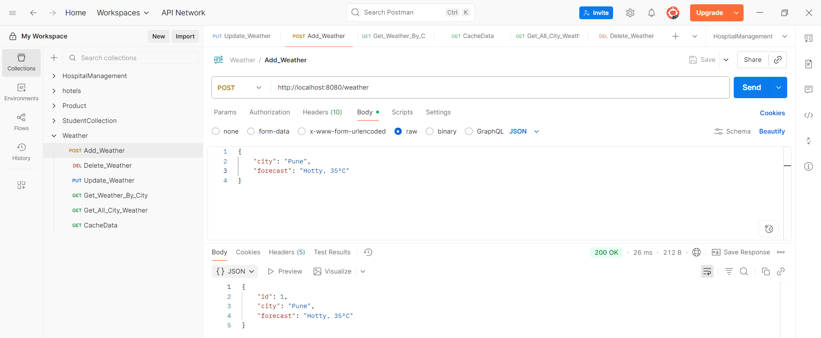

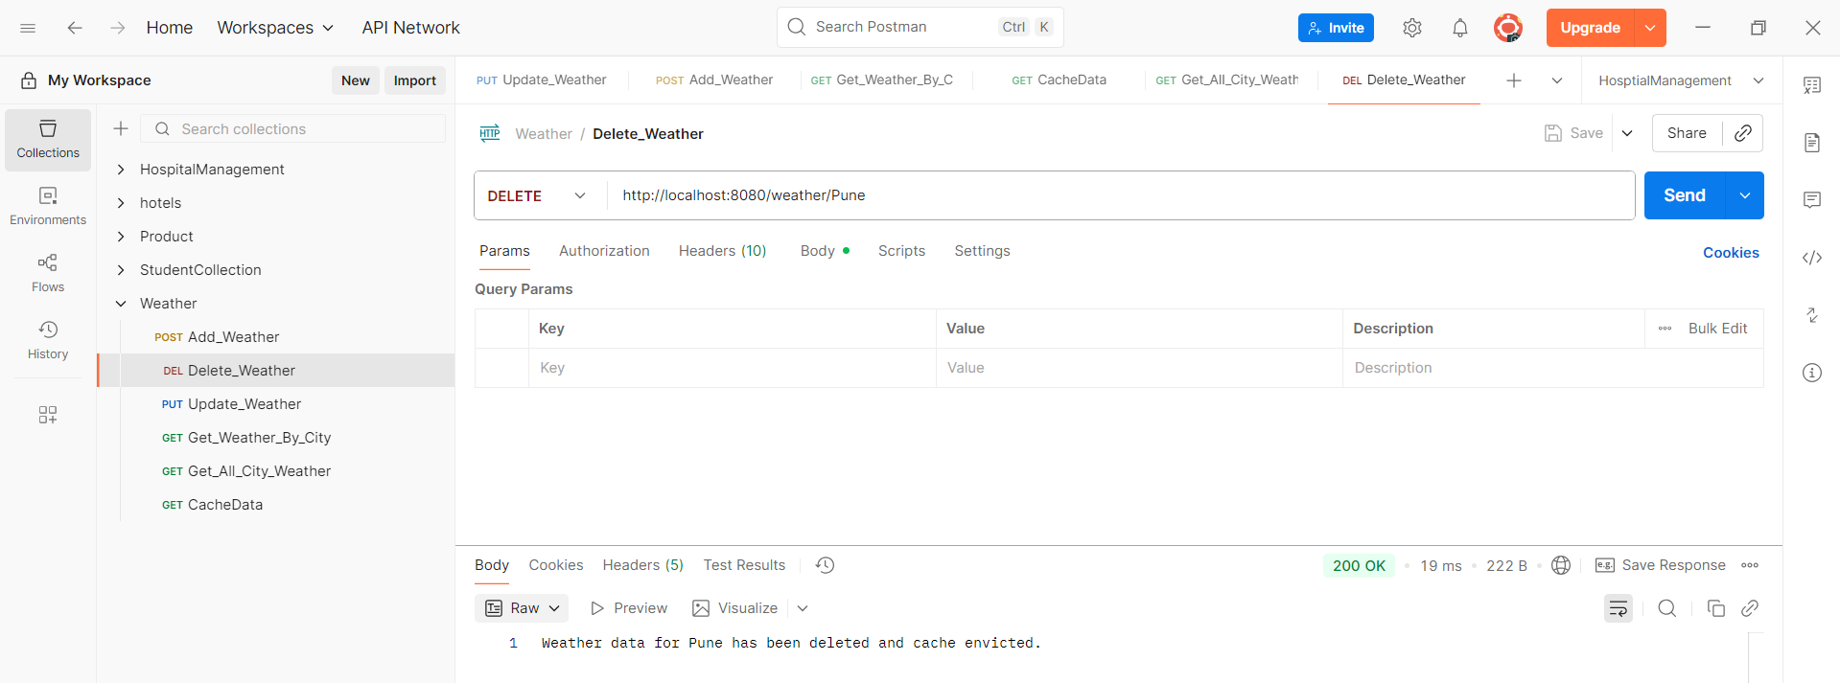

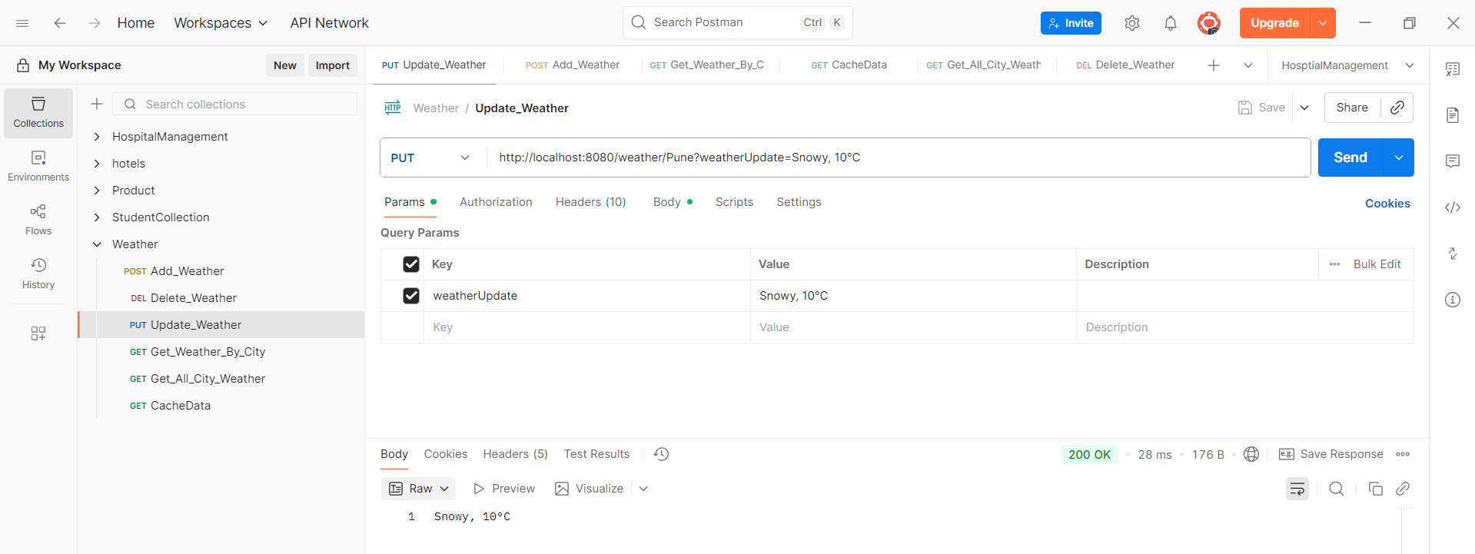

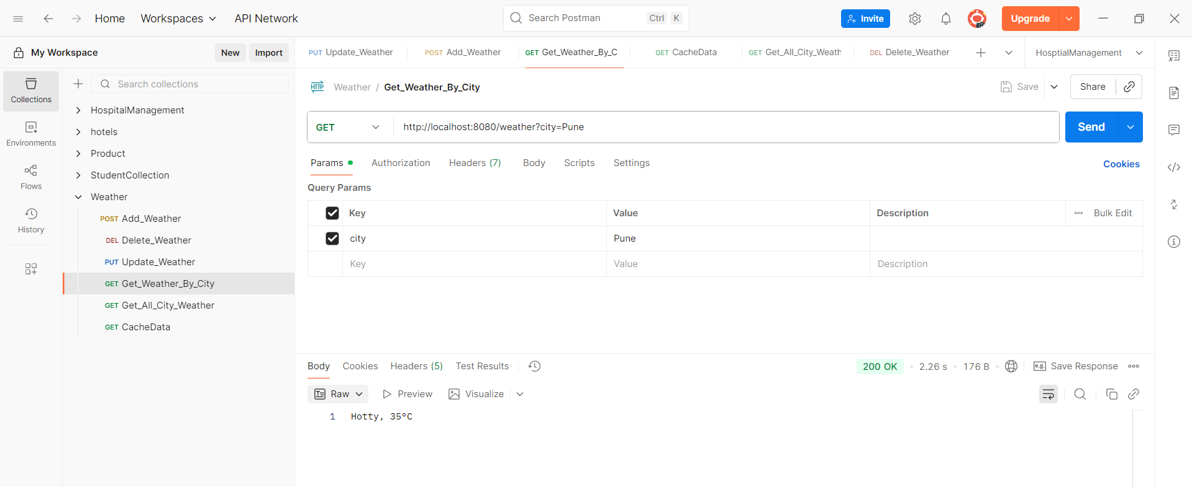

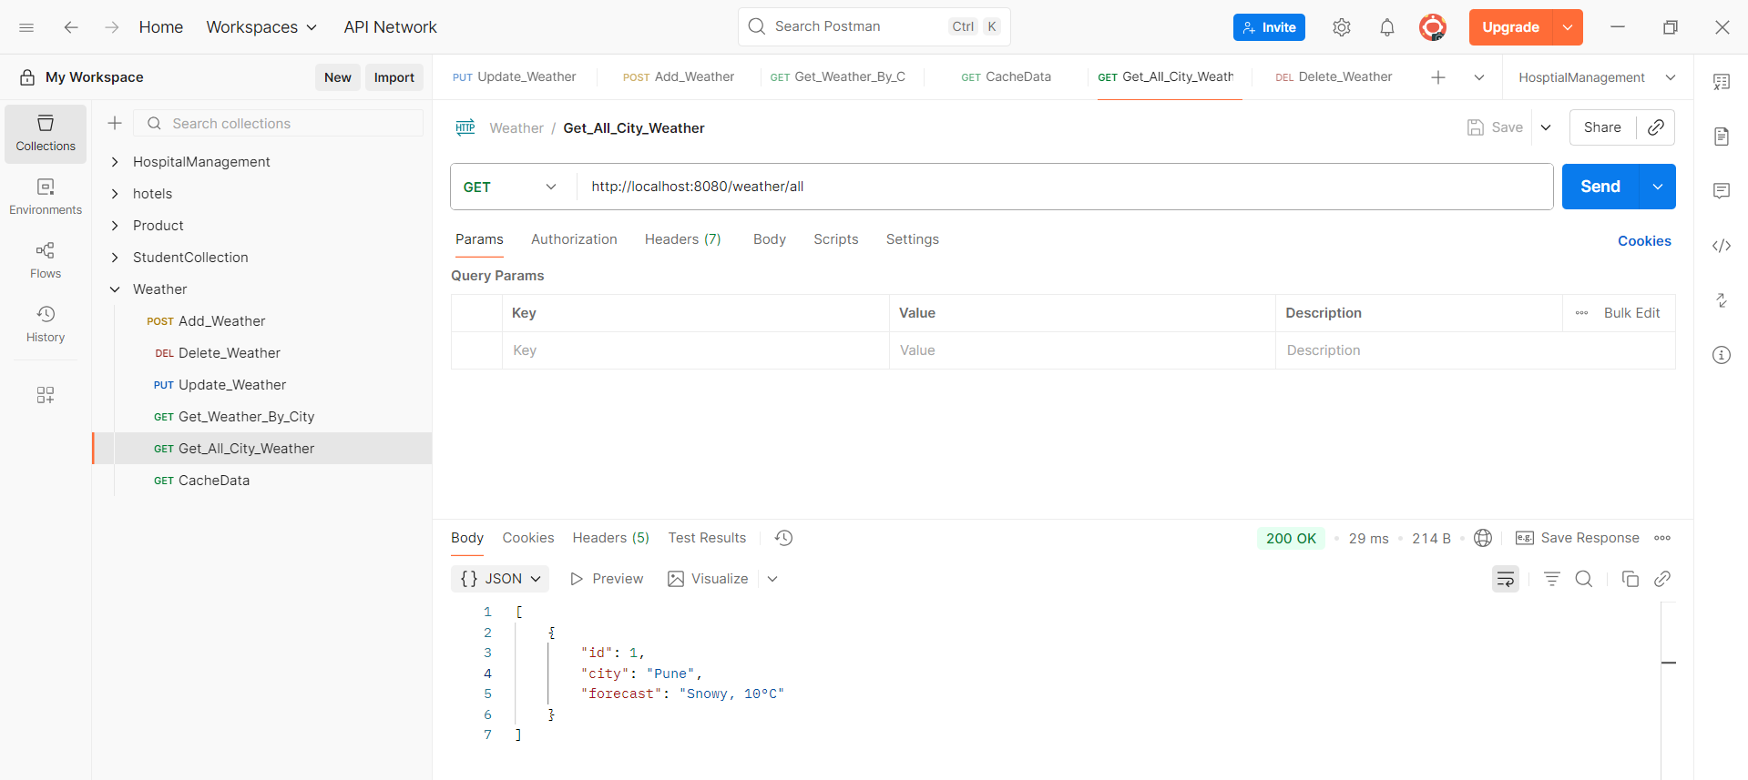

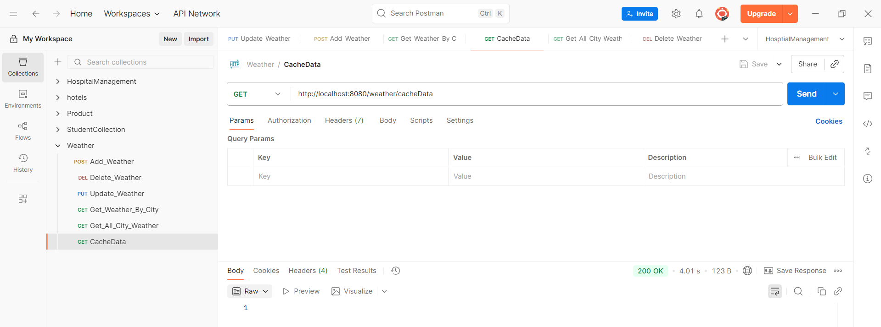
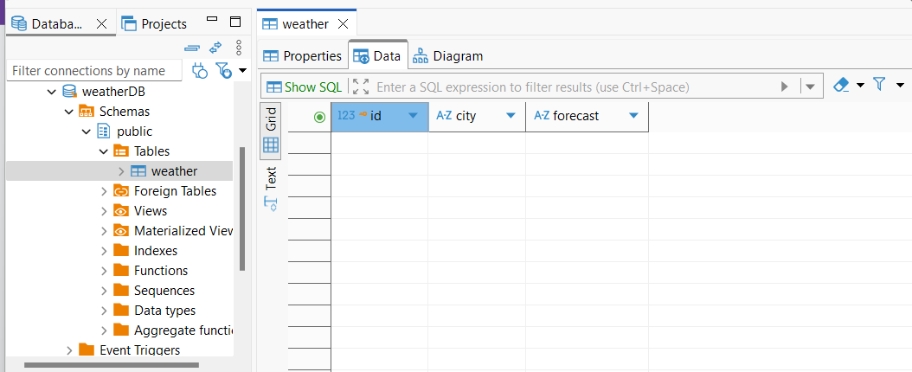

Spring Boot Caching with Redis(Distributed Caching)
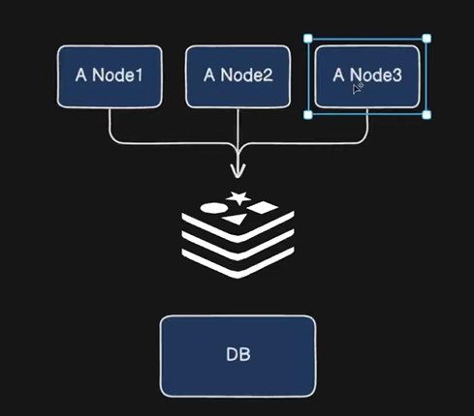

Redis (Remote Dictionary Server) is an open-source, in-memory data structure store that is widely used as a database, cache, and message broker. It supports various data structures such as strings, hashes, lists, sets, and more, allowing for fast data access. Redis is known for its high performance, scalability, and flexibility, making it suitable for various applications like caching, session management, and real-time analytics.

Key Features of Redis:
In-Memory Storage: Stores data in RAM for faster access.
Persistence: Supports data persistence using RDB (snapshotting) and AOF (append-only file) mechanisms.
Pub/Sub Messaging: Provides publish/subscribe messaging capabilities.
High Availability: Offers features like replication and persistence for durability.
Data Structures: Supports various data types like strings, lists, sets, sorted sets, hashes, and more.

Connecting Spring Boot to Redis

To connect a Spring Boot application to Redis, follow these steps:

1. Add Dependencies:
Add the necessary dependencies in your `pom.xml` for Maven or `build.gradle` for Gradle.

For Maven:
```
<dependency>
<groupId>org.springframework.boot</groupId>
<artifactId>spring-boot-starter-data-redis</artifactId>
</dependency>
<dependency>
<groupId>org.springframework.boot</groupId>
<artifactId>spring-boot-starter-web</artifactId>
</dependency>
<dependency>
<groupId>redis.clients</groupId>
<artifactId>jedis</artifactId> <!-- Optional Redis client -->
</dependency>
```

For Gradle:
```
implementation 'org.springframework.boot:spring-boot-starter-data-redis'
implementation 'org.springframework.boot:spring-boot-starter-web'
implementation 'redis.clients:jedis' // Optional Redis client
```

2. Configure Redis Connection:
Add the Redis configurations in your `application.properties` or `application.yml` file.

Example for `application.properties:

spring.redis.host=localhost
spring.redis.port=6379
spring.redis.password=yourpassword # Optional, if you have set a password

Example for `application.yml:

spring:
redis:
host: localhost
port: 6379
password: yourpassword # Optional

3. Create a Redis Configuration Class (optional):
You can create a custom configuration class if you want to have more control over the connection.

import org.springframework.context.annotation.Bean;
import org.springframework.context.annotation.Configuration;
import org.springframework.data.redis.connection.RedisConnectionFactory;
import org.springframework.data.redis.connection.jedis.JedisConnectionFactory;
import org.springframework.data.redis.core.RedisTemplate;
import org.springframework.data.redis.serializer.StringRedisSerializer;

@Configuration
public class RedisConfig {

@Bean
public RedisConnectionFactory redisConnectionFactory() {
return new JedisConnectionFactory();
}

@Bean
public RedisTemplate<String, Object> redisTemplate() {
RedisTemplate<String, Object> template = new RedisTemplate<>();
template.setConnectionFactory(redisConnectionFactory());
template.setKeySerializer(new StringRedisSerializer());
template.setValueSerializer(new StringRedisSerializer());
return template;
}
}

4. Using Redis in Your Service:
You can now autowire the `RedisTemplate` in your service class and use it to interact with Redis.

import org.springframework.beans.factory.annotation.Autowired;
import org.springframework.data.redis.core.RedisTemplate;
import org.springframework.stereotype.Service;

@Service
public class MyService {

@Autowired
private RedisTemplate<String, Object> redisTemplate;

public void saveValue(String key, Object value) {
redisTemplate.opsForValue().set(key, value);
}

public Object getValue(String key) {
return redisTemplate.opsForValue().get(key);
}
}

5. Run Redis Server:
Make sure that your Redis server is running. You can use Docker to start a Redis instance quickly:

docker run --name redis -d -p 6379:6379 redis

Install docker desktop then go to your project terminal and run this: docker run -d --name redis-cahce -p 6379:6379 redis

To run Redis using Docker, you do not need to create an image yourself because the official Redis team provides a pre build image on Docker Hub.

→ Pull the Official Redis Image: Open your terminal and use the docker pull command to download the lastest stable version of the Redis image.
docker pull redis
This command pulls the image named redis:latest (or you can specify a version, like redis:7.2)

→ Run Redis as a Docker Container: Use the docker run command to start a container from the pulled image.
docker run –name my-redis-instance -d -p 6379:6379 redis
This command runs Redis in detached mode (-d) and maps the default Redis port (6279) from the container to the same port on your local machine (-p 6379:6379)

Note: Redis stores it’s data in memory. If you stop the container from the Quick Start option, you will lose all the data. To prevent this, you should use vloume mounting to save data to your local machine.

Also install redis cli command line Interface
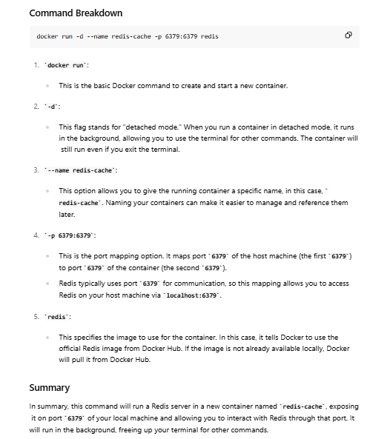

Application.properties file
spring.application.name=Weather_Service

# Established the postgres connection
spring.datasource.url=jdbc:postgresql://localhost:5432/weatherDB
spring.datasource.username=postgres
spring.datasource.password=postgres

#spring.jpa.hibernate.ddl-auto=update
spring.jpa.hibernate.ddl-auto=create
spring.jpa.show-sql=true
spring.jpa.properties.hibernate.format_sql=true

spring.cache.type=redis
spring.data.redis.host=localhost
spring.data.redis.port=6379
spring.cache.cache-names=weather

