

**A PROJECT REPORT**

**ON**

**Random Password Generator**

**Submitted to: Submitted by:**

Mr. Rakesh Patra Rohit Joshi

Assistant Professor University RollNo.:2018663

GEHU, Dehradun Class Roll. No./Section: 52/B

**DEPARTMENT OF COMPUTER SCIENCE AND ENGINEERING**

**GRAPHIC ERA HILL UNIVERSITY, DEHRADUN**

**2021-22**

**DECLARATION**

## I **Rohit Joshi** student of **B-tech Semester 3** Department of Computer Science and Engineering Graphic Era Hill University, Dehradun. Declare that the technical project work entitled “**Random Password Generator**” has been carried out by me and submitted for the fulfillment of the course requirements for the award of degree in B- tech of **Graphic Era Hill University** during the academic year **2021-2022**. The matter embodied in this synopsis has not been submitted to any other university or institution for the award of any other degree or diploma.

Date: 23/02/22

**ACKNOWLEDGEMENT**

Here by I am submitting the project report on **“Random Password Generator”** as per the scheme of Graphic Era Hill University, Dehradun.

I would like to express our sincere gratitude to My Teachers who helped me for providing a congenial environment to work in and carry out our project, and for the invaluable guidance extended at every stage and in every possible way.

Finally I am very much thankful to all the faculty members of the Department of Computer Science and Technology, friends and our parents for their constant encouragement, support and help throughout the period of project conduction.

**Rohit Joshi**

**2018663**

**Section-B | Roll No:- 52**

**INTRODUCTION**

A password generator is an application that can auto-generate passwords for you. These generated passwords are comprised of letters, numbers, and symbols. This application helps the user create a solid password that cannot be easily guessed or brute-forced.

As hacking and phishing scams become more advanced, many developers are taking extra precautions to protect their users. One example is implementing a random password generator, which prompts a user to select a completely randomized password when registering on a site or application, reducing the chances of hackers guessing or stealing login credentials.

In this project we’ll building our random password generator. Our program will generate a random password of a specified length and character composition. After the password is generated, it will give you the option to be copied to your clipboard, meaning it’s ready for use.

**Tools And Software Used**

In order to accomplish this project following tools were used :-

1. A Code Editor it can be Notepad but here we are using Visual Studio Code Editor.
2. Languages used

* HTML
* CSS
* JavaScript

1. Hostinger a for Hosting our website.

**Random Password Generator**

**Methodology**

**Building up a project on Random Password Generator was a great piece of experience, it not only help me in gathering information about new technologies but also made me realize the use of programming in real life.**

**Discussing about how this learning process started and journey up to building up this project goes like this:-**

Firstly I start my project by making a structure of my website how it will be going to look like.

And for it HTML is most Important to make structure of any webpage.

So i start making structure of my website using HTML.

Secondly, after making the structure it looks good but not too much attractive

So to make it attractive start my CSS.

In CSS I have done things like coloring the whole body of the webpage and some container and different elements of the webpage also.

I also use transition property to make it beautiful.

Also add a clipboard button so the user can easily copy the generated password with only one single click.

Thirdly, Up till now Structuring and Designing of the webpage has been done.

Now comes the most important thing to do and it is giving life to our webpage.

Yes making all the buttons works and generating the password and having a functionality of copying the generated password.

All these things are done by using JAVASCRIPT a wonderful exciting language for the WebDevelopers.

Lastly, Our website is ready but the bigger problem comes here.

My website is ready I can run it but only on my computer so here comes the challenge of Hosting my website and getting a Domain name.

And this problem I solved by using the free services of Hostinger which gives the domain name and hosting services paid. But I use its free service where I can host only one website. For this project it is enough so this problem get also solved.

**Finally Our website is ready fully working.**

**Random Password Generator**

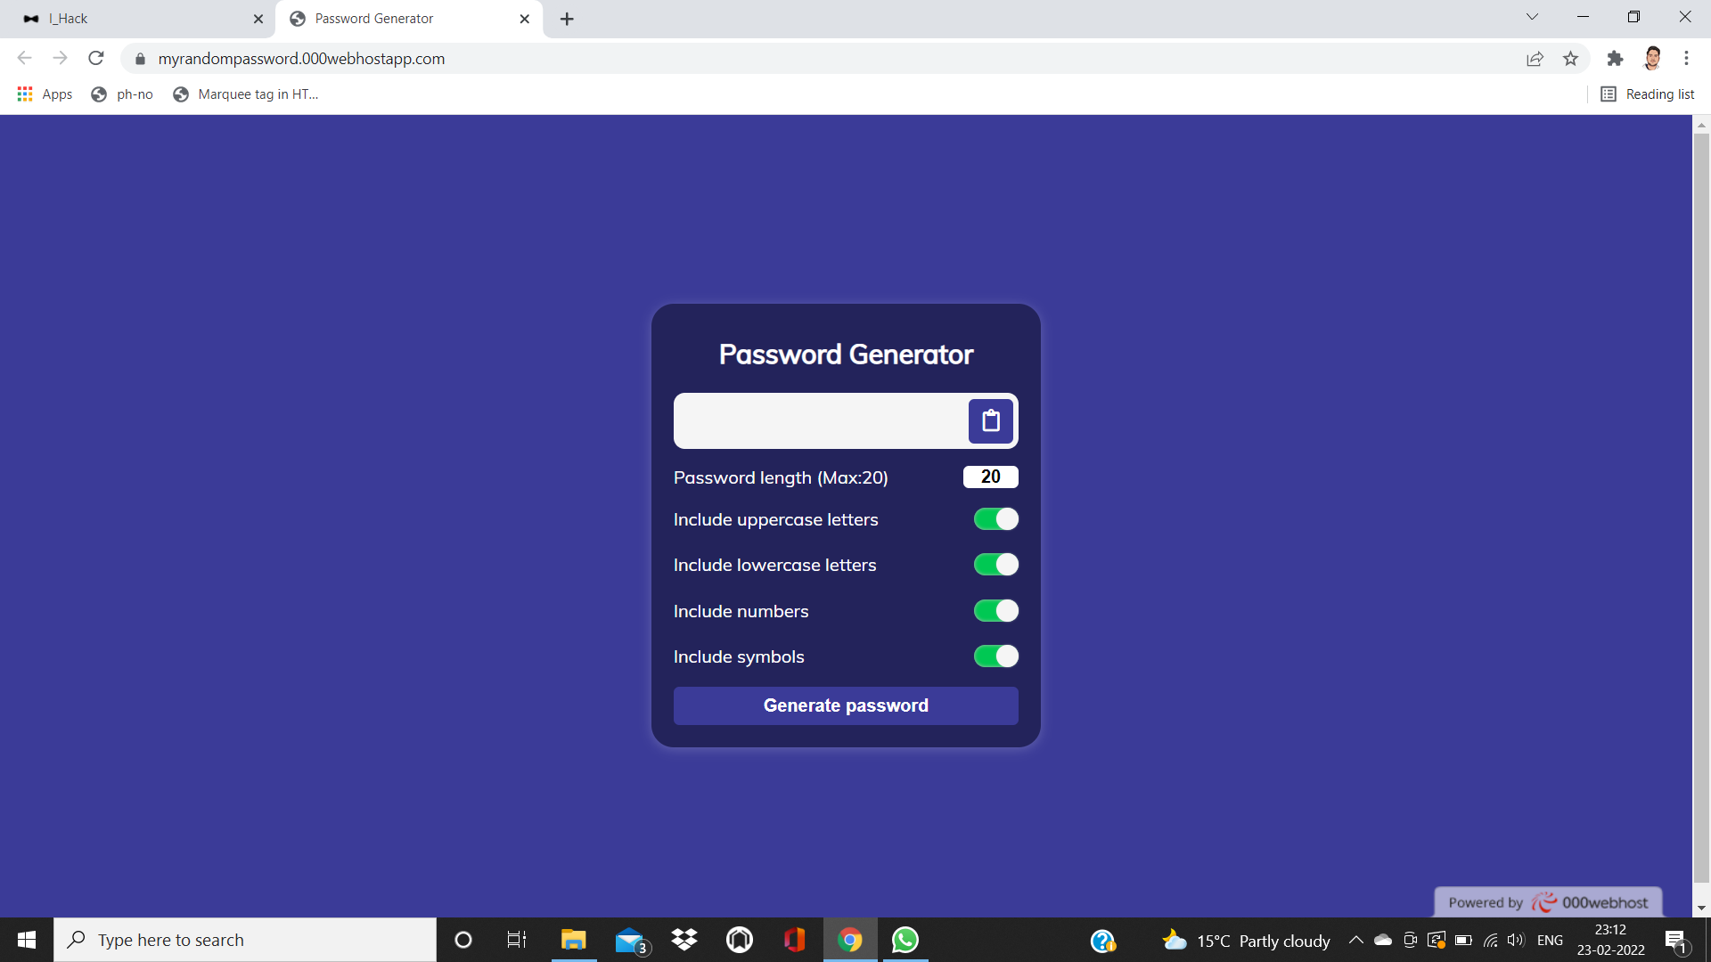

**Conclusion**

The completion of the project went quiet well, I learned much new things while I was building up it, and I get up to know various platforms which help us to learn all this stuff. I was able to learn the practical use of Frontend languages. The practical helped me to learn the debugging of code and development of a website.

Overall working on this project was great fun as I came up with great piece of knowledge and understanding of the topic.

***Reference:***

<https://www.youtube.com>

<https://www.google.com>