Business Requirements Document
Automated Data Reconciliation AI Agent
SAP ERP vs SAGE ERP
Date: Jan 2026
Prepared by: Rohit Joshi
Version: 1.0

Table of Contents
Contents
Table of Contents 2
1. Executive Summary 4
2. Objectives 4
3. Scope 4
In Scope 4
Financial data reconciliation: 4
Master data comparison: 4
Transaction-level matching 4
Exception reporting and dashboards 4
AI-driven anomaly detection 4
Out of Scope 4
4. Stakeholders 5
5. Current Challenges 5
6.Proposed Solution 5
7. Key Features 5
7.1 Data Integration 5
7.2 Data Mapping & Transformation 5
7.3 Matching Engine 6
Rule-based matching: 6
AI/ML-based fuzzy matching: 6
7.4 AI Anomaly Detection 6
7.5 Exception Handling 6
Categorize discrepancies: 6
Suggest root causes 6
7.6 Reporting & Dashboard 6
7.7 Learning & Feedback Loop 6
8. Process Flow 7
Extract → Transform → Match → Detect → Report 7
Flow Chart 8
9. Functional Requirements 8
FR1: Data Extraction 8
FR2: Data Matching 8
FR3: Discrepancy Detection 8
FR4: Reporting 8
FR5: User Interface 8
FR6: Feedback Mechanism 9
10. Non-Functional Requirements 9
Performance 9
Scalability 9
Security 9
Reliability 9
11. Integration Requirements 9
12. Data Requirements 9
Transaction data: 9
Master data: 10
Historical data for ML training 10
13. Risks & Mitigation 10
14. Implementation Phases 10
15. Success Metrics 10
16. Future Enhancements 10

Executive Summary
Organizations using both SAP ERP and SAGE ERP systems face challenges in maintaining consistent financial and operational data across platforms. Manual reconciliation is time-consuming, error-prone, and not scalable.
This project proposes an AI-powered automated reconciliation agent that compares, identifies discrepancies, and suggests resolutions between SAP and SAGE datasets.

Objectives
- Automate reconciliation between SAP and SAGE systems
- Reduce manual effort and human errors
- Enable near real-time discrepancy detection
- Provide intelligent root-cause analysis
- Improve financial data integrity and compliance

Scope

In Scope

Financial data reconciliation:
- General Ledger (GL)
- Accounts Payable (AP)
- Accounts Receivable (AR)

Master data comparison:
- Vendors
- Customers

Transaction-level matching

Exception reporting and dashboards

AI-driven anomaly detection

Out of Scope
- Modification of source ERP systems
- Non-financial modules (e.g., HR, Manufacturing – unless future phase)
- Manual data entry processes

4. Stakeholders
- Finance Team
- IT Team
- Audit
- Compliance
- Executives

5. Current Challenges
- Data mismatches between SAP and SAGE
- Different data formats and structures
- Timing differences in postings
- Manual reconciliation delays
- Lack of centralized visibility
- High risk of compliance issues

6.Proposed Solution
An AI-powered reconciliation agent that:
- Extracts data from SAP and SAGE
- Normalizes and maps data fields
- Matches transactions using rules + machine learning
- Detects anomalies and discrepancies
- Suggests probable causes and fixes
- Generates reconciliation reports and dashboards

7. Key Features

7.1 Data Integration
- API / ETL integration with SAP and SAGE
- Scheduled or real-time data ingestion
- Support for batch uploads (CSV, Excel)

7.2 Data Mapping & Transformation
- Configurable mapping rules
- Currency normalization
- Date format standardization

7.3 Matching Engine

Rule-based matching:
  - Exact match (amount, date, reference)
  - Tolerance-based matching

AI/ML-based fuzzy matching:
- Text similarity (invoice numbers, descriptions)
- Pattern recognition

7.4 AI Anomaly Detection
- Identify unusual transactions
- Detect duplicates or missing entries
- Highlight outliers using ML models

7.5 Exception Handling

Categorize discrepancies:
  - Missing transactions
  - Amount mismatch
  - Timing differences

Suggest root causes

7.6 Reporting & Dashboard
- Reconciliation summary
- Exception reports
- Drill-down capability
- Export (PDF, Excel)

7.7 Learning & Feedback Loop
- User feedback to improve matching accuracy
- Continuous model training

8. Process Flow

Extract → Transform → Match → Detect → Report
- Data extraction from SAP and SAGE
- Data cleansing and normalization
- Field mapping
- Transaction matching
- Discrepancy identification
- AI analysis and classification
- Report generation
- User review and feedback
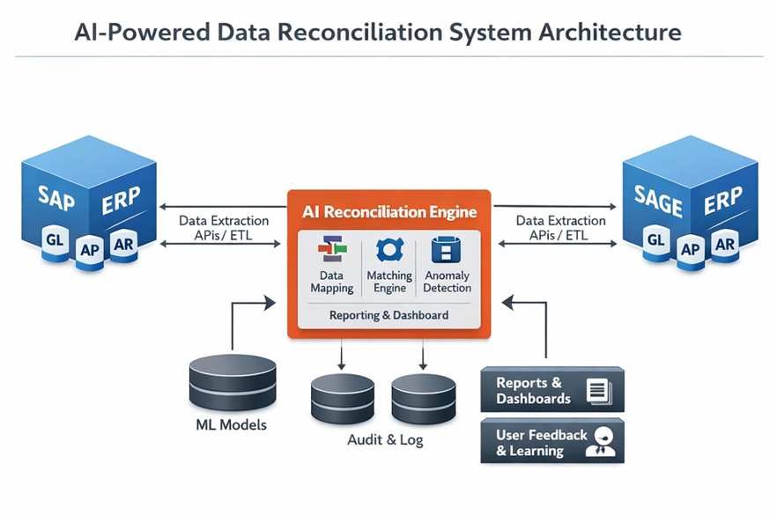
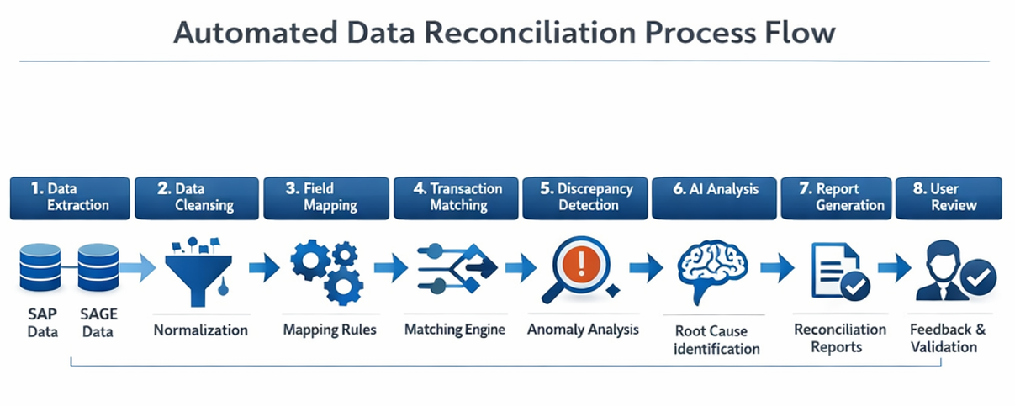

Flow Chart
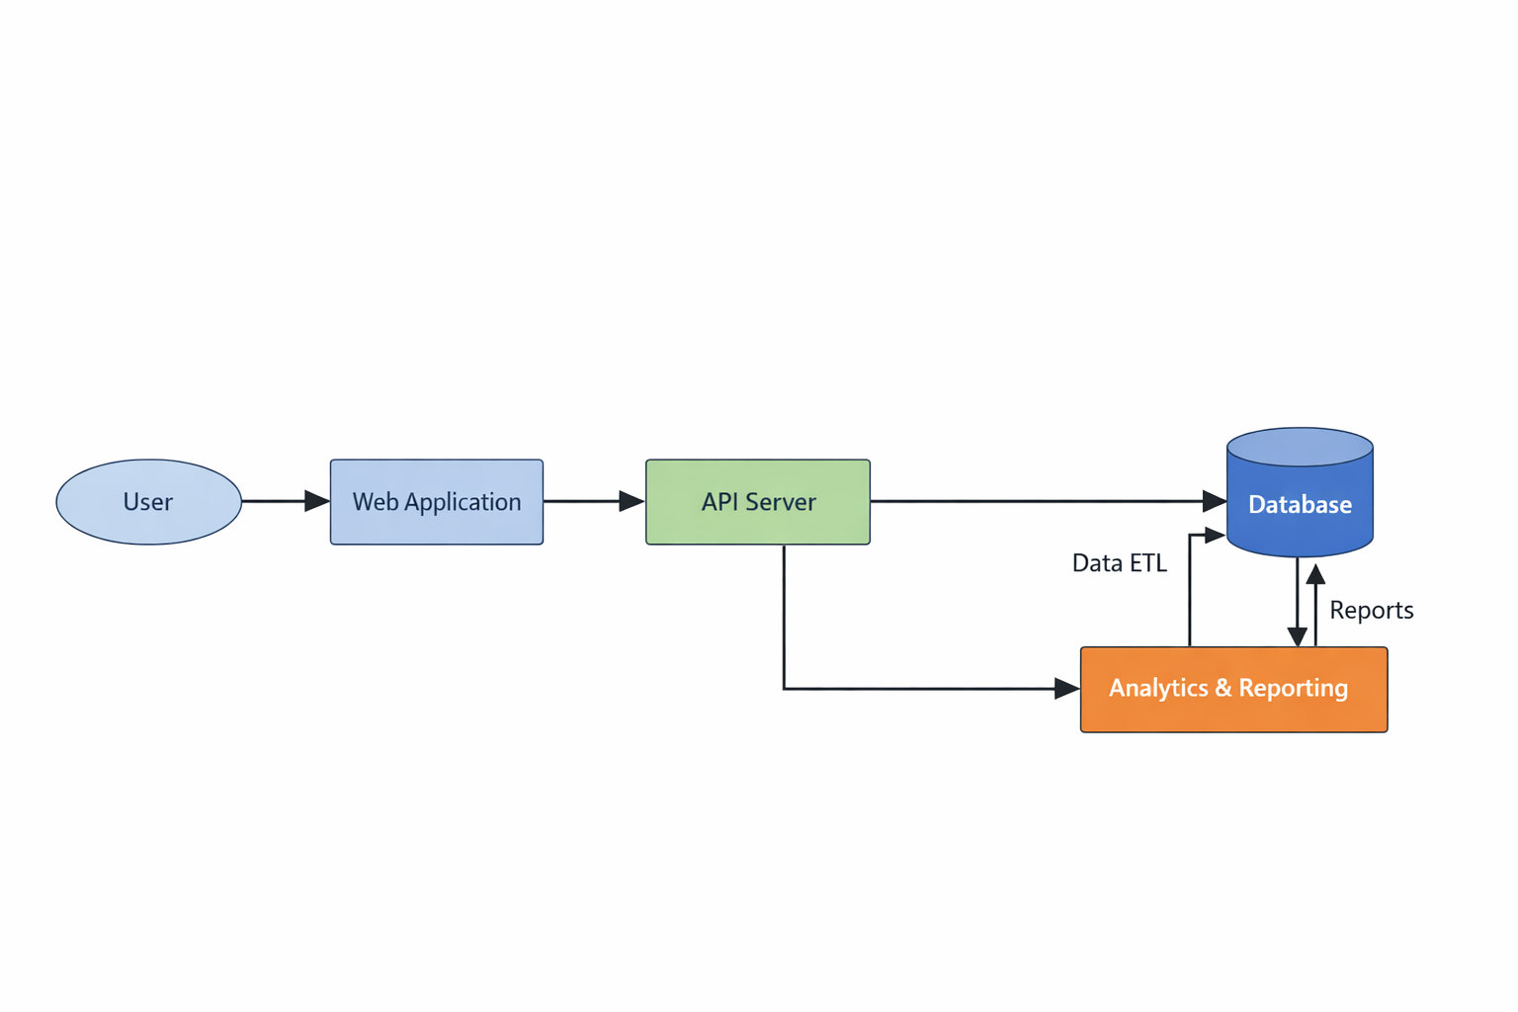

9. Functional Requirements

FR1: Data Extraction
- System shall extract data from SAP and SAGE via APIs or connectors
- Support scheduled and on-demand extraction

FR2: Data Matching
- System shall match transactions based on configurable rules
- System shall support fuzzy matching using AI

FR3: Discrepancy Detection
- System shall identify unmatched or mismatched records
- System shall classify discrepancies

FR4: Reporting
- System shall generate reconciliation reports
- System shall provide dashboards with KPIs

FR5: User Interface
- Web-based UI for monitoring and review
- Ability to filter, search, and drill down

FR6: Feedback Mechanism
- Users shall validate matches and exceptions
- System shall learn from corrections

10. Non-Functional Requirements

Performance
- Process large datasets (millions of records) efficiently
- Response time < 5 seconds for queries

Scalability
- Support multi-entity, multi-region deployments

Security
- Role-based access control (RBAC)
- Data encryption (in transit & at rest)
- Compliance with GDPR / financial regulations

Reliability
- 99.9% uptime
- Fault-tolerant architecture

11. Integration Requirements
- SAP ERP (via SAP APIs / OData / RFC)
- SAGE ERP (via APIs or database connectors)
- Data warehouse (optional)
- BI tools (Power BI, Tableau)

12. Data Requirements

Transaction data:
- Document ID
- Date
- Amount
- Currency
- Vendor/Customer ID

Master data:
- Vendor/Customer details

Historical data for ML training

13. Risks & Mitigation

Risk | Mitigation
Data inconsistency | Robust data validation rules
Integration complexity | Use middleware / APIs
AI model inaccuracies | Continuous training & feedback
Security concerns | Implement strict access controls

14. Implementation Phases
- Phase 1: Integration
- Phase 2: AI
- Phase 3: Optimization

15. Success Metrics
- Accuracy >95%
- Reduced effort
- Faster reconciliation

16. Future Enhancements
- Predictive analytics
- Auto journal entries

