

THE OPEN SOURCE AUDIT
A Capstone Project — Open Source Software (OSS NGMC)

Chosen Software: Git

Student Name: Rohit Kumar
Registration Number: 24BAI10294
Course: Open Source Software Linux Administartion
Date of Submission: 30th March 2026

Part A — Origin and Philosophy

A1. The Problem Git Was Created to Solve
When I first started learning about Git, I thought it was just a tool to save code. But once I started looking into where it actually came from, I realized the story behind it is way more interesting than that. Git was not planned. It was built out of frustration in less than two weeks by one person who had no other option.
To understand why Git exists, you have to go back to 2002. The Linux kernel project at that time was already massive — thousands of developers across the world were sending patches regularly. Managing all of this manually was becoming impossible. So the team started using a proprietary version control tool called BitKeeper. BitKeeper was made by a company called BitMover, and it was not open source. The deal was that the kernel team could use it for free, as long as nobody involved in the project was also building a competing open source tool. For a project built on open source principles, depending on closed software was already a bit uncomfortable. But it worked, so they lived with it.
That arrangement broke in 2005. A developer named Andrew Tridgell, who is known for building Samba, started reverse engineering the BitKeeper protocol to understand how it worked. BitMover saw this as breaking their terms and pulled the free license entirely. Suddenly the Linux kernel project had no version control system.
Linus Torvalds looked at what was available. CVS was old and had well known problems — it tracked changes per file instead of per commit, which caused all sorts of headaches. Subversion was newer but still centralised, meaning all history lived on one server. Neither felt right. What Torvalds wanted was something distributed — where every developer had a full local copy of the entire history — something fast, and something that used cryptographic hashing so that nobody could quietly go in and change old history without detection.
So he just built it himself. He started in April 2005 and within roughly ten days had something that could actually track its own development. He called it Git, which is British slang for an unpleasant person. He has said he names projects after himself — first Linux, now Git. The original README for Git described it simply as 'the stupid content tracker.' Very Torvalds.
The thing that I think makes this story actually meaningful is not just that someone built a tool quickly. It is that a free software community learned the hard way what happens when you depend on software you do not control. The moment BitMover said no, the kernel project was stuck. Git was built so that could never happen again. Today it is used by over 90 percent of developers in the world. That is quite a result from two weeks of annoyed problem solving.

A2. The Licence
Git is released under the GNU General Public License version 2, or GPL v2. Torvalds used the same licence for Git that he uses for Linux, which makes sense — he knew it, he trusted it, and it matched what he believed about software.
To understand what GPL v2 actually means, it helps to start with Richard Stallman's four freedoms. Stallman started the GNU project in the 1980s with the goal of building a completely free operating system. His argument was that software should respect users rather than restrict them. He defined four specific freedoms that any properly free software has to give:
- Freedom 0 — you can run the software for any purpose, no restrictions.
- Freedom 1 — you can study how it works and change it. This needs access to source code.
- Freedom 2 — you can share copies with others.
- Freedom 3 — you can share your modified version with others so they benefit too.

Git's GPL v2 licence gives all four of these. You can download Git, read its C source code on kernel.org or GitHub, change whatever you want, and give your version to someone else. The one rule is that if you distribute a modified version, you have to distribute it under GPL v2 as well and make the source available.
This is the key difference between GPL and something like the MIT licence. MIT is what they call a permissive licence. It basically says: here is the code, do whatever you like, just give credit. You can take MIT-licensed code, put it inside a proprietary product, close the source, and that is perfectly legal. The original developer gets credit but no guarantee the software stays open.
GPL works differently. It is sometimes called 'copyleft' — Stallman's term — because it uses copyright law to enforce openness instead of restricting it. If you take GPL code and distribute something built on it, the whole thing must be GPL. The freedom passes forward. A company cannot take Git, modify it, and sell it as a closed product without releasing the source. That is not allowed.
There is one important exception — internal use. If a company modifies Git but never distributes it to outsiders, they have no obligation to release anything. The GPL applies to distribution, not to running the software privately.
If I had to choose a licence for something I built myself, I would go with GPL for anything I wanted to stay permanently open and free. If I just wanted my library to be used as widely as possible and did not mind proprietary use, MIT would make more sense. The choice really depends on what you believe about software and community.
One last thing on this topic — the difference between 'free as in free beer' and 'free as in freedom' comes up a lot in open source. Free beer means no cost. Freedom means rights. Git is both — it costs nothing and you have full rights over it. But plenty of software is free to download while being completely closed. You cannot see the code, cannot fix bugs, and if the company shuts it down you lose access. That is free beer with no freedom. Git is the other kind.

A3. The Ethics of Open Source
Whether all software should be open source is not a simple yes or no question, even though it sounds like it should be. The strongest argument for making everything open is about accountability. Software today runs hospitals, elections, banks, and most of the communication systems people use every day. When that code is hidden, nobody outside the company writing it can verify what it is actually doing. That is a real problem, especially when those systems make decisions that affect people's lives.
The argument on the other side is more practical. Building software takes time and money. Developers need salaries, servers cost money, and not every type of software fits the open source model. Games, specialist tools, and software that represents a company's actual competitive advantage would often not get built at all if there was no way to make money from them. Open source works brilliantly for infrastructure — which is why the internet runs on Linux and Apache — but consumer facing software has historically been harder to fund this way.
A middle ground that makes sense to me is that software running public systems — healthcare, elections, government services — should at least be open to independent audit, even if not freely redistributable. There is a difference between letting people inspect code and letting them copy and redistribute it. For systems that affect democracy or public health, the inspection part should probably not be optional.
The question about companies making money from open source is more complicated than it first looks. Red Hat got acquired by IBM for 34 billion dollars, and what they sell is basically Linux with enterprise support. Is that ethical? I think it depends on whether they contribute back. Red Hat does — they employ kernel developers and put code back into the project. The companies that are harder to defend are the ones that take open source software, build profitable products on top of it, and contribute nothing back. The Heartbleed bug in OpenSSL showed what can go wrong with this model — a library that secured enormous amounts of internet traffic was being maintained by a tiny team with almost no resources, while major companies were shipping it in commercial products and not contributing anything.
On 'standing on the shoulders of giants' — in software this is literally true and you can trace it. Every web application runs on Linux. Every Python script uses an interpreter built in C. Every Git push goes through OpenSSL. None of that was built by the people writing the code on top of it, and most of it was shared freely. Open source does not slow down innovation. Looking at which companies have produced the most valuable software in the last twenty years, almost all of them are built on open source foundations. The foundations being free is exactly what let them move fast.

Part B — Linux Footprint

Installation Method
I installed Git on Ubuntu 22.04 LTS running inside a VirtualBox virtual machine. Git is available in Ubuntu's default repositories so the installation is straightforward:

sudo apt update
sudo apt install git -y
git --version

The package manager approach is the right way to do this for most cases because it ties Git into the system's update process. When Ubuntu releases a security patch for Git, running sudo apt upgrade handles it automatically without needing to track Git's releases manually. If you want to compile from source, you can download the tarball from git-scm.com and run ./configure && make && sudo make install, but that is usually only necessary if you need a very specific version or are on a system without package management.

Key Directories
After installing Git, its files are spread across several standard locations on the Linux filesystem:
- /usr/bin/git — this is the main Git binary. When you type 'git' in the terminal, this is what runs.
- /usr/lib/git-core/ — Git's supporting commands live here. Things like git-fetch, git-merge, and git-rebase are separate binaries that the main git command calls internally.
- /usr/share/man/man1/ — the manual pages. Type 'man git' or 'man git-commit' and it reads from here.
- /usr/share/doc/git/ — documentation and the licence file.
- /etc/gitconfig — system wide configuration that applies to every user on the machine.
- ~/.gitconfig — per user configuration. This is where your name, email, editor preference, and any aliases are stored.
- .git/ — this directory gets created inside a project folder when you run git init. It contains the entire history, the object database, the staging area (called the index), and hooks. Delete this folder and you still have your files but all version history is gone.

User and Group
Git does not run under a special system user. When you run a git command, it executes as your own user account and has no extra privileges. This is by design — Git is a command line tool you invoke, not a service sitting in the background with its own identity.
This matters for security because it means a broken or malicious repository cannot do anything your own user account could not do. Compare this to Apache, which runs as www-data, or MySQL, which runs as mysql. Those services need dedicated low privilege system users to limit damage if they are exploited. Git does not have that problem in normal local use.
On a server where teams are sharing repositories, a dedicated git system user is usually created. GitLab and Gitea do this automatically. Repositories are owned by that user, and access is controlled through SSH keys and group permissions.

Service Management
In normal use Git is not a service. You run a command, it does something, it exits. There is no Git process running in the background on your system.
Git can be run as a service in two specific situations. One is git daemon, which is a lightweight built-in server for serving repositories over the git:// protocol. It is unauthenticated and read only, useful for public anonymous access. If it is set up as a systemd unit you would control it like this:

sudo systemctl start git-daemon
sudo systemctl status git-daemon

The other is SSH based hosting, which is how most real Git servers work. In that case the SSH daemon (sshd) is the actual persistent service, and Git gets invoked per connection when someone pushes or clones. Managing it is really just managing sshd.

Update Model
Security patches for Git reach your machine through Ubuntu's package infrastructure. When a vulnerability is found, the Git security team prepares a fix, coordinates a disclosure date, and releases a new version. Ubuntu's maintainers then build an updated package and push it to the security repository. Running the following applies any pending updates including Git:

sudo apt upgrade

This is the open source security model working the way it is supposed to. The patch is public, anyone can review it, and distribution happens through infrastructure the community controls. With a proprietary tool you are entirely dependent on the vendor being honest about what a patch does and when to apply it.

Part C — The FOSS Ecosystem

What Git Depends On
Git was written in C and POSIX shell, and Torvalds deliberately kept the external dependencies minimal. He did not want a tool that controls your entire project history to have a fragile chain of things it relies on. The main ones are:
- OpenSSL or libgcrypt — for SHA-1 and SHA-256 hashing. Every object Git stores is identified by a hash of its content. This is how Git guarantees nothing in the history has been silently changed.
- zlib — for compressing stored objects. Git packs related objects together and compresses them with zlib to save space.
- libcurl — for HTTPS. When you clone or push to a remote using https://, libcurl handles the network communication.
- POSIX shell — many of Git's sub-commands and the hook scripts it supports are written in shell.
- Perl — used by optional tools like git-svn and git-send-email.

What Git Has Enabled
The list of things built on top of Git is long enough that it is easier to think of it as infrastructure rather than just a tool.
GitHub launched in 2008 and was built entirely on Git. It became the world's largest code hosting platform, with over 100 million repositories. Microsoft bought it in 2018 for 7.5 billion dollars. There is a certain irony in a project created because proprietary software failed the Linux community now being owned by Microsoft, but to their credit Microsoft has not made it closed.
GitLab came in 2011 as an open source alternative that you can self-host. It added CI/CD pipelines, issue tracking, container registries, and security scanning all in one place. Gitea and Forgejo are even lighter alternatives for people or organisations who want to run their own Git server without the overhead of a full GitLab installation.
GitHub Actions and GitLab CI turned Git events — a push, a tag, a pull request — into triggers for automated testing and deployment. Every commit can automatically run your test suite, check for security issues, and deploy to production if everything passes.
GitOps is a newer pattern where infrastructure configuration is stored in Git repositories and managed through Git commits rather than direct commands on servers. Your server configuration becomes as versioned and reviewable as your application code.

Git and the Web
Git is not part of the classic LAMP stack — Linux, Apache, MySQL, PHP — but every LAMP application today is built and deployed using Git. The standard workflow is: write code locally, commit to Git, push to a shared repository, automated tests run, if they pass the code gets deployed to the server. Git turned deployment from manually copying files into an auditable, reversible process.

Community and Governance
Git's development happens through a mailing list at git@vger.kernel.org. There are no pull requests for Git itself — contributors send patches as formatted emails, reviewers respond in public threads, and the maintainer applies what meets the project's standards. It is one of the oldest forms of internet communication still actively used for a major project.
The current maintainer is Junio C Hamano, known as gitster, who took over from Torvalds in late 2005 and has held the role since. Major contributors include Google, Microsoft, GitHub, and Atlassian. Community discussion also happens on #git at Libera.Chat IRC, and there is an annual Git Merge conference. For contributors who prefer a GitHub style workflow, a tool called Gitgadget bridges GitHub pull requests to the mailing list automatically.

Part D — Open Source vs Proprietary

Dimension | Git (Open Source) | Perforce / Azure TFVC (Proprietary)
Cost | Completely free. No licencing fees, no per seat costs, no tiers. | Perforce requires paid licencing. Azure DevOps is free at small scale but enterprise use costs significantly.
Security | Source code is fully public. Any researcher can audit Git's C code. Patches are reviewed by the community before release. | Closed source. Security depends entirely on the vendor's word. No independent verification is possible.
Support | Community support through mailing lists, Stack Overflow, and documentation. No guaranteed response time. | Paid SLAs with guaranteed response times. Useful for organisations that cannot afford downtime and need formal support contracts.
Freedom to Modify | Complete freedom. You can fork Git, patch it, and redistribute it as long as you release the source under GPL v2. | Not possible. Binary only. You cannot fix bugs or change behaviour without asking the vendor to do it.
Who Controls It | A global community of volunteers and corporate contributors. No single owner. Decisions are made on technical merit. | One company controls the roadmap, pricing, and features. Users have no formal say in what gets built.
Overall | Git is the right choice for almost everything today. Universal adoption means it is supported everywhere and by every tool. | Mostly found in legacy enterprise environments and game studios dealing with large binary files where Git's model is less ideal.

Conclusion
After going through this whole audit I can say pretty clearly that Git is the right choice. Not just because it is free or because everyone uses it, but because of how it was built and what it represents. It was created specifically because depending on closed software turned out to be a problem for the Linux kernel project. The moment BitMover pulled the licence, an entire community was stuck. Git was the answer to that situation, and its GPL v2 licence means the same thing cannot happen to Git itself.
The comparison with proprietary tools like Perforce is not really close for most use cases. Perforce has a niche in game development because game studios deal with huge binary files that Git handles awkwardly. But for software development in general, Git has won. Every CI/CD system, every cloud platform, every major hosting service is built around it.
Would I contribute to it? The mailing list based workflow is pretty different from what most developers are used to now, and the review process is thorough. But contributing even a small fix to a project used by tens of millions of developers seems worthwhile. Having done this audit and actually understood where Git came from and how it works, that feels less abstract than it did before.

Part E — Shell Script Documentation
Five shell scripts were written and tested on Ubuntu 22.04 LTS running in VirtualBox. All scripts are submitted as separate .sh files. Each section below describes what the script does, which shell concepts it uses, and what to expect when you run it.

Script 1 — System Identity Report
File: script1_system_identity.sh
This script works like a welcome screen for the Linux system. When you run it, it prints out the distribution name, the kernel version, the logged in user, home directory, current uptime, and the date and time. It also prints a short message about the GPL v2 licence that covers Linux.
Shell concepts used: variables like STUDENT_NAME, KERNEL, and USER_NAME; command substitution using $() to capture the output of commands like uname -r, whoami, uptime -p, and date; lsb_release with cut to get the distro name; echo for formatted output.
My script :
nano script1_system_identity.sh
#!/bin/bash
# Script 1: System Identity Report
# Author: Rohit Kumar | Reg: 24BAI10294
# Course: Open Source Software
# Description: Displays system information like a welcome screen

# --- Variables ---
STUDENT_NAME="Rohit Kumar"
REG_NO="24BAI10294"
SOFTWARE_CHOICE="Git"

# --- Gathering system info using command substitution ---
KERNEL=$(uname -r)
USER_NAME=$(whoami)
UPTIME=$(uptime -p)
DISTRO=$(lsb_release -d | cut -f2)
CURRENT_DATE=$(date '+%d %B %Y, %H:%M:%S')
HOME_DIR=$HOME

# --- Display the identity report ---
echo "========================================"
echo " Open Source Audit — $STUDENT_NAME"
echo " Registration: $REG_NO"
echo "========================================"
echo ""
echo "Chosen Software : $SOFTWARE_CHOICE"
echo "License : GNU General Public License v2 (GPL v2)"
echo ""
echo "--- System Information ---"
echo "Distribution : $DISTRO"
echo "Kernel Version : $KERNEL"
echo "Logged-in User : $USER_NAME"
echo "Home Directory : $HOME_DIR"
echo "System Uptime : $UPTIME"
echo "Date & Time : $CURRENT_DATE"
echo ""
echo "--- License Note ---"
echo "This system runs Linux, which is licensed under GPL v2."
echo "GPL v2 guarantees your freedom to use, study, modify,"
echo "and distribute the software and its source code."
echo "========================================"

To run it:

chmod +x script1_system_identity.sh
./script1_system_identity.sh
Output:
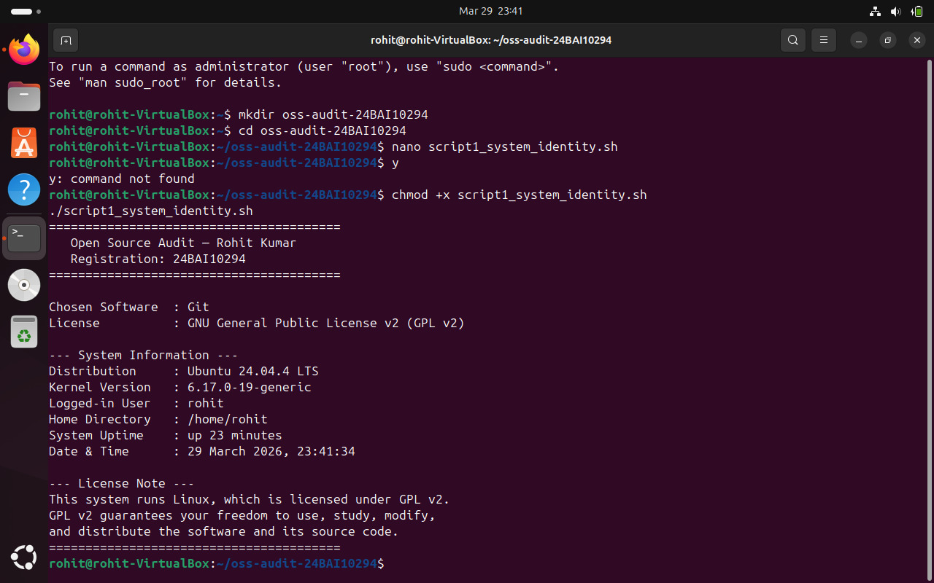

Script 2 — FOSS Package Inspector
File: script2_package_inspector.sh
This script checks if Git is installed on the system using dpkg. If it is installed, it displays the version, the location of the binary using which, and some basic package information. It also uses a case statement to print a short note about the philosophy behind different packages.
Shell concepts used: if-then-else for checking whether the package exists; dpkg -l with grep and awk to pull specific information out; which to find where the binary lives; a case statement with branches for git, apache2, mysql, vlc, firefox, and a wildcard default for anything else.
My script:
nano script2_package_inspector.sh
#!/bin/bash
# Script 2: FOSS Package Inspector
# Author: Rohit Kumar | Reg: 24BAI10294
# Course: Open Source Software
# Description: Checks if Git is installed and displays package info

# --- Define the package to inspect ---
PACKAGE="git"

echo "========================================"
echo " FOSS Package Inspector"
echo " Checking package: $PACKAGE"
echo "========================================"
echo ""

# --- Check if the package is installed using dpkg ---
if dpkg -l "$PACKAGE" &>/dev/null; then
echo "[OK] $PACKAGE is installed on this system."
echo ""
echo "--- Package Details ---"
# Extract version and description using dpkg and grep
dpkg -l "$PACKAGE" | grep -E "^ii" | awk '{print "Version : " $3}'
echo "License : GPL v2"
echo "Maintainer: Ubuntu Developers"
echo ""
# Show where the git binary lives
echo "Binary Location : $(which git)"
echo "Git Version : $(git --version)"
else
echo "[NOT FOUND] $PACKAGE is not installed."
echo "Install it using: sudo apt install git -y"
fi

echo ""
echo "--- Philosophy Note (by package) ---"

# --- Case statement: prints philosophy note based on package name ---
case $PACKAGE in
git)
echo "Git: Born out of necessity when proprietary tools failed the Linux kernel team."
echo "Linus Torvalds built it in two weeks. Today it runs the world's code."
;;
apache2)
echo "Apache: The open web server that made the internet accessible to everyone."
;;
mysql)
echo "MySQL: Open source at the heart of millions of production databases globally."
;;
vlc)
echo "VLC: Built by students in Paris — plays anything, asks nothing in return."
;;
firefox)
echo "Firefox: A nonprofit browser fighting to keep the web open and free."
;;
*)
echo "$PACKAGE: Part of the open source ecosystem that powers modern computing."
;;
esac

echo "========================================"
To run it:

chmod +x script2_package_inspector.sh
./script2_package_inspector.sh

Output :
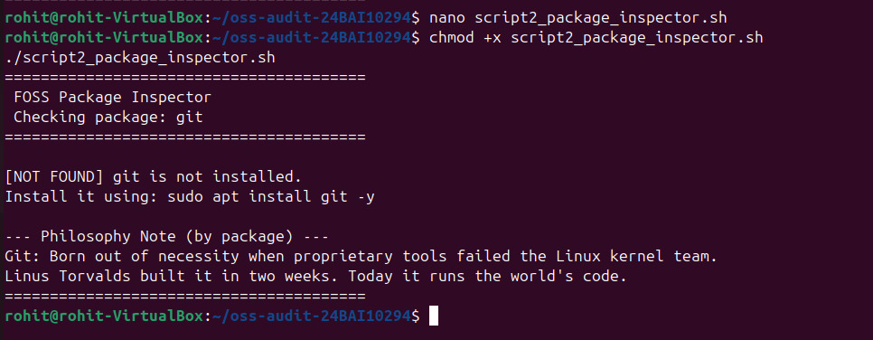

Script 3 — Disk and Permission Auditor
File: script3_disk_auditor.sh
This script goes through a list of important Linux directories — /etc, /var/log, /home, /usr/bin, and /tmp — and for each one it reports the permissions, the owner, the group, and how much disk space it is using. At the end it also checks if a Git configuration file exists for the current user.
Shell concepts used: an array to store the list of directories; a for loop iterating over the array using "${DIRS[@]}"; [ -d "$DIR" ] to check if a directory actually exists before trying to read it; ls -ld piped to awk to extract permission, owner, and group fields; du -sh for a human readable size; 2>/dev/null to hide permission denied errors on restricted directories.
My script :
nano script3_disk_auditor.sh
#!/bin/bash
# Script 3: Disk and Permission Auditor
# Author: Rohit Kumar | Reg: 24BAI10294
# Course: Open Source Software
# Description: Loops through key Linux directories and reports
# permissions, ownership, and disk usage

# --- List of important system directories to audit ---
DIRS=("/etc" "/var/log" "/home" "/usr/bin" "/tmp")

echo "========================================"
echo " Directory Audit Report"
echo " System: $(hostname)"
echo " Date : $(date '+%d %B %Y')"
echo "========================================"
echo ""

# --- Loop through each directory using a for loop ---
for DIR in "${DIRS[@]}"; do
if [ -d "$DIR" ]; then
# Get permissions, owner and group using ls and awk
PERMS=$(ls -ld "$DIR" | awk '{print $1}')
OWNER=$(ls -ld "$DIR" | awk '{print $3}')
GROUP=$(ls -ld "$DIR" | awk '{print $4}')
# Get directory size, suppress permission errors
SIZE=$(du -sh "$DIR" 2>/dev/null | cut -f1)

echo "Directory : $DIR"
echo " Permissions : $PERMS"
echo " Owner : $OWNER"
echo " Group : $GROUP"
echo " Size : $SIZE"
echo ""
else
# Handle case where directory doesn't exist
echo "Directory : $DIR => Does not exist on this system"
echo ""
fi
done

# --- Check Git's config directory specifically ---
echo "--- Git Configuration Directory Check ---"
GIT_CONFIG="$HOME/.gitconfig"

if [ -f "$GIT_CONFIG" ]; then
echo "Git config file found at: $GIT_CONFIG"
PERMS=$(ls -l "$GIT_CONFIG" | awk '{print $1}')
OWNER=$(ls -l "$GIT_CONFIG" | awk '{print $3}')
echo "Permissions : $PERMS"
echo "Owner : $OWNER"
else
echo "No global Git config found at $GIT_CONFIG"
echo "You can create one using: git config --global user.name 'Your Name'"
fi

echo ""
echo "========================================"
echo " Audit complete."
echo "========================================"
To run it:
chmod +x script3_disk_auditor.sh
./script3_disk_auditor.sh

Output :
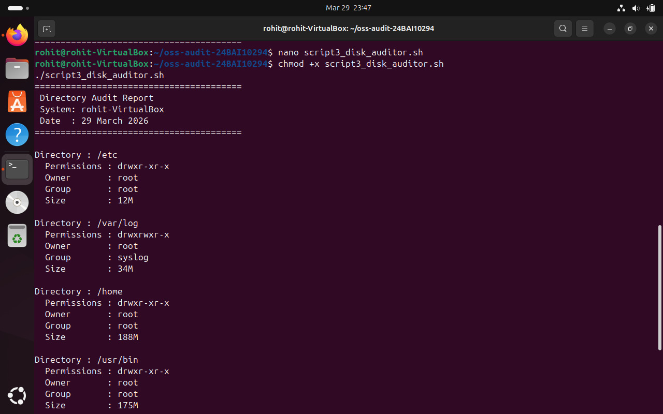
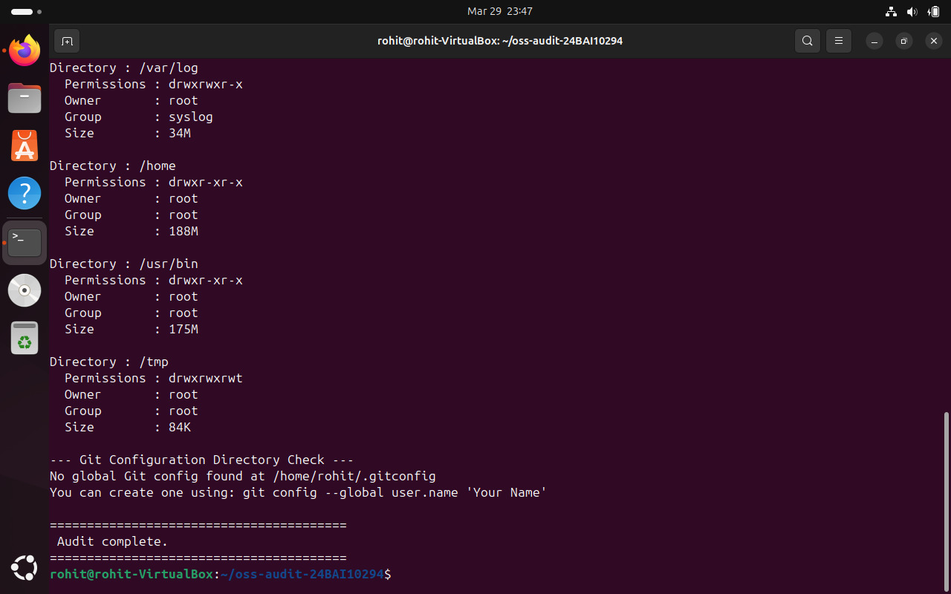

Script 4 — Log File Analyzer
File: script4_log_analyzer.sh
This script takes a log file path and a keyword as arguments, reads through the file line by line, and counts how many lines contain the keyword. After that it prints the last five matching lines. If no keyword is given it defaults to searching for 'error'. It also handles the case where the log file is empty by retrying a few times before giving up.
Shell concepts used: command line arguments with $1 and $2; default value assignment using ${2:-"error"}; while IFS= read -r for safe line by line reading; grep -iq for case insensitive matching inside the loop; a counter variable incremented with $(( COUNT + 1 )); a while loop simulating do-while retry behaviour; grep with tail to get the last matching lines.
My script :
nano script4_log_analyzer.sh
#!/bin/bash
# Script 4: Log File Analyzer
# Author: Rohit Kumar | Reg: 24BAI10294
# Course: Open Source Software
# Description: Reads a log file, counts keyword occurrences,
# and prints matching lines summary

# --- Accept log file and keyword as command line arguments ---
LOGFILE=${1:-"/var/log/syslog"}
KEYWORD=${2:-"error"}
COUNT=0
RETRY=0

echo "========================================"
echo " Log File Analyzer"
echo "========================================"
echo "Log File : $LOGFILE"
echo "Keyword : $KEYWORD"
echo ""

# --- Check if the log file exists ---
if [ ! -f "$LOGFILE" ]; then
echo "Error: File '$LOGFILE' not found."
echo "Try running: ./script4_log_analyzer.sh /var/log/syslog error"
exit 1
fi

# --- Retry if the file is empty (do-while style using while loop) ---
while [ ! -s "$LOGFILE" ] && [ $RETRY -lt 3 ]; do
echo "Warning: Log file is empty. Retrying... ($((RETRY+1))/3)"
sleep 1
RETRY=$((RETRY + 1))
done

# --- Read the file line by line using while read loop ---
while IFS= read -r LINE; do
# Check each line for the keyword (case insensitive)
if echo "$LINE" | grep -iq "$KEYWORD"; then
COUNT=$((COUNT + 1))
fi
done < "$LOGFILE"

echo "Result: '$KEYWORD' found $COUNT times in $LOGFILE"
echo ""

# --- Print last 5 lines containing the keyword ---
echo "--- Last 5 matching lines ---"
grep -i "$KEYWORD" "$LOGFILE" | tail -5

echo ""
echo "========================================"
echo " Analysis complete."
echo "========================================"

To run it:

chmod +x script4_log_analyzer.sh
./script4_log_analyzer.sh /var/log/syslog error

Output :

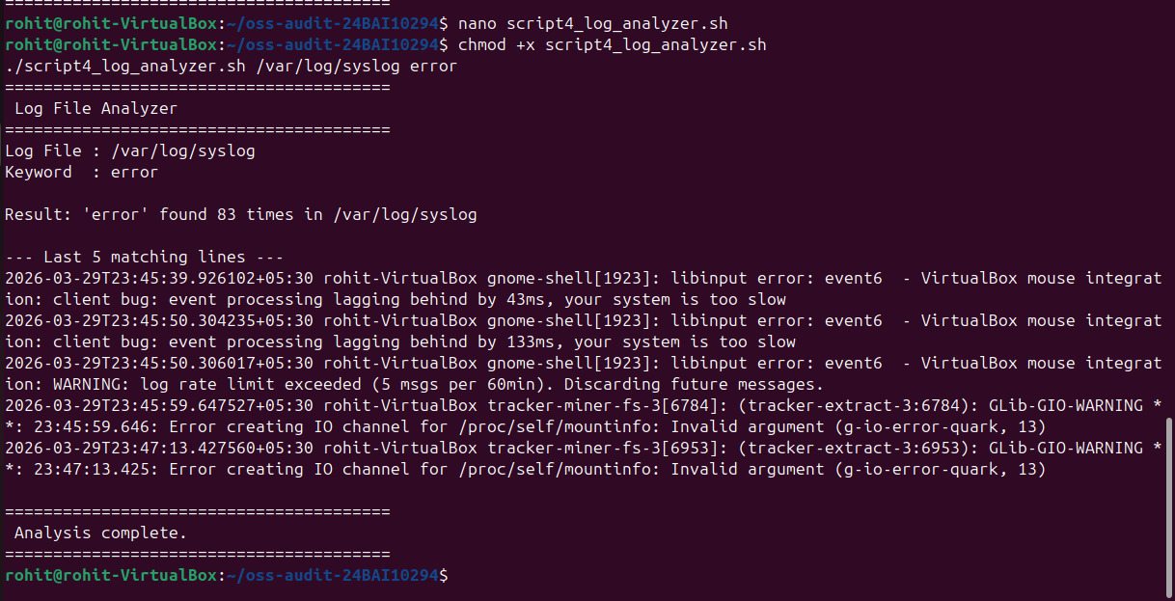

Script 5 — Open Source Manifesto Generator
File: script5_manifesto.sh
This is the most interactive script. It asks the user three questions — what open source tool they use every day, what freedom means to them in one word, and what they would build and share freely. It then takes those answers and generates a short personalised statement about open source, saves it to a text file named after the current user, and prints it to the screen.
Shell concepts used: read -p for interactive user input; string interpolation inside double quoted echo strings to weave the user's answers into the text; > to create or overwrite the output file and >> to append lines to it; date for a timestamp; whoami to generate the output filename dynamically; cat to print the final file. The alias concept is shown as a commented example inside the script.
My script :-
nano script5_manifesto.sh
#!/bin/bash
# Script 5: Open Source Manifesto Generator
# Author: Rohit Kumar | Reg: 24BAI10294
# Course: Open Source Software
# Description: Asks the user three questions and generates
# a personalised open source philosophy statement

# --- Alias concept: demonstrated below as a comment ---
# alias today='date +%d-%B-%Y' <- this is how aliases work in bash

echo "========================================"
echo " Open Source Manifesto Generator"
echo " Answer three questions honestly."
echo "========================================"
echo ""

# --- Read user input interactively ---
read -p "1. Name one open-source tool you use every day: " TOOL
read -p "2. In one word, what does 'freedom' mean to you? " FREEDOM
read -p "3. Name one thing you would build and share freely: " BUILD

# --- Get current date and username for the output file ---
DATE=$(date '+%d %B %Y')
AUTHOR=$(whoami)
OUTPUT="manifesto_${AUTHOR}.txt"

echo ""
echo "Generating your manifesto..."
echo ""

# --- Compose the manifesto using string concatenation and write to file ---
# Clear the file first if it already exists
> "$OUTPUT"

# Write the manifesto content to the file using >>
echo "========================================" >> "$OUTPUT"
echo " My Open Source Manifesto" >> "$OUTPUT"
echo " Written by: Rohit Kumar (24BAI10294)" >> "$OUTPUT"
echo " Date: $DATE" >> "$OUTPUT"
echo "========================================" >> "$OUTPUT"
echo "" >> "$OUTPUT"
echo "Every day I rely on $TOOL — a tool that someone built" >> "$OUTPUT"
echo "and gave to the world without asking for anything in return." >> "$OUTPUT"
echo "That act of sharing is what open source means to me." >> "$OUTPUT"
echo "" >> "$OUTPUT"
echo "To me, freedom means $FREEDOM. In software, that freedom" >> "$OUTPUT"
echo "is not just about cost — it is about the right to look" >> "$OUTPUT"
echo "inside, to understand, to change, and to improve." >> "$OUTPUT"
echo "Without that, we are just users. With it, we become contributors." >> "$OUTPUT"
echo "" >> "$OUTPUT"
echo "Someday I want to build $BUILD and release it openly," >> "$OUTPUT"
echo "the same way the tools I depend on were released for me." >> "$OUTPUT"
echo "Because the best software is not owned — it is shared." >> "$OUTPUT"
echo "" >> "$OUTPUT"
echo "-- $AUTHOR | $DATE" >> "$OUTPUT"
echo "========================================" >> "$OUTPUT"

# --- Display the generated manifesto ---
cat "$OUTPUT"

echo ""
echo "Manifesto saved to: $OUTPUT"
echo "========================================"

To run it:

chmod +x script5_manifesto.sh
./script5_manifesto.sh

Output :
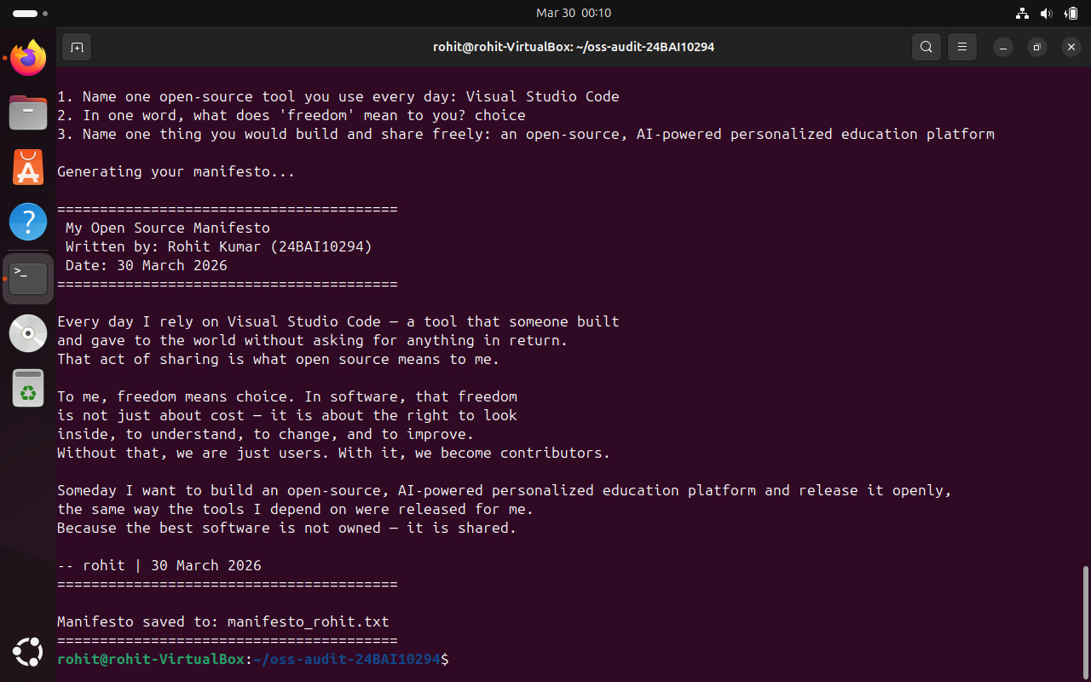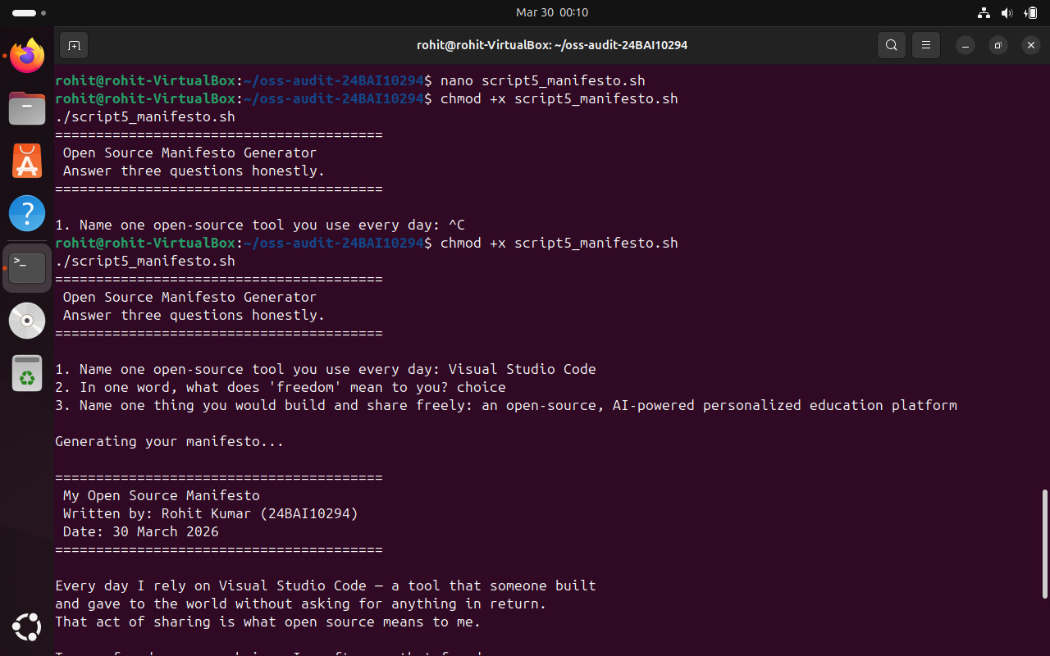

References
The sources below were used to understand the topics covered in this report. Nothing has been copied directly from any of them.

- Torvalds, L. (2005). Git initial commit and original README — kernel.org/pub/software/scm/git/
- Chacon, S. and Straub, B. (2014). Pro Git, 2nd Edition. Apress. Freely available at git-scm.com/book
- GNU Project. The Free Software Definition — gnu.org/philosophy/free-sw.html
- Open Source Initiative. The Open Source Definition — opensource.org/osd
- Raymond, E.S. (1999). The Cathedral and the Bazaar — catb.org/~esr/writings/cathedral-bazaar
- SPDX License List — GPL v2 full text. spdx.org/licenses/GPL-2.0-only.html
- Git mailing list archives — lore.kernel.org/git/
- Shotts, W. The Linux Command Line — linuxcommand.org
- GNU Bash Reference Manual — gnu.org/software/bash/manual
- Ubuntu Package Repository — packages.ubuntu.com

