Talkative

Project

Report

An offline gesture to speech for mute people using Android device and a simple glove with Machine learning Model.

Student:

Rohit K Vinod [S4 CSE]

R V Vivek Viswam [S4 CSE]

Chris George [S4 ECE]

Arjun M B [S4 AEI]

College: Rajagiri School of Science and Technology, Kochi

# Introduction

Project Talkative is a one stop solution for enabling interpersonal voice communication for mute people even through phone calls.

Problem Statement

In the present, communication between mute people is achieved with American Sign Language(ASL). As only mute is trained in ASL, this community is forced to accompany an interpreter in public places or use simple Android applications that convert text to speech. This age-old method deprives them of expressing their thoughts with emotion and eye contact. And phone calls even a dream.

Constraints

* A simple device operable by a common man.
* A low resource consuming, software and hardware, device.
* Workable even at remote locations.

Proposed Solution

A wearable device and an Android Application that interprets gesture and convert it to speech is the proposed solution.

Thereby enabling voice-voice communication, as for normal people.

The device also has unique feature that allows the user to create his own custom sign language for his or her convenience and even make calls.

# Technical Details

## Hardware

The wearable device consists of a glove mounted with

* **3-axis accelerometer :** 
  + The accelerometer is used to detect the orientation of the hand. Example , the gesture “thumbs up” and “thumbs down” is same if we only look at the position of fingers. Therefore the accelerometer helps differentiate between different hand orientations. The output of the accelerometer consists of 3 varying analog voltage signals for each of the 3 axis.
  + 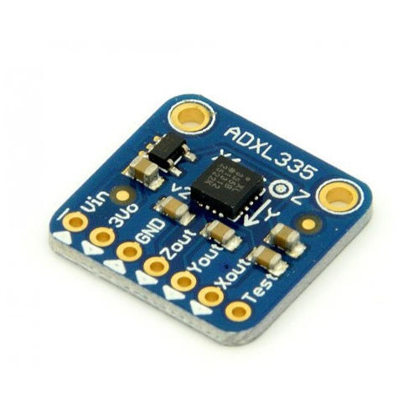
* **Micro-controller :** 
  + ATMEGA328P , the brain of the device ,used to collect the data from all the sensors in board. It is connected to the Bluetooth module, 5 flex sensors on each hand, and the accelerometer.
  + 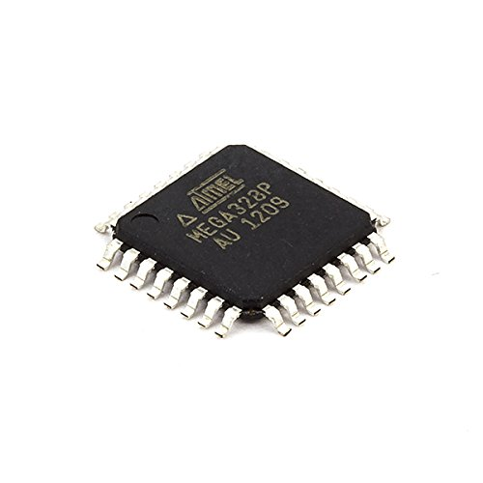
* **Flex Sensors :**
  + It is used to measure the degree of bending of each finger. It is placed in each of the fingers of the gloves. The resistance of the flex sensor changes with bending of the material.
  + 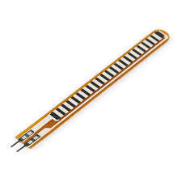
* **Bluetooth module :** 
  + Bluetooth module is used is HC-05. It is used to send all the collected data from the 5 flex sensors and the accelerometer to the smart phone application for further process.
  + 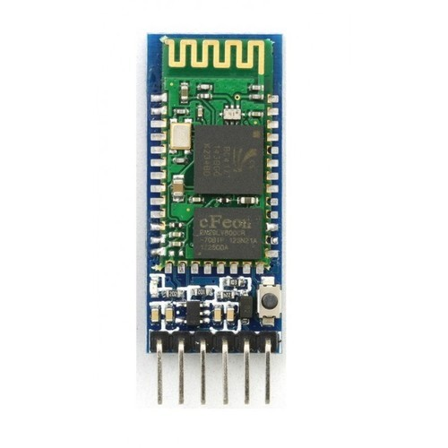
* Schematics :
* 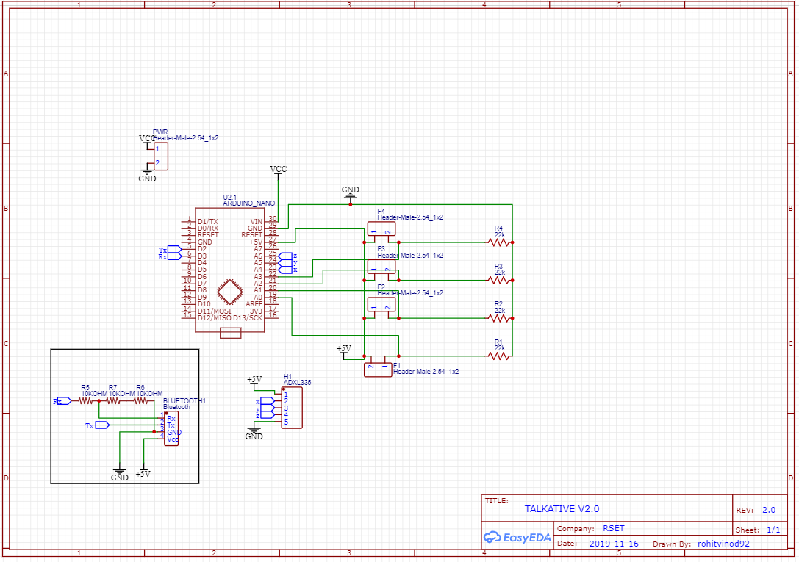

**Component Specification**

|  |  |  |  |
| --- | --- | --- | --- |
| Sl.no | Component | Specification | Quantity |
| 1. | Accelerometer 3-axis | ADXL335 | 1 |
| 2. | Microcontroller | ATMEGA328P | 1 |
| 3. | Flex Sensors | 2.2 inch | 5 |
| 4. | Bluetooth module | HC-05 | 1 |

## Current Working Model :

## WhatsApp Image 2020-02-24 at 8.11.05 PM

## Working

The device is initiated by powering up of the glove (wearable), then the Android application is launched.

Once the Android Application in launched with the Bluetooth turned on, the application connects to the Bluetooth module of the wearable device(glove).

After successful connection, the user is presented with 4 options

1. Run
2. Call
3. Train
4. Delete

1.Run

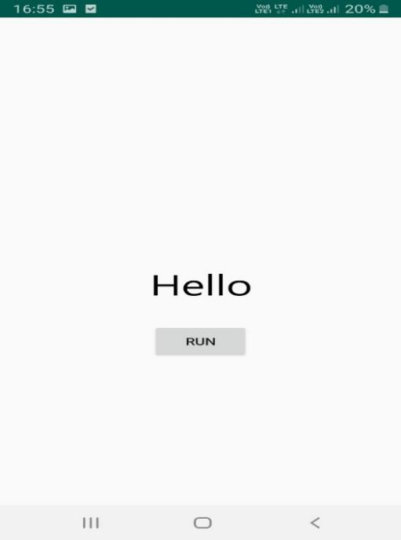

The application enters “**Interpreter mode**”

2. Call

Similar to “Run”, “Call” also acts an entry point to “Call mode”, here the user is prompted to enter the unique id of the receiver assigned. On pressing call button in the UI, the server exchange IP address of each nodes, thereafter the Android App enters “Call mode”.

3.Train

The Application enters “Train mode” .

4.Delete

The Tensorflow lite model trained in “Train mode” is deleted from the Android device.

For using the application again, the user needs to train a new model using the train button in Launch screen of the Android Application.

## Modes of Operation

The user can use the Android Application in 3 different modes

* Interpreter mode
* Train mode
* Call mode

1.TRAIN MODE:

In train mode, the user is prompted to enter the word in an allocated text box and hold the gesture to be trained. The user can start the training by pressing the designated button in UI of the application. The device is set to receive the data through the established Bluetooth channel.

After running for a reasonable time (10 sec), during which it receives sensor data, the mobile device establishes a client-server connection with cloud server. On successful establishment, the mobile application sends the collected data to server. The server trains a new Tensorflow Lite Classifier model and returns the trained model to the connected client mobile device.

2.INTERPRETER MODE:

In INTERPRETER MODE, the android device acts as a server and receives the data transmitted by the client glove, via the established RFCOMM channel. The data is further input to the pre-trained Tensorflow Lite model existing on the android device. The output from the model is mapped to corresponding word and returned to the caller.

3.CALL MODE:

The android device establishes a call over internet, using P2P connection, to another android device that supports the call feature of the application as defined by the calling “Android Activity ” or “function”. By default, the application creates a thread to invoke “Interpreter mode” in parallel. The word returned from the “Interpreter mode” thread is then encoded and transferred to the other node (other end of the call). The encoded data received is decoded and converted to audio using Google Text-to-Speech API (offline).

The device works offline in INTERPRETER MODE, i.e. without internet connection, but requires internet connection for CALL MODE and TRAIN MODE.

## Conclusion

After several considerations, such as implementing stored English Language Model, pair

of glove instead of one and other constrains, the solution turned out to be a glove

mounted with required senors and an Android Application that detects gesture and

predicts a trained word corresponding to gesture assigned. Also unique utility functions

such as Call over Internet, train unlimited(varies as per device secondary storage space)

words or phrases and delete a trained model are included in the proposed solution.

(prototype developed referred throughout the report)

The device could be rolled out as commercial product based on the prototype

mentioned, after replacing the general purpose hardware with specific purpose

hardware at a cheaper price, and can help mute people achieve their dream of

expressing themselves independently.