
----------------------------------------------------------------------Smart Helmet
----------------------------------------------------------------------

Name of the Team | Non-Luddite
Number of members in the Group | 1
Group Leader
Name | Rohit K Vinod
Contact No. | 9567700937
Email id | rohitvinod92@gmail.com
DOB (dd/mm/yy) | 02/11/99
Institute | Rajagiri School of Engineering
Year of Graduation | 2022

FIELD/ STREAM OF ENGINEERING OF THE PROJECT :

Related Streams of Engineering:
- Computer Science Engineering
- Electrical and Electronics Engineering
- Electronics and Communication Engineering

PROBLEM STATEMENT :
Now a days driving or riding a vehicle is a challenge in the roads of India . Especially the motorcycles, which are rated to the most dangerous vehicle in the world.
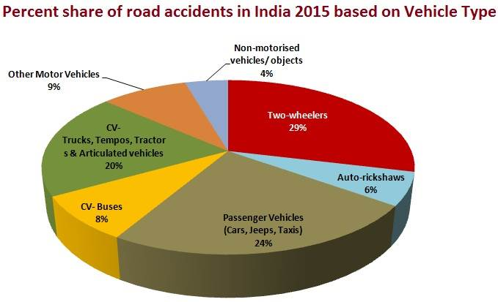
In India 29% of all accidents are caused by a motorcycle (2015 studies) . And deaths due to Road accidents are rising .
Few of the major factors of road accidents are due to :
- Increases in average speed
- Driving under the influence of alcohol or drugs
- *Inadequate post-crash care

*Inadequate Post-Crash Care
Delays in detecting and providing care for those involved in a road traffic crash increase the severity of injuries. Care of injuries after a crash has occurred is extremely time-sensitive: delays of minutes can make the difference between life and death. Improving post-crash care requires ensuring access to timely pre-hospital care, and improving the quality of both
pre-hospital and hospital care, such as through specialist training programmes.

These factors worsen in remote area where there is no immediate medical center.
"There is one death every four minutes due to a road accident in India. Motorcycles account for 29% of total road crash deaths "

IDEA :
Looking on to one the major factor of road accidents , Inadequate Post-Crash Care is a major are which could be improved .
The Idea is to introduce a Accident Detection System onto the helmet that can provide the following functions :
- Accident Detection : Detects accident when a sudden changes in acceleration is
detected by using set of accelerometer.

- Sends GPS location : Collects Data of the position of incident using GPS .

- Sends Alert to nearby Medical services and Traffic Control : The collected data is then send to nearby Hospital or any emergency centers for immediate help for the victim of the accident . By the time the hospital is ready with the ambulance ,the alert received by the traffic control will help clear a fast route to the accident .

This should be able to drastically reduce the reaction time to the accident and there by improving post-crash care. This can ensure less deaths due to road accidents.
This could be more useful in remote areas where an accident might even go unnoticed.
And places like adventurousness spots which many motorcyclist are attracted to can have rough terrain which is mostly hilly areas and medical support there would be weak.
With the smart helmet we could provide immediate medical help to places where an accident might go unnoticed .

WORKING :
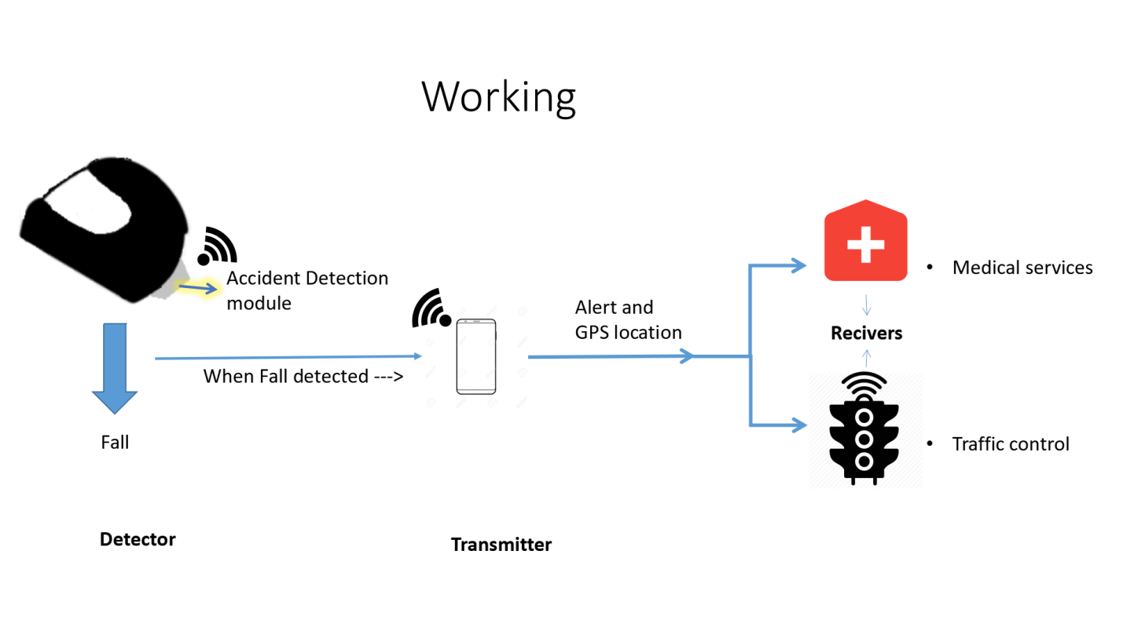
The smart helmet consists of 3 parts ;
- Detector : This module contains the Accident Detection System. It contains a set of micro- controllers, a accelometer and a Bluetooth module. The module is equipped with
a kill switch and a buzzer to stop false alarms.

- Transmitter : Transmitter is the smart phone which will be running a custom application concreted to a web server and will be used to connect to the Detector module using Bluetooth and to receive GPS location data to send to the receiver.

- Receiver : This module contain a screen, micro-controller and Wi-Fi module and will be hosting a web server to receive GPS location data from the Transmitter and and display the GPS location on the screen.

So the smart helmet works when the detector detects very high g forces(acceleration of gravity),about 30+ g . When it detects that high g forces it starts ALERT protocol.
ALERT protocol :
- If the accelometer detects 30+ g
- Starts a timer for 15 seconds .(sets off a buzzer for 15s)
- If the kill switch if pressed the process is stooped
- Else GPS data is collected and send to the Receiver
To avoid false alarms the transmitter is equipped with a kill switch and a buzzer. When the protocol is triggered by mistake the buzzer goes off and can be stopped .The timer length can be changed .

Schematic :
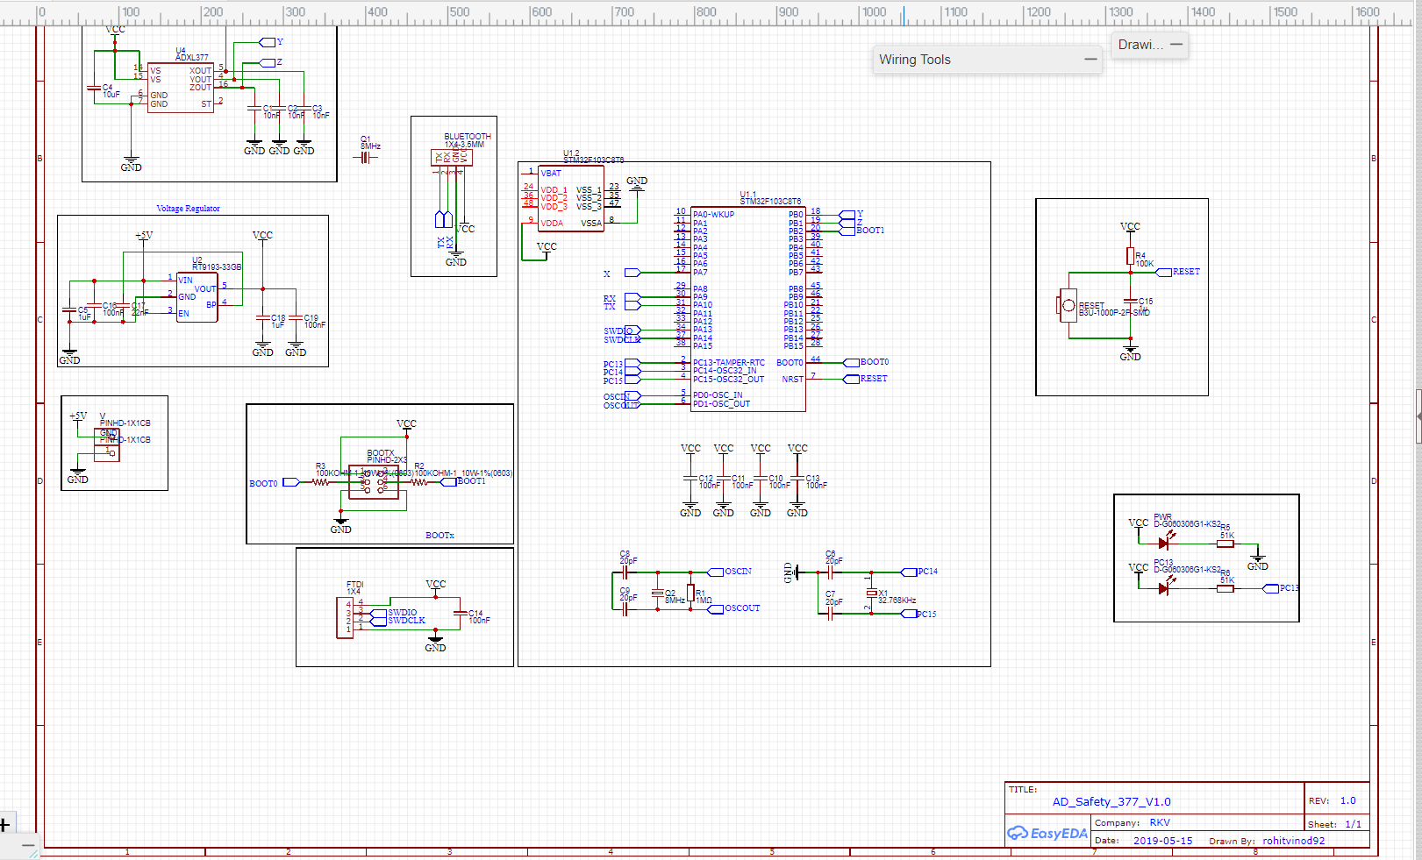

PCB layout :
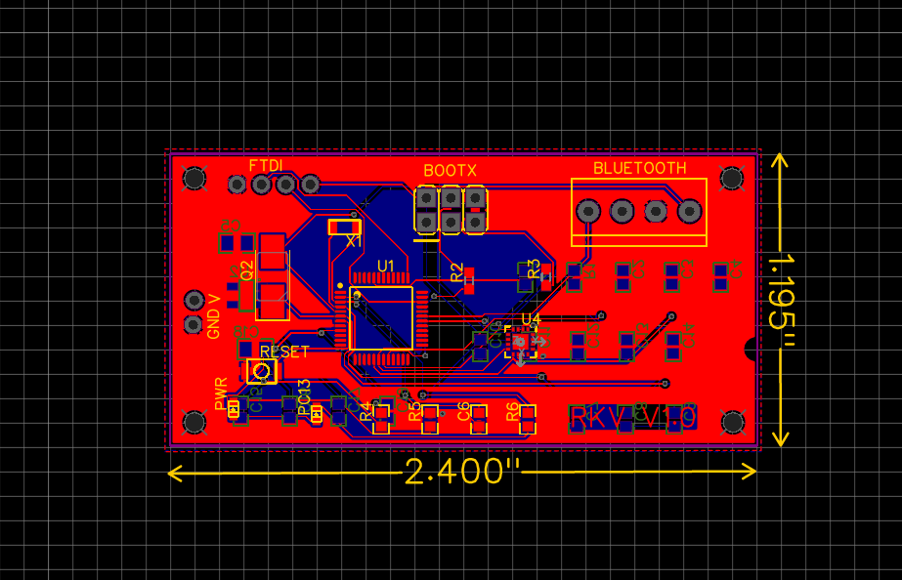

Hardware
- Micro-controller - STM32F103C8T6 :
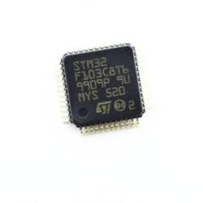
STM32F103C8T6 is a 32-bit micro-controller based around the same 32-bit ARM processor core .Its a very powerfull and fast micro-controller which is perfect for the accident detection as it needs to do calculations for the g forces fast.

- Accelometer - ADXL377 :
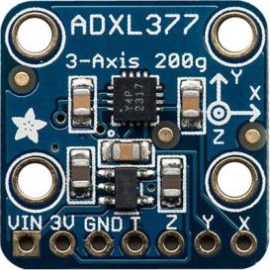
The ADXL377 is a complete 3-axis acceleration measurement system with a typical measurement range of ±200 g. We needed a accelometer that could with stand extreme forces therefore range of ±200 g was more than enough.

- Bluetooth Module - HC-05 :
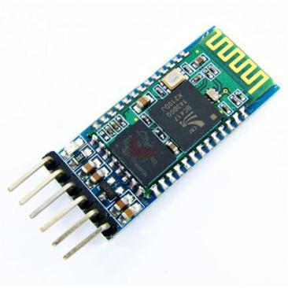
HC-05 module is an easy to use Bluetooth SPP (Serial Port Protocol) module, designed for transparent wireless serial connection setup. This will be used to connect to the transmitter (smart phone) .

- Raspberry pi 3 b+ :
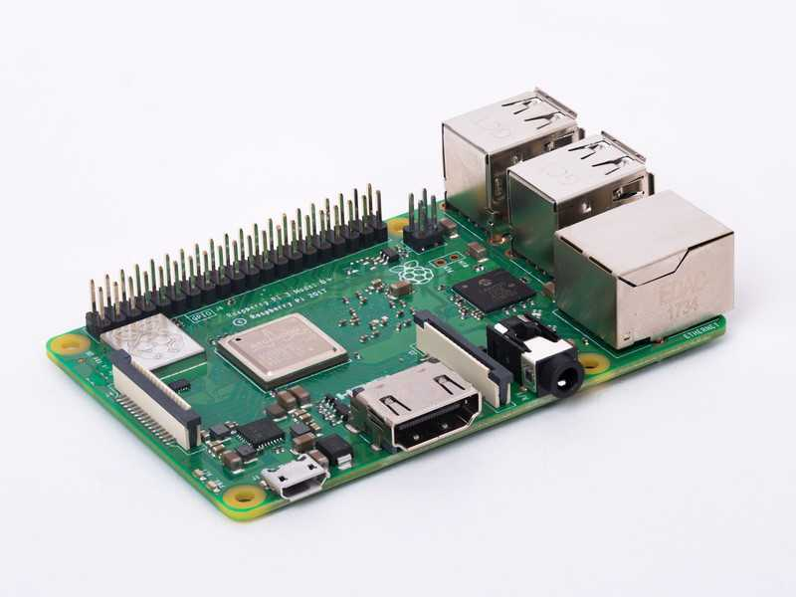
The Raspberry Pi 3 Model B is the third generation Raspberry Pi. This powerful credit-card sized single board computer can be used for many applications and supersedes the original Raspberry Pi Model B+ and Raspberry Pi 2 Model B.
This will be used as Receiver and to host the wb server to get the GPS location data from the transmitter.

- Display :
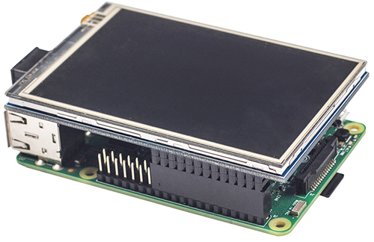
This will be connected to the rasberry pi and will display the location received

Software
- Arduino IDE - Used to program the micro controller.

- Android studio - Used to develope the transmitter application.

IMPLEMENTATION :
The Receiver module will be placed on the surface of the back of the helmet.
It will be removable and portable.
The Reciver will be held in the hospitals and traffic control.
COST:

Sl No. | Item | Quantity | Cost (in Rs.)
1. | STM32F103C8T6 | 1 | 260
2. | ADXL377 | 1 | 2,195
3 | HC-05 | 1 | 350
4 | Raspberry pi 3 b+ | 1 | 2,990
5 | Display | 1 | 1,500
6 | SMD components | - | 150

SOCIAL IMPACT :
Every year the number of road accidents is increasing.
1214 road crashes occur every day in India.
377 people die every day, equivalent to a jumbo jet crashing every day.
"There is one death every four minutes due to a road accident in India. Motorcycles account for 29% of total road crash deaths "
So its pretty obvious that something should be done to reduce these deaths…
I am doing my part….giving my contributions to save lifes…
The smart helmet can save those few minutes for the victim to get medical help........a few minutes might just be the difference between death and life....

FURTHER ADVANCEMENT :
The Future Scope of this project will be to implement this as a mandatory device to be built in while the production of helmets. And this can be expanded into all the vehicles of all size .

References
https://sites.ndtv.com/roadsafety/important-feature-to-you-in-your-car-5/
https://www.jrlawfirm.com/blog/car-accident-g-force/
https://www.thehindu.com/news/cities/mumbai/helping-patients-get-to-hospital-on-time/article18031300.ece
chrome-extension://cbnaodkpfinfiipjblikofhlhlcickei/src/pdfviewer/web/viewer.html?file=https://www.who.int/violence_injury_prevention/road_traffic/activities/roadsafety_training_manual_unit_5.pdf?ua=1

