**MINOR PROJECT INDEX**

|  |
| --- |
| **INDEX** |
| 1. Introduction     1. Project Description    2. Project Profile 2. Objectives 3. System Flow Diagram 4. DFD / UML Diagram 5. ER Diagram 6. Database Design 7. System Design 8. References |

**INTRODUCTION**

**Project Description**

* In this website user can buy a software as a service for bussiness.
* Also,user can review web services & analysis of each service or software.
* If user is first visitor of site than user first can register and then can login. If the user nor registered they cannot login.
* If user can buy service so user can check status of purchased software as a service.

**Overview Of System**

* If user is first visitor of site than user first can register and then can login. If the user nor registered they cannot login.
* Main objective of the system is to buy best bussiness management software & any customized software that needs to improve bussiness.
* In the home page include just basic info of service & software name, about us with story and vision along with testimonial and also, it’s included services and contact us.
* Next page is user dashboard , in this page include all deep information about service like how costly is it and many more information about services.
* After that next page is admin dashboard where admin do all changes over a website and manage services and many more functionality.
* LIST OF MODULES :
  + Admin Side :
  + User Side :
* ADMIN SIDE :
* First of all, admin can login in the system with their admin username and password.
* Admin can insert, update, view and delete services also Admin can see the order details which are booked of user.
* Admin can read the messages or issue which are send by user.
* Admin can make another admin and manage services.
* Admin view list of users,admin,contact us reports,services .
* USER SIDE :
* User visit the website.
* User can register their self in system and then login in the system.

user can login with their registered username and password.

* Through the contact page the user can write mail to the owner and gives reviews for our website.
* Through the service book page user can book the sofware as a service of bussiness management softwares.

**PROJECT PROFILE**

|  |  |
| --- | --- |
| Project title: | **Finance Management System** |
| Frontend: | React Js,Bootstrap |
| Backend: | PHP, MySQL |
| Browser: | Google Chrome,Microsoft Edge |
| Platform: | Visual Studio Code |
| Documentation tool: | MicroSoft word 2019 |
| Internal Guide: | Ms. Rupal k. Panchal |
| Submitted to: | Ms. Rupal k. Panchal |

**OBJECTIVES**

* The main purpose of Finance management system is to create modern system.
* On Finance management system provide an attereactive environment where you can manipulate data and information about bussiness and employee easily.
* The purpose of this project is to built an application program to reduce the manual work for managing the Bussiness activity,Employee information and resources and etc.
* Reliable for Admin to easily give addmission without any complex process.
* To reduce paper work .
* Data security.
* Increase accuracy and reliability.

SYSTEM FLOW DIAGRAM

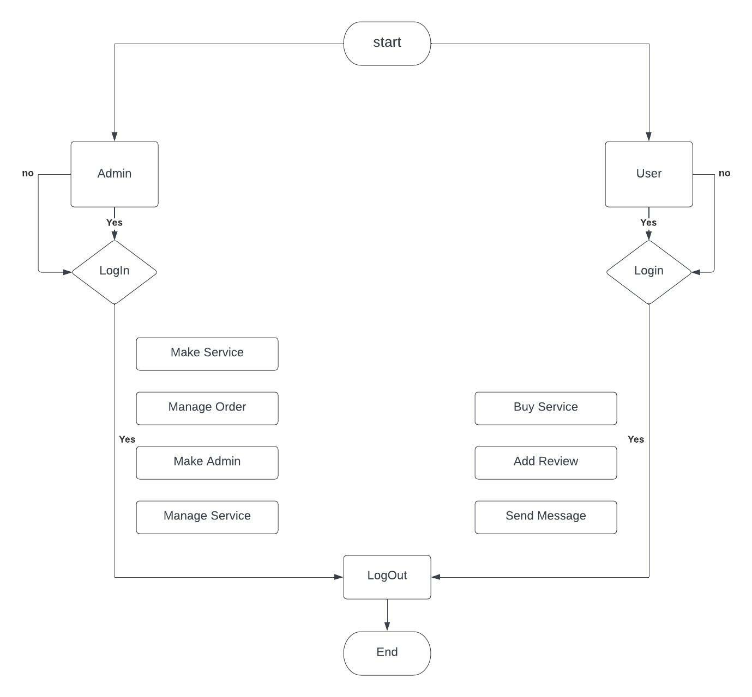

CONTEXT DIAGRAM

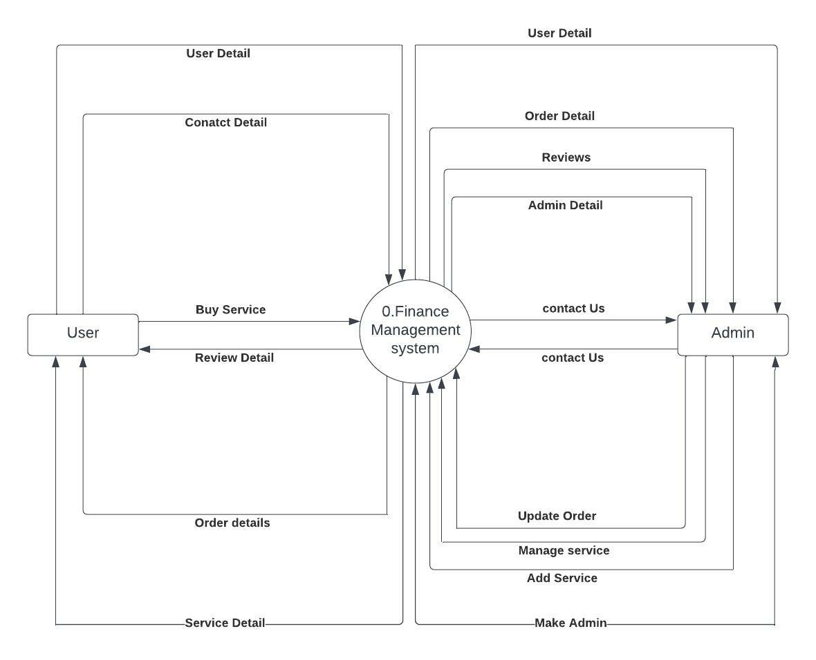

ER DIAGRAM

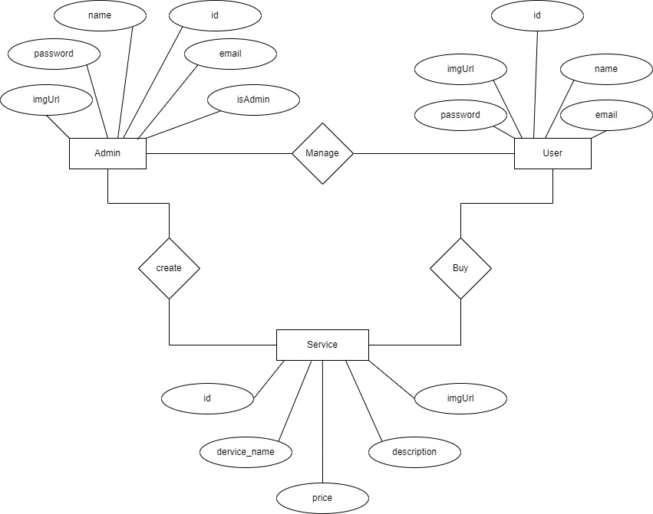

1ST LEVEL DFD OF USER

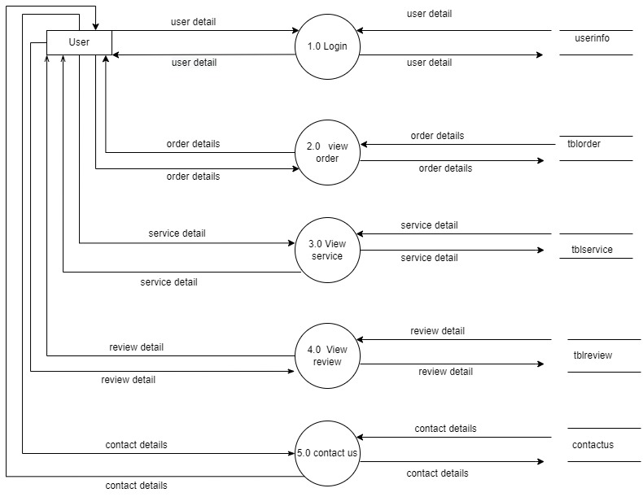

1ST LEVEL DFD OF ADMIN

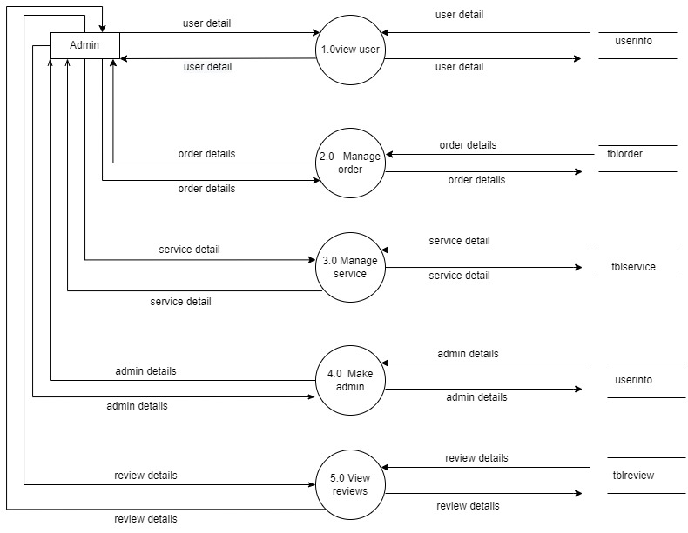

**DATABASE DESIGN**

|  |  |  |  |
| --- | --- | --- | --- |
|  | User & admin registration (usernnfo) | |  |
| No | Field Name | Data type | Constraints |
| 1 | id | Int (255) | Primary key |
| 2 | Name | Varchar (255) | Not null |
| 3 | Email | Varchar (255) | Not null |
| 4 | Password | Varchar (255) | Not null |
| 5 | imgUrl | Varchar (255) | Not null |
| 6 | Updated_at | default | Not null |
| 7 | isAdmin | TINYINT(1) | Not null |

|  |  |  |  |
| --- | --- | --- | --- |
|  | Service Booking (tblservice) | |  |
| no | Field name | datatype | Constraints |
| 1 | id | Int (255) | Primary key |
| 2 | Service_name | Varchar (255) | Not null |
| 3 | description | Varchar (255) | Not null |
| 4 | price | Varchar (255) | Not null |
| 5 | imgUrl | Varchar (255) | Not null |
| 6 | Updated_at | default | Not null |

|  |  |  |  |
| --- | --- | --- | --- |
|  | order (tblorder) | |  |
| No | Field Name | Data type | Constraints |
| 1 | orderId | Int(255) | Primary Key |
| 2 | uname | Varchar (255) | Not null |
| 3 | email | Varchar (255) | Not null |
| 4 | address | Varchar (255) | Not null |
| 5 | sname | Varchar (255) | Not null |
| 6 | price | Int (255) | Not null |
| 7 | description | Varchar (255) | Not null |
| 8 | imgUrl | Varchar (255) | Not null |
| 9 | paymentMethod | Varchar (255) | Not null |
| 10 | status | Varchar (255) | Not null |
| 11 | updated_at | default | Not null |

|  |  |  |  |
| --- | --- | --- | --- |
|  | User reviews (tblreview) | |  |
| No | Field Name | Data type | Constraints |
| 1 | _id | Int (255) | Primary Key |
| 2 | name | Varchar (255) | Not null |
| 3 | email | Varchar (255) | Not null |
| 4 | imgUrl | Varchar (255) | Not null |
| 5 | address | Varchar (255) | Not null |
| 6 | description | Varchar (255) | Not null |
| 7 | updated_at | default | Not null |

|  |  |  |  |
| --- | --- | --- | --- |
| Contact us (contactus) | | | |
| No | Field Name | Data type | Constraints |
| 1 | id | Int (255) | Primary Key |
| 2 | name | Varchar (255) | Not null |
| 3 | email | Varchar (255) | Not null |
| 4 | subject | Varchar (255) | Not null |
| 5 | message | Varchar (255) | Not null |
| 6 | Updated_at | default | Not null |

**Web Design**

**HOME PAGE**

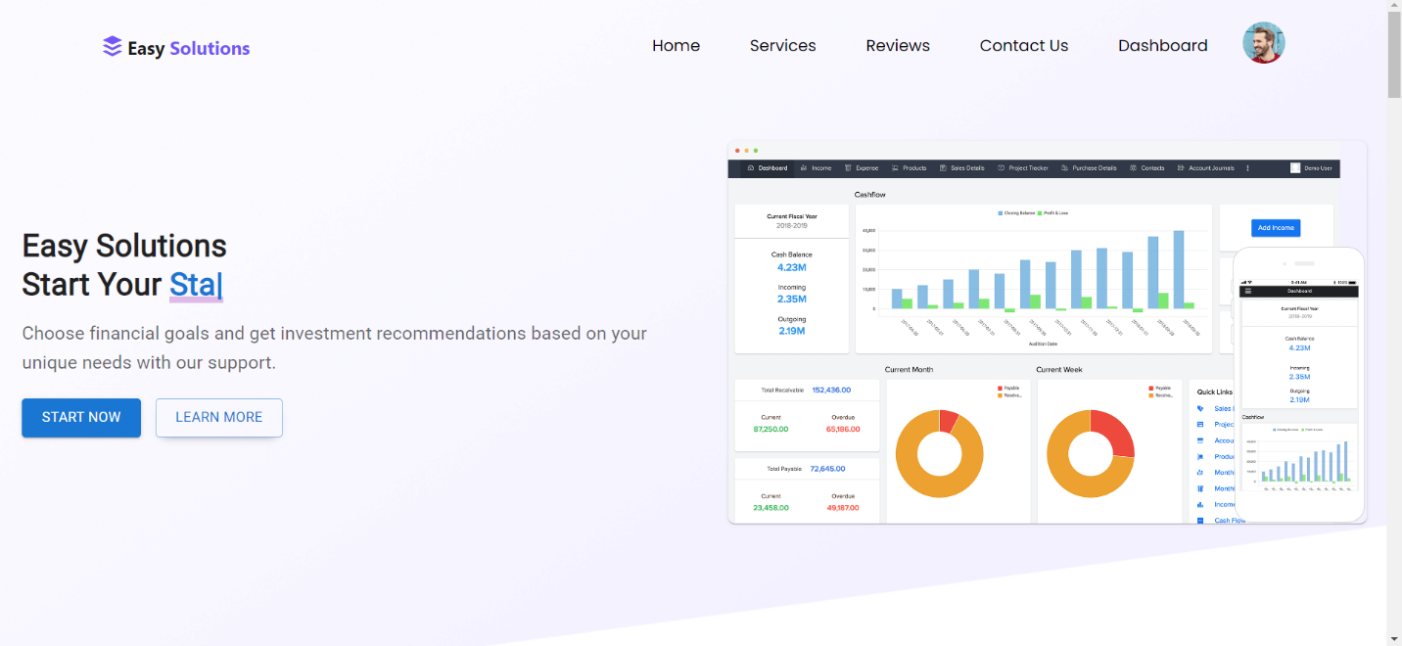

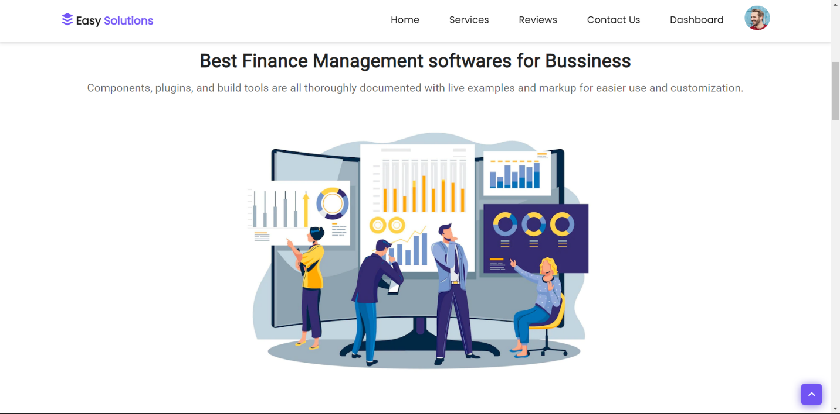

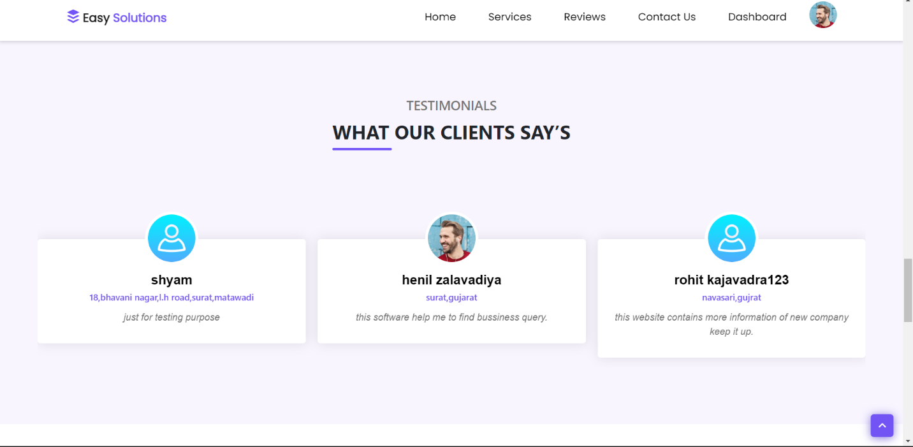  
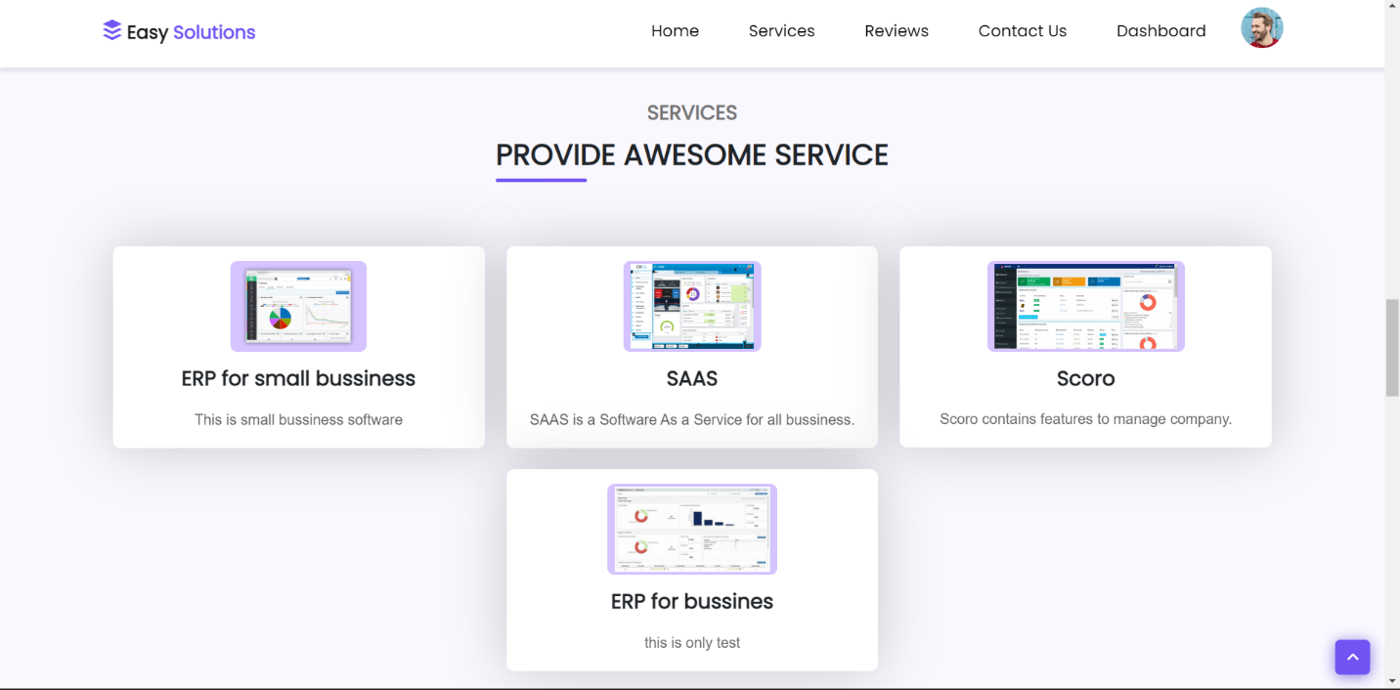

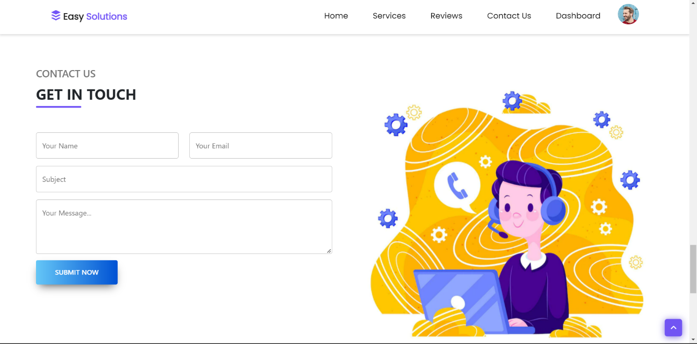

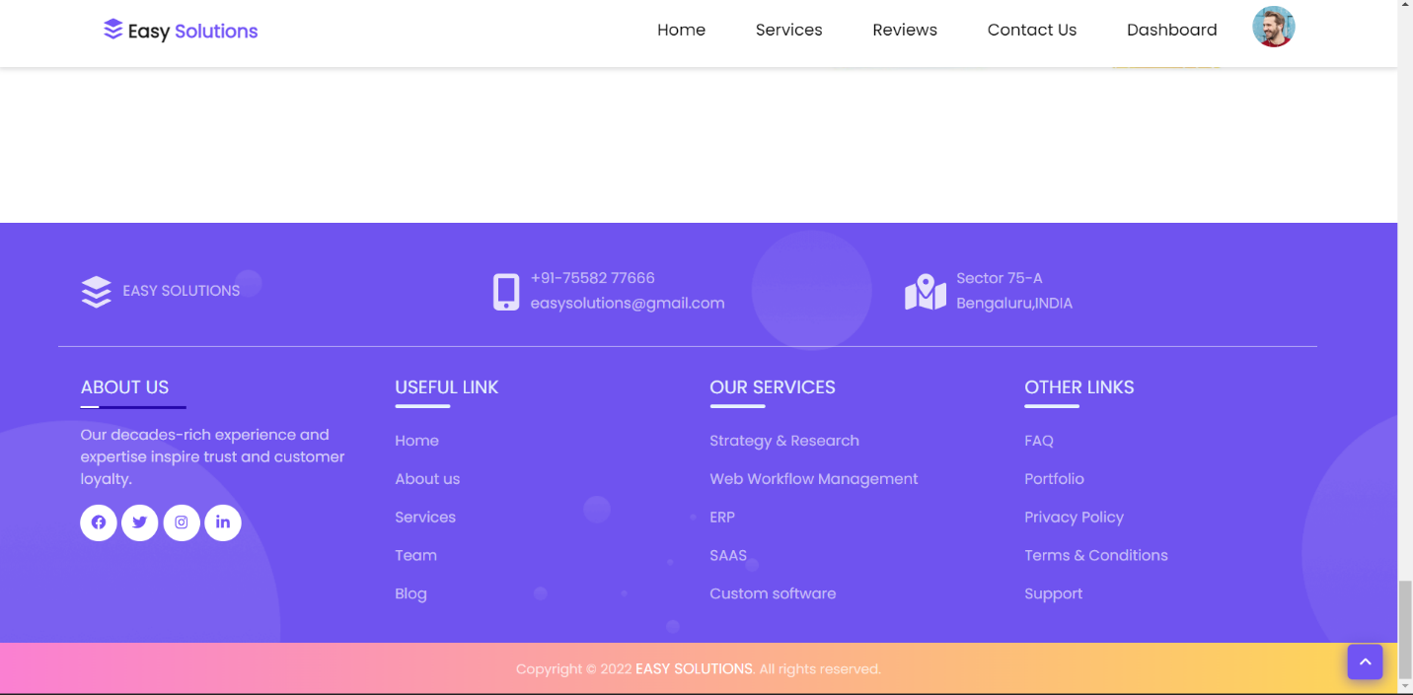

**User Registration**

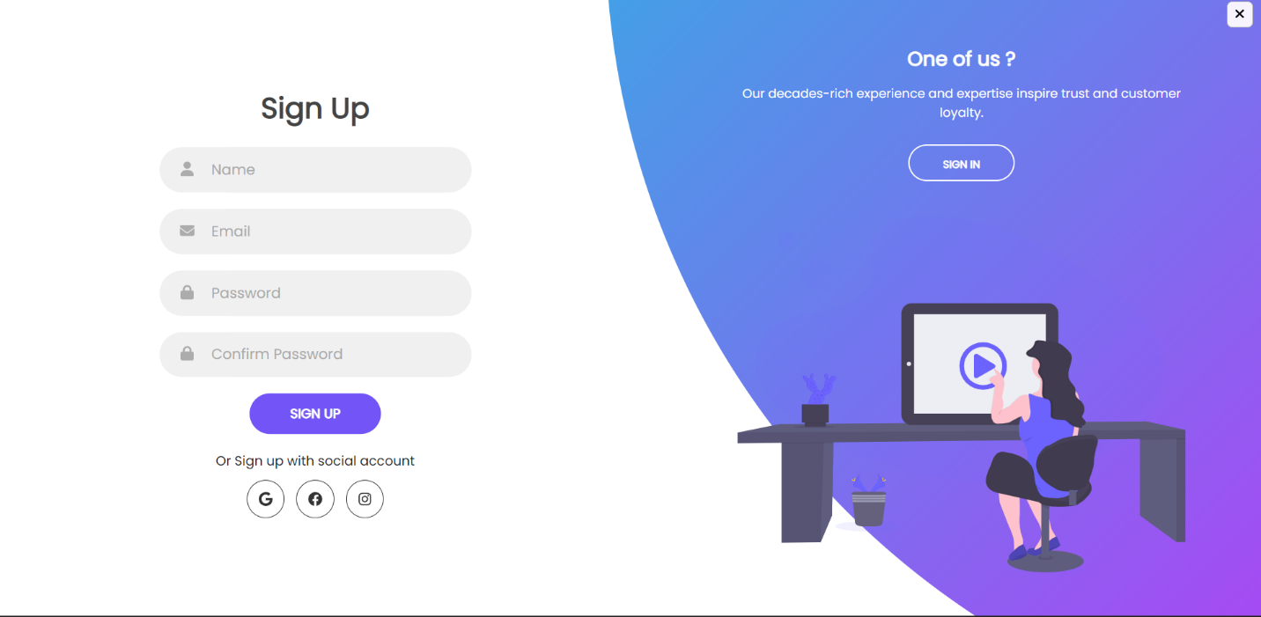

**ADMIN & USER LOGIN**

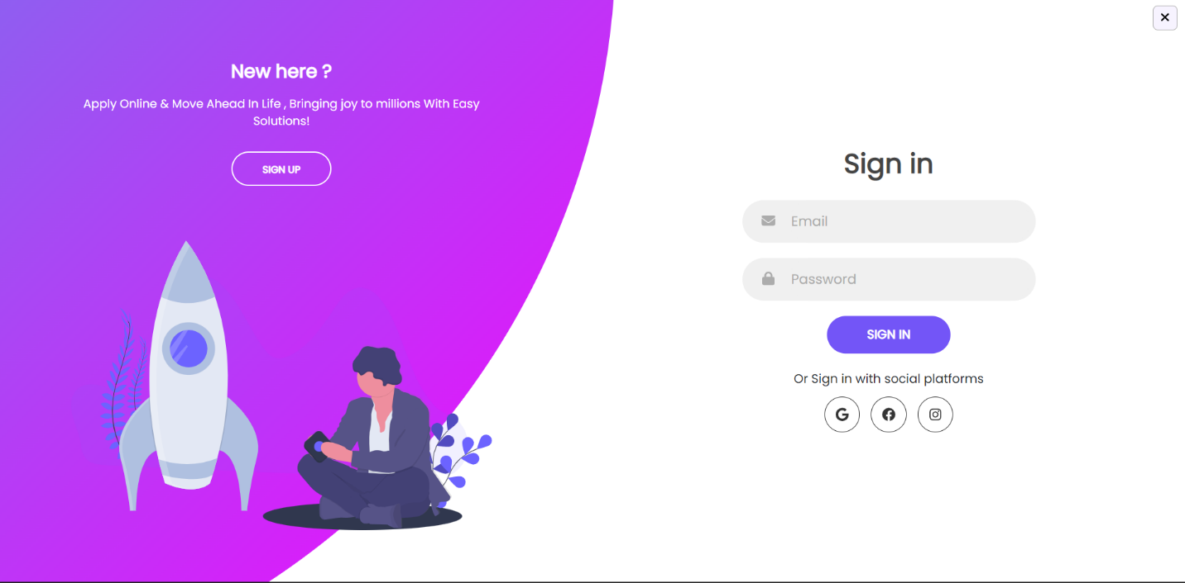

**USER DASHBOARD**

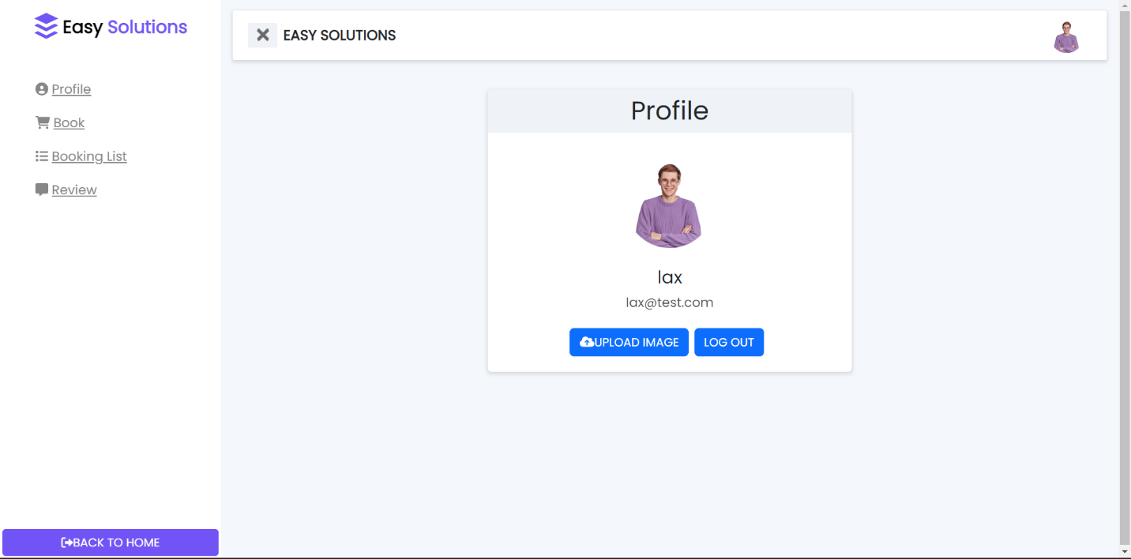

**\* USER BOOK SERVICE**

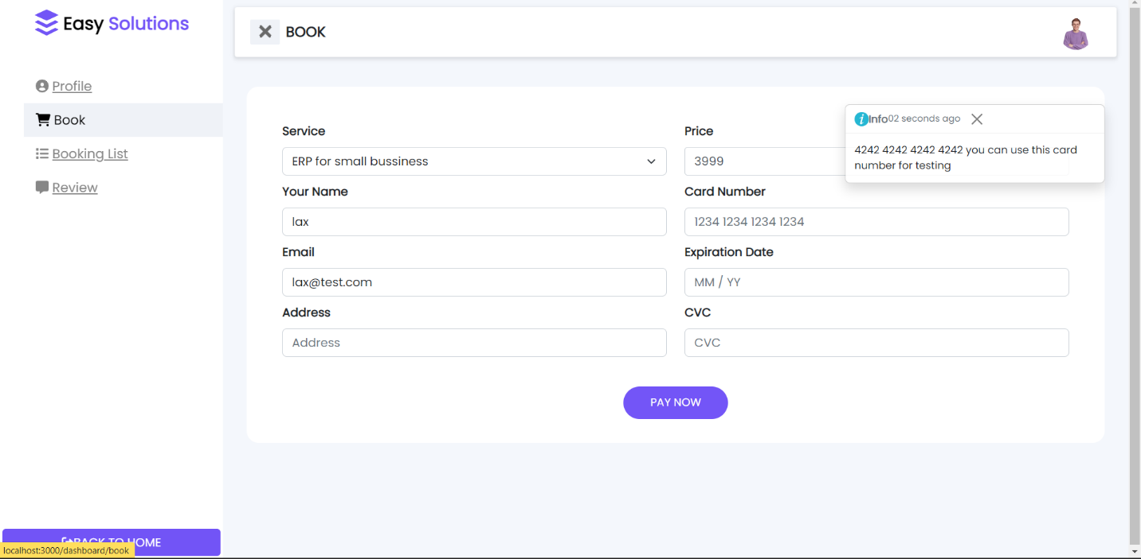

**\* USER ORDER LIST**

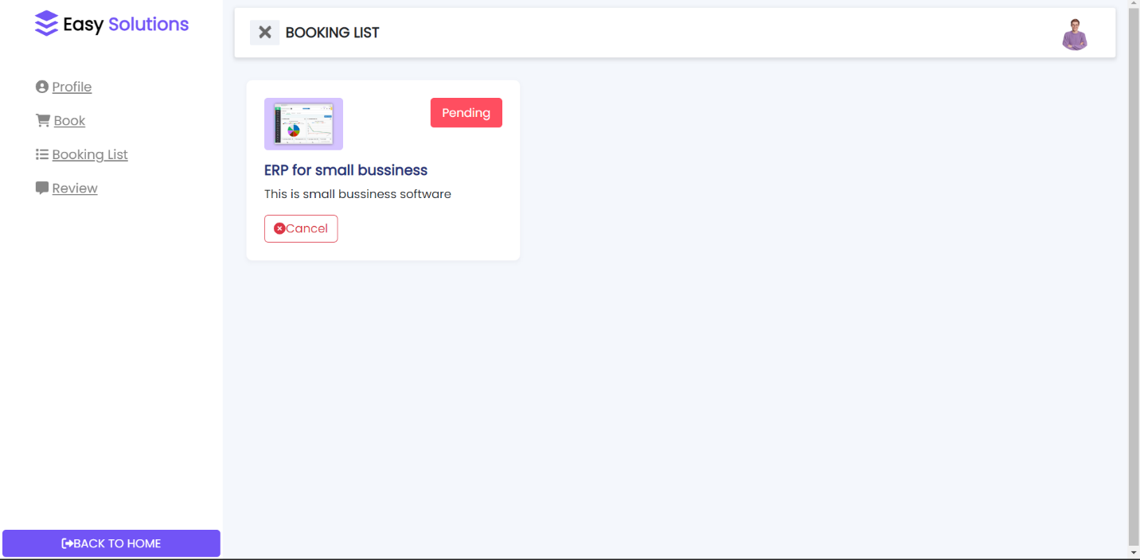

**\* USER REVIEW**

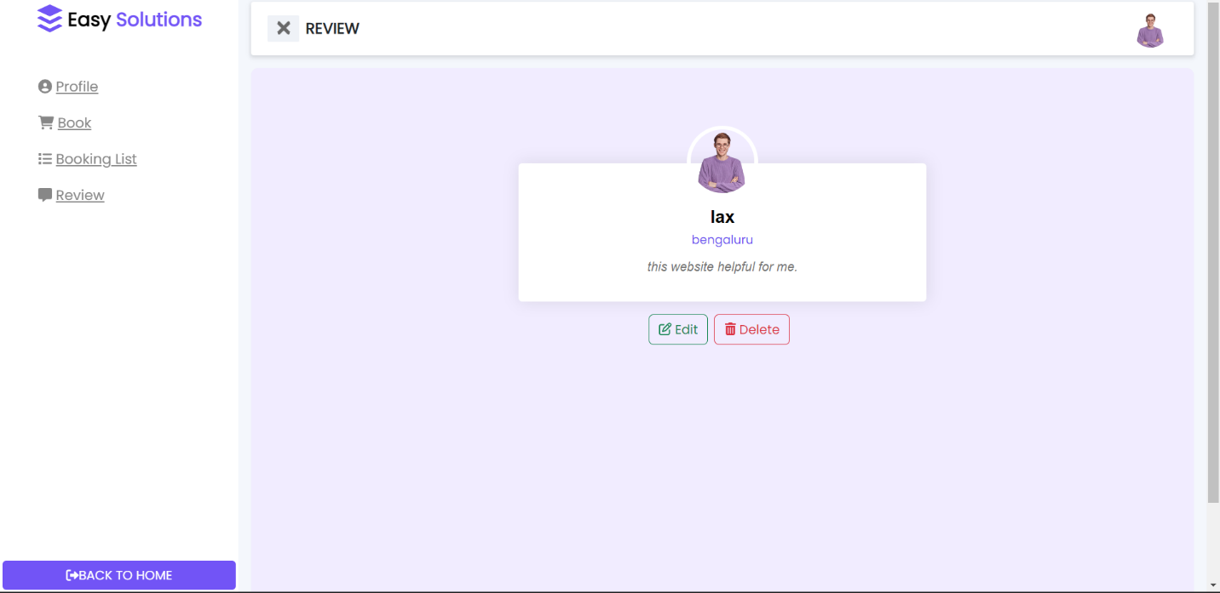

**ADMIN DASHBOARD**

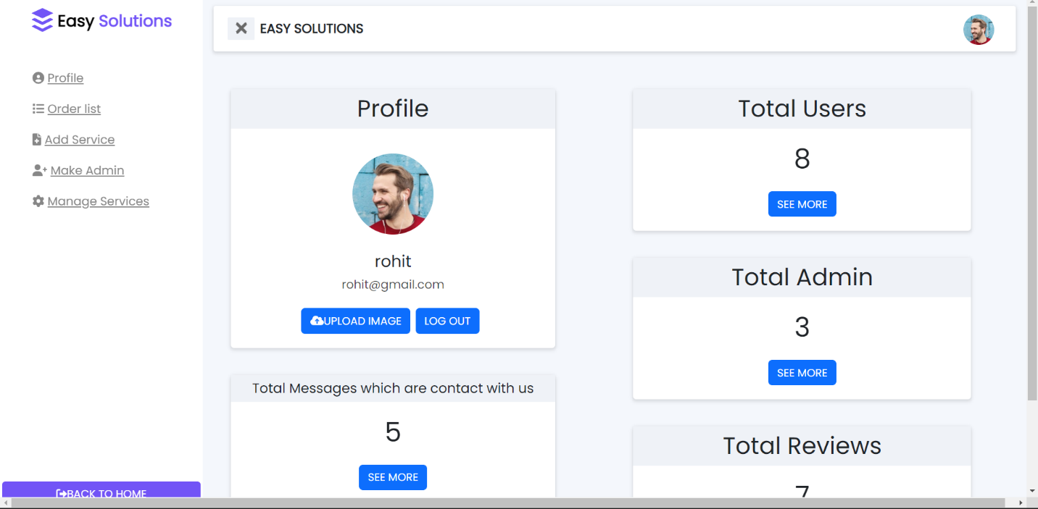

**ADD SERVICE**

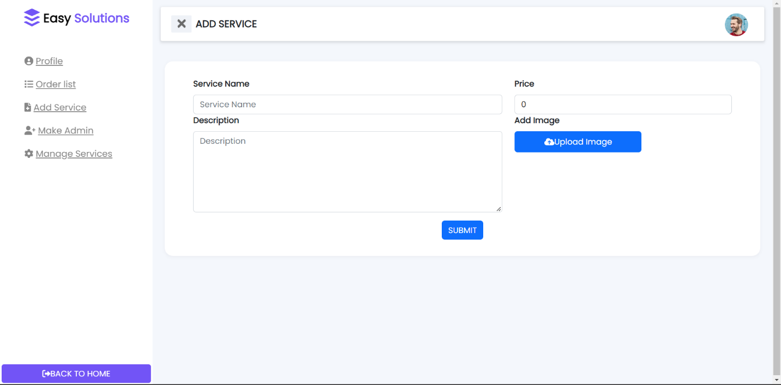

**MAKE ADMIN**

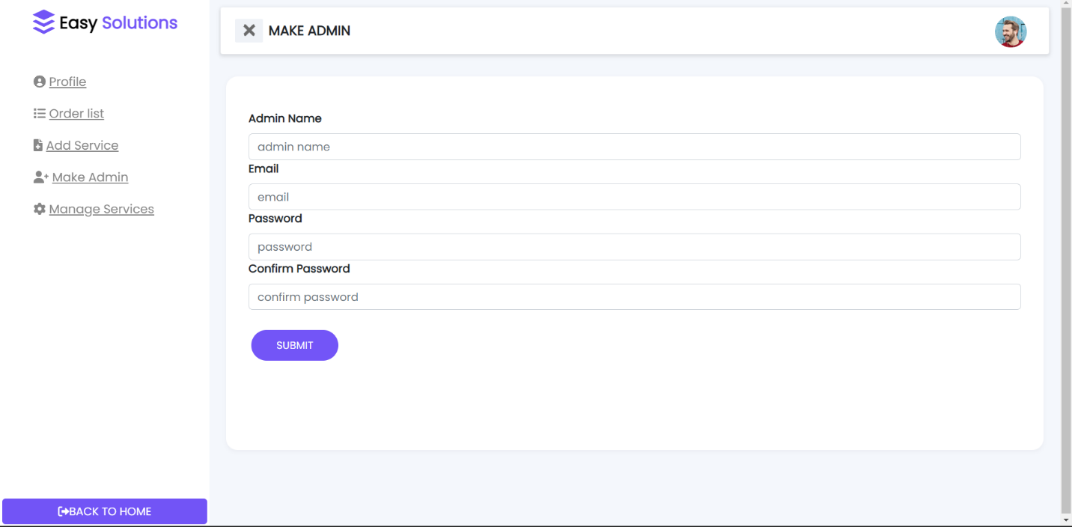

**MANAGE ORDERS**

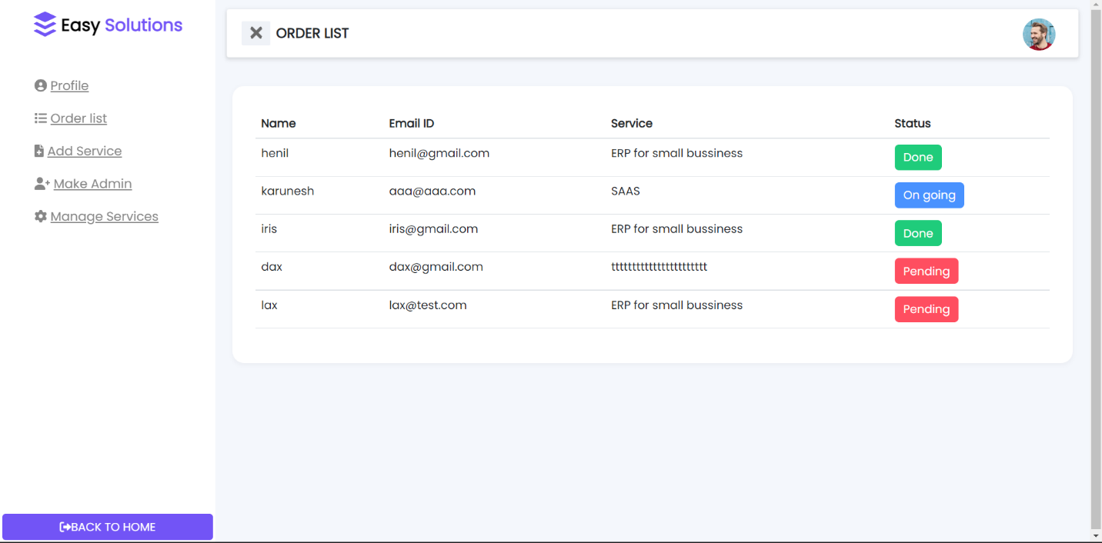

**MANAGE SERVICE**

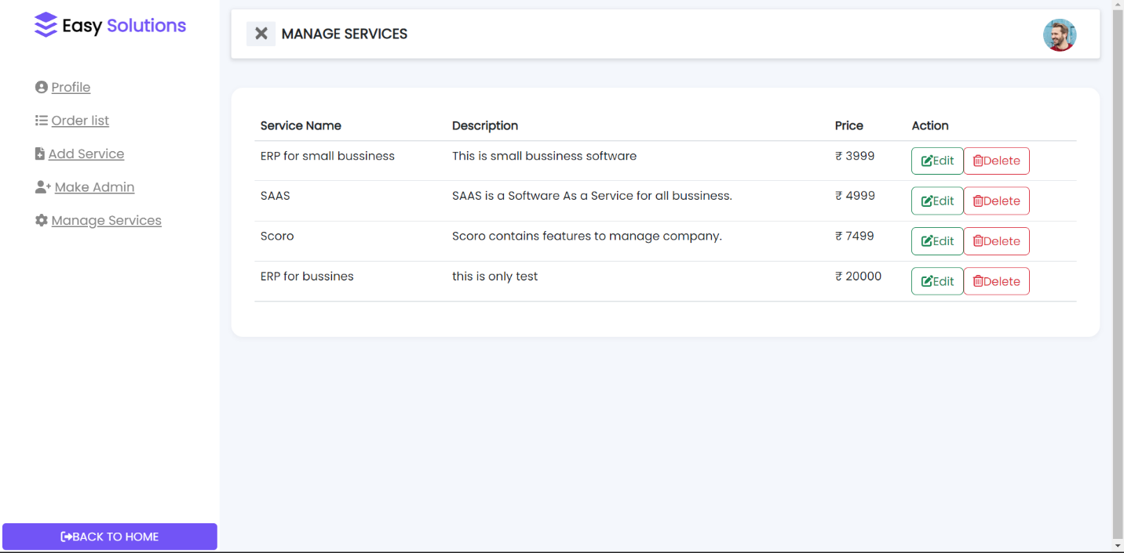

**REFERENCES**

|  |  |
| --- | --- |
| **Reference person detail** | |
| Name | Status |
| ABC | Classmate |
| XYZ | Classmate |

|  |
| --- |
| Reference site’s details |
| For code |
| Reactjs.org  Bootstrap.org |