1).
select e.ename as manager_name
from employee e
where e.empno in (
select mgr_no
from employee
where mgr_no is not null
group by mgr_no
having count(*) = (
select max(emp_count)
from (
select count(*) as emp_count
from employee
where mgr_no is not null
group by mgr_no
) temp
)
);



2).
select m.ename as manager_name
from employee e
join employee m on e.mgr_no = m.empno
group by m.empno, m.ename, m.sal
having m.sal > avg(e.sal);
3).
select e.ename from employee e
join employee t on e.mgr_no = t.empno
where t.mgr_no is null;
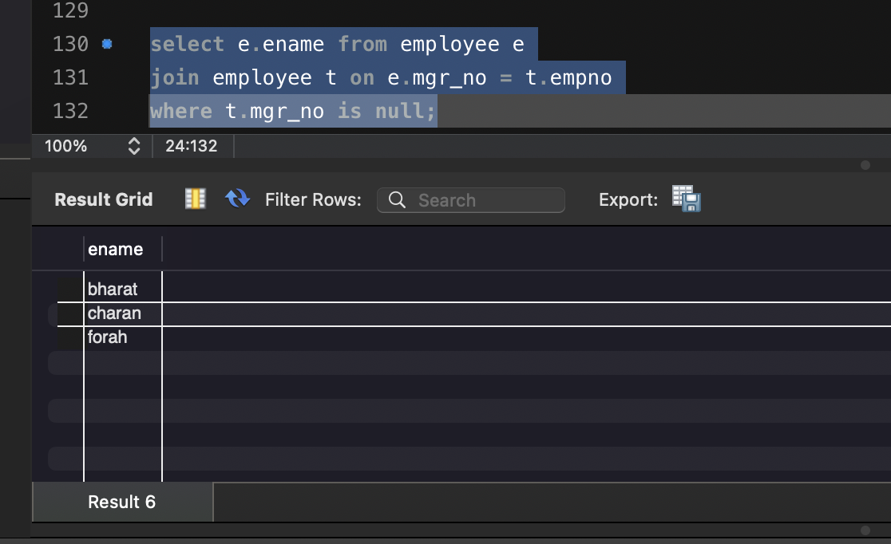

4).

select e.ename from employee e
join incentives i on e.empno = i.empno
where i.incentive_amount = (
select max(incentive_amount) from incentives
where incentive_amount < (select max(incentive_amount) from incentives)
);
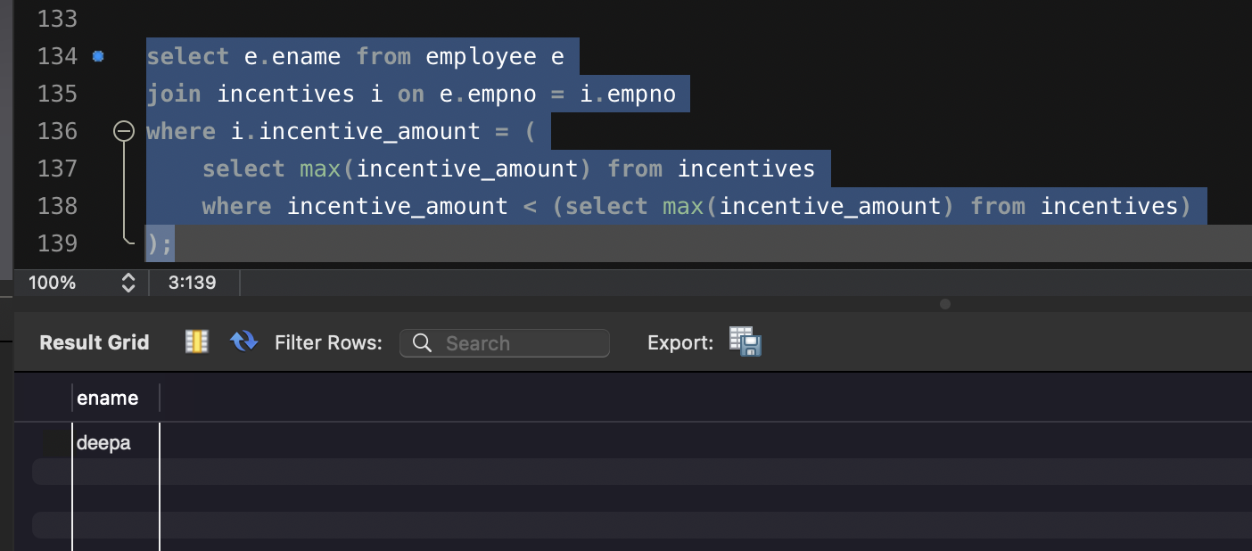
5).
select e.ename from employee e
join employee m on e.mgr_no = m.empno
where e.deptno = m.deptno;


