test> use Restaurant;
switched to db Restaurant

Restaurant> db;
Restaurant

Restaurant> db.getCollection("Restaurant");
Restaurant.Restaurant

INPUT:-

Restaurant> db.Restaurant.insertMany([
... {
... restaurant_id: "R1",
... name: "Tasty Bites",
... town: "DVG",
... cuisine: "Indian",
... hours: [8, 6, 10]
... },
... {
... restaurant_id: "R2",
... name: "Food Point",
... town: "Haveri",
... cuisine: "Chinese",
... hours: [8, 6, 5]
... },
... {
... restaurant_id: "R3",
... name: "Grill House",
... town: "Bangalore",
... cuisine: "BBQ",
... hours: [15, 7, 9]
... },
... {
... restaurant_id: "R4” ,
... name: "Roman”,
... town: "Hubli",
... cuisine: "Japanese",
... hours: [8, 5, 7, 9]
... },
... {
... restaurant_id: "R5",
... name: "Fast Food",
... town: "DVG",
... cuisine: "Chinese",
... hours: [4, 6, 8, 9]
... }
... ]);
OUTPUT:-

{
acknowledged: true,
insertedIds: {
'0': ObjectId('693efde89e68458bfea365cc'),
'1': ObjectId('693efde89e68458bfea365cd'),
'2': ObjectId('693efde89e68458bfea365ce'),
'3': ObjectId('693efde89e68458bfea365cf'),
'4': ObjectId('693efde89e68458bfea365d0')
}
}
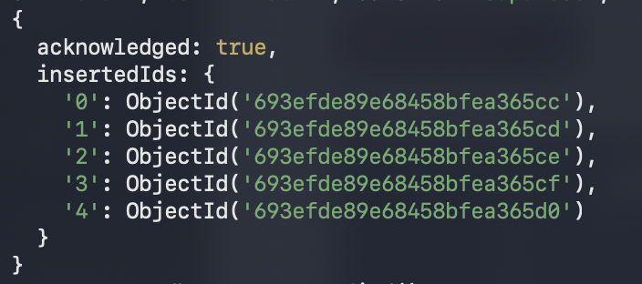

INPUT:-

Restaurant> db.Restaurant.find();

OUTPUT:-

[
{
_id: ObjectId('693efde89e68458bfea365cc'),
restaurant_id: 'R1',
name: 'Tasty Bites',
town: 'DVG',
cuisine: 'Indian',
hours: [ 8, 6, 10 ]
},
{
_id: ObjectId('693efde89e68458bfea365cd'),
restaurant_id: 'R2',
name: 'Food Point',
town: 'Haveri',
cuisine: 'Chinese',
hours: [ 8, 6, 5 ]
},
{
_id: ObjectId('693efde89e68458bfea365ce'),
restaurant_id: 'R3',
name: 'Grill House',
town: 'Bangalore',
cuisine: 'BBQ',
hours: [ 15, 7, 9 ]
},
{
_id: ObjectId('693efde89e68458bfea365cf'),
restaurant_id: 'R4',
name: 'Roman',
town: 'Hubli',
cuisine: 'Japanese',
hours: [ 8, 5, 7, 9 ]
},
{
_id: ObjectId('693efde89e68458bfea365d0'),
restaurant_id: 'R5',
name: 'Fast Food',
town: 'DVG',
cuisine: 'Chinese',
hours: [ 4, 6, 8, 9 ]
}
]

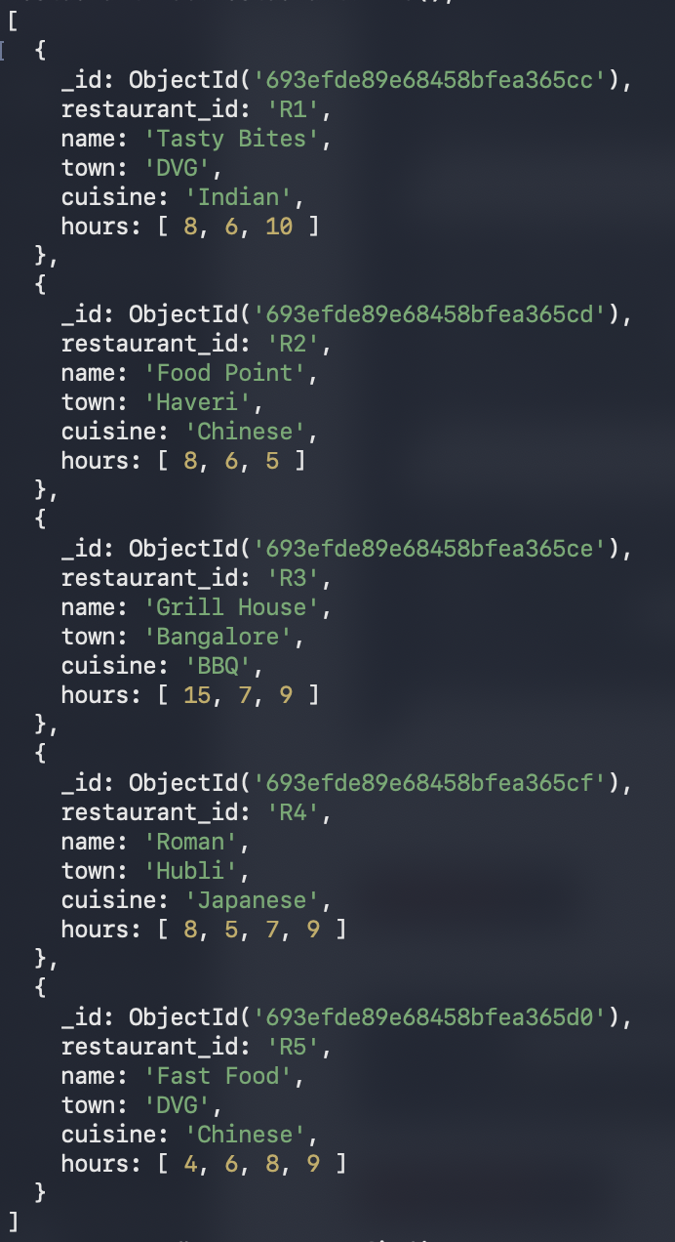

INPUT:-

Restaurant> db.Restaurant.find(
... {},
... { name: 1, _id: 0 }
... ).sort({ name: -1 });

OUTPUT:-

[
{ name: 'Tasty Bites' },
{ name: 'Roman' },
{ name: 'Grill House' },
{ name: 'Food Point' },
{ name: 'Fast Food' }
]

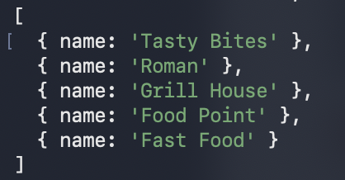

INPUT:-

Restaurant> db.Restaurant.find(
... { hours: { $lte: 10 } },
... { restaurant_id: 1, name: 1, town: 1, cuisine: 1, _id: 0 }
... );

OUTPUT:-

[
{
restaurant_id: 'R1',
name: 'Tasty Bites',
town: 'DVG',
cuisine: 'Indian'
},
{
restaurant_id: 'R2',
name: 'Food Point',
town: 'Haveri',
cuisine: 'Chinese'
},
{
restaurant_id: 'R3',
name: 'Grill House',
town: 'Bangalore',
cuisine: 'BBQ'
},
{
restaurant_id: 'R4',
name: 'Roman',
town: 'Hubli',
cuisine: 'Japanese'
},
{
restaurant_id: 'R5',
name: 'Fast Food',
town: 'DVG',
cuisine: 'Chinese'
}
]
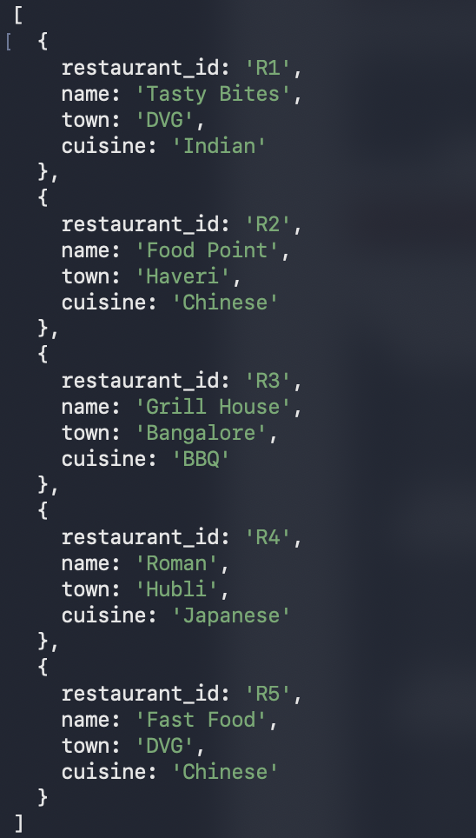

INPUT:-

Restaurant> db.Restaurant.aggregate([
... {
... $project: {
... restaurant_id: 1,
... name: 1,
... AvgHours: { $avg: "$hours" }
... }
... }
... ]);

OUTPUT:-

[
{
_id: ObjectId('693efde89e68458bfea365cc'),
restaurant_id: 'R1',
name: 'Tasty Bites',
AvgHours: 8
},
{
_id: ObjectId('693efde89e68458bfea365cd'),
restaurant_id: 'R2',
name: 'Food Point',
AvgHours: 6.333333333333333
},
{
_id: ObjectId('693efde89e68458bfea365ce'),
restaurant_id: 'R3',
name: 'Grill House',
AvgHours: 10.333333333333334
},
{
_id: ObjectId('693efde89e68458bfea365cf'),
restaurant_id: 'R4',
name: 'Roman',
AvgHours: 7.25
},
{
_id: ObjectId('693efde89e68458bfea365d0'),
restaurant_id: 'R5',
name: 'Fast Food',
AvgHours: 6.75
}
]
