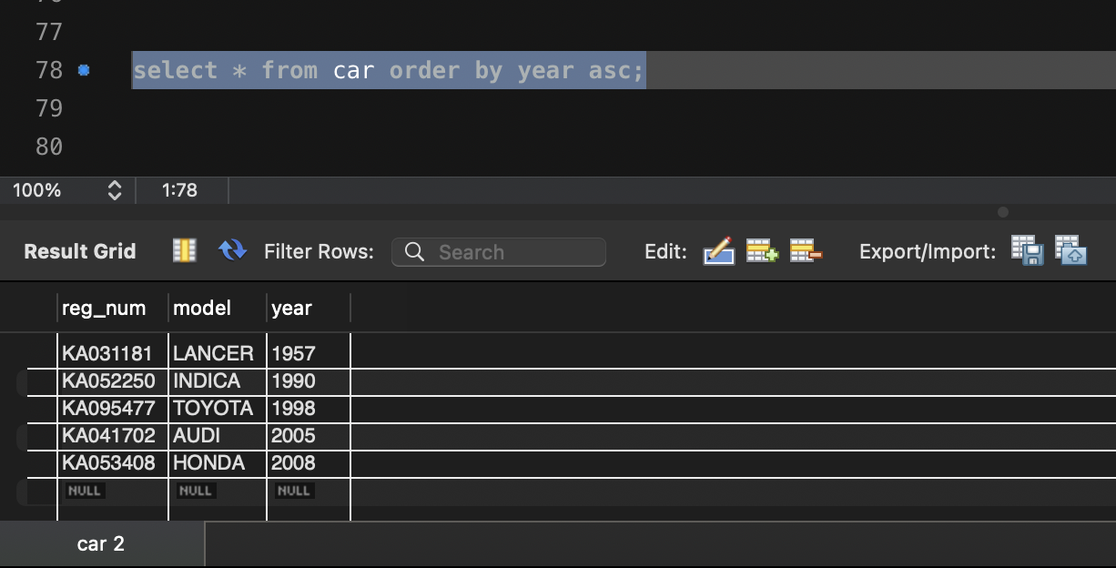
1). select * from car order by year asc;

2). select count(*) from participated p, car c
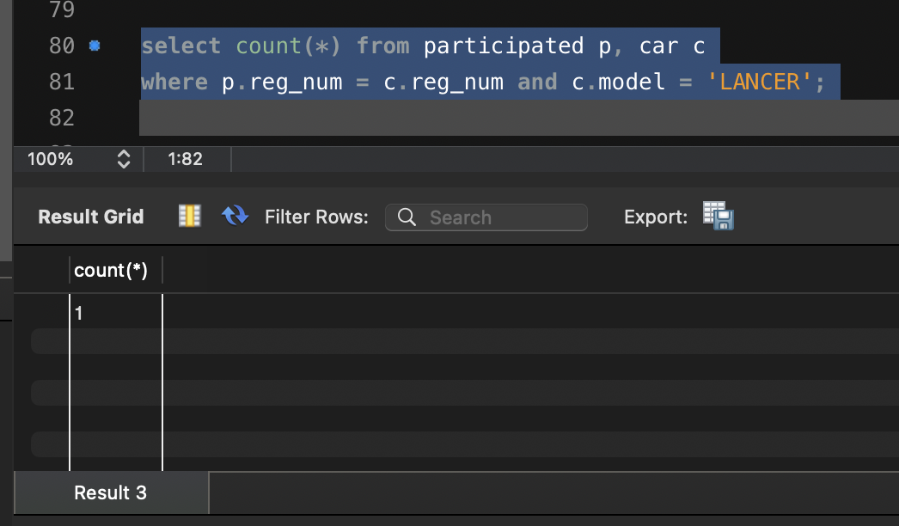
where p.reg_num = c.reg_num and c.model = 'LANCER';
3). select count(distinct p.driver_id)
from participated p, accident2 a
where p.report_num = a.report_num
and year(a.accident_date) = 2008;
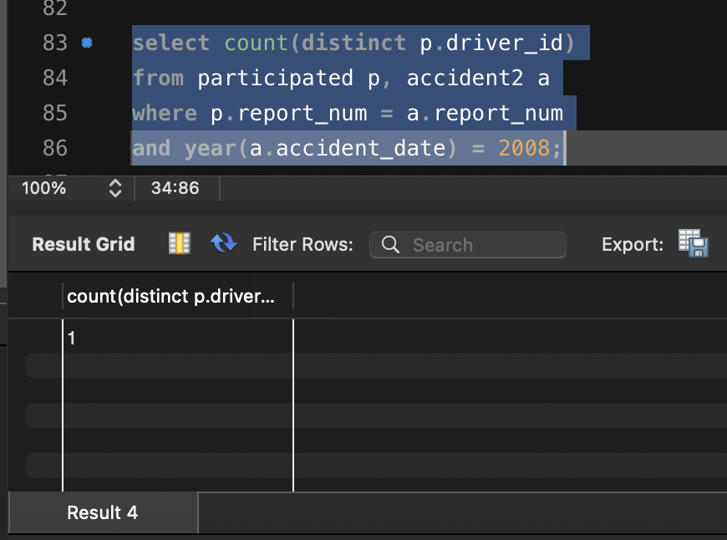

4). select * from participated order by damage_amount desc;
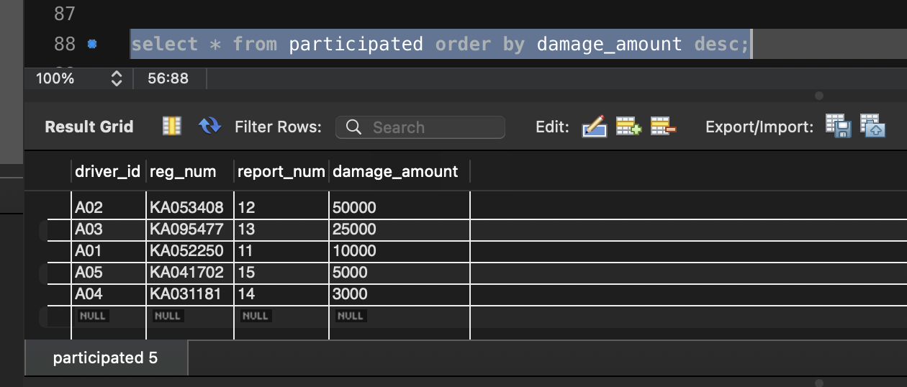
5). select avg(damage_amount) from participated;
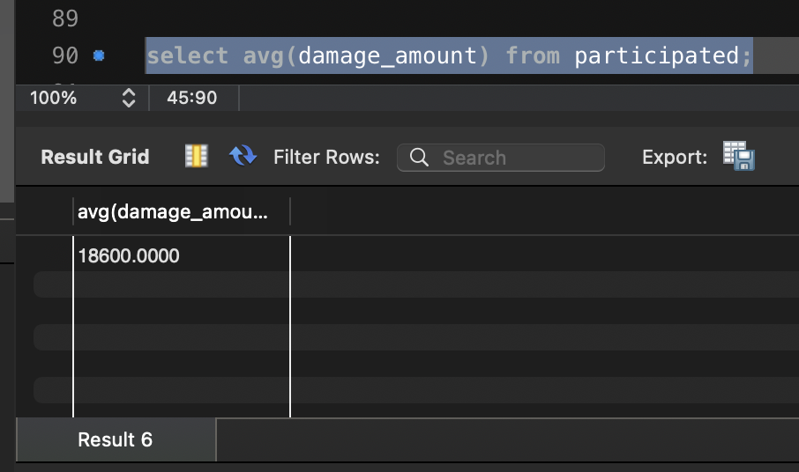
6). delete from participated
where damage_amount < (select avg(damage_amount) from participated);

7). select * from participated
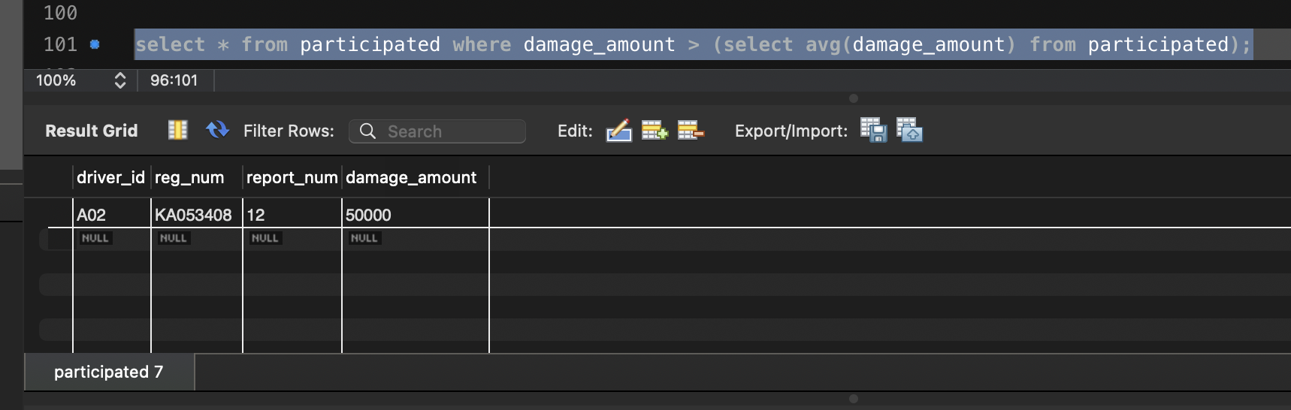
where damage_amount > (select avg(damage_amount) from participated);

8).select max(damage_amount) from participated;



