test> use customer;
switched to db customer

customer> db.createCollection("Customers")
{ ok: 1 }

INPUT:-

customer> db.Customers.insertMany([{ Cust_id: 101, Acc_Bal: 1500, Acc_Type: "Saving" },{ Cust_id: 102, Acc_Bal: 900, Acc_Type: "Current" },{ Cust_id: 103, Acc_Bal: 2000, Acc_Type: "Saving" },{ Cust_id: 104, Acc_Bal: 1100, Acc_Type: "Currencustomer> db.Customers.insertMany([{ Cust_id: 101, Acc_Bal: 1500, Acc_Type: "Saving" },{ Cust_id: 102, Acc_Bal: 900, Acc_Type: "Current" },{ Cust_id: 103, Acc_Bal: 2000, Acc_Type: "Saving" },{ Cust_id: 104, Acc_Bal: 1100, Acc_Type: "Current" },{ Cust_id: 105, Acc_Bal: 1800, Acc_Type: "Current" }]);
{
acknowledged: true,
insertedIds: {
'0': ObjectId('693eef754bb07ddb6da365cc'),
'1': ObjectId('693eef754bb07ddb6da365cd'),
'2': ObjectId('693eef754bb07ddb6da365ce'),
'3': ObjectId('693eef754bb07ddb6da365cf'),
'4': ObjectId('693eef754bb07ddb6da365d0')
}
}

OUTPUT:-
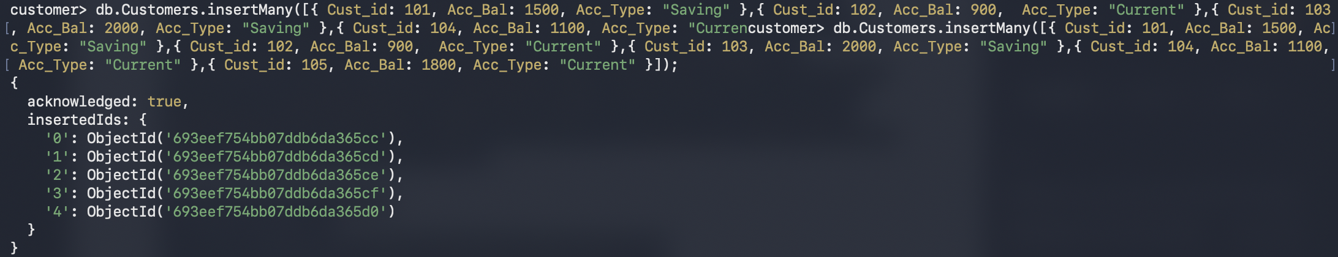

INPUT:-

customer> db.Customers.find({Acc_Bal: {$gt:1200},Acc_Type: "Saving"},{Cust_id: 1, Acc_Bal: 1, Acc_Type: 1, _id:0});
[
{ Cust_id: 101, Acc_Bal: 1500, Acc_Type: 'Saving' },
{ Cust_id: 103, Acc_Bal: 2000, Acc_Type: 'Saving' }
]

OUTPUT:-

INPUT:-

customer> db.Customers.aggregate([{$group: { _id: "$Cust_id", Min_Bal: { $min: "$Acc_Bal" }, Max_Bal:{ $max: "$Acc_Bal" }}}]);
[
{ _id: 104, Min_Bal: 1100, Max_Bal: 1100 },
{ _id: 103, Min_Bal: 2000, Max_Bal: 2000 },
{ _id: 101, Min_Bal: 1500, Max_Bal: 1500 },
{ _id: 102, Min_Bal: 900, Max_Bal: 900 },
{ _id: 105, Min_Bal: 1800, Max_Bal: 1800 }
]

OUTPUT:-
