select d.customername from depositer D join bankaccount a on d.accno=a.accno join branch b on a.branchname=b.branchname where b.branchcity="Delhi" group by d.customername;


SELECT DISTINCT c.customername
FROM bankcustomer c
JOIN branch b ON c.customercity = b.branchcity
JOIN loan l ON b.branchname = l.branchname
WHERE c.customername NOT IN (
SELECT customername FROM depositer);
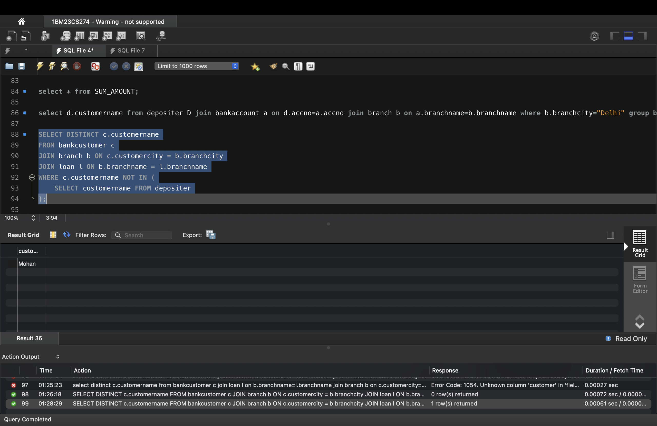


select c.customername from bankcustomer c join branch b on c.customercity=b.branchcity join loan l on b.branchname=l.branchname where c.customername in (select customername from depositer)group by c.customername;

update bankaccount set balance=balance*1.05;


select * from bankaccount;

