WEEK 4 PROJECT REPORT

Machine Learning Model Development and Evaluation
UCI Student Performance — Mathematics | Python and Scikit-learn

1. Executive Summary
This project trains classification models to estimate whether a student reaches the report's descriptive threshold of G3 >= 10/20, using background and study-related variables while deliberately excluding G1 and G2 from the predictors to reduce target leakage. The dataset contains 395 eligible records; 67.1% meet the threshold. Four candidate models were compared by stratified five-fold cross-validation on the training split. The selected model was Logistic regression, with mean cross-validation ROC-AUC 0.689. On the held-out test set, accuracy was 0.595, balanced accuracy 0.561, F1 0.686, and ROC-AUC 0.595. These metrics are educational evidence, not a validated high-stakes prediction system.

2. Problem Definition and Target
Objective: demonstrate the end-to-end classification workflow, compare simple algorithms fairly, and discuss the strengths and limits of model evaluation.
Target label: 1 when final Mathematics grade G3 >= 10; 0 when G3 < 10. This binary threshold is an analytical convention for this assignment and is not a universal school policy.
Important leakage prevention: G1 and G2 are earlier grades closely related to G3, so they are excluded from all features. The goal is to test the value of non-grade predictors rather than letting earlier marks dominate the model. G3 is used only to construct the target and is never passed to the model.

3. Dataset and Preparation
Dataset: UCI Machine Learning Repository, Student Performance Mathematics file. Page: https://archive.ics.uci.edu/dataset/320/student%2Bperformance. DOI: https://doi.org/10.24432/C5TG7T. Acquisition: Existing official UCI Mathematics CSV from the Week 1 project.
Rows before preparation: 395; duplicate rows removed: 0; missing final grades: 0; invalid final grade values removed: 0; records retained: 395.
Exact duplicate rows are removed, text fields are trimmed, known numeric columns are converted safely, and final grades are checked for the plausible 0–20 range. Rows without a target are excluded rather than assigning an invented outcome. Predictors are processed inside Scikit-learn pipelines: numeric missing values are median-imputed and scaled; categorical missing values are most-frequent-imputed and one-hot encoded. The preprocessor is fitted separately within each training fold.

4. Train/Test Design and Model Selection
A stratified 80/20 split was made with random_state=42. The held-out test set contains 79 records and is not used to choose a model. Stratified five-fold cross-validation was run on training data, with mean ROC-AUC specified as the selection metric.
Candidate algorithms:
- Dummy prior classifier: baseline reflecting the training-set class prevalence.
- Logistic Regression: a regularized linear baseline with class weighting.
- Decision Tree: a shallow, interpretable non-linear model with a minimum leaf size.
- Random Forest: an ensemble of trees, using class weighting and a minimum leaf size to limit excessive complexity.
Model | Mean CV AUC | CV AUC SD | Mean CV F1 | CV balanced acc.
Logistic regression | 0.689 | 0.058 | 0.756 | 0.662
Random forest | 0.687 | 0.100 | 0.776 | 0.641
Decision tree | 0.640 | 0.044 | 0.750 | 0.619
Dummy baseline | 0.500 | 0.000 | 0.803 | 0.500

5. Held-Out Evaluation Metrics
Metric | Test score
Accuracy | 0.595
Balanced accuracy | 0.561
Precision for class 1 | 0.714
Recall for class 1 | 0.660
F1-score for class 1 | 0.686
ROC-AUC | 0.595
Accuracy is the share of all test cases classified correctly. Precision describes the fraction of predicted-positive cases that are actual positives. Recall describes the fraction of actual-positive cases found. F1 combines precision and recall. Balanced accuracy averages sensitivity across the two classes; ROC-AUC measures ranking across classification thresholds. No metric alone is sufficient.

6. Visualizations and Interpretation

Figure 1. Cross-validation model comparison
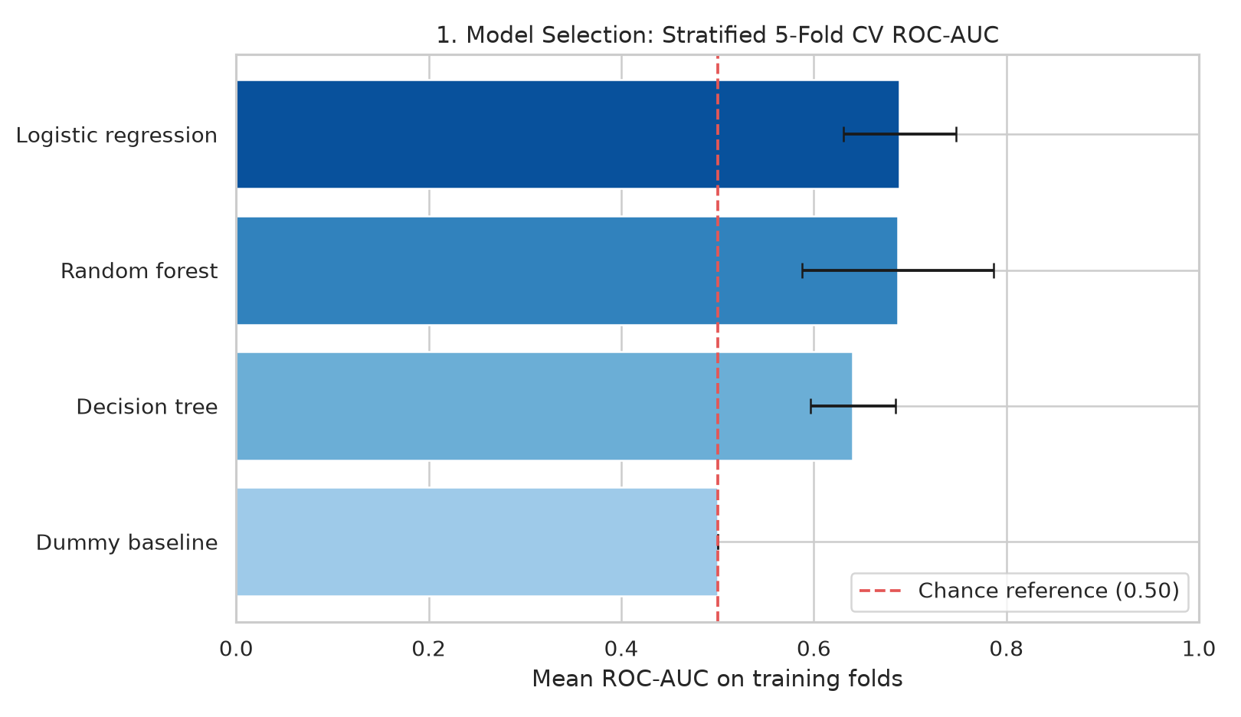
Compares candidate models by training-only cross-validation ROC-AUC; error bars show fold-to-fold standard deviation. The highest mean score is used for model selection.

Figure 2. Test confusion matrix
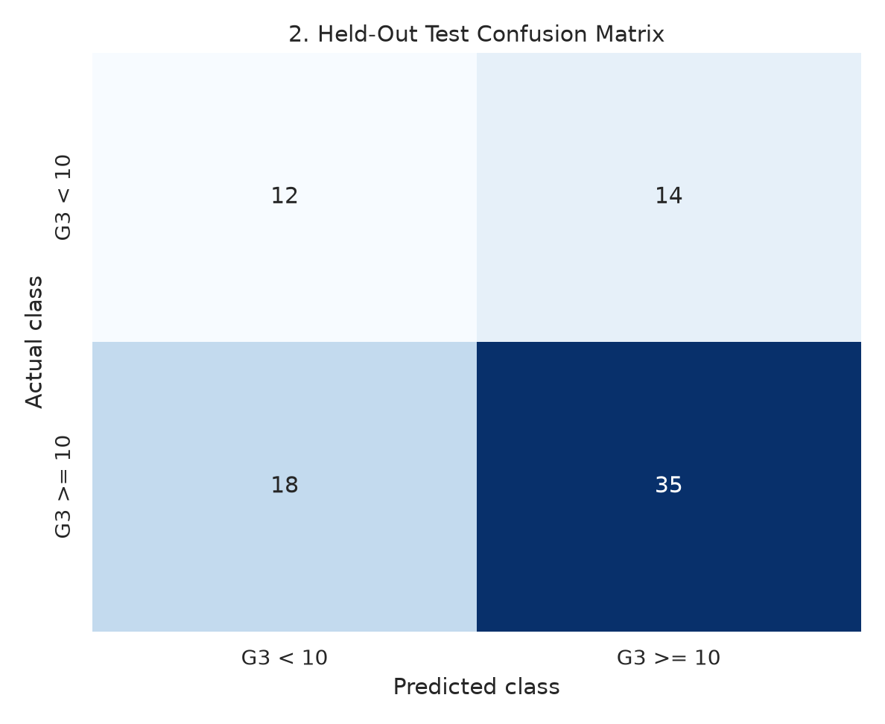
Shows true negatives, false positives, false negatives, and true positives on held-out test cases. False negatives may mean an at-risk student is missed; false positives may cause unnecessary follow-up.

Figure 3. Test ROC curve
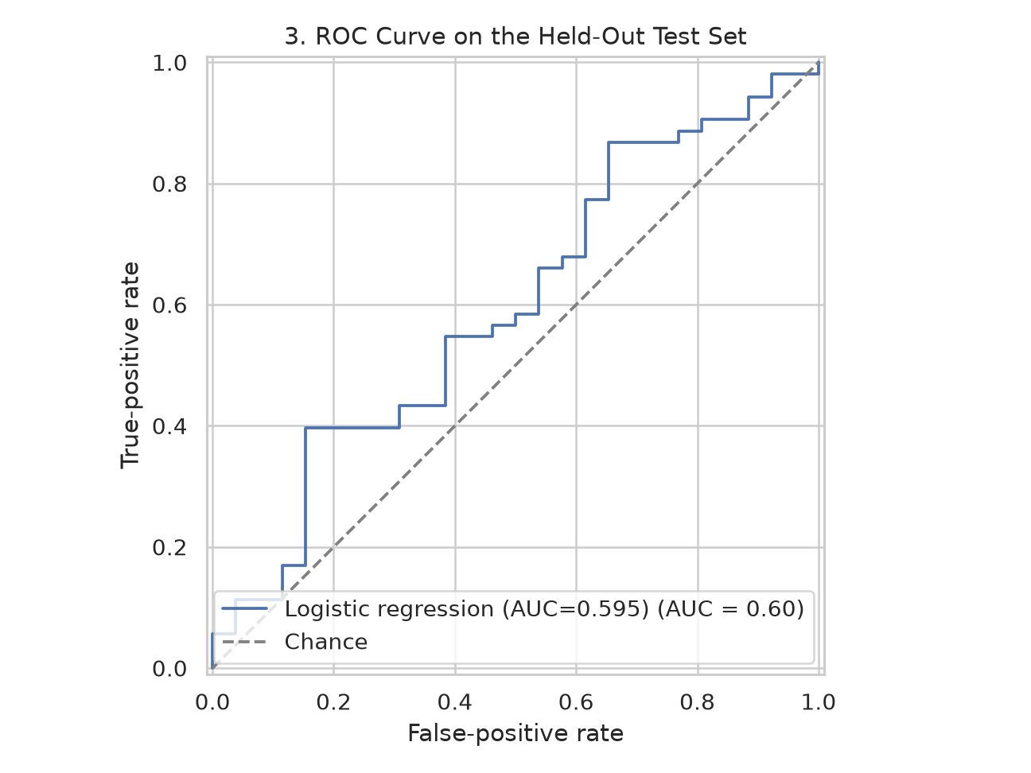
Shows the sensitivity-versus-false-positive-rate trade-off as the decision threshold changes. The diagonal is chance-level ranking.

Figure 4. Test performance metrics
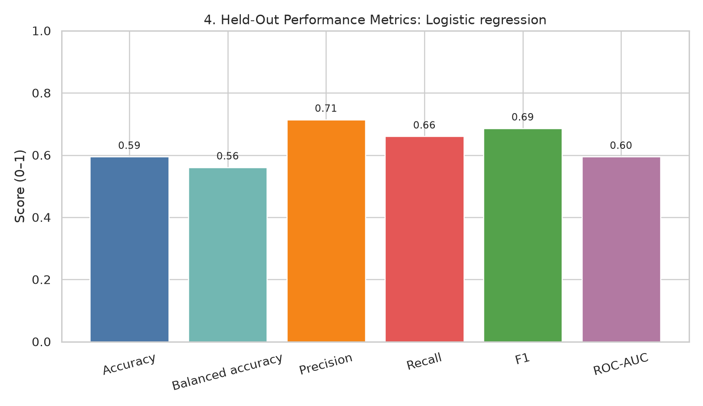
Presents complementary metrics on the same 0–1 scale; gaps between precision and recall can reveal different kinds of model error.

Figure 5. Permutation feature importance
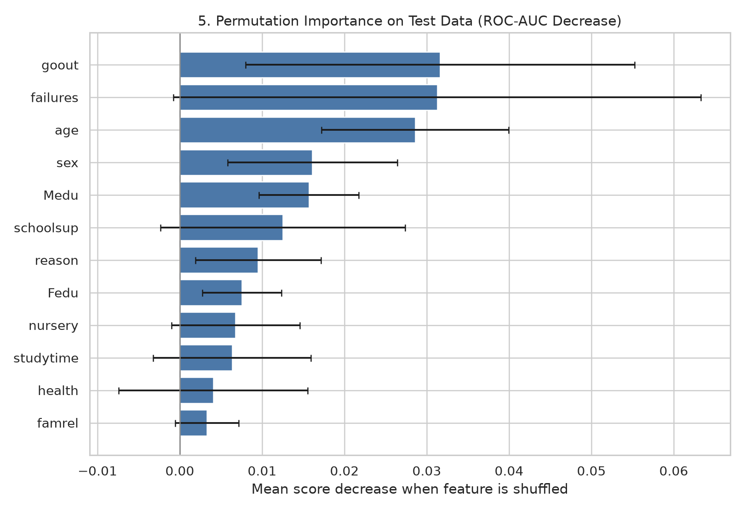
Measures how much test ROC-AUC changes when one input feature is shuffled. This is a model-dependence diagnostic, not a causal effect; correlated features and small samples can make rankings unstable.

7. Error Analysis, Overfitting, and Limitations
The confusion matrix is ordered as actual/predicted classes [G3 < 10, G3 >= 10]. Its rows are [[12, 14], [18, 35]]. Inspect off-diagonal entries in the chart and consider whether false positives or false negatives are costlier for the intended context.
- Overfitting is limited by training-only cross-validation, a shallow decision tree, minimum leaf sizes, and a held-out test split. A large gap between training and validation performance would be a warning; this workflow emphasizes validation scores.
- The dataset is relatively small, and the final test metrics can vary with the random split. Cross-validation standard deviation is shown to make this variability visible.
- Class prevalence affects raw accuracy. Balanced accuracy, precision, recall, F1, and ROC-AUC provide additional perspectives.
- G1 and G2 are excluded to prevent the model from using earlier grades that might not be available at prediction time. If the practical use case includes those grades, a separate time-defined model could be evaluated, but it would answer a different question.
- Students come from two Portuguese secondary schools. Results may not generalize to other regions, schools, or later cohorts.
- Feature importance is not causal importance. Sensitive personal or family variables should not be used for real student decisions without domain review, fairness assessment, consent/privacy safeguards, and external validation.

8. Improvement Plan
- Validate on a larger and more recent dataset from additional schools.
- Report confidence intervals for performance metrics and repeat the evaluation over several stratified splits.
- Check calibration and threshold choice in consultation with educators instead of assuming 0.5 is always optimal.
- Measure subgroup performance and error rates before considering any operational use.
- Compare against a simpler interpretable baseline and document the costs of false positives and false negatives.

9. Conclusion
The selected model, Logistic regression, was chosen using training-fold cross-validation and evaluated on a separate test set. The report records its metrics and errors transparently and uses five figures to explain model selection, predictive performance, and feature dependence. This is a reproducible learning exercise, not a tool for high-stakes individual decisions.

10. References
Cortez, P. (2008). Student Performance [Dataset]. UCI Machine Learning Repository. https://doi.org/10.24432/C5TG7T
Pedregosa, F., et al. (2011). Scikit-learn: Machine Learning in Python. Journal of Machine Learning Research, 12, 2825–2830.
Dataset page: https://archive.ics.uci.edu/dataset/320/student%2Bperformance

