AUTOMOTIVE STOCK MARKET ANALYSIS INTERN

Automotive Market Overview & Trend Analysis
India-listed automotive equities | Historical market data + public industry research

Executive Summary
This report reviews the Indian automotive equity sector using daily historical price data downloaded on 13 October 2026. The market-data analysis includes Nifty 50 and an equal-weighted auto-stock sample basket built from 10 listed manufacturers/component businesses where sufficient data were available. Yahoo Finance returned only one usable ^CNXAUTO observation during this run, so the official Nifty Auto index was not used for historical-return calculations. The most recent common price observation in the downloaded data is 12 October 2026. Over the one-year measured window, the Auto sample basket returned 4.3% versus -11.4% for Nifty 50; over the available five-year window, the respective returns were 187.9% and 23.1%. The basket is a descriptive equal-weighted proxy, not the official Nifty Auto index. Among included individual shares, the highest observed one-year return was Bharat Forge (48.7%), and the lowest was Maruti Suzuki (-30.0%). These are historical, sample-dependent outcomes, not forecasts or recommendations.
The industry context is constructive but not one-directional. SIAM's August 2026 data reported record-high August sales in covered passenger-vehicle, three-wheeler and two-wheeler categories, while explicitly noting the lower prior-year base. Policy changes to GST in September 2025 improved price affordability in selected vehicle categories and auto parts. The PM E-DRIVE scheme continues to evolve, while fresh investment plans and export ambitions reinforce India's manufacturing opportunity. Against these positives, equity outcomes remain sensitive to valuations, commodity and energy costs, financing conditions, currency movements, competition, model launches and execution.

Key Conclusions at a Glance
- Benchmark check: Auto sample basket 1Y return 4.3% compared with Nifty 50 -11.4%; the gap helps distinguish the selected sample's performance from the broad market.
- Cross-section: Bharat Forge was the strongest and Maruti Suzuki the weakest included share over the observed one-year window; rank alone does not establish value or future performance.
- Demand: SIAM's August 2026 release reported 439,309 passenger vehicles, 93,764 three-wheelers and 2,034,698 two-wheelers sold domestically in the covered categories, with a lower-base caveat [S1].
- Profitability: growth must translate into margins, cash flow and return on capital; volume growth alone is not enough.
- Investment posture: use this as a screening/reporting framework, not personalized investment advice. Check current valuations, latest exchange filings and risk tolerance before any decision.

1. Objective and Scope
The task is to analyze public information about India's automotive stock market, identify trends and industry factors, visualize evidence, and explain how those factors can influence listed auto companies. The research reviews Nifty Auto as the official sector-index reference and Nifty 50 as the broad-market benchmark. For five-year historical comparison, the report uses an equal-weighted basket of the included listed auto shares because Yahoo's ^CNXAUTO feed supplied only one usable observation. The sample covers passenger vehicles, two- and three-wheelers, commercial vehicles, selected component suppliers and batteries and is not an exhaustive stock universe or a recommendation list.
Companies in the downloaded sample include Maruti Suzuki, Mahindra & Mahindra, Bajaj Auto, Eicher Motors, Hero MotoCorp, TVS Motor, Ashok Leyland, Bharat Forge, Bosch and Exide Industries, subject to market-data availability. Each business has different exposure to vehicle segments, exports, premiumization, fleet demand, commodity input costs and technology transition.

2. Data Sources and Methodology
Price-source method: yfinance retrieval from Yahoo Finance's public historical market-data interface. The script queried a five-year daily window on 13 October 2026; source tickers, first/last observations and valid row counts are recorded in outputs/run_metadata.json and outputs/historical_prices.csv. Indexes use supplied close levels, while equity returns use adjusted close when available, falling back to close where not. That treatment aims to account for stock splits and distributions, but it does not make stock returns and index levels perfectly identical concepts.
Returns are computed as P_end/P_start − 1. Daily volatility is the sample standard deviation of daily percentage returns multiplied by sqrt(252). Maximum drawdown is the minimum of P_t / max(P_0 ... P_t) − 1. The annualized return shown for risk-return comparisons compounds the observed period return to an annual rate based on calendar days and must be read cautiously when history is less than five years. Daily return correlations use overlapping observations. The code does not fill missing prices backwards or synthesize prices.
Limitations: public data providers can revise adjusted histories, have occasional gaps, or change symbol availability. The five-year period is rolling and ends at the latest price observation available at run time, not necessarily the current calendar day. Individual-stock prices are affected by corporate actions and idiosyncratic news. Index price levels are not total-return indices. Conclusions therefore emphasize relative context, risk, and drivers rather than precise investable total-return estimates.

3. Historical Market Performance
The sample-basket return is computed from equal-weighted daily returns of the included automotive companies, not copied from an official index. It helps illustrate the collective behavior of the selected sample relative to Nifty 50 but can differ from a free-float market-cap-weighted index.
In the individual-stock sample, Bharat Forge led the one-year table at 48.7%, while Maruti Suzuki was lowest at -30.0%. That range illustrates why treating 'auto stocks' as one uniform trade is misleading. A two-wheeler exporter, a domestic SUV manufacturer, a commercial-vehicle producer and a component maker have distinct revenue mixes, margin drivers and valuation expectations.
Return ranking is a starting point, not an investment conclusion. A high historical return may be accompanied by a higher valuation, greater drawdown or elevated expectations; a low return may reflect structural problems, temporary conditions, or a valuation reset. Fundamental context is needed to distinguish those cases.

4. Industry Conditions and Demand Drivers

4.1 Sales volumes and base effects
SIAM's release dated 15 September 2026 reports August domestic sales of 439,309 passenger vehicles, 93,764 three-wheelers and 2,034,698 two-wheelers for its covered categories. It reports year-on-year growth rates of 36.5%, 22.8% and 10.5%, respectively, and also cautions that the comparison benefits from a lower base in August 2025 [S1]. For analysts, this means that sequential momentum, retail registrations, inventory, model mix and company disclosures should be evaluated alongside the headline annual growth rate.
Passenger vehicles are influenced by household income, urban consumption, replacement demand, SUV/premium mix, launch cycles and availability. Two-wheelers are particularly sensitive to affordability, rural cash flows, entry-level demand, finance availability and export markets. Commercial vehicles depend more heavily on freight activity, infrastructure investment, fleet utilization, replacement cycles and financing. Tractors add exposure to monsoon performance and farm economics.

4.2 Tax and policy transmission
The Government of India's September 2025 GST rationalization included rate changes for selected motorcycles up to 350 cc, small cars and auto components, with official communications describing the aim of improving affordability and supporting upstream suppliers [S2, S3]. The policy transmission is not automatic: lower tax can support unit demand, but the effect on manufacturers also depends on price pass-through, discounting, supplier pricing, mix and incremental fixed costs. Large-vehicle categories have different treatment, so the policy should not be summarized as one uniform cut for all vehicles.

4.3 Electrification and technology
The PM E-DRIVE scheme notification page lists updates during 2026, including an enhancement/extension for e-two-wheelers in August and amendments related to e-trucks and e-buses in September [S4]. Such support can influence adoption and economics by segment, but investors should distinguish scheme duration, category eligibility, incentive exhaustion, charging infrastructure, battery cost, localization requirements and post-subsidy product competitiveness. EV transition is also a capital-allocation question: incumbent OEMs and suppliers may benefit from new products but can face write-downs or margin pressure on legacy platforms.

4.4 Exports and investment
On 13 October 2026, Reuters reported Hyundai Motor Group's announced $15.5 billion investment in India through 2032, including research and production-related plans [S6]. This reinforces the country's role in international manufacturing networks while also raising the competitive bar for product development, scale, localization, cost and exports. Export potential diversifies revenue, but it introduces currency, tariff, regulatory, shipping and demand-cycle risks in destination markets.

5. Company and Segment Context
Maruti Suzuki offers a high-volume passenger-vehicle and export lens; analysis should monitor market share, channel inventory, product mix, capacity utilization and small-car demand. Mahindra & Mahindra spans SUVs, light commercial vehicles, farm equipment and other businesses, so consolidated earnings require careful segment reading. Its FY26 release reported consolidated revenue of Rs 198,639 crore, consolidated PAT of Rs 17,099 crore, FY26 auto volumes growth of 19% and UV volumes growth of 20% [S5]. These company-reported numbers show why segment leadership and execution can matter, but consolidated metrics should not be compared directly with a pure-play OEM without accounting for business mix.
Bajaj Auto, Eicher Motors, Hero MotoCorp and TVS Motor cover different points across motorcycles, scooters, premiumization, exports and three-wheelers. Their earnings sensitivities vary with the premium vs commuter mix and geography. Ashok Leyland is more exposed to commercial-vehicle replacement, freight and fleet economics. Bharat Forge and Bosch depend on manufacturing scale, technology content and global OEM order patterns; Exide has exposure to replacement batteries and evolving EV/energy-storage supply chains. These descriptions are analytical context, not current valuation recommendations.

6. Reading the Charts

Figure 1. Five-Year Indexed Trend: Auto Sample Basket vs Broad Market
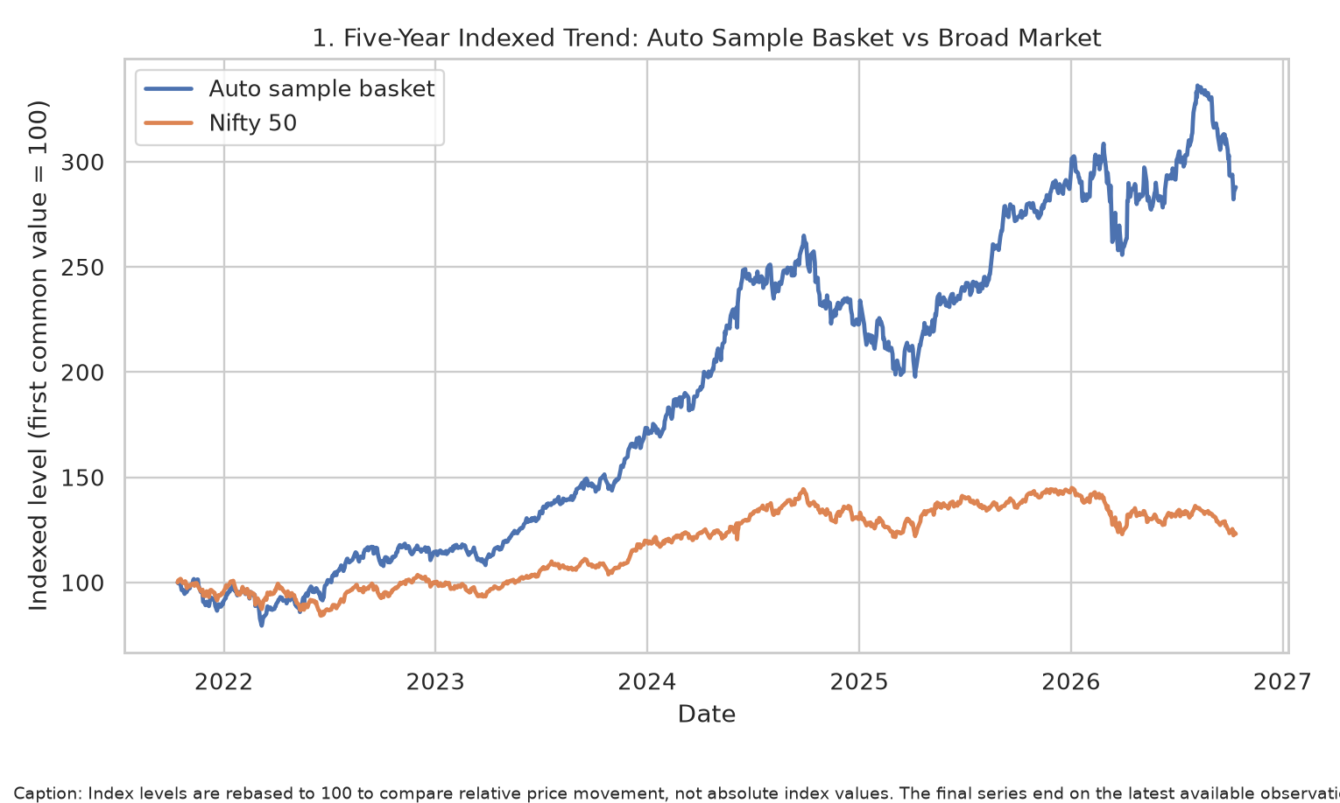
Rebases the equal-weighted automotive sample basket and Nifty 50 to a common starting value so relative direction and compounding can be compared. It does not compare nominal index levels or represent the official Nifty Auto index.

Figure 2. Individual Auto Stocks: One-Year vs Available Five-Year Return
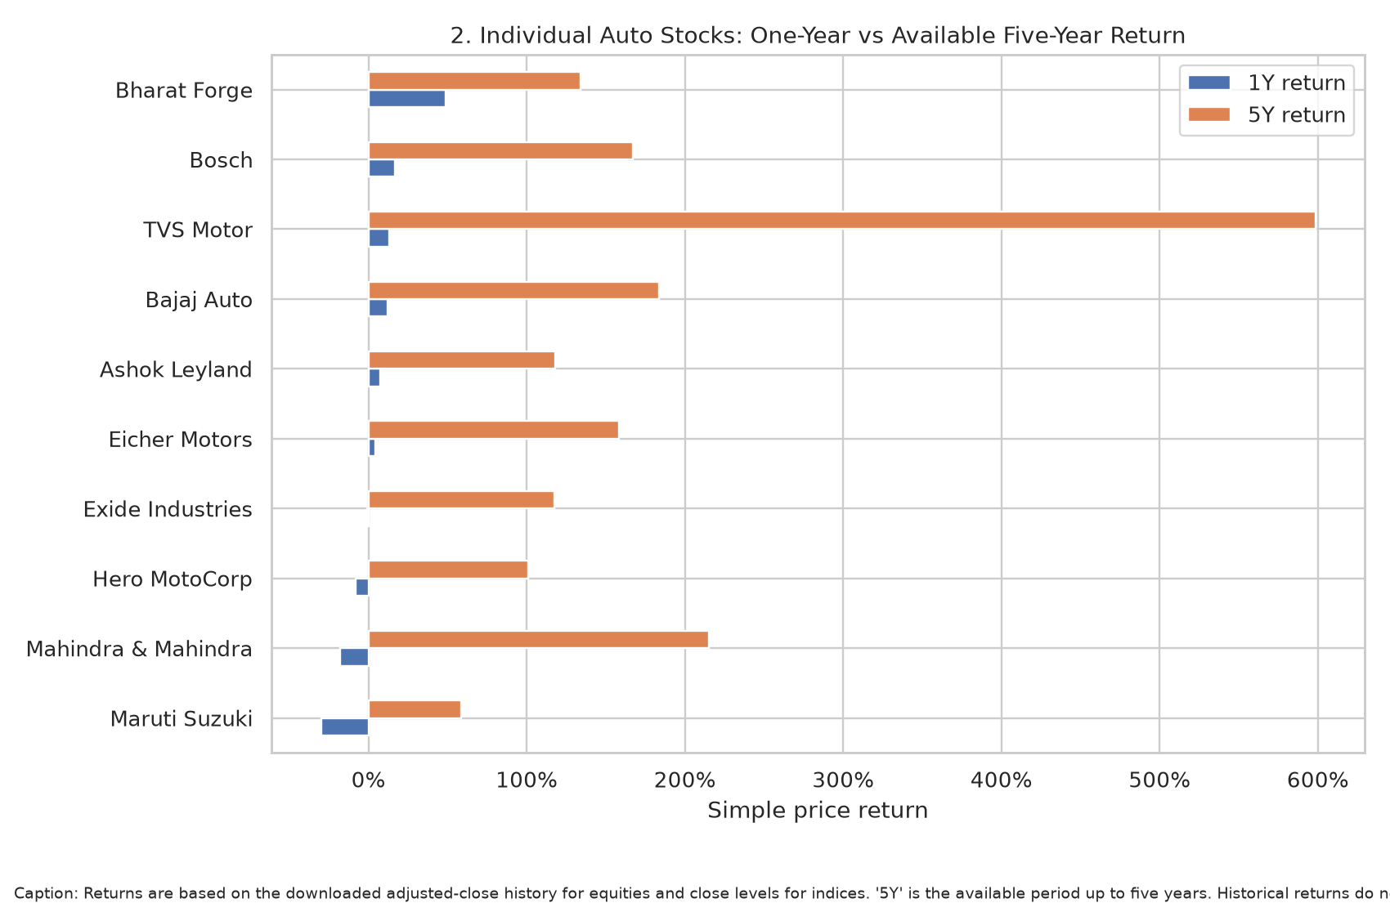
Shows dispersion across listed companies. The cross-section supports avoiding one-size-fits-all sector conclusions; history lengths and corporate actions may differ.

Figure 3. Observed Return vs Annualized Volatility
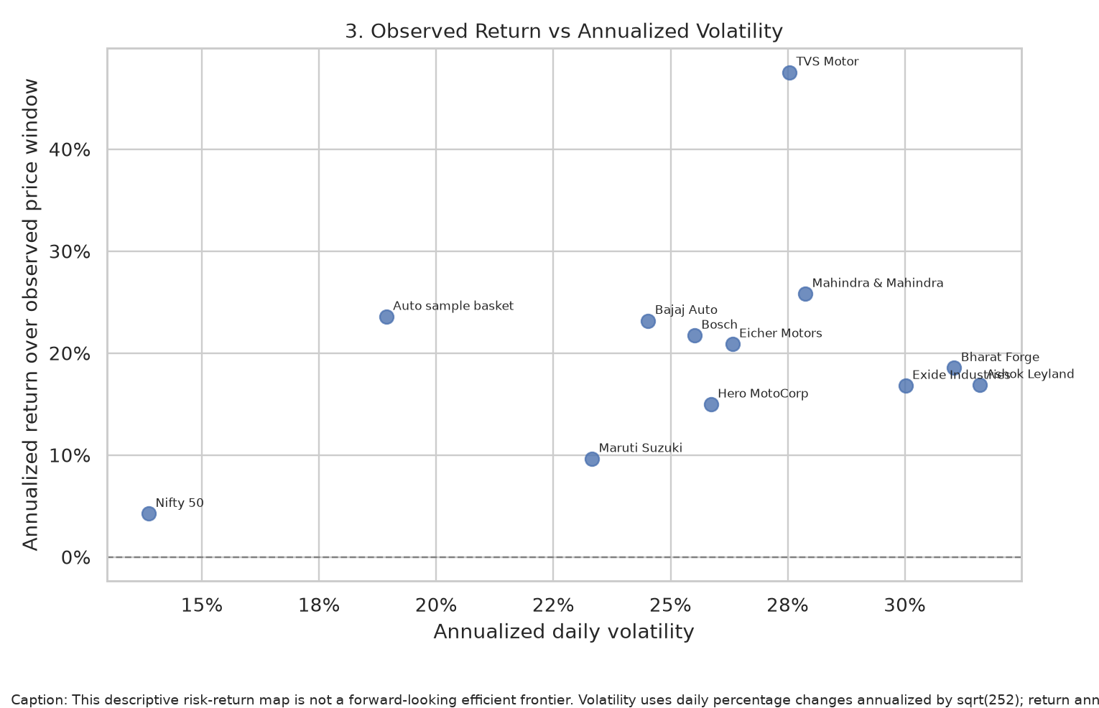
Maps return against realized risk. A high return/high volatility point is not automatically better than a lower-risk outcome, and past return is not expected return.

Figure 4. Benchmark Drawdowns
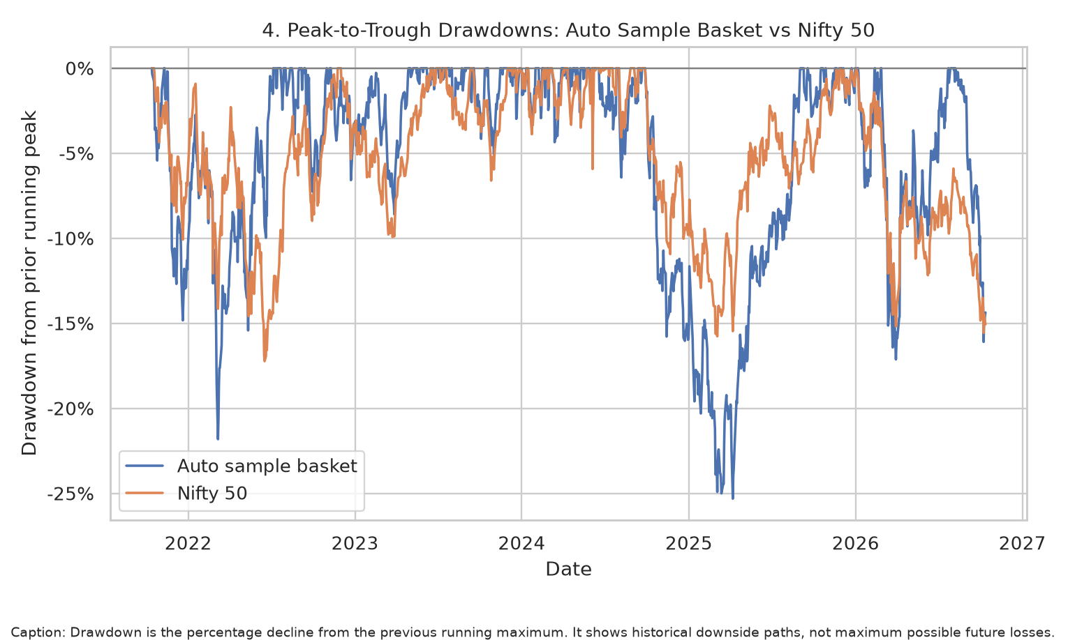
Shows how far the equal-weighted auto-stock sample basket and Nifty 50 moved below prior peaks. Drawdowns help communicate the lived path of risk, which a single return number hides.

Figure 5. Daily-Return Correlation
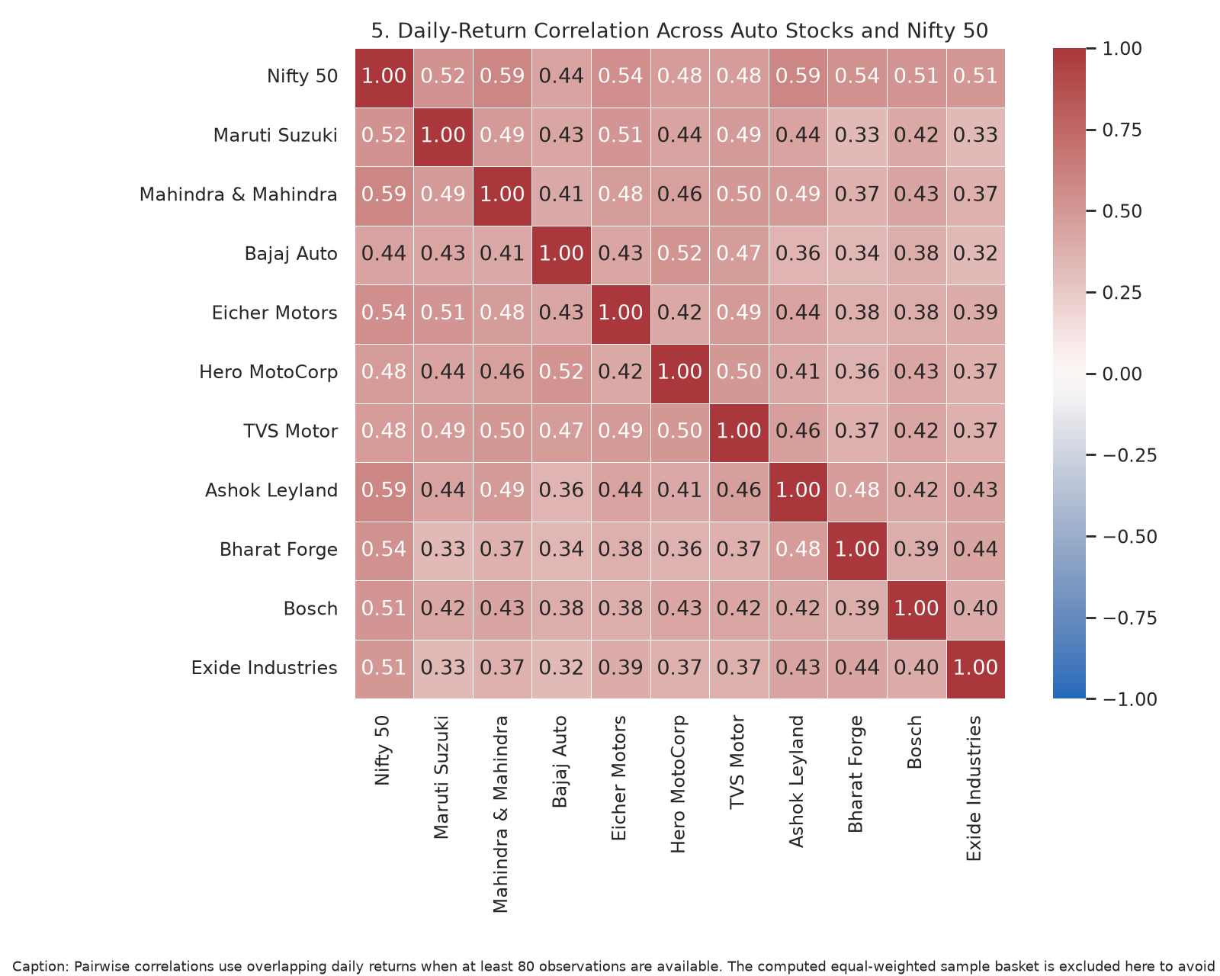
Shows which stocks tended to co-move over the overlapping daily window. Correlation can change in stress periods and does not itself make a diversified portfolio.

Figure 6. Auto Sample Basket Monthly Return Heatmap
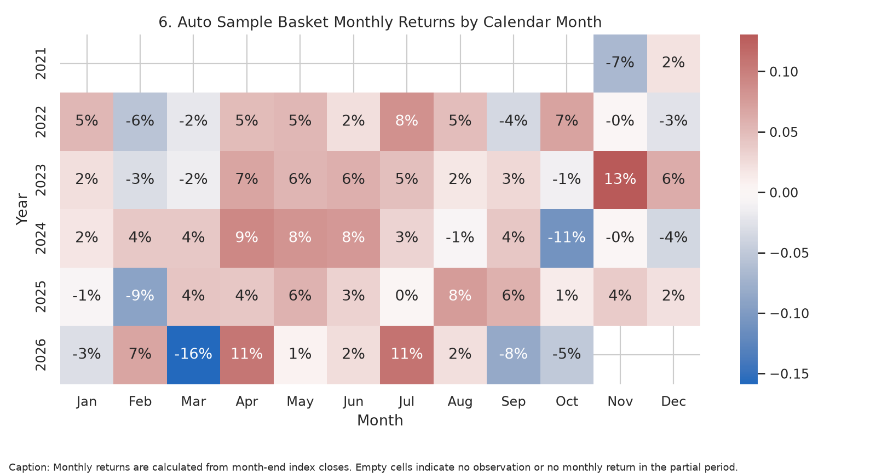
Highlights calendar periods of positive and negative returns in the selected auto-stock basket without assuming that a seasonality pattern will repeat.

Figure 7. Latest One-Year Relative Trend
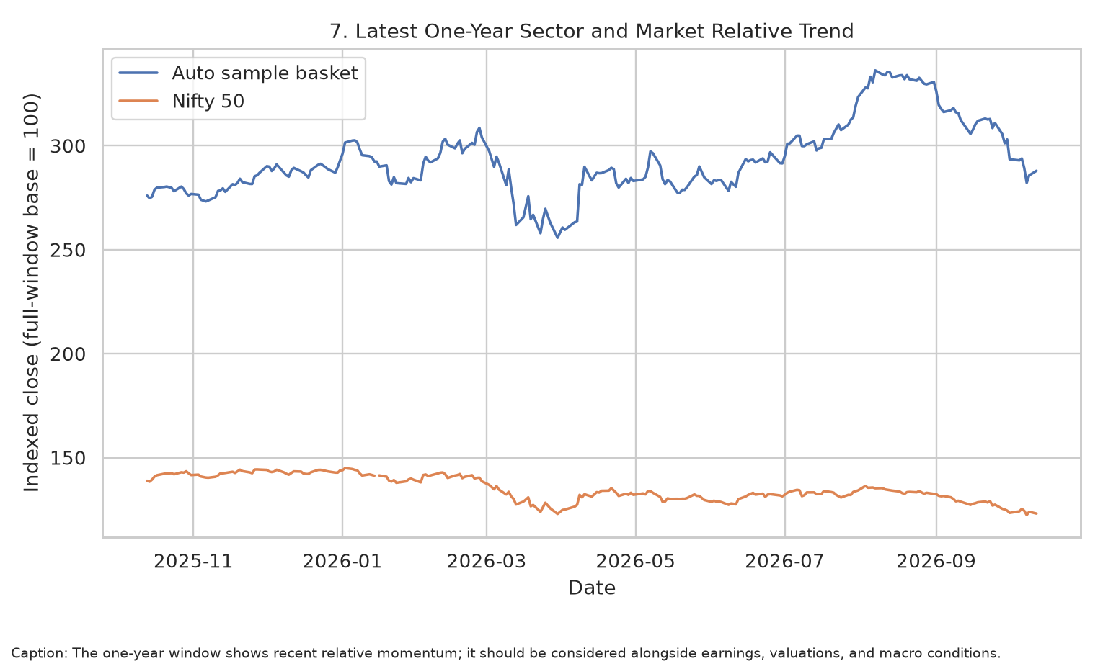
Provides more recent context for the sector-vs-market relationship; it remains backward-looking and should be connected to valuation and fundamentals.

7. Key Trends and What Could Move Stocks

Demand rebound vs normalization
Monthly growth can look unusually strong after a weak comparison period or tax/policy change. Analysts should compare multi-month trends, wholesales and retail registrations, inventory, booking conversion and management guidance.

Mix and margins matter as much as volume
A shift toward SUVs, premium motorcycles or higher-spec vehicles can lift revenue per unit, but competition, discounts, warranty provisions, freight and raw-material costs can offset those gains.

Financing and interest rates
Vehicle purchases often depend on monthly payments and lender availability. Higher borrowing costs can hurt affordability; looser financing can support demand but may increase household or dealer leverage risk.

Commodities, energy and currency
Steel, aluminium, copper, rubber, plastics, semiconductors and battery materials affect input costs. Currency weakness can raise imported-input cost while benefiting exporters; the net effect depends on hedging and localization. Reuters has recently highlighted possible commodity pressure even amid a more positive earnings outlook [S7, S8].

EV investment and policy execution
The long-term opportunity involves electric two-wheelers, buses, trucks and passenger vehicles, software, charging and components. Risks include subsidy changes, low utilization, price competition, battery life, warranty liability and asset obsolescence.

Valuation and expectations
A good business can be a weak stock investment if the price already assumes exceptional growth. Compare valuation multiples with growth, ROCE, operating cash flow, capital intensity, net cash/debt and peers rather than selecting only the best price chart.

8. Strategic Recommendations for an Analyst

Use a two-layer research process
Start with the sector index and segment-level demand; then test each company’s market share, realizations, product mix, operating margin, cash conversion, capital expenditure and valuation. This reduces the risk of treating a sector tailwind as proof that every company benefits equally.

Maintain a balanced watchlist rather than a buy list
Group companies by exposure: passenger vehicles, two/three-wheelers, commercial vehicles, diversified OEMs, components and batteries. Compare peers within a similar business model and record the catalyst, valuation concern and invalidation condition for each thesis.

Track leading indicators monthly
Monitor SIAM wholesales, FADA retail registrations when published, exports, production, inventory, dealer commentary, new launches, financing rates, commodity prices and policy notifications. Separate industry volume growth from company market-share gains.

Measure downside and concentration
Use drawdown and volatility charts alongside return. Avoid assuming that high historical performers will lead in future; sector correlations can rise during risk-off events. Define acceptable loss, diversification and position-sizing rules independently of this sector report.

Update views after disclosures
Reconcile company monthly sales with quarterly financials, consolidated vs standalone reporting, segment profit, free cash flow, debt, capex, warranty/quality news and capacity utilisation. Use official exchange filings and annual reports for final decisions.

Keep an explicit evidence log
For each conclusion, record source, date, measured variable, counterargument and next checkpoint. This supports reproducibility and stops a plausible macro narrative from turning into an unsupported stock forecast.

9. Risks, Limitations and Further Research
- Market-data availability and corporate-action adjustments vary by ticker and vendor. The report records the observed source window and does not fabricate missing prices.
- A sample of selected liquid listed companies does not represent every OEM, supplier, EV pure-play or small-cap stock. Survivorship and selection bias are possible.
- Past price correlations are not stable structural parameters. Short windows, crisis periods and index composition changes can alter estimates.
- Market prices incorporate expectations before reported sales or earnings. A strong industry metric does not guarantee a positive share-price response if expectations were higher.
- Industry data (wholesales, retails, production and exports) use different measurement points. Comparisons must preserve the source's definition and coverage.
- Policy benefits differ by vehicle category and company position. Confirm current eligibility and notifications at the official source before interpreting an incentive as a forecast of future earnings.
- This report is educational research, not personalized financial advice, and does not set a buy/sell target. Validate current quotes, filings, valuation and suitability independently.

10. Conclusion
India's automotive sector offers multiple demand and technology themes, but the listed-equity opportunity is heterogeneous. Recent official industry figures point to strong August 2026 volumes in covered categories, government tax changes and evolving EV support affect demand economics, and new investment plans underline strategic manufacturing importance. However, stock performance depends on the earnings and cash flow captured by each firm, valuation paid, cost control and execution. The most robust analyst approach combines sector data with company fundamentals, uses return and risk together, keeps sources dated, and updates the view after each reporting cycle. The quantitative charts in this report are descriptive evidence to support that process—not predictions.

11. References and Public Sources
[S1] Society of Indian Automobile Manufacturers (SIAM), Auto Industry Performance of August 2026, 15 September 2026. SIAM reports August 2026 production of 3,157,822 units across covered categories; domestic sales included 439,309 passenger vehicles, 93,764 three-wheelers and 2,034,698 two-wheelers. It reports year-on-year growth of 36.5%, 22.8% and 10.5%, respectively, and cautions that the prior-year base was lower. URL: https://www.siam.in/pressrelease-details.aspx?mpgid=53&pgidtrail=50&pid=620
[S2] Press Information Bureau / Ministry of Heavy Industries, GST rates for automobiles, 4 September 2025. The government describes GST reductions across vehicle categories and auto parts, aimed at supporting affordability and downstream component demand. URL: https://www.pib.gov.in/PressReleasePage.aspx?PRID=2163763&lang=2&reg=48
[S3] Press Information Bureau / Ministry of Road Transport and Highways, Road Transport and Auto Sector Get a Big Push Through GST Rationalisation, 12 September 2025. Official notice reports measures for two-wheelers, cars, tractors, buses, commercial vehicles and auto components. URL: https://www.pib.gov.in/PressReleasePage.aspx?PRID=2165916&lang=2&reg=48
[S4] PM E-DRIVE, Scheme Notifications. Official notifications include August 2026 enhancement/extension for e-two-wheelers, September 2026 amendments for e-trucks and e-buses, and other scheme updates. URL: https://pmedrive.heavyindustries.gov.in/policy_document
[S5] Mahindra & Mahindra, Results Q4 F26 and FY26, 5 May 2026. M&M reported FY26 consolidated revenue of Rs 198,639 crore (+25%) and consolidated PAT of Rs 17,099 crore; its release reports FY26 auto volumes up 19% and UV volumes up 20%. Figures are company-reported and definitions in the release should be consulted. URL: https://www.mahindra.com/news-room/press-release/en/m-and-m-results-q4-f26-and-fy26
[S6] Reuters, Hyundai Motor Group bets $15.5 billion on India as global auto hub, 13 October 2026. Reuters reports Hyundai Motor Group's announced $15.5 billion India investment through 2032, including R&D and capacity-related investment, underscoring competition and localization. URL: https://www.reuters.com/world/asia-pacific/hyundai-motor-group-invest-155-billion-india-through-2032-2026-10-13/
[S7] Reuters, Indian firms seen posting faster profit growth despite global headwinds, 8 October 2026. Reuters summarizes brokerage expectations of stronger September-quarter earnings growth but also notes demand uncertainties and possible commodity-cost pressure. This is a forecast summary, not a confirmed earnings result. URL: https://www.reuters.com/world/india/indian-firms-seen-posting-faster-profit-growth-despite-global-headwinds-2026-10-08/
[S8] Reuters, India steel ministry unlikely to seek new curbs on cheap imports, 7 October 2026. Reuters discusses steel import and pricing conditions as a potential input-cost and margin factor for steel consumers, including automotive manufacturers. URL: https://www.reuters.com/world/china/india-steel-ministry-unlikely-seek-new-curbs-on-cheap-imports-2026-10-07/
[S9] Yahoo Finance public historical market data interface (accessed at run time). Historical price data are retrieved programmatically via yfinance. Availability, corporate actions, index symbol conventions and adjustments depend on the source. The script records the actual download window and latest observation. URL: https://finance.yahoo.com/
[S10] Nifty Indices, Nifty Auto index overview and methodology. Nifty Auto is an Indian automotive-sector index calculated using free-float market capitalization. This report does not calculate historical official-index returns because Yahoo returned only one usable observation for its ^CNXAUTO symbol in this run; instead it uses a clearly labeled equally weighted basket of the included stock sample. URL: https://www.niftyindices.com/indices/equity/sectoral-indices/nifty-auto
Market-data retrieval timestamp: 2026-10-13T19:03:14+00:00. Requested window: 5y; observed date range: 2021-10-13 to 2026-10-12.
Usable source histories: 11. No synthetic market prices were used. Detailed ticker coverage, row counts and generated chart names are preserved in outputs/run_metadata.json.

