WEEK 3 PROJECT REPORT

Statistical Analysis and Hypothesis Testing in Python
UCI Student Performance — Mathematics | SciPy, Pandas, NumPy, Matplotlib, Seaborn

1. Executive Summary
This report tests whether students with no previous class failures have higher final Mathematics grades than students with one or more previous failures. The analyzed sample contains 395 official UCI records. Mean G3 is 11.25 for the no-failure group (n=312) and 7.27 for the prior-failure group (n=83). The estimated mean difference is 3.99 grade points; Welch t=7.02, df=118.4, one-sided p=7.66e-11. The two-sided 95% confidence interval for the difference is [2.86, 5.11], and Hedges' g=0.93. At alpha=0.05, the primary decision is: Reject H0 in favor of H1. Statistical evidence does not establish causation.

2. Research Question and Hypotheses
Research question: In this dataset, do students with zero recorded previous class failures have higher mean final Mathematics grades than students with at least one recorded previous failure?
Group A: failures = 0. Group B: failures ≥ 1. Outcome: final-period Mathematics grade G3, recorded on a 0–20 scale.
Null hypothesis (H0): μA ≤ μB. Alternative hypothesis (H1): μA > μB. Significance level: α = 0.05, specified before interpreting the test.
This is a directional research hypothesis, so the primary Welch test uses a one-sided p-value. A two-sided 95% confidence interval is reported alongside it to quantify the estimated mean difference and its uncertainty.

3. Dataset, Data Quality, and Preparation
Source: UCI Machine Learning Repository, Student Performance Mathematics file. Dataset page: https://archive.ics.uci.edu/dataset/320/student%2Bperformance. DOI: https://doi.org/10.24432/C5TG7T. Acquisition method: Existing official UCI Mathematics CSV from the Week 1 project.
Rows before cleaning: 395; exact duplicate rows removed: 0; missing cells in required analysis variables before filtering: 0; rows removed for missing required fields: 0; rows removed for invalid ranges: 0; rows analyzed: 395. Synthetic data used: No.
The code trims text fields, converts the analysis variables to numeric types, removes exact duplicate records, and checks valid ranges for G1/G2/G3, study-time category, previous failures, and absences. It does not impute missing grade outcomes. All exclusions are recorded in the audit JSON.

4. Statistical Methodology

4.1 Primary: Welch independent-samples t-test
Welch's t-test compares the independent means of Group A and Group B without assuming equal population variances. Independence is assumed at the student-record level. Because grades are bounded and discrete, the report includes distribution plots, Q-Q diagnostics, and a rank-based sensitivity test.
The estimated difference is A − B = 3.99. Standard error = 0.57; t = 7.016; Welch degrees of freedom = 118.38; one-sided p = 7.6567e-11. Two-sided 95% CI for A − B = [2.86, 5.11].

4.2 Effect size
Hedges' g = 0.928, a small-sample corrected standardized mean difference. The raw-point difference is more directly interpretable on the 0–20 grading scale; the standardized effect should be read together with the group spread.

4.3 Sensitivity: Mann–Whitney U
Mann–Whitney U tests whether values in Group A tend to be greater than values in Group B without relying on normally distributed outcomes. U = 19359.5; one-sided p = 1.6511e-12. This is a sensitivity analysis, not a test of means in general.

4.4 Secondary: chi-square test of independence
A threshold indicator (G3 ≥ 10) is cross-tabulated with failure-history group. This threshold is an analysis convention, not a universal institutional grading rule. Pearson χ²(1) = 42.091, p = 8.7144e-11, Cramér's V = 0.326. Expected cell counts are available in outputs/test_results.json and are checked before interpreting Pearson's chi-square approximation.
Failure-history group | Below 10/20 | At or above 10/20
No previous failures | 78 | 234
One or more previous failures | 52 | 31

4.5 Exploratory: Kruskal–Wallis across study-time categories
Kruskal–Wallis compares grade ranks across the four study-time categories: H(3) = 7.579, p = 0.055567. This result is exploratory; no unplanned pairwise post-hoc claims are made.

5. Visualizations and Interpretation

Figure 1. Final grade distributions by previous-failure history
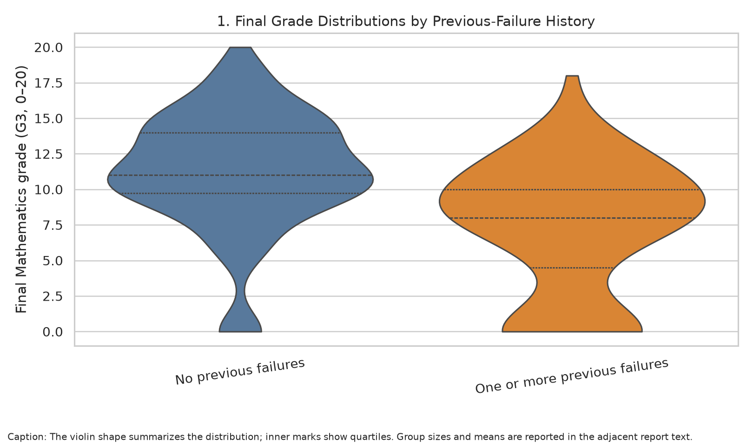
Result: No-failure mean: 11.25; prior-failure mean: 7.27.
Why this visualization: The violin plot shows the shape and spread of grades in the two groups, complementing the mean-based primary test.

Figure 2. Mean final grades with confidence intervals
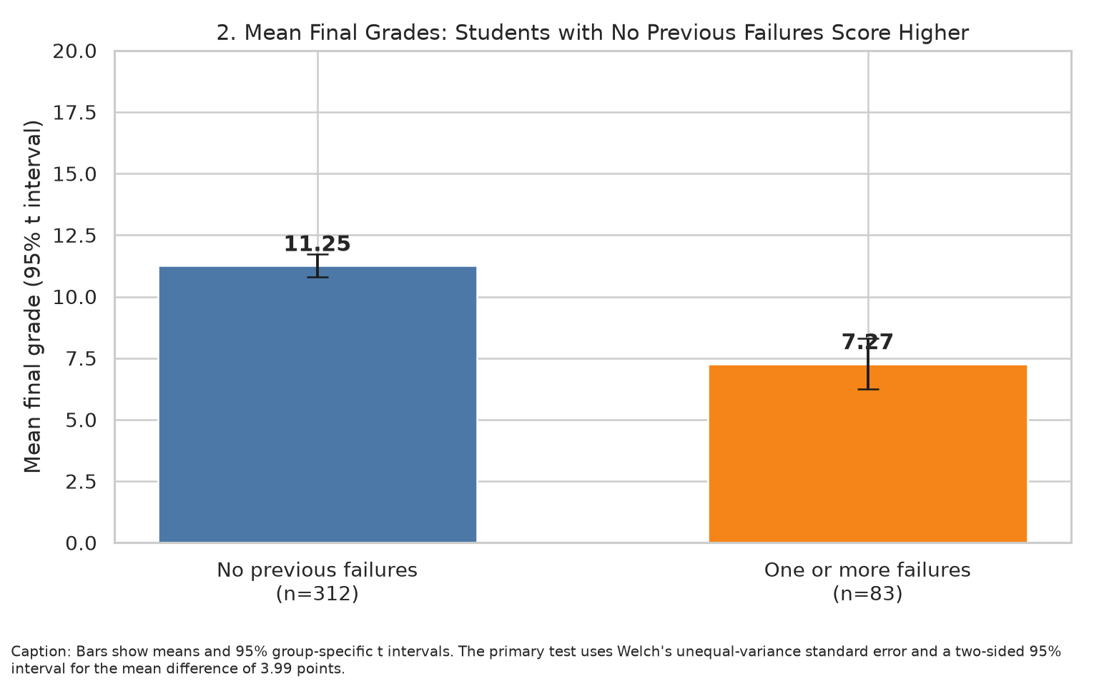
Result: Estimated mean difference: 3.99; 95% CI [2.86, 5.11].
Why this visualization: Means and 95% group-specific t intervals make the central difference and group uncertainty visible. The inferential test uses Welch's unequal-variance method.

Figure 3. Threshold attainment by failure history
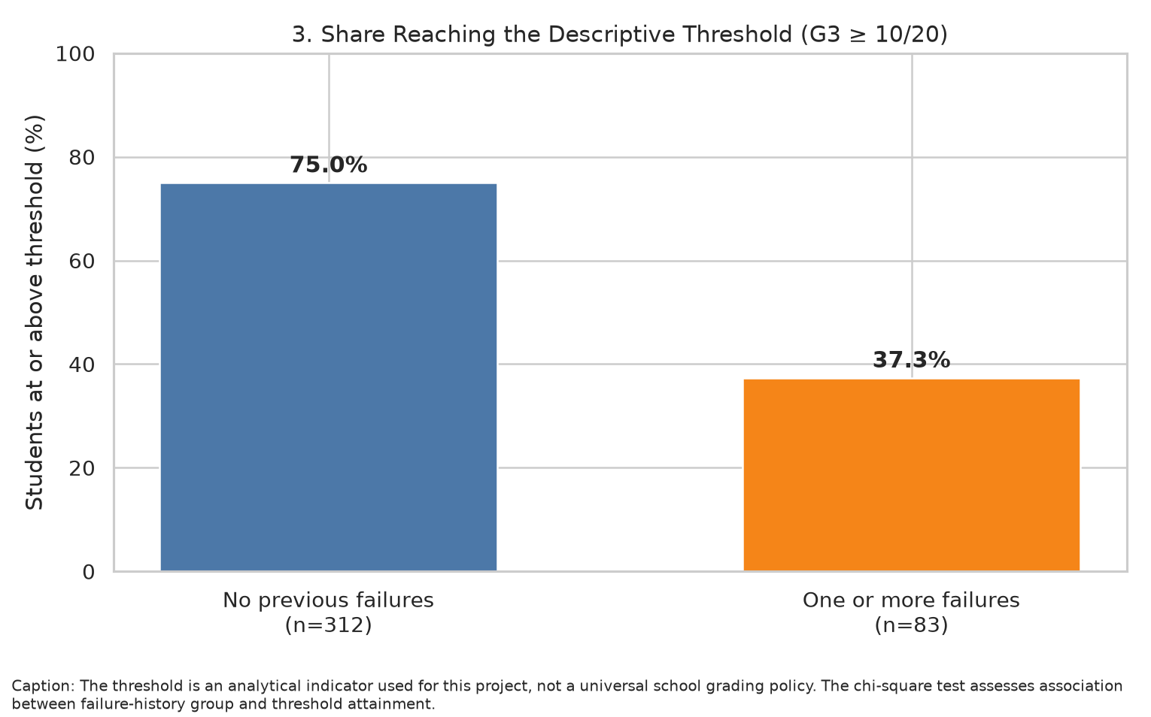
Result: No-failure threshold rate: 75.0%; prior-failure rate: 37.3%.
Why this visualization: Percentages translate the final grade into a simple descriptive outcome for a non-technical audience. A chi-square test evaluates association between the two categorical variables.

Figure 4. Q-Q diagnostics for grade groups
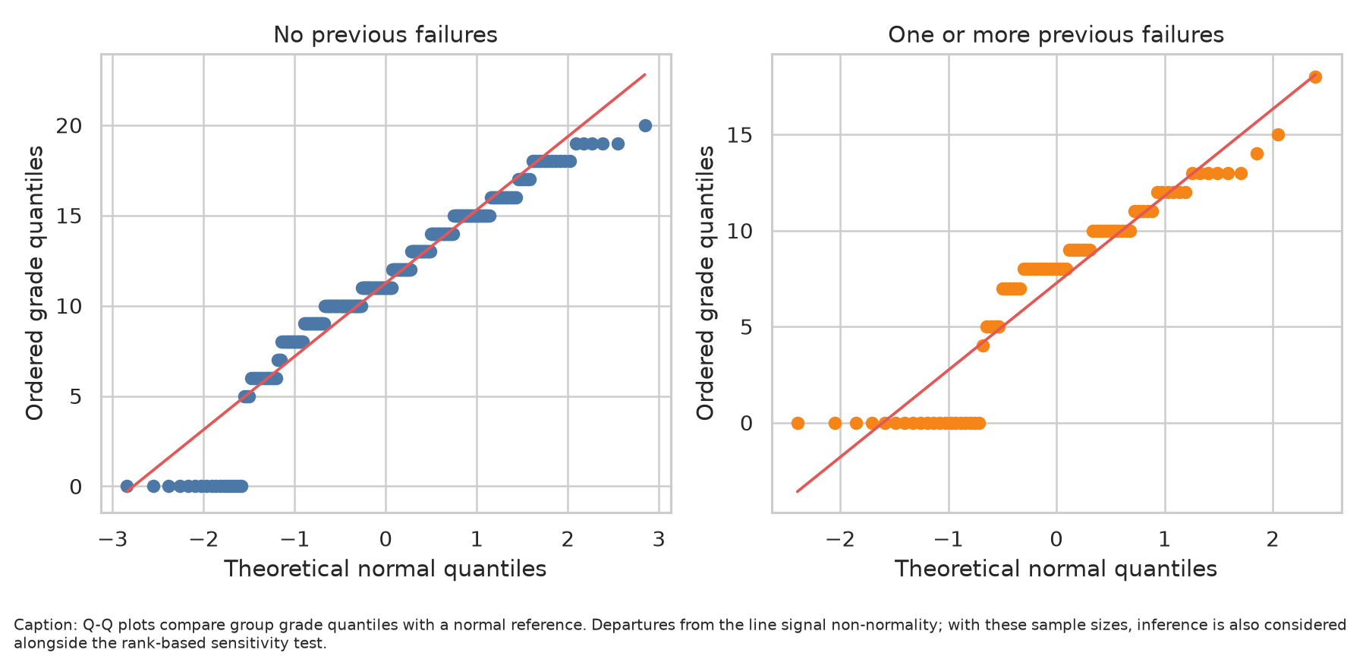
Result: The discrete 0–20 grade scale cannot be perfectly normal; tests are interpreted with group sizes, the estimated difference, confidence interval, and sensitivity analysis.
Why this visualization: Q-Q plots examine departures from a normal reference and make the rationale for adding a non-parametric sensitivity test explicit.

Figure 5. Final grade by weekly study-time category
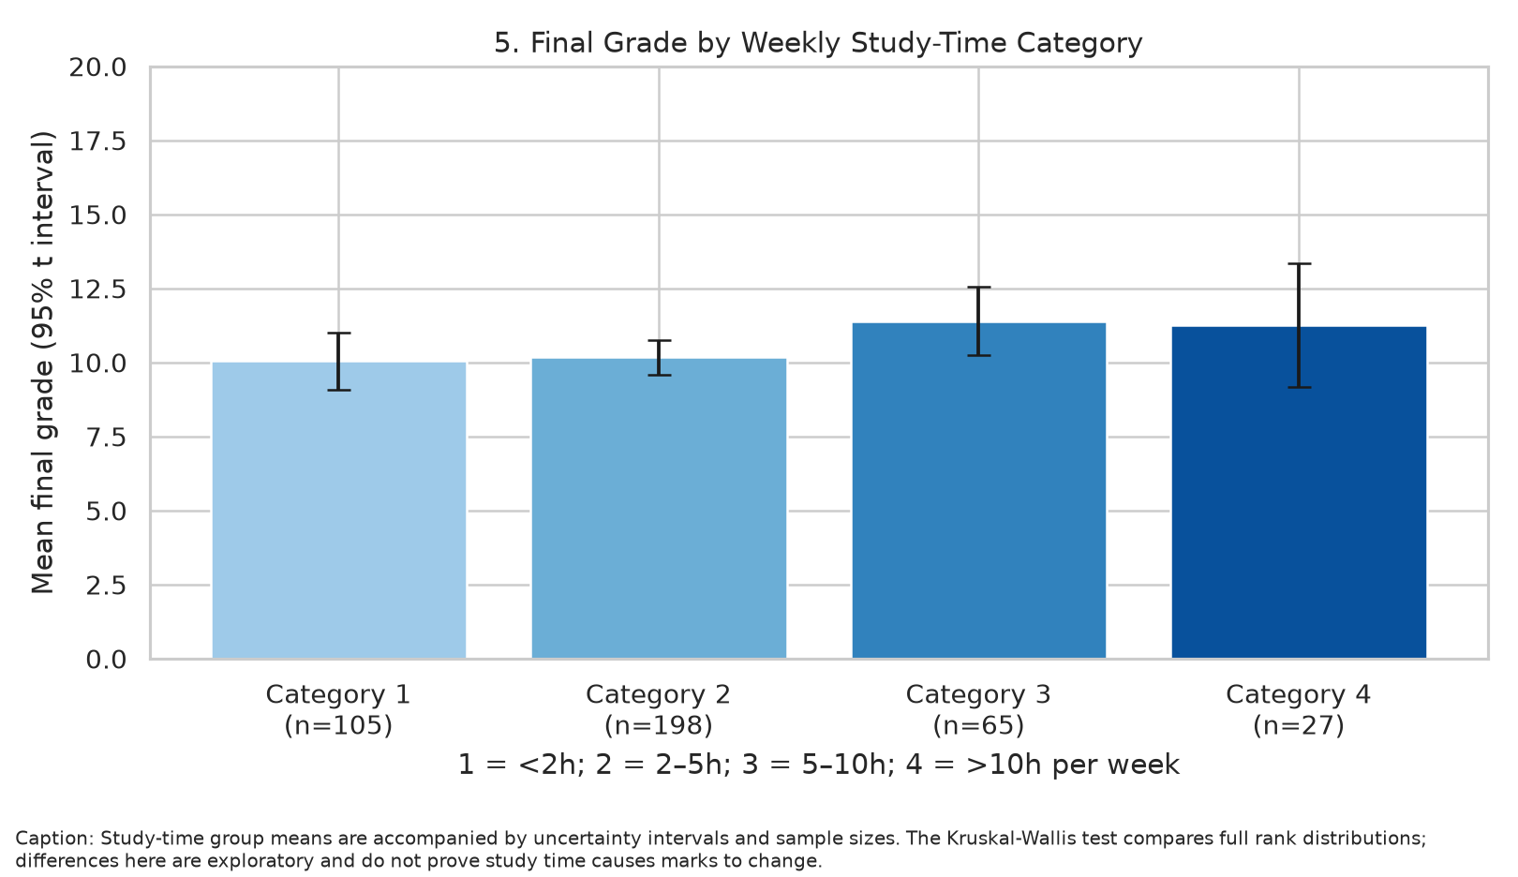
Result: Kruskal–Wallis p = 0.055567; the result is exploratory and not evidence that more study time necessarily causes higher grades.
Why this visualization: Group means with intervals and n labels show patterns without hiding unequal group sizes. The Kruskal–Wallis test compares the rank distributions across categories.

Figure 6. Evidence across statistical tests
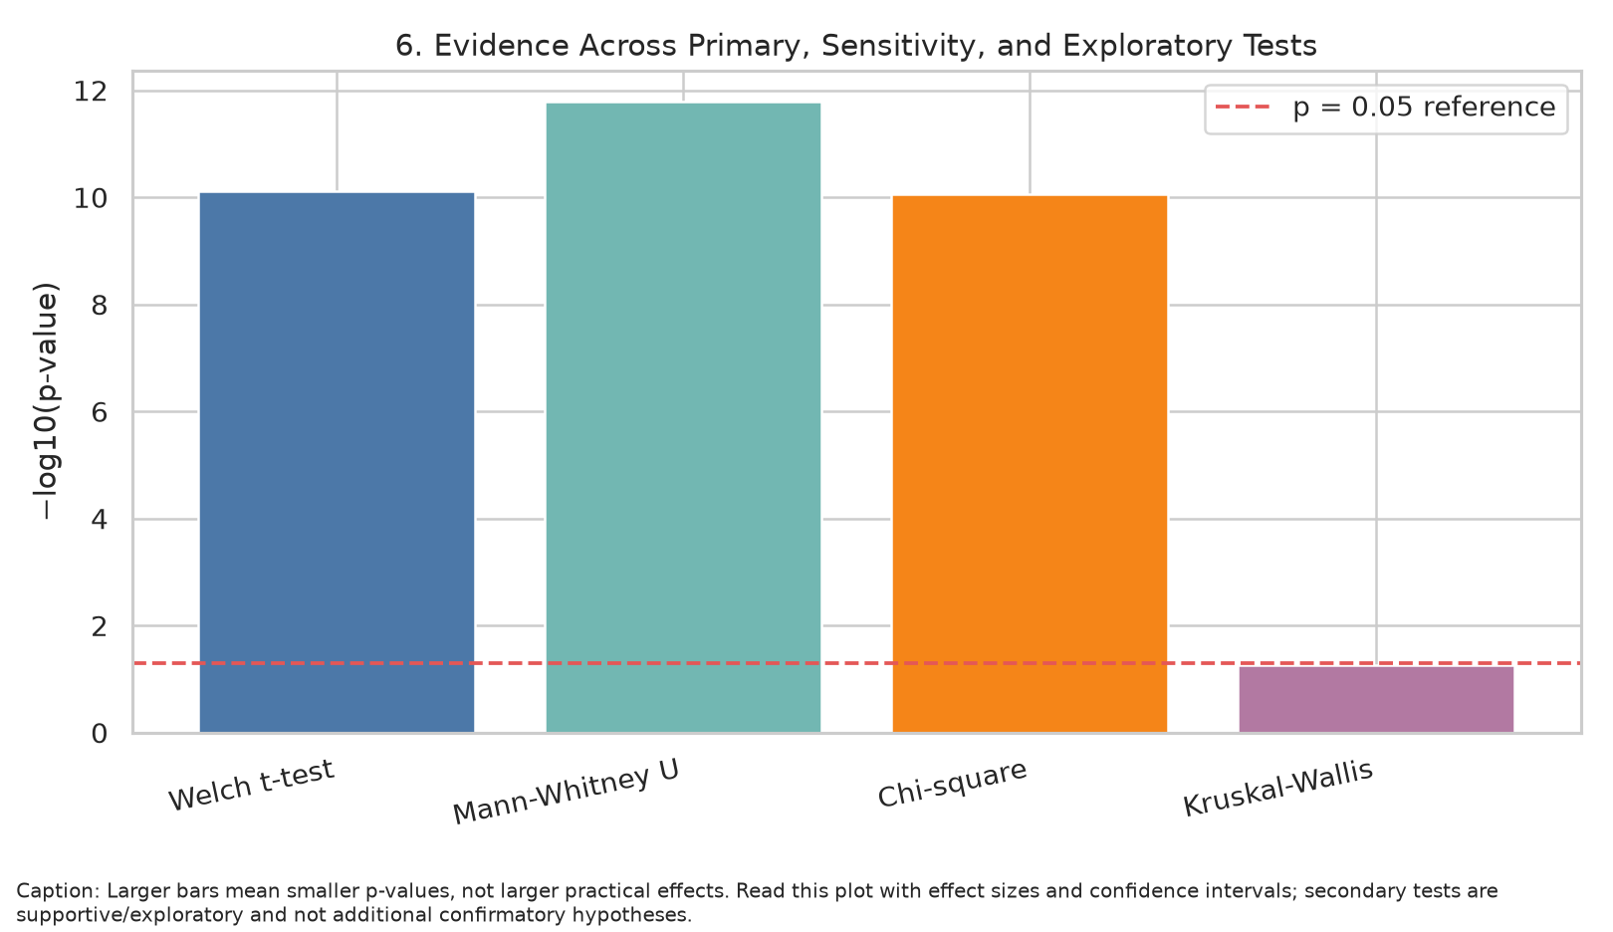
Result: Primary Welch test p = 7.6567e-11; Hedges' g = 0.93.
Why this visualization: The negative log base 10 of p-value gives a compact view of statistical evidence; it does not measure practical importance. Effect size and confidence interval remain essential.

6. Primary Result and Hypothesis Decision
Decision at α = 0.05: Reject H0 in favor of H1. The no-failure group's sample mean was 11.25 compared with 7.27 for students with at least one prior failure. The estimated difference was 3.99 points, with 95% CI [2.86, 5.11]. Hedges' g was 0.93.
Because the pre-specified one-sided p-value is below 0.05, the null hypothesis is rejected in favor of the directional alternative for this dataset. This does not prove that previous failures cause lower final grades; prior failures may reflect earlier achievement, learning context, or other factors.
The sensitivity Mann–Whitney test p-value is 1.6511e-12; the secondary chi-square result is p = 8.7144e-11. These are supplementary analyses and should not be conflated with the single primary confirmatory test.

7. Validity, Assumptions, and Limitations
- Welch's t-test assumes independent observations; it does not require equal population variances. Q-Q plots and the Mann–Whitney sensitivity test help contextualize non-normal grade distributions.
- Students are observational units; class or school clustering may affect standard errors if records share unmodelled group-level factors.
- Previous failures are not randomly assigned. Confounding and reverse timing mean the group contrast is association, not a causal effect.
- A 10/20 cutoff is used only as a descriptive threshold and may not represent every institution's policy.
- The dataset represents students from two Portuguese secondary schools; findings may not generalize to other populations.
- Secondary chi-square and Kruskal–Wallis tests are exploratory/supportive. The p-value of the primary directional Welch test is pre-specified; effect sizes and confidence intervals are reported to avoid p-value-only conclusions.

8. Conclusion and Practical Implications
The analysis provides a reproducible way to assess whether prior-failure history is associated with later academic outcomes. If the group difference is statistically significant, it can support reviewing how students who have experienced prior failure are offered timely, constructive academic support. It must not be used to label students or assume their future performance. Follow-up should account for prior grades, attendance, learning resources, and educator context, with suitable privacy protections.

9. Reproducibility and Deliverables
Run python week3_hypothesis_testing.py after installing requirements.txt. The script creates this DOCX report, Submission_Description.docx, six PNG visualizations, cleaned analysis data, a data-quality audit, and a JSON file with test statistics, effect sizes, confidence intervals, contingency-table counts, and study-time summaries.

10. References
Cortez, P. (2008). Student Performance [Dataset]. UCI Machine Learning Repository. https://doi.org/10.24432/C5TG7T
Cortez, P., & Silva, A. M. G. (2008). Using data mining to predict secondary school student performance. Proceedings of the 5th Annual Future Business Technology Conference.
Dataset page: https://archive.ics.uci.edu/dataset/320/student%2Bperformance

