WEEK 2 PROJECT REPORT

Advanced Data Visualization and Storytelling with Python
Student Performance — Mathematics | Python, Pandas, NumPy, Matplotlib, Seaborn

1. Executive Summary
This report tells a seven-chart story about 395 students in the official UCI Mathematics dataset. The mean final grade is 10.42/20, and 265 students (67.1%) meet the report's descriptive threshold of 10/20. Prior-period grade G2 has a Pearson correlation of 0.90 with G3, while the linear correlation between absences and G3 is 0.03. These results provide context for targeted support but do not prove causal relationships.

2. Audience, Question, and Narrative
Audience: educators, academic coordinators, and readers without a specialist statistics background.
Guiding question: What patterns in grades, study time, absences, and previous failures help describe academic outcomes, and which patterns deserve careful follow-up?
- Start with the final-grade distribution to establish the overall level and spread.
- Compare grade distributions across assessment periods to show the cohort-level progression.
- Highlight the relationship between second-period and final grades.
- Compare study-time groups while showing uncertainty and group sizes.
- Check absences through a density view rather than relying only on an average.
- Compare threshold attainment by previous failures, then summarize relationships in a correlation heatmap.

3. Dataset and Method
Source: UCI Machine Learning Repository, Student Performance. https://archive.ics.uci.edu/dataset/320/student%2Bperformance
DOI: https://doi.org/10.24432/C5TG7T. Acquisition: Existing official UCI Mathematics CSV: /home/runner/work/Week1-Student-Performance-EDA-Copy/Week1-Student-Performance-EDA-Copy/data/student-mat.csv. The report uses the official Mathematics course CSV (student-mat.csv), not the Portuguese-language course file.
Initial source file: 395 records. Records after duplicate removal and validation: 395. Duplicate rows removed: 0; invalid rows excluded from charts: 0. Synthetic data used: No.
The pipeline checks required grade/study/absence fields, converts numeric columns safely, removes exact duplicate rows, and validates plausible ranges before visualizing. It does not impute final grades because that would invent outcome data. Any records excluded for missing required values or invalid ranges are counted in the run metadata/audit.

4. Visualization Design and Findings

Figure 1. Final-grade distribution
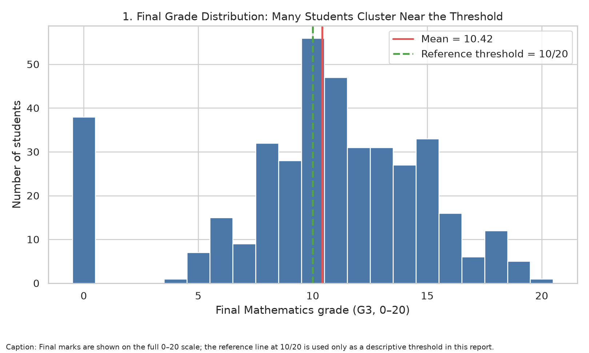
What the chart shows: Mean G3: 10.42; median: 11.0; standard deviation: 4.58. 265 students (67.1%) have G3 ≥ 10.
Why this visual: The histogram shows the full grade range. The mean and 10/20 reference line give the reader two simple points of orientation before interpreting more detailed relationships.

Figure 2. Grades across assessment periods
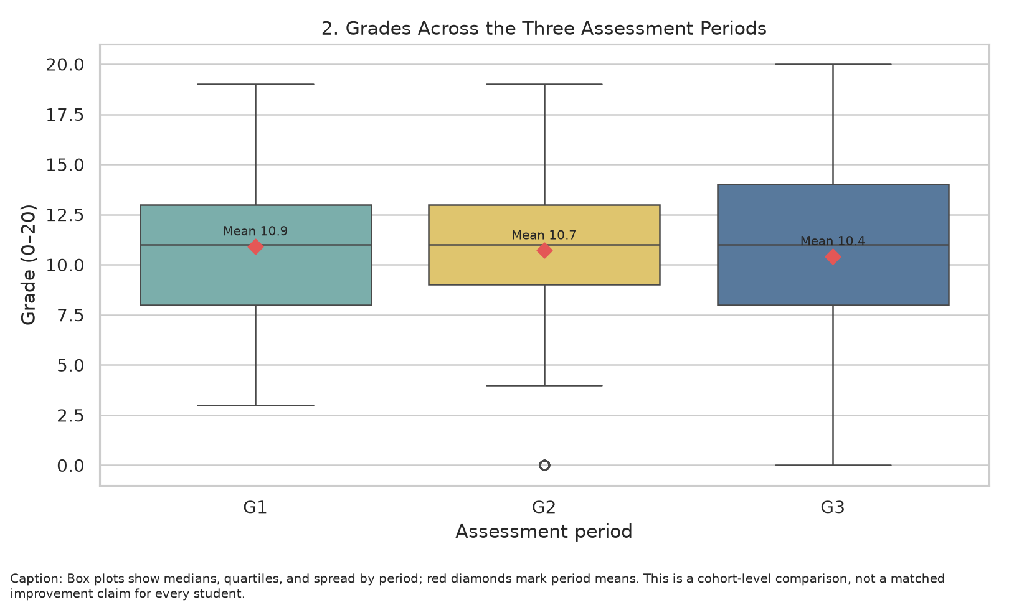
What the chart shows: Mean G1: 10.91; mean G2: 10.71; mean G3: 10.42. Compare the distributions rather than assume every student's grade increased.
Why this visual: Box plots are a compact way to compare medians, quartiles, variability, and potential extreme values. Red diamonds mark means, making central tendency easier to compare.

Figure 3. Second-period versus final grade
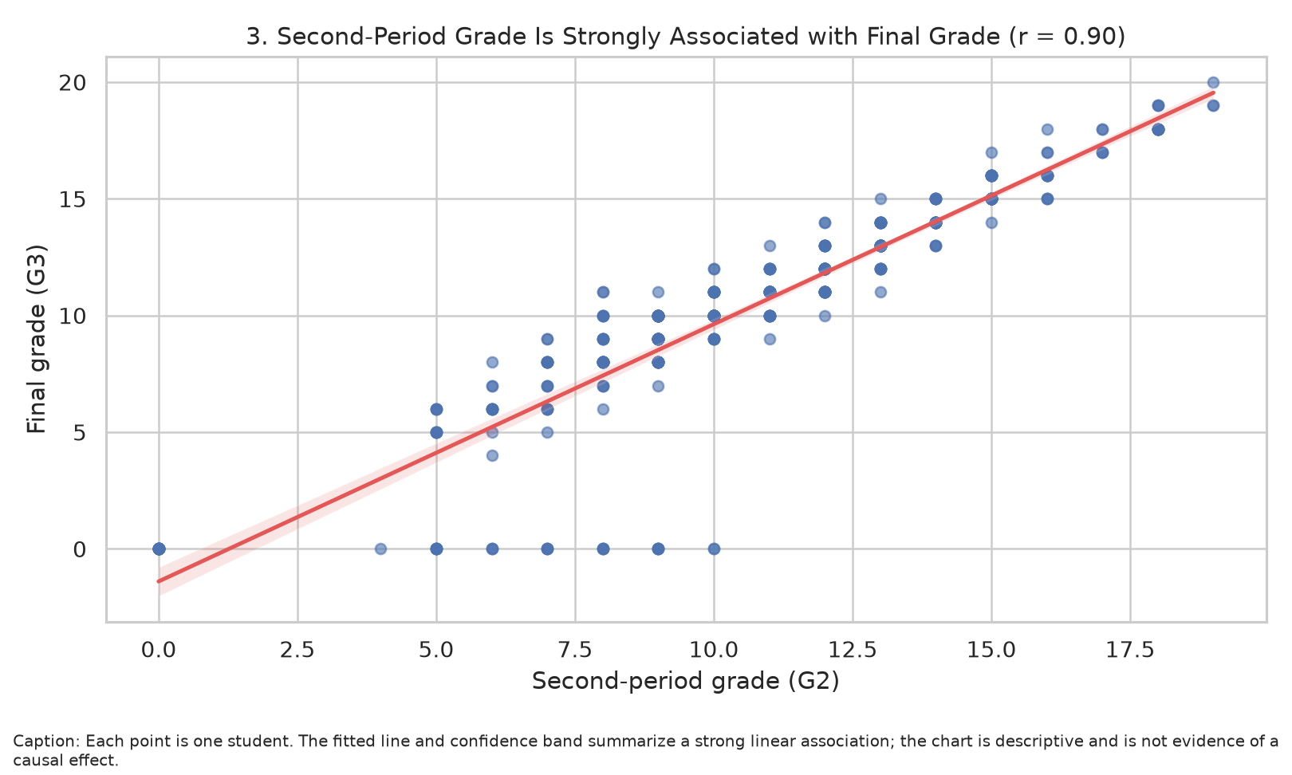
What the chart shows: Pearson correlation between G2 and G3: 0.90. G2 and G3 come from the same course timeline, so this relationship should not be described as causal.
Why this visual: A scatter plot preserves individual observations; a fitted line and confidence band expose the strength and direction of a linear association.

Figure 4. Study-time comparison
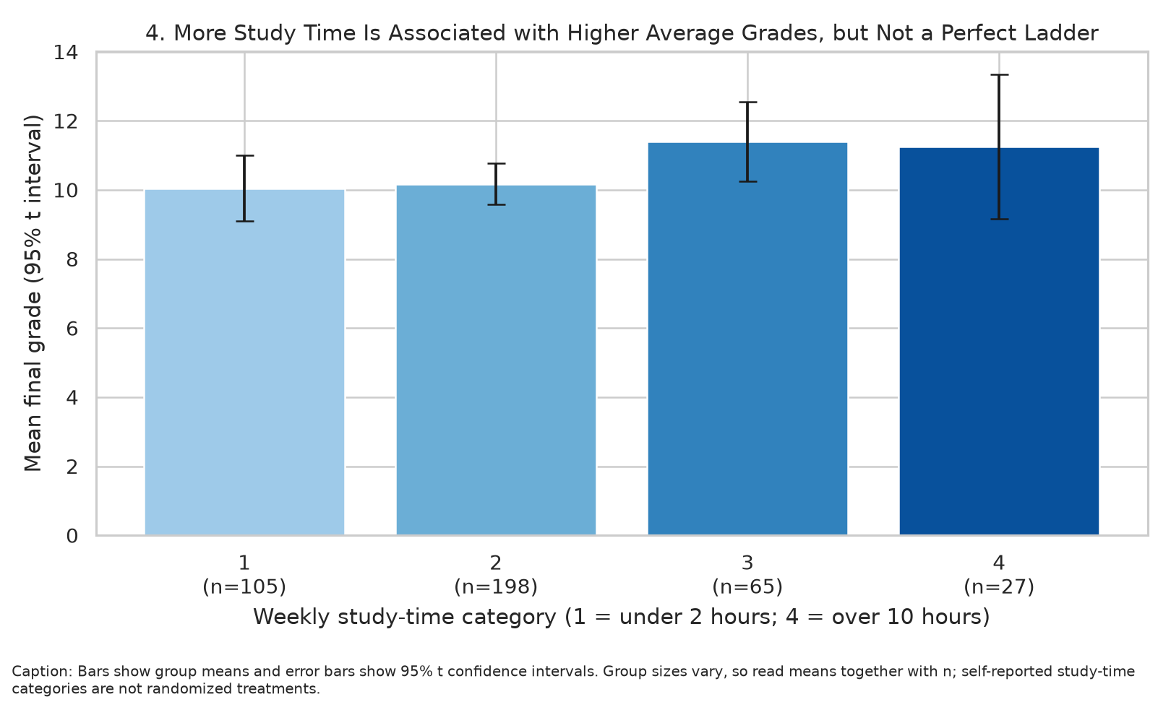
What the chart shows: Weekly study time is self-reported and categories are observational. Mean differences may reflect other variables, including prior attainment and support.
Why this visual: A bar chart with confidence intervals compares group means, and sample-size labels prevent a small group from looking as certain as a large one.

Figure 5. Absences and final-grade density
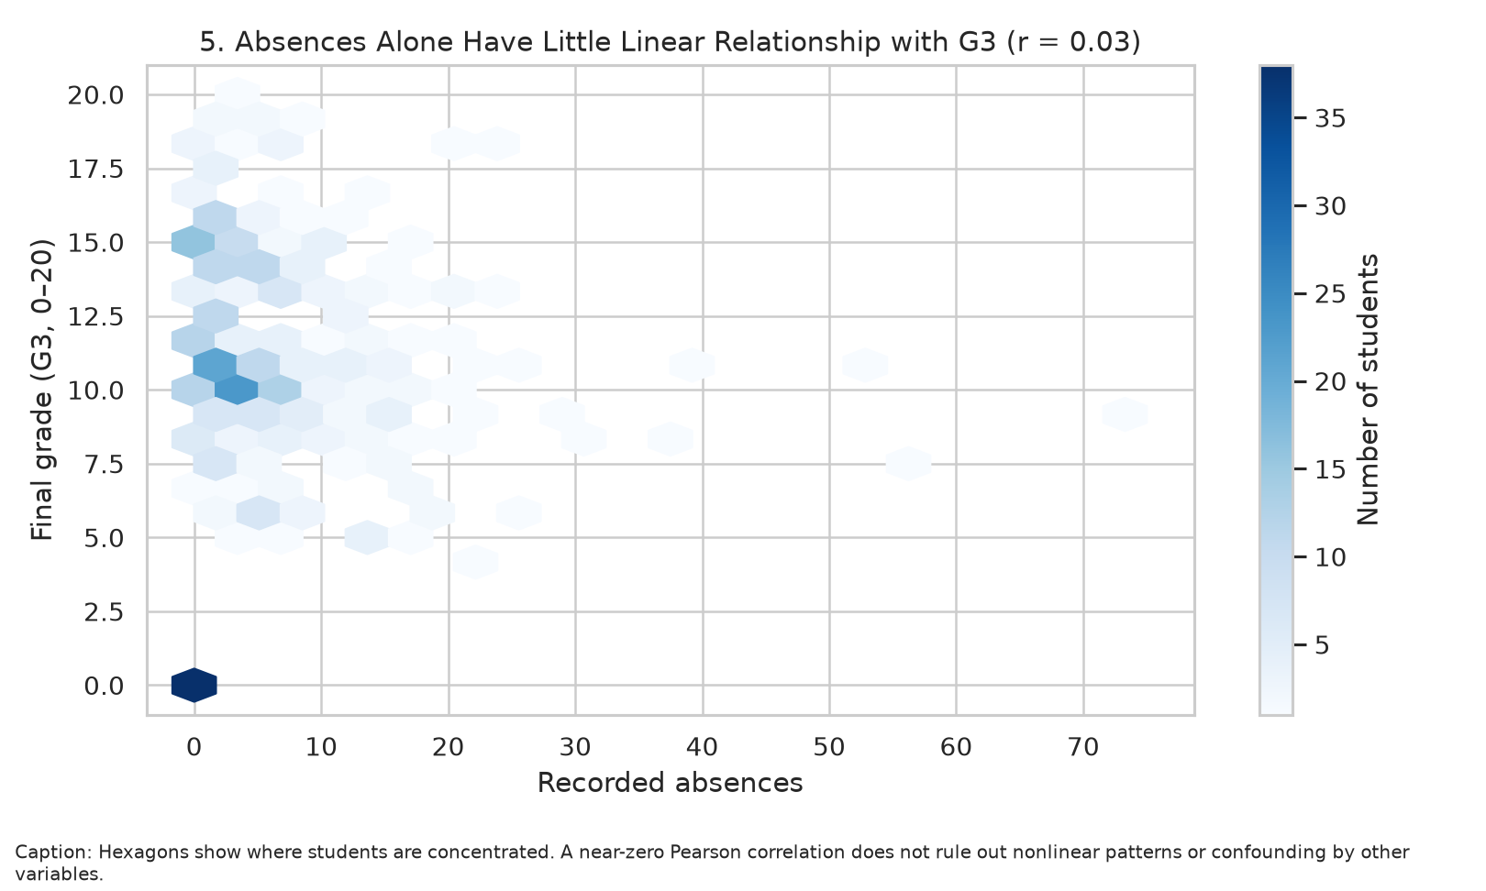
What the chart shows: Pearson correlation between absences and G3: 0.03. A weak linear correlation does not rule out nonlinear relationships or hidden factors.
Why this visual: Hexbin aggregates overlapping points into cells. This shows where students are concentrated and avoids a dense scatter plot becoming difficult to read.

Figure 6. Pass-threshold rate by prior failures
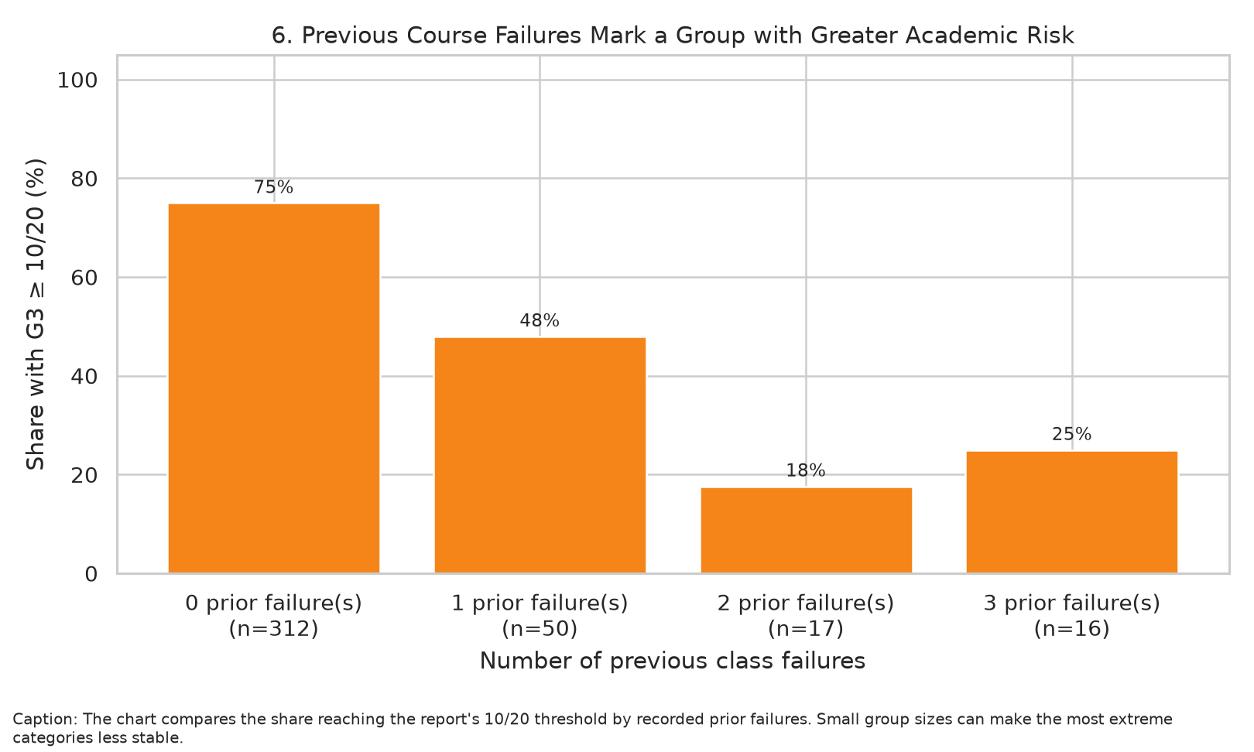
What the chart shows: Previous failures are an indicator of risk in these records, not a label for an individual student. Small groups can have unstable percentages.
Why this visual: A bar chart converts the binary threshold outcome into percentages that are easy to compare. Sample sizes are included because failure groups may be unequal.

Figure 7. Correlation heatmap
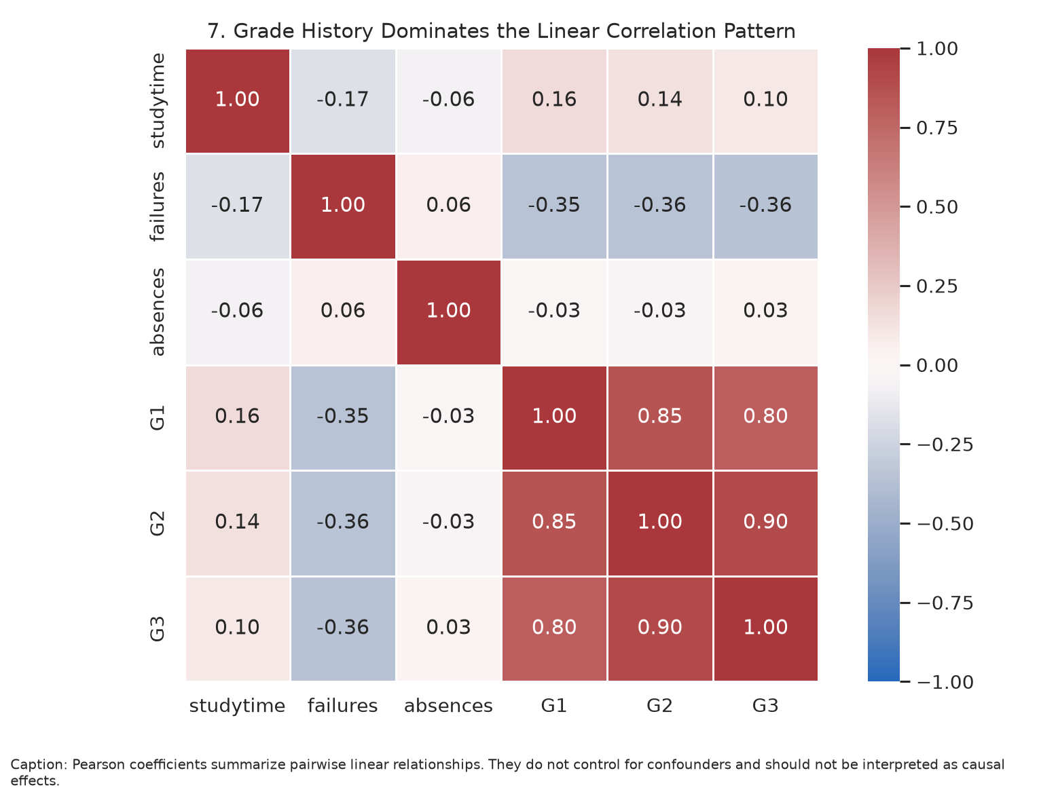
What the chart shows: G2–G3 correlation: 0.90; absences–G3 correlation: 0.03; failures–G3 correlation: -0.36. Correlation is not causation.
Why this visual: A single heatmap summarizes the direction and magnitude of several pairwise linear relationships, making the strong grade-history pattern visible at a glance.

5. Business / Scientific Implications
For educators, the results support using multiple signals rather than relying on a single variable. Earlier-period grades may help identify students who could benefit from timely check-ins, and previous failure history can provide context for offering additional academic support. The weak overall linear relationship between absences and final marks in this sample suggests that absences alone would be a poor substitute for reviewing a student's broader circumstances.
Recommended follow-up is supportive, not punitive: combine teacher context, formative assessment, attendance records, and student input before deciding on an intervention. The charts describe associations in historical records and should not be used as a deterministic ranking of individual students.

6. Limitations and Responsible Interpretation
- The dataset is observational; visual patterns do not prove causes.
- The records come from two Portuguese secondary schools, so results may not transfer directly to other education systems.
- Study time is reported in categories rather than measured as an exact number of hours.
- A threshold of G3 ≥ 10 is used as a convenient analytical indicator in this report, not as a universal institutional policy.
- G1 and G2 are earlier grades from the same course. They are informative for retrospective description but may create target leakage in a prediction model if their timing is not handled correctly.
- Small categories and outliers can affect the reliability of means and rates; sample sizes and uncertainty should be considered.

7. Reproducibility and Files
Run python week2_storytelling.py after installing requirements.txt. The script writes seven figures under visualizations/, computed metrics and audit information under outputs/, this Word report, and a separate Word version of the submission description. The dataset is acquired from the official UCI archive or the checked Week 1 source file.

8. Conclusion
The story is not that one factor explains grades; rather, grade history stands out in the correlation pattern, study-time groups show descriptive differences, and absences have a weak linear relationship with final grade in this cohort. Visuals, captions, group sizes, and limitations together make these findings clearer while discouraging unsupported causal claims.

9. References
Cortez, P. (2008). Student Performance [Dataset]. UCI Machine Learning Repository. https://doi.org/10.24432/C5TG7T
Cortez, P., & Silva, A. M. G. (2008). Using data mining to predict secondary school student performance. Proceedings of the 5th Annual Future Business Technology Conference.
Dataset page: https://archive.ics.uci.edu/dataset/320/student%2Bperformance

