WEEK 1 PROJECT REPORT

Data Acquisition, Cleaning, and Exploratory Data Analysis
UCI Student Performance — Mathematics course | Python, Pandas, NumPy, Matplotlib, Seaborn

1. Objective
This project demonstrates data acquisition, data-quality inspection, cleaning, summary statistics, visualization, and interpretation using a publicly available student-performance dataset. The analysis focuses on final grade (G3) and its relationship with study time, school absences, and previous period grades.

2. Dataset and acquisition
The Mathematics file student-mat.csv is part of the UCI Machine Learning Repository Student Performance dataset. It contains grade records, study habits, absences, demographics, and family/social context for Portuguese secondary-school students. The script downloads the UCI ZIP archive and extracts the official Mathematics CSV; synthetic fallback data is not used.
Official source: https://archive.ics.uci.edu/dataset/320/student%2Bperformance
DOI: https://doi.org/10.24432/C5TG7T
Acquisition: Downloaded from official UCI ZIP archive: https://archive.ics.uci.edu/static/public/320/student+performance.zip
Initial table size: 395 rows × 33 columns.

3. Methodology and cleaning decisions
- Acquire the source archive and load the Mathematics course CSV using its semicolon delimiter.
- Inspect dimensions, column types, duplicate rows, and missing cells.
- Trim whitespace in text fields and safely convert numeric fields.
- Check plausible ranges for grades, absences, study-time ratings, age, and scaled questionnaire variables; invalid values are treated as missing.
- Remove exact duplicate rows; impute numeric missing values with column medians and categorical missing values with the most frequent category (or Unknown if no mode exists).
- Export the cleaning audit and summary statistics for reproducibility.
These checks are retained even though the UCI dataset documentation indicates that the original data has no missing values. No valid record is dropped solely because a value is missing; the script records every duplicate, invalid value, and imputation in outputs/cleaning_audit.csv.

Cleaning audit
Metric | Value
rows_before_cleaning | 395
columns_before_cleaning | 33
duplicate_rows_removed | 0
rows_after_duplicate_removal | 395
missing_cells_before_range_validation | 0
invalid_values_marked_missing | 0
numeric_cells_imputed | 0
categorical_cells_imputed | 0
missing_cells_after_cleaning | 0
invalid_values_age | 0
invalid_values_Medu | 0
invalid_values_Fedu | 0
invalid_values_traveltime | 0
invalid_values_studytime | 0
invalid_values_failures | 0
invalid_values_famrel | 0
invalid_values_freetime | 0
invalid_values_goout | 0
invalid_values_Dalc | 0
invalid_values_Walc | 0
invalid_values_health | 0
invalid_values_absences | 0
invalid_values_G1 | 0
invalid_values_G2 | 0
invalid_values_G3 | 0

4. Exploratory data analysis
G3 is the final Mathematics grade on a 0–20 scale. For descriptive reporting only, G3 ≥ 10 is used as an operational pass threshold; this should not be taken as a statement about every institution's grading policy.

Figure 1. Final-grade distribution
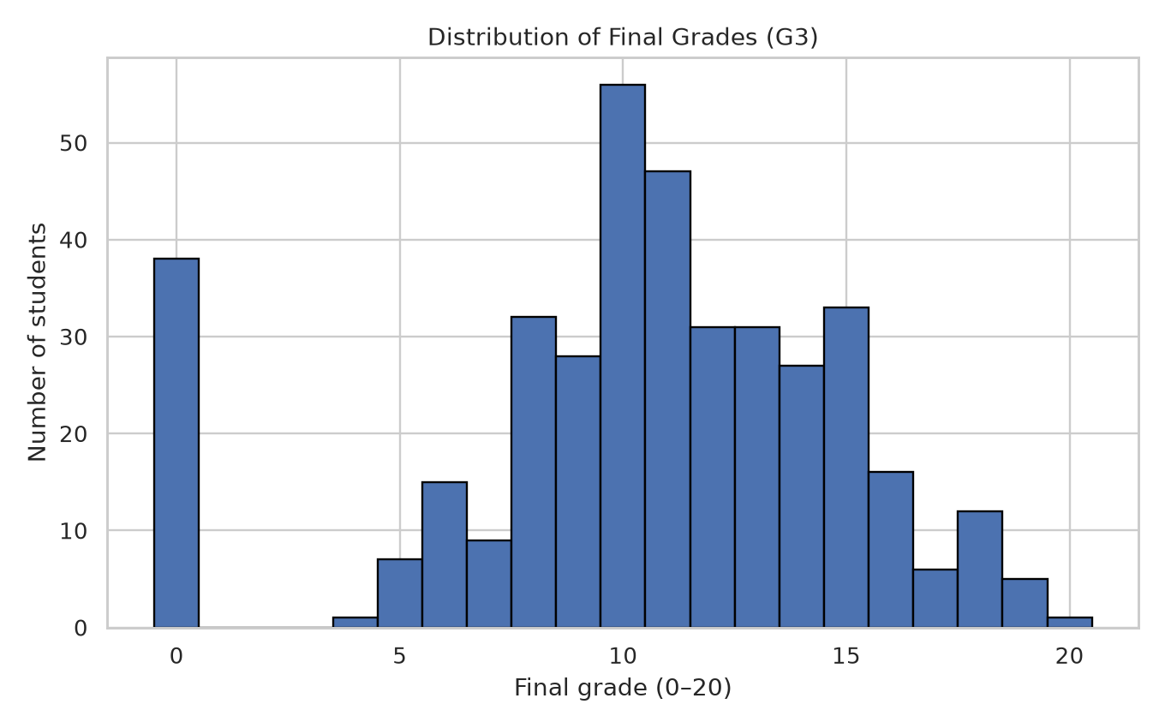
The histogram shows how final marks are spread across the 0–20 range.

Figure 2. Average final grade by weekly study time
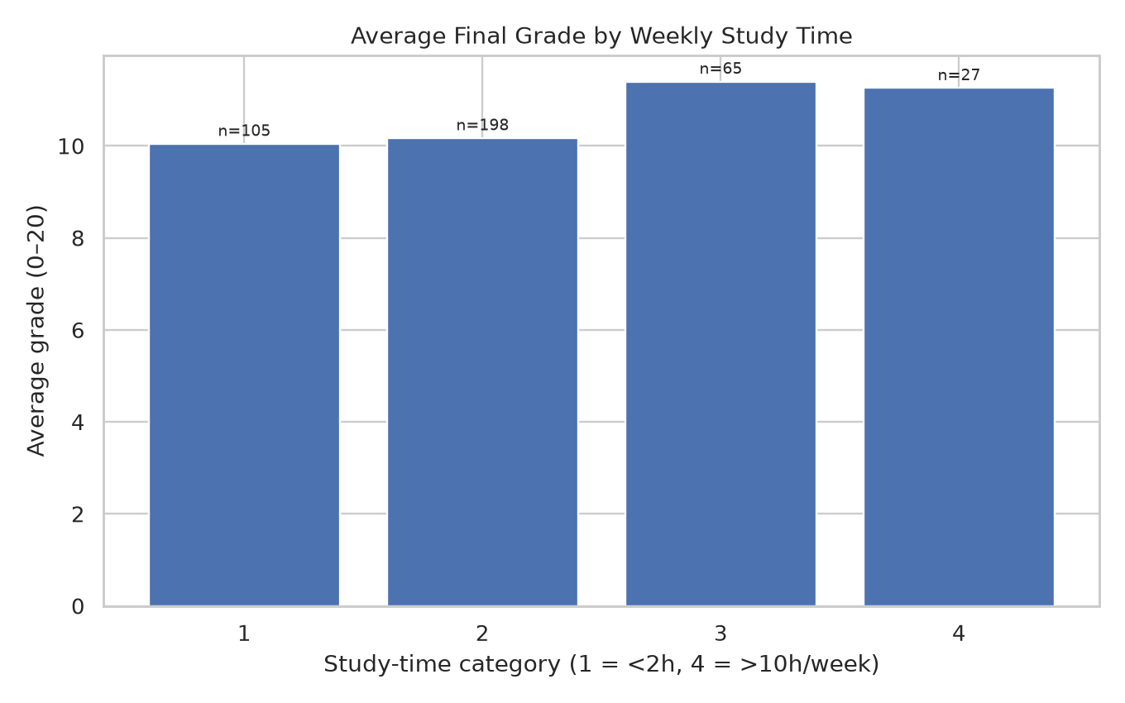
Group means compare the four study-time categories; sample sizes are printed above bars. Differences are associations, not proof of causation.

Figure 3. Absences versus final grade
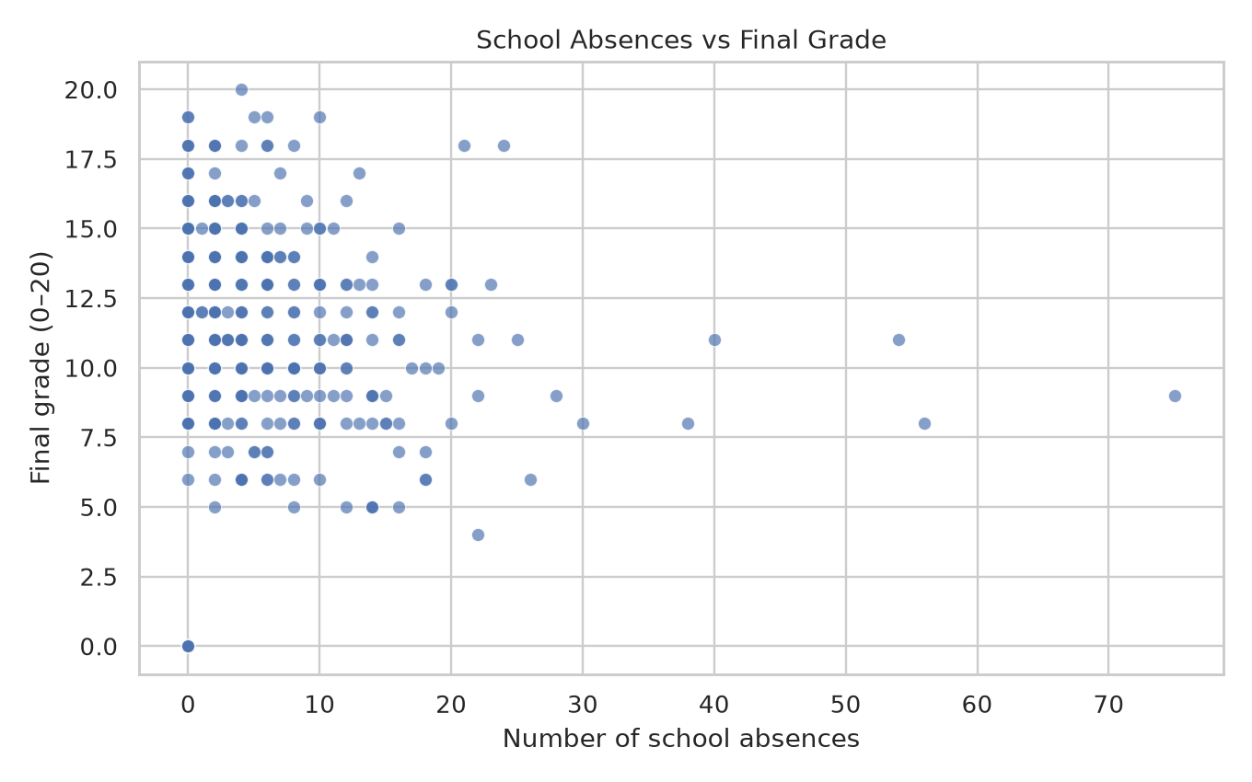
The scatter plot shows the distribution of marks by recorded absences and helps reveal variation and potential outliers.

Figure 4. Numeric correlation heatmap
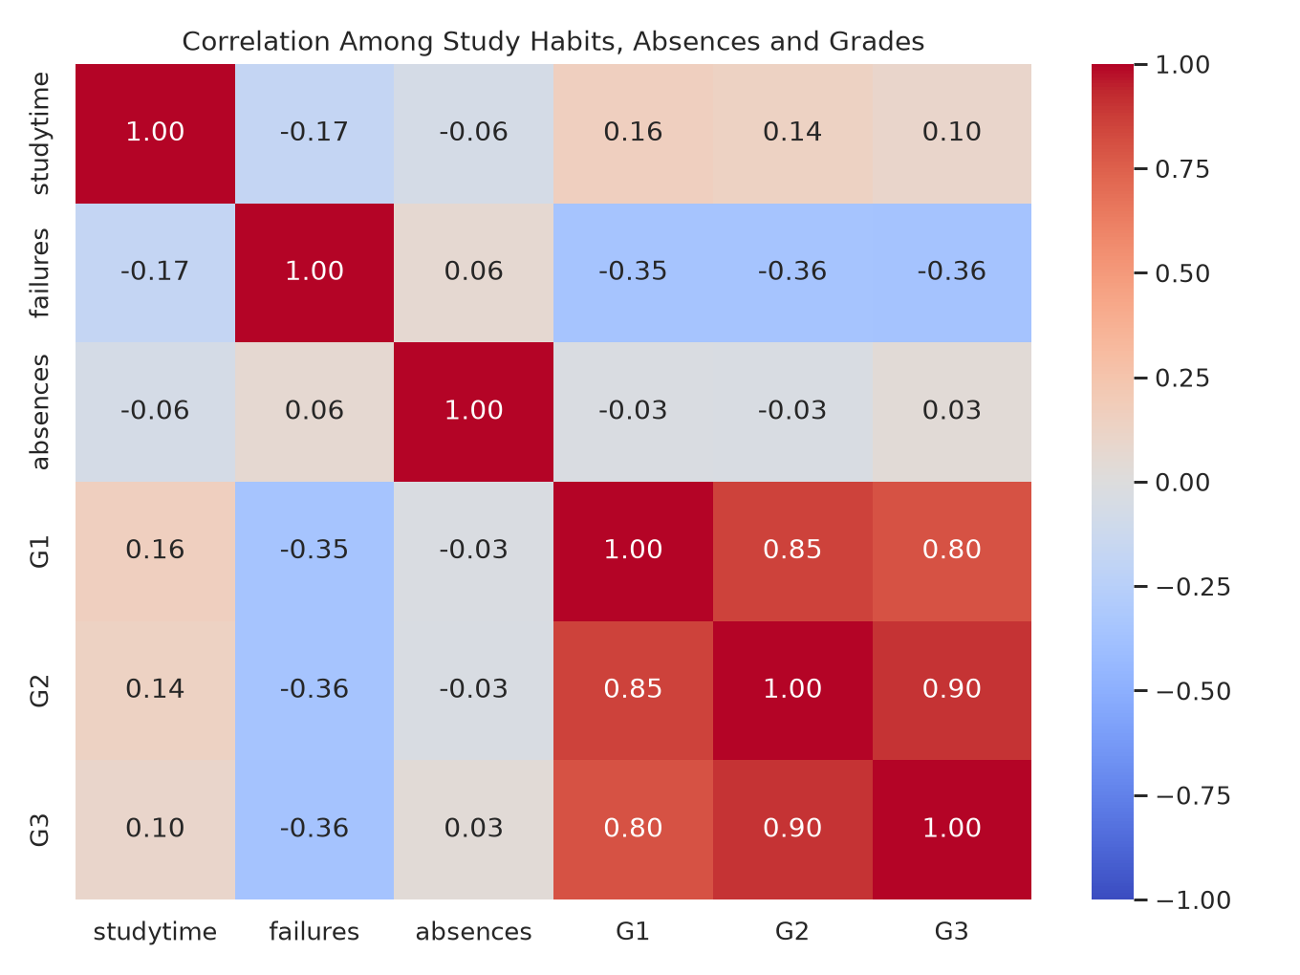
The heatmap compares linear correlations among study time, failures, absences, and grades. Correlation does not establish causation.

5. Results and insights from the official data
After cleaning, the dataset contains 395 students and 33 columns. G3 has a mean of 10.42, a median of 11.00, a standard deviation of 4.58, and a range of 0–20.
With the report's G3 ≥ 10 pass indicator, 265 students (67.1%) meet the threshold and 130 are below it.
Study-time category 3 has the highest average final grade among represented categories: 11.40. Categories mean: 1 = less than 2 hours, 2 = 2–5 hours, 3 = 5–10 hours, and 4 = more than 10 hours per week.
Pearson correlations with G3 are 0.034 for absences, 0.801 for G1, and 0.905 for G2. G1 and G2 are earlier grades from the same course, so their correlation with final marks is expected and creates a target-leakage risk if used for predictions made before those grades exist.

6. Limitations
- The records are observational; correlations cannot prove causal effects.
- Study-time groups can differ in other factors, and group sizes should be considered.
- G1 and G2 are closely linked to G3 by the grading timeline and should be avoided in prediction models intended to operate before those marks are available.
- Data from two Portuguese secondary schools should not automatically be generalized to all students or countries.

7. Reproducibility and outputs
Install packages from requirements.txt and run python student_performance_eda.py. The script saves the official source CSV in data/, cleaned data and audit/statistics files in outputs/, four PNG visualizations in visualizations/, metadata proving that synthetic fallback was not used, and this DOCX report in the project root. If UCI retrieval fails and no previously downloaded official CSV exists, the script exits with an error rather than generating substitute findings.

8. Conclusion
The project demonstrates a reproducible workflow for acquiring, cleaning, and exploring a real public dataset. The cleaning audit makes transformations transparent, while grade-distribution, study-time, absence, and correlation visualizations provide complementary views of student achievement. The findings are descriptive and should be interpreted with due attention to observational-data limitations.

9. References
Cortez, P. (2008). Student Performance [Dataset]. UCI Machine Learning Repository. https://doi.org/10.24432/C5TG7T
Cortez, P., & Silva, A. M. G. (2008). Using data mining to predict secondary school student performance. Proceedings of the 5th Annual Future Business Technology Conference.
Dataset page: https://archive.ics.uci.edu/dataset/320/student%2Bperformance

