WEEK 5 CAPSTONE REPORT

Comprehensive Data Science Project Reporting and Strategic Recommendations
Integrated analysis of UCI Student Performance — Mathematics | Weeks 1–4 synthesis

1. Executive Summary
This capstone integrates data preparation, exploratory analysis, visual storytelling, hypothesis testing and machine learning for 395 student records from the official UCI Mathematics dataset. Average final grade is 10.42/20 (median 11.0); 265 students (67.1%) meet the report's descriptive threshold of 10/20. The pre-specified Welch test found that students with no prior failures had a mean G3 of 11.25, compared with 7.27 for students with one or more failures; difference 3.99 points, 95% CI [2.86, 5.11], p=7.7e-11. A Logistic Regression model trained without G1/G2 achieved held-out ROC-AUC 0.595, only modestly above chance. Consequently, the most defensible recommendation is to use transparent descriptive indicators to guide supportive review, not to automate decisions about students.

Executive Recommendations
- Offer timely, supportive academic review to students with recorded prior failures, while considering individual context rather than using a single variable as a label.
- Treat the current classifier as a learning prototype only; its test ROC-AUC indicates limited discrimination and does not justify operational deployment.
- Validate any future model on larger, newer and more diverse cohorts; assess calibration, subgroup error rates, privacy and fairness before considering use.
- Keep analysis reproducible with documented cleaning, held-out evaluation, effect sizes, confidence intervals and clear limitations.

2. Project Scope and Research Questions
Business/scientific objective: summarize student achievement patterns, test one clear hypothesis, evaluate whether non-grade context variables can classify a descriptive grade threshold, and translate the evidence into careful recommendations for educators.
- EDA question: How are final grades distributed, and how do they relate to prior grade history, absences, study-time categories and previous failures?
- Statistical question: Do students with no recorded previous class failures have a higher mean final grade than students with one or more prior failures?
- Modeling question: How well can non-grade features classify whether G3 reaches 10/20, when G1 and G2 are excluded to avoid target leakage?
- Decision question: Which actions are supported by the evidence, and what additional validation is needed?

3. Dataset, Acquisition and Quality
Source: UCI Machine Learning Repository, Student Performance Mathematics file. Dataset page: https://archive.ics.uci.edu/dataset/320/student%2Bperformance. DOI: https://doi.org/10.24432/C5TG7T. Acquisition method: Official UCI Mathematics CSV already present in the Week 1 repository. The analysis uses the official data, not a synthetic substitute.
The source contained 395 rows and 33 columns. The quality audit recorded 0 exact duplicates, 0 missing cells in required analysis fields and 0 rows removed for invalid ranges. After preparation, 395 records remain.
Cleaning process: trim text fields; safely convert known numeric columns; check required fields; remove exact duplicates; validate grade, study-time, previous-failure and absence ranges; exclude records with missing target/required values rather than fabricate grade outcomes. The original official dataset had no missing values or exact duplicates under these checks, so no imputation or row removal was needed in this run.

4. Integrated Methodology

4.1 Week 1 — Cleaning and EDA
Final grade G3 has mean 10.42, median 11.0, standard deviation 4.58, and range 0–20. The dataset has 265 cases at or above 10/20 and 130 below. The 10/20 cut-off is used only as an analysis convention, not a universal school policy.
G2 and G3 have Pearson correlation 0.905; absences and G3 correlation is 0.034; recorded failures and G3 correlation is -0.360. These are descriptive pairwise relationships and do not establish cause.

4.2 Week 2 — Visual Storytelling
Charts are arranged as a narrative: establish the overall grade distribution, compare grade history and context, then show the prior-failure contrast and the limitations of predictive modeling. Captions explain the analytical purpose, and the report distinguishes observations from recommendations.

4.3 Week 3 — Hypothesis Test
H0: μ(no prior failures) ≤ μ(one or more failures). H1: μ(no prior failures) > μ(one or more failures). The one-sided Welch independent-samples t-test was specified as primary at α=0.05; Welch's method avoids assuming equal group variances. A two-sided 95% confidence interval for the mean difference and Hedges' g are reported. Mann–Whitney U is a sensitivity analysis; chi-square tests association with threshold attainment; Kruskal–Wallis compares full grade distributions across study-time categories.
Primary result: t=7.016, df=118.38, p=7.66e-11; difference=3.99, 95% CI [2.86, 5.11], Hedges' g=0.93. Decision: Reject H0 at alpha=0.05. Mann–Whitney p=1.65e-12. Chi-square p=8.71e-11, Cramér's V=0.33. Kruskal–Wallis by study time p=0.056; at α=0.05 it does not cross the significance threshold.

4.4 Week 4 — Machine Learning
The binary target is 1 when G3 ≥ 10 and 0 otherwise. G1, G2 and G3 are excluded from predictors so the model does not rely on earlier grades that may not be available in a prospective prediction setting. Numeric variables use median imputation and scaling; categorical variables use most-frequent imputation and one-hot encoding inside Scikit-learn pipelines. Models are selected using stratified five-fold CV ROC-AUC on training data, then evaluated on a held-out stratified test split.
Candidate models: Dummy prior baseline, Logistic Regression, Decision Tree and Random Forest. The chosen model is Logistic Regression. Training CV mean ROC-AUC is 0.689; test accuracy 0.595, balanced accuracy 0.561, precision 0.714, recall 0.660, F1 0.686, and ROC-AUC 0.595.
The test-set ROC-AUC is modest and therefore does not indicate strong discrimination. Cross-validation scores are more favorable than the final held-out score, illustrating how performance estimates can vary across splits and why external validation is essential.

5. Evidence-Based Visualizations

Figure 1. Final-grade distribution
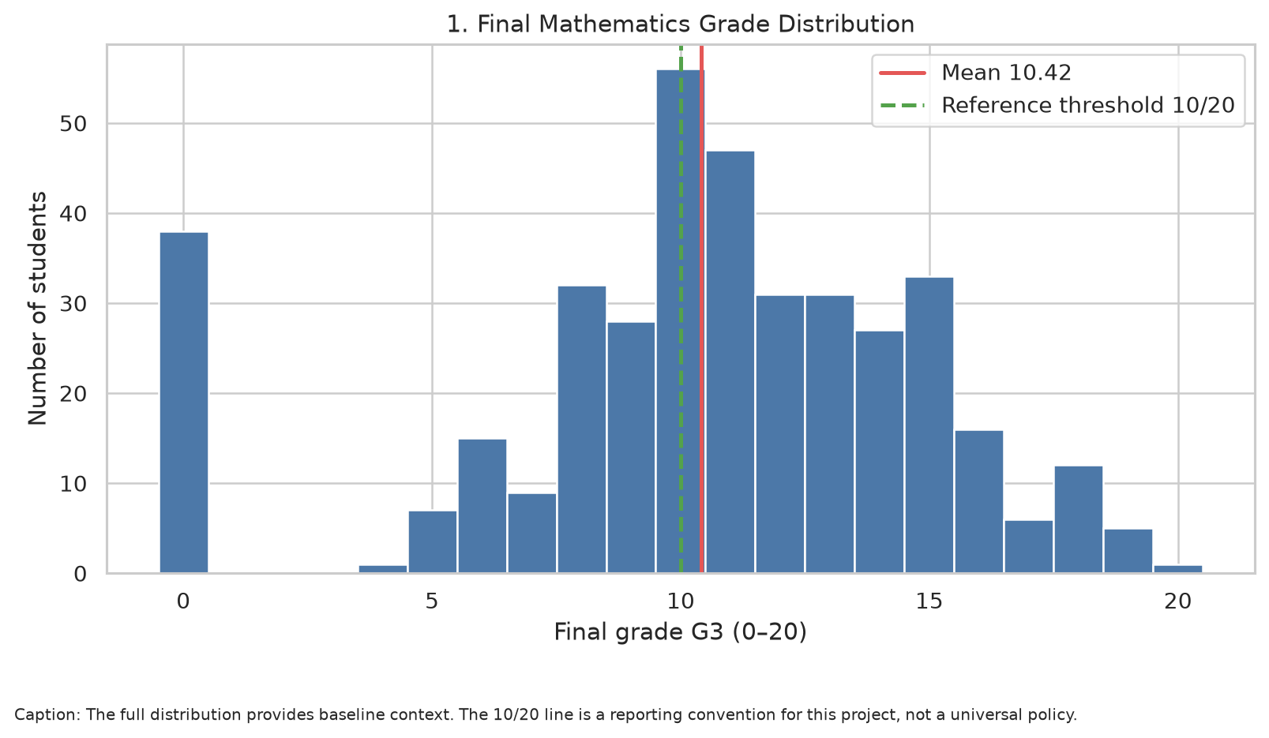
Interpretation: Establishes the outcome scale, spread and reference threshold before more complex results.

Figure 2. Grade distributions across assessment periods
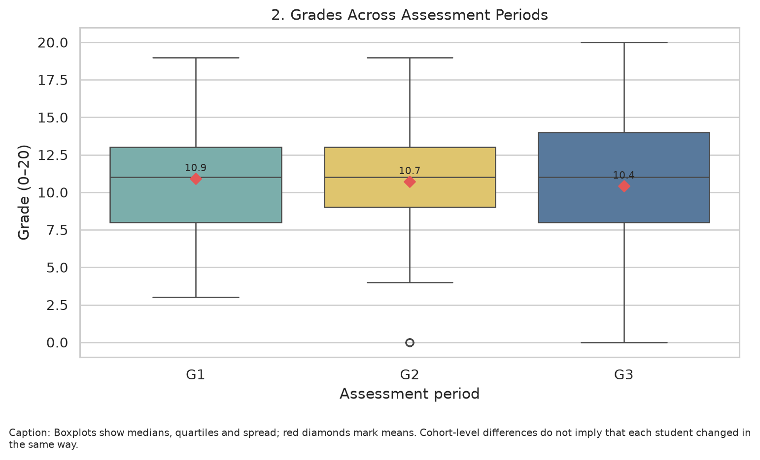
Interpretation: Compares medians, quartiles and means to show cohort patterns without assuming all students improved.

Figure 3. Mean G3 by previous-failure group
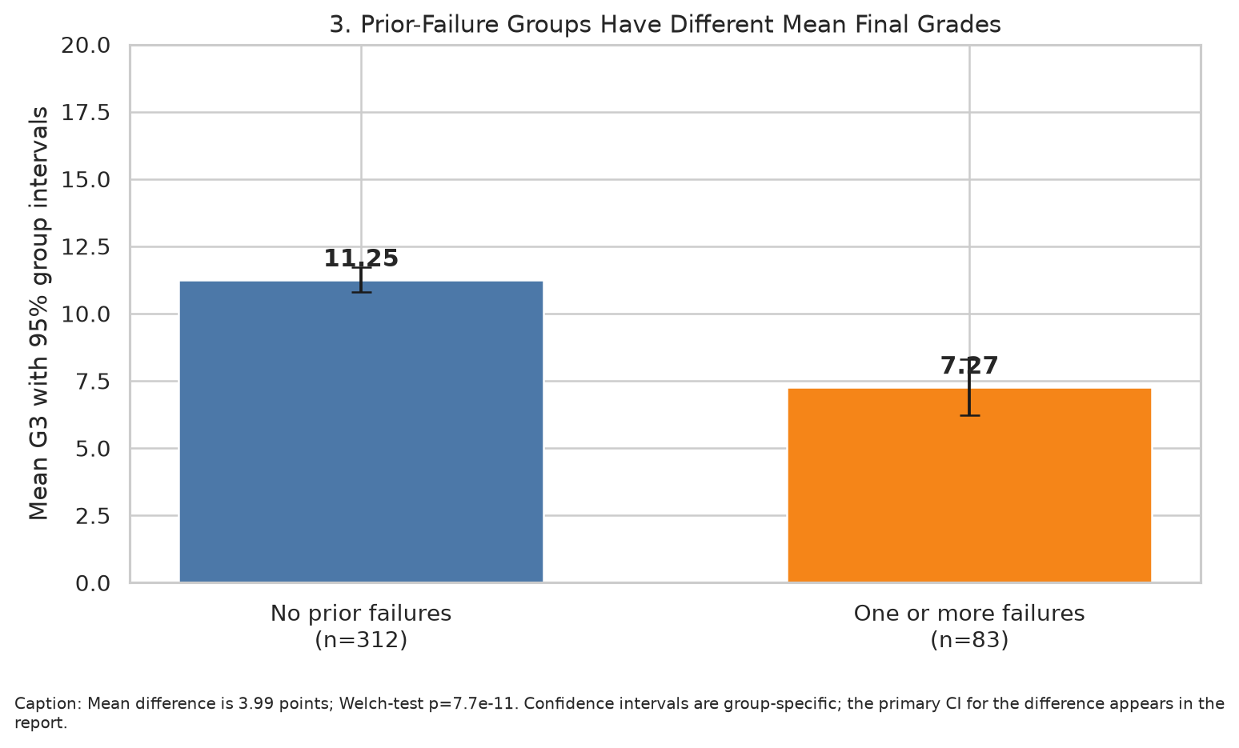
Interpretation: Connects a key EDA pattern to the primary Welch test; uncertainty and group sizes are shown.
Observed means are 11.25 with no prior failures and 7.27 with one or more failures. The difference is statistically significant in this sample, but confounding prevents a causal conclusion.

Figure 4. Correlation heatmap
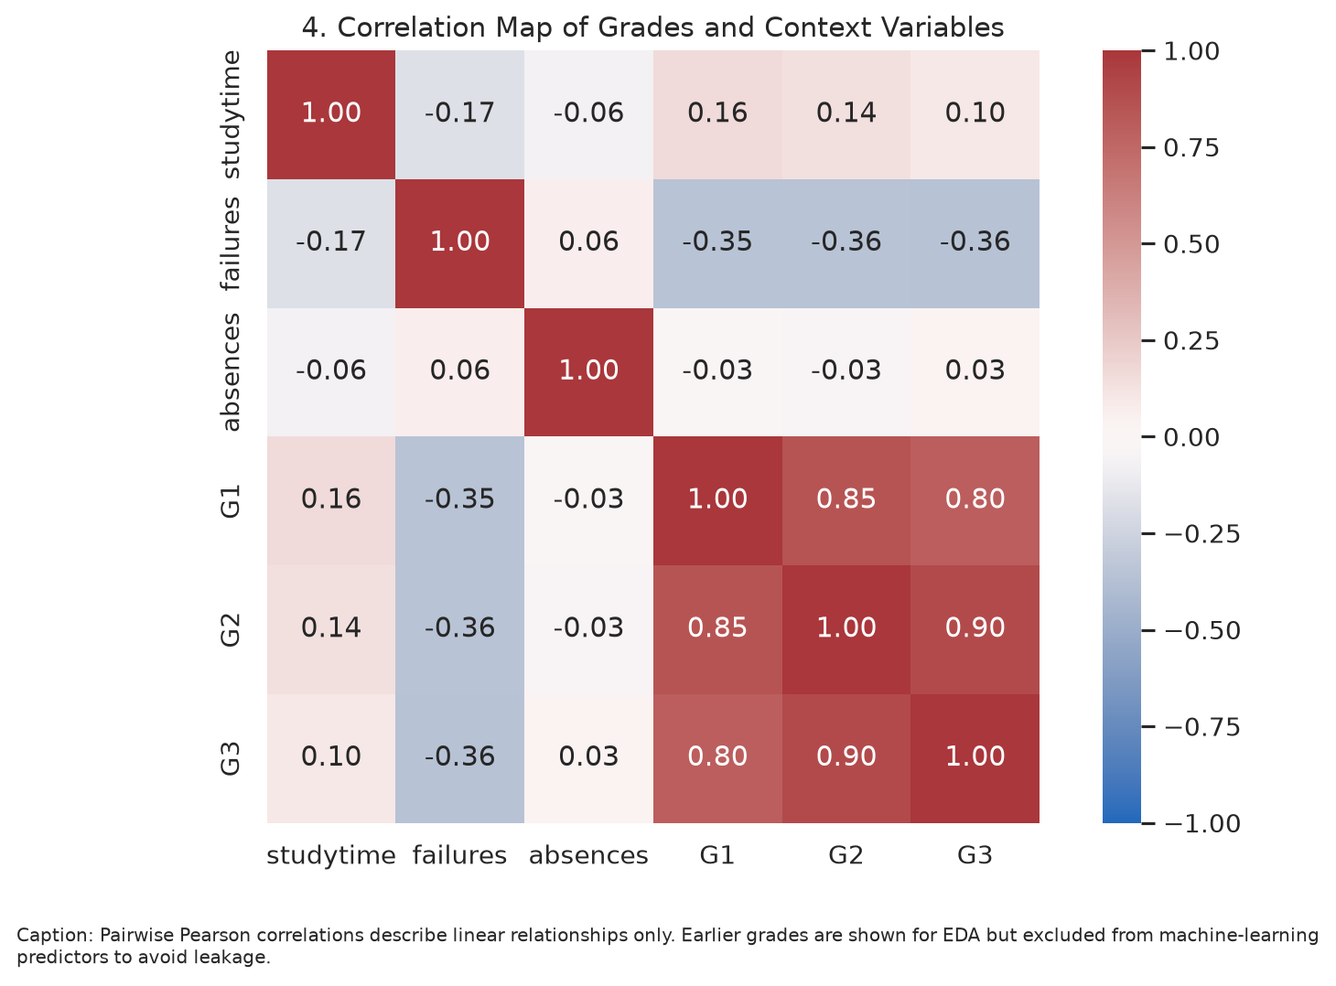
Interpretation: Summarizes pairwise linear relationships and reinforces why G1/G2 are excluded from the prospective ML feature set.

Figure 5. Threshold attainment by previous-failure group
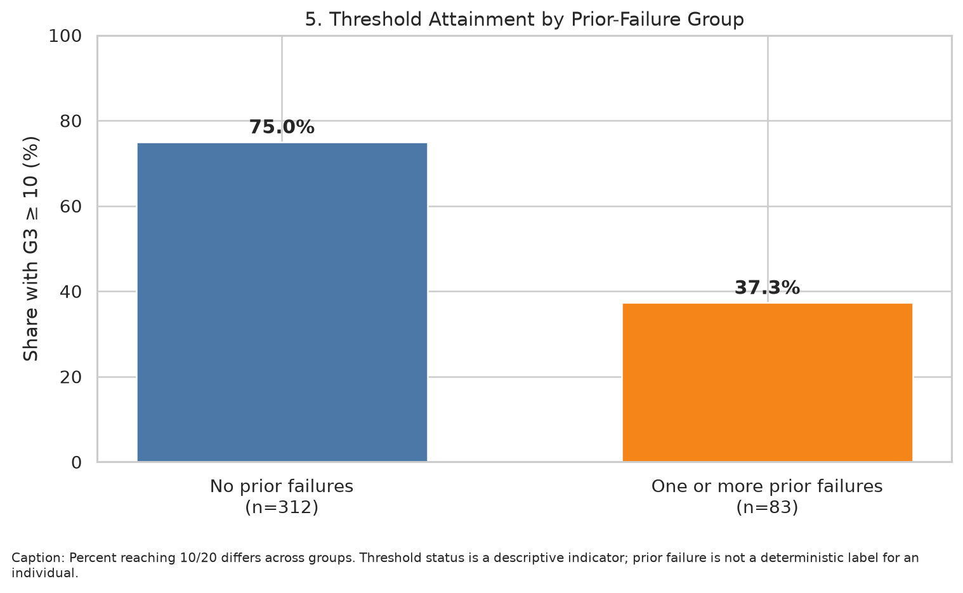
Interpretation: Communicates the magnitude of the group association in a simple percentage format.

Figure 6. Cross-validation model comparison
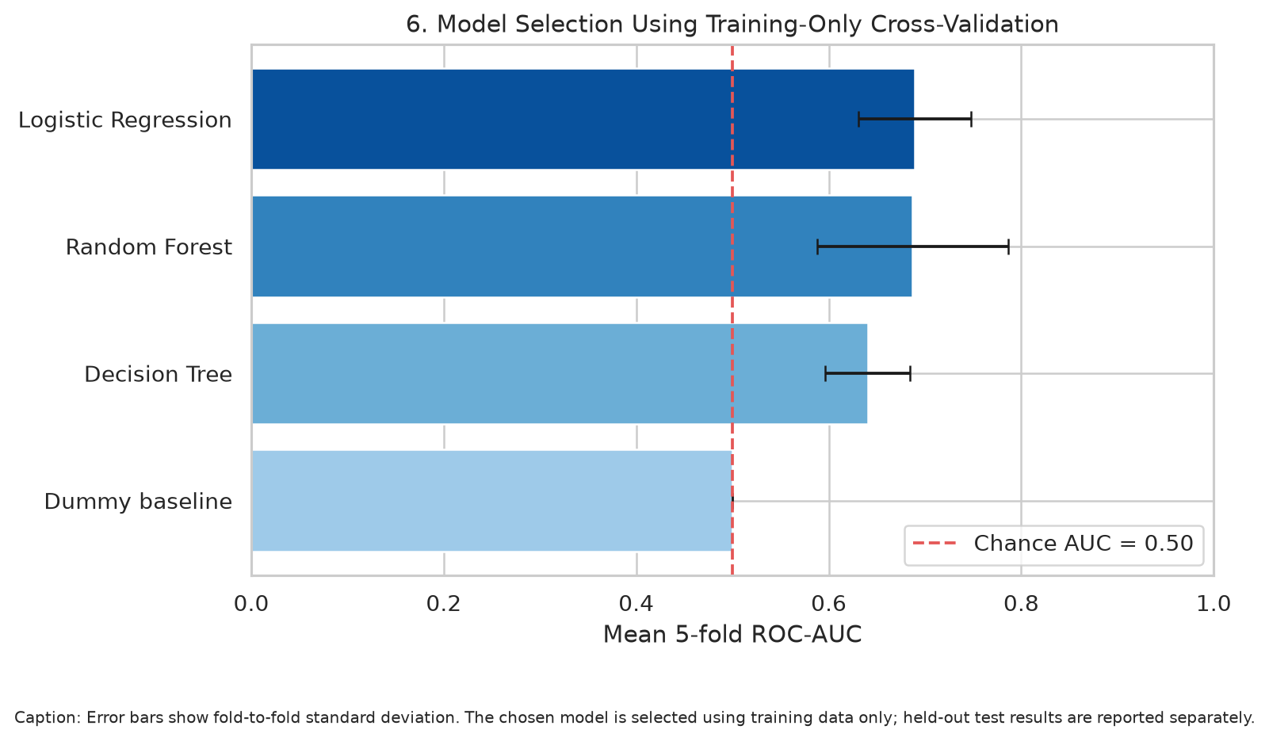
Interpretation: Shows how candidate algorithms compare using training-only validation, with fold variability.

Figure 7. Test confusion matrix
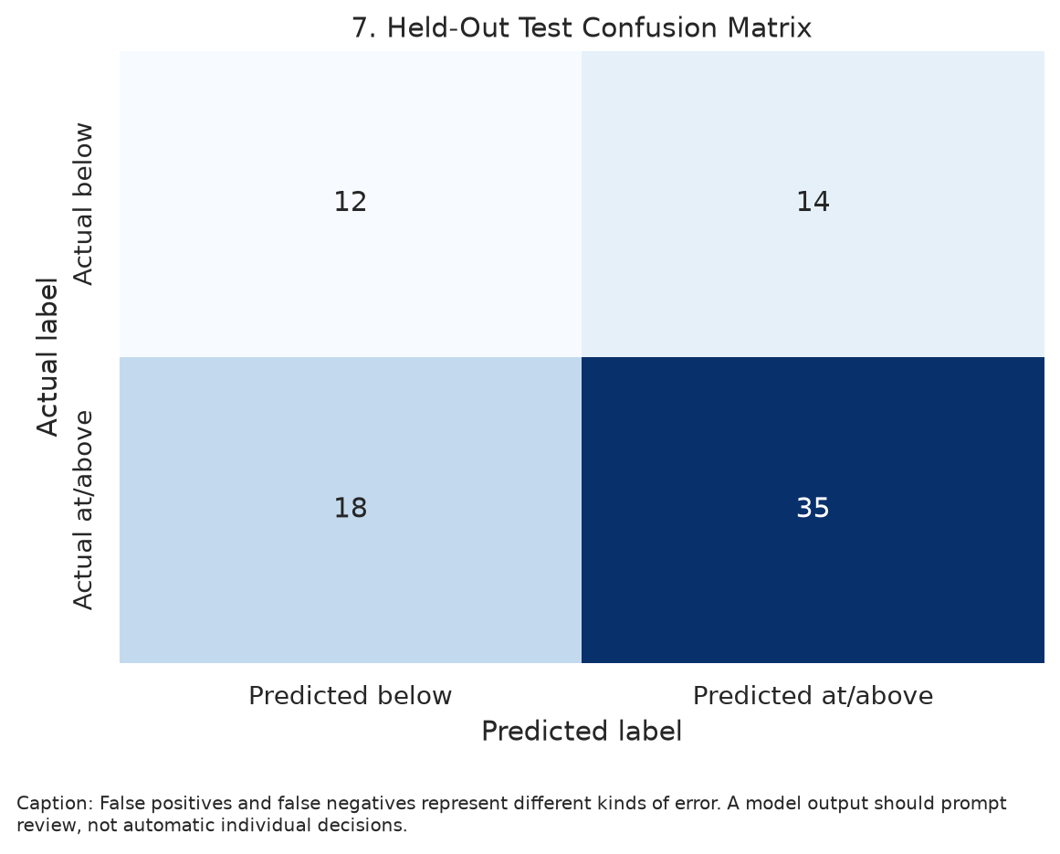
Interpretation: Shows false positives and false negatives on the held-out test cases.

Figure 8. Test ROC curve
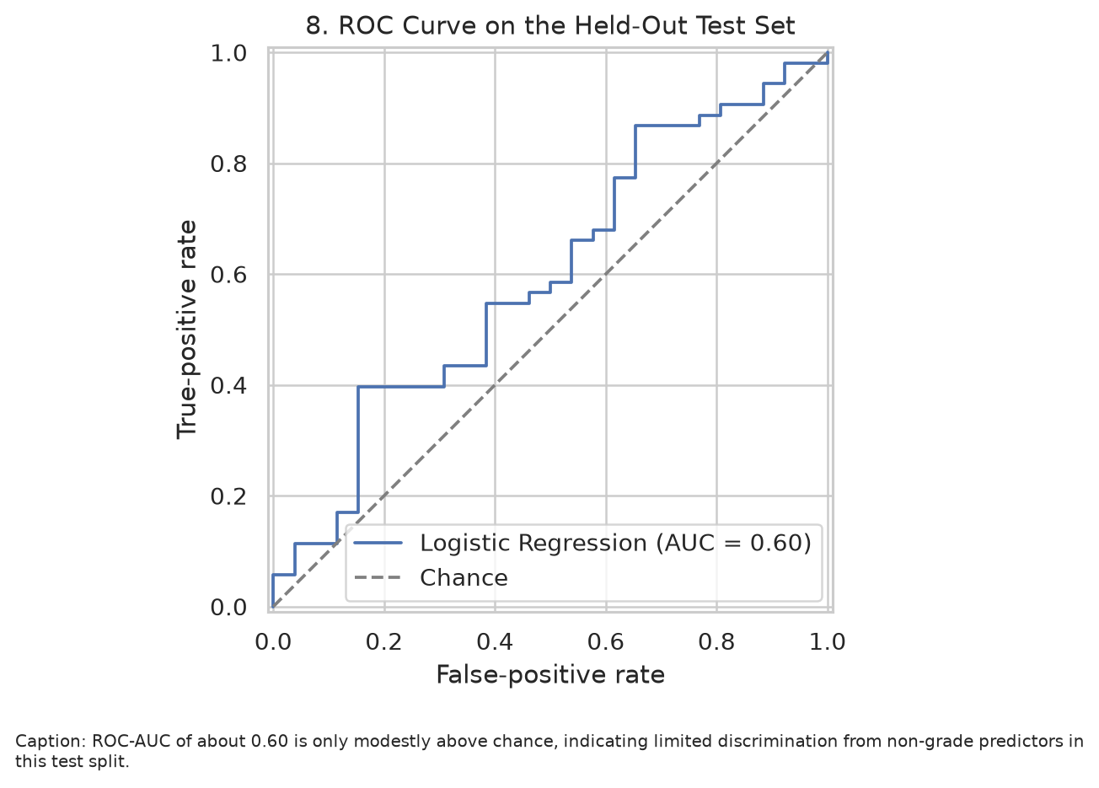
Interpretation: Shows the classifier's trade-off across thresholds and its limited ranking performance.
Test ROC-AUC of 0.595 is only modestly above 0.50 chance-level ranking. This is a central limitation, not a success claim.

Figure 9. Permutation importance
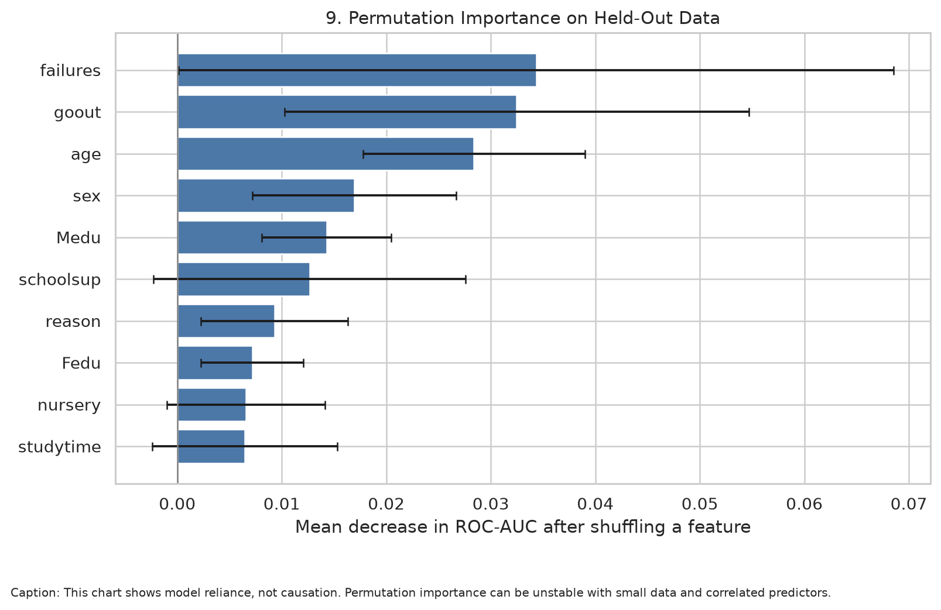
Interpretation: Describes which input variables the selected model relies on; this is not causal importance.

6. Strategic Recommendations

Recommendation 1 — Supportive early review for students with prior failures
The no-failure group has mean G3 11.25, compared with 7.27 in the prior-failure group; the difference is 3.99 points and the primary test p-value is 7.7e-11. Use this pattern as a reason to offer a supportive check-in, not as a label or deterministic prediction.

Recommendation 2 — Do not deploy the current model for automated decisions
Test ROC-AUC is 0.595 and balanced accuracy is 0.561. These scores show limited discrimination on the held-out data. Treat outputs only as a prototype for learning and evaluation.

Recommendation 3 — Improve data coverage and validation
Collect appropriately governed data from more schools and later cohorts, retain source definitions, document missingness and verify data quality before re-estimating models. Compare performance across institutions and time periods.

Recommendation 4 — Measure errors and fairness before any operational use
Audit false negatives, false positives, calibration, and subgroup error rates. If an educational support workflow is ever explored, involve educators and students, protect privacy, and keep a human review process.

Recommendation 5 — Keep analyses reproducible and interpretation cautious
Preserve the code, requirements, run metadata, cleaning audit, test statistics, model comparison, and charts. Report effect sizes and confidence intervals alongside p-values, and clearly separate exploratory questions from a pre-specified primary hypothesis.

7. Limitations and Future Improvement
- The data are observational; neither hypothesis testing nor feature importance proves causal effects.
- The dataset represents two Portuguese secondary schools and may not generalize to other populations or time periods.
- The outcome threshold G3 ≥ 10 is an analytical convention. It must not be confused with all institutions' official passing rules.
- The ML dataset is relatively small. A single held-out test split can yield noisy estimates; external validation and uncertainty intervals should be added before practical use.
- Prior failures are predictive context but may overlap with historical educational disadvantage. Interpreting them punitively risks unfairness.
- Potential improvements include a larger external dataset, repeated stratified splits or nested CV, calibration checks, threshold analysis based on support costs, subgroup fairness evaluation, and pre-registered hypotheses.

8. Conclusion
Across Weeks 1–4, the project demonstrates a complete workflow from acquisition and cleaning through EDA, statistical inference, and model evaluation. The most reliable insight is the strong observed association between prior-failure history and final-grade outcomes; the predictive model using non-grade variables is much less compelling. The responsible next step is supportive academic review and improved data collection, followed by independent model validation—not automated decisions about students.

9. Reproducibility and Deliverables
Run python week5_capstone.py after installing requirements.txt. The script writes the capstone DOCX, a separate Word version of the submission description, integrated visualizations, cleaned data, source/run metadata, statistical test results, model cross-validation comparisons, held-out metrics, confusion-matrix values, and permutation importance output.

Illustrative code excerpts
Target construction and leakage control:
df["target_pass"] = (df["G3"] >= 10).astype(int)\nX = df.drop(columns=["G1", "G2", "G3", "target_pass"])
Training-only cross-validation for model selection:
cv = StratifiedKFold(n_splits=5, shuffle=True, random_state=42)\nscores = cross_validate(model, X_train, y_train, cv=cv, scoring="roc_auc")
Primary hypothesis test:
test = stats.ttest_ind(no_failures, prior_failures,\n equal_var=False, alternative="greater")
The excerpts illustrate the main analytical decisions; the full reproducible implementation is available in week5_capstone.py.

10. References
Cortez, P. (2008). Student Performance [Dataset]. UCI Machine Learning Repository. https://doi.org/10.24432/C5TG7T
Cortez, P., & Silva, A. M. G. (2008). Using data mining to predict secondary school student performance. Proceedings of the 5th Annual Future Business Technology Conference.
Pedregosa, F., et al. (2011). Scikit-learn: Machine Learning in Python. Journal of Machine Learning Research, 12, 2825–2830.
Dataset page: https://archive.ics.uci.edu/dataset/320/student%2Bperformance

