**Requirement take input as Document number and show the Header and Item details for it In ALV format.  
1.if we clicked on document number it should show item details for that document.  
2.If we click on material number it should take mm03 transaction with the value.  
3. If we click on Payer number it should take to xd03 transaction with value.  
  
CODE:**  
REPORT zrk_alv_acessment.  
DATA : it_vbrk TYPE STANDARD TABLE OF zjana_vbrk.  
  
DATA v_vbeln TYPE vbeln.  
  
SELECT-OPTIONS s_vbeln FOR v_vbeln.  
  
DATA : it_vbrp TYPE TABLE OF zjana_vbrp,  
 wa_vbrp LIKE LINE OF it_vbrp.  
  
START-OF-SELECTION.  
 PERFORM get_data.  
  
END-OF-SELECTION.  
 PERFORM display.  
  
*\*&---------------------------------------------------------------------\**  
*\*& Form get_data*  
*\*&---------------------------------------------------------------------\**  
*\*& text*  
*\*&---------------------------------------------------------------------\**  
*\*& --> p1 text*  
*\*& <-- p2 text*  
*\*&---------------------------------------------------------------------\**  
FORM get_data .  
 SELECT * FROM zjana_vbrk INTO TABLE it_vbrk WHERE vbeln IN s_vbeln.  
ENDFORM.  
*\*&---------------------------------------------------------------------\**  
*\*& Form display*  
*\*&---------------------------------------------------------------------\**  
*\*& text*  
*\*&---------------------------------------------------------------------\**  
*\*& --> p1 text*  
*\*& <-- p2 text*  
*\*&---------------------------------------------------------------------\**  
FORM display .  
  
 DATA: lt_sort TYPE STANDARD TABLE OF slis_t_sortinfo_alv.  
  
 DATA: wa_sort TYPE slis_sortinfo_alv.  
 DATA : lt_fcat TYPE slis_t_fieldcat_alv,  
 lw_fcat LIKE LINE OF lt_fcat.  
  
 lw_fcat-col_pos = 1.   
 lw_fcat-fieldname = 'VBELN'.  
 lw_fcat-tabname = 'IT_VBRK'.  
 lw_fcat-seltext_m = 'Document number'.  
 lw_fcat-outputlen = 20.  
 lw_fcat-edit_mask = '==ALPHA'.  
 APPEND lw_fcat TO lt_fcat.  
  
 lw_fcat-col_pos = 2.   
 lw_fcat-fieldname = 'FKDAT'.  
 lw_fcat-tabname = 'IT_VBRK'.  
 lw_fcat-seltext_m = 'Billing date'.  
 lw_fcat-outputlen = 20.  
 APPEND lw_fcat TO lt_fcat.  
  
 lw_fcat-col_pos = 3.   
 lw_fcat-fieldname = 'KUNRG'.  
 lw_fcat-tabname = 'IT_VBRK'.  
 lw_fcat-seltext_m = 'Payer'.  
 lw_fcat-outputlen = 20.  
 APPEND lw_fcat TO lt_fcat.  
  
 CALL FUNCTION 'REUSE_ALV_GRID_DISPLAY'  
 EXPORTING  
*\* I_INTERFACE_CHECK = ' '*  
*\* I_BYPASSING_BUFFER = ' '*  
*\* I_BUFFER_ACTIVE = ' '*  
 i_callback_program = 'ZRK_ALV_ACESSMENT'  
*\* i_callback_pf_status_set = 'PF_STATUS'*  
 i_callback_user_command = 'USER_COMMAND'  
*\* I_CALLBACK_TOP_OF_PAGE = ' '*  
*\* I_CALLBACK_HTML_TOP_OF_PAGE = ' '*  
*\* I_CALLBACK_HTML_END_OF_LIST = ' '*  
*\* I_STRUCTURE_NAME =*  
*\* I_BACKGROUND_ID = ' '*  
*\* I_GRID_TITLE =*  
*\* I_GRID_SETTINGS =*  
*\* IS_LAYOUT =*  
 it_fieldcat = lt_fcat  
*\* IT_EXCLUDING =*  
*\* IT_SPECIAL_GROUPS =*  
*\* IT_SORT =*  
*\* IT_FILTER =*  
*\* IS_SEL_HIDE =*  
*\* I_DEFAULT = 'X'*  
*\* I_SAVE = ' '*  
*\* IS_VARIANT =*  
*\* IT_EVENTS =*  
*\* IT_EVENT_EXIT =*  
*\* IS_PRINT =*  
*\* IS_REPREP_ID =*  
*\* I_SCREEN_START_COLUMN = 0*  
*\* I_SCREEN_START_LINE = 0*  
*\* I_SCREEN_END_COLUMN = 0*  
*\* I_SCREEN_END_LINE = 0*  
*\* I_HTML_HEIGHT_TOP = 0*  
*\* I_HTML_HEIGHT_END = 0*  
*\* IT_ALV_GRAPHICS =*  
*\* IT_HYPERLINK =*  
*\* IT_ADD_FIELDCAT =*  
*\* IT_EXCEPT_QINFO =*  
*\* IR_SALV_FULLSCREEN_ADAPTER =*  
*\* O_PREVIOUS_SRAL_HANDLER =*  
*\* IMPORTING*  
*\* E_EXIT_CAUSED_BY_CALLER =*  
*\* ES_EXIT_CAUSED_BY_USER =*  
 TABLES  
 t_outtab = it_vbrk  
 EXCEPTIONS  
 program_error = 1  
 OTHERS = 2.  
 IF sy-subrc <> 0.  
*\* Implement suitable error handling here*  
 ENDIF.  
  
ENDFORM.  
  
  
FORM user_command USING r_ucomm TYPE sy-ucomm  
 rs_selfield TYPE slis_selfield.  
 IF r_ucomm EQ '&IC1' AND rs_selfield-fieldname EQ 'VBELN'.  
 DATA v_vbeln TYPE vbeln.  
 v_vbeln = rs_selfield-value.  
 CALL FUNCTION 'CONVERSION_EXIT_ALPHA_INPUT'  
 EXPORTING  
 input = v_vbeln  
 IMPORTING  
 output = v_vbeln.  
  
  
 SELECT * FROM zjana_vbrp INTO TABLE it_vbrp WHERE vbeln = v_vbeln.  
 CALL FUNCTION 'REUSE_ALV_GRID_DISPLAY'  
 EXPORTING  
 i_callback_program = 'ZRK_ALV_ACESSMENT'  
 i_callback_user_command = 'USER_COMMAND'  
 i_structure_name = 'ZJANA_VBRP'  
 TABLES  
 t_outtab = it_vbrp  
 EXCEPTIONS  
 program_error = 1  
 OTHERS = 2.  
 IF sy-subrc <> 0.  
  
 ENDIF.  
 ELSEIF r_ucomm EQ '&IC1' AND rs_selfield-fieldname EQ 'KUNRG'.  
 SET PARAMETER ID 'KUN' FIELD rs_selfield-value.  
 CALL TRANSACTION 'XD03'.  
  
 ELSEIF r_ucomm EQ '&IC1' AND rs_selfield-fieldname EQ 'MATNR'.  
 SET PARAMETER ID 'MAT' FIELD rs_selfield-value.  
 CALL TRANSACTION 'MM03'.  
  
 ENDIF.  
ENDFORM.  
……………………………………………………………………………………………………………………………………………………..

OUTPUT:  
It is the header data:

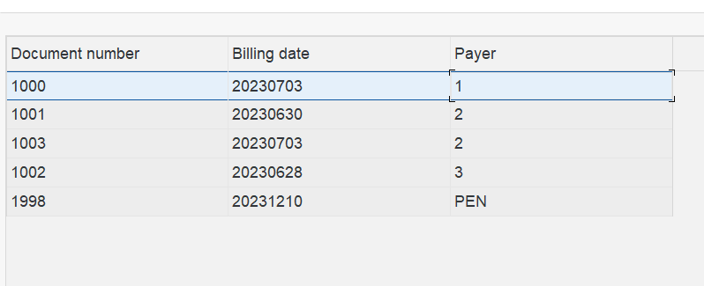

On clicking on Document number, it will show item details for that particular document.  
So here is the Item data:  
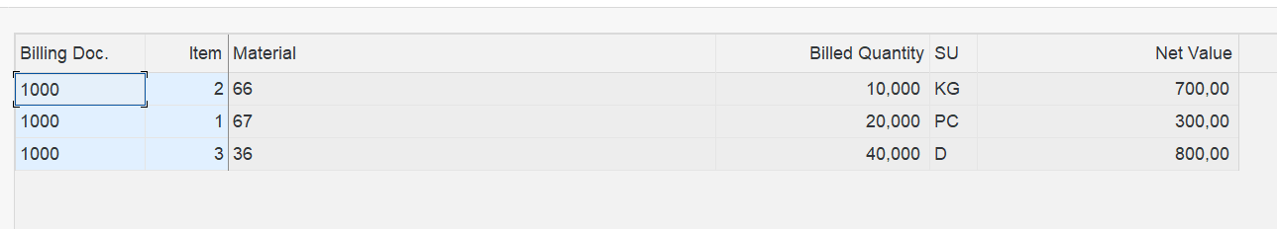

On clicking on Material number 66 it will open mm03 transaction with clicked value:  
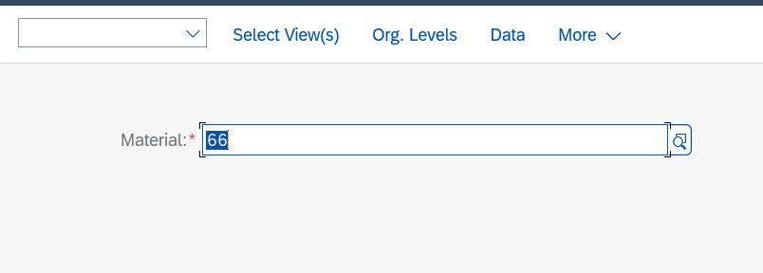

Header data:

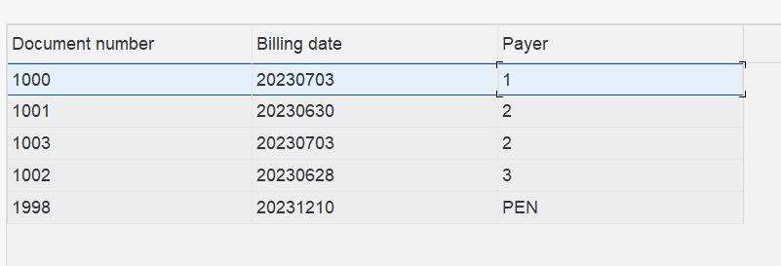

If we double click on a Payer:  
It will take value with it on what value we clicked and opens **xd03** transaction.  
