Assignment1: Displaying Material details by taking input material number through Parameter.

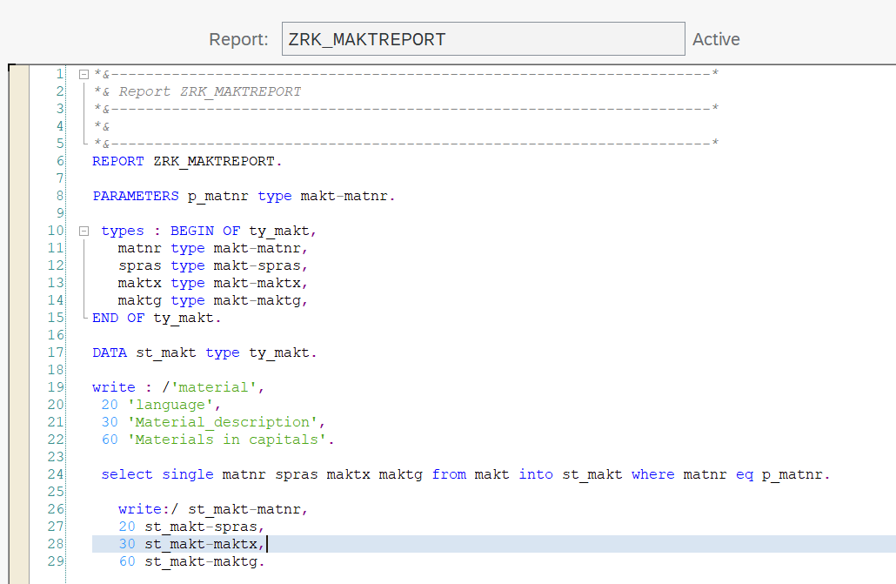

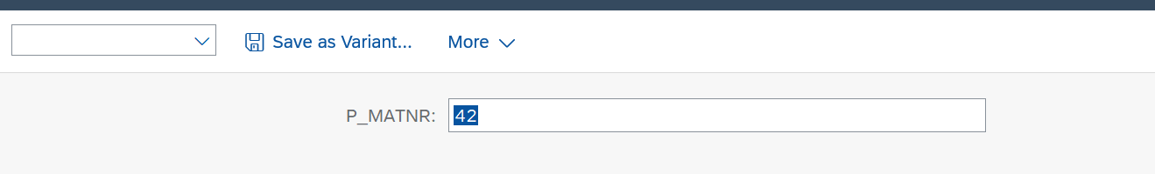  
  
Assignment2:Program to show material description (which is in makt table) using plant number  
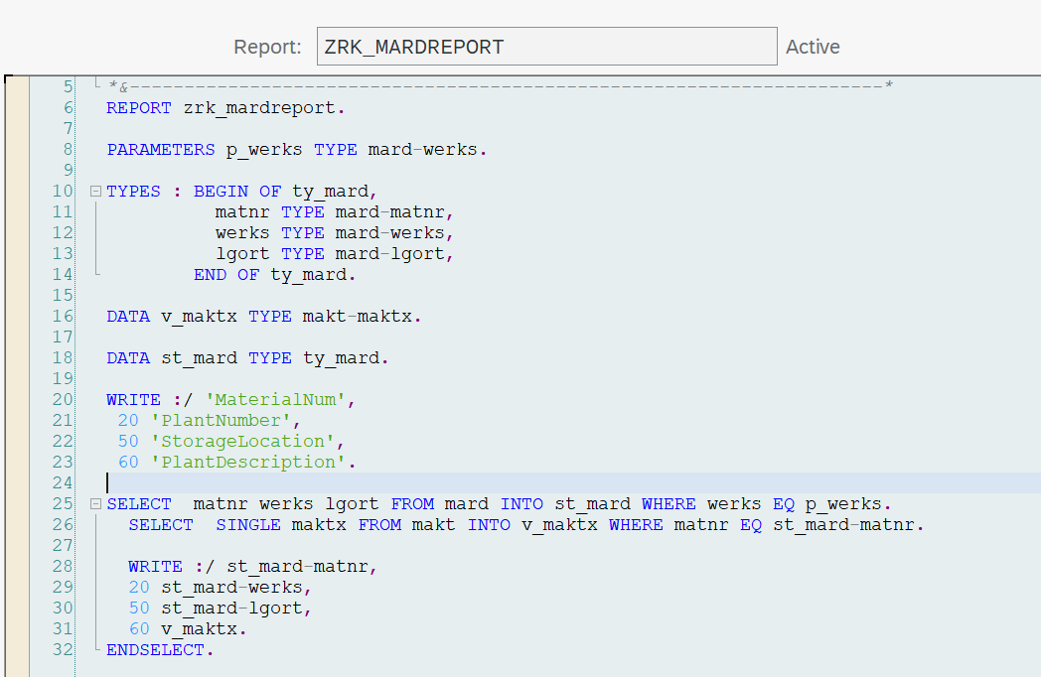

Assignment 3: display the dilling document details. Display header and item details header with payer name(which is in other table) item with unit of measure(which is in other table) used select ….ENDSELECT. and used only structure to display.  
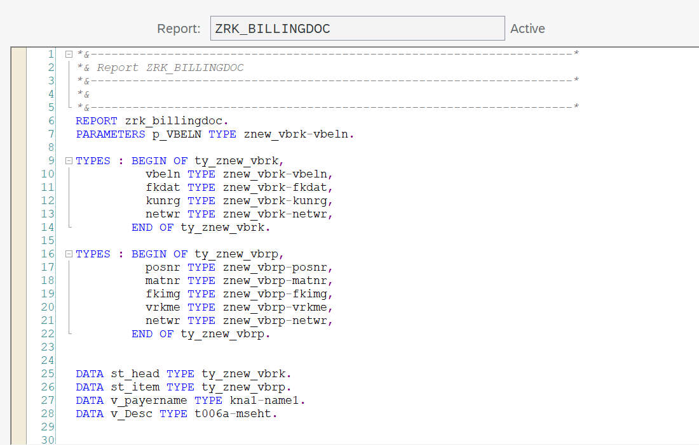  
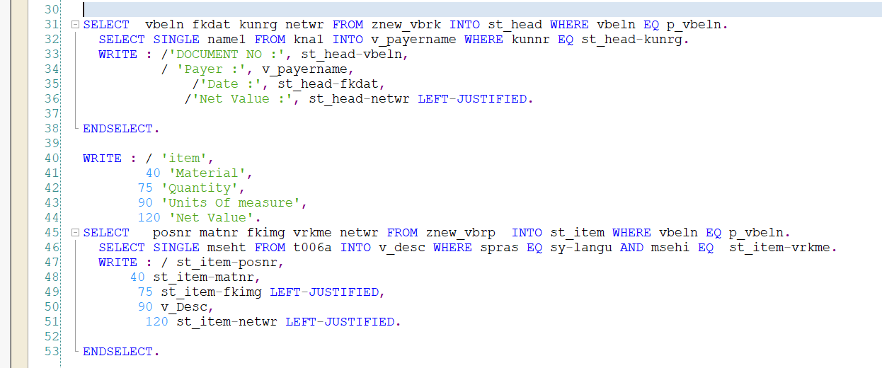  
  
Assignment4: adding data to internal table and accessing data from it.  
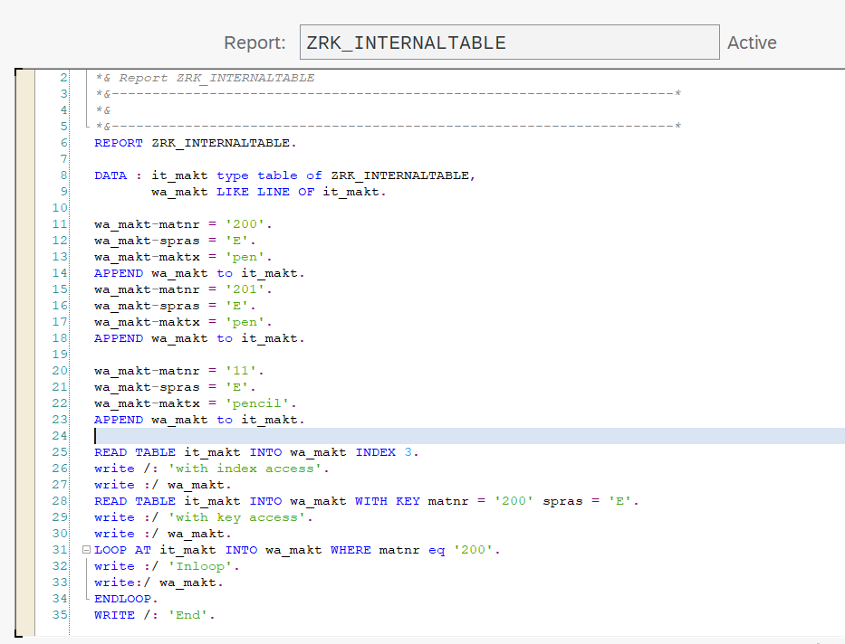

Assignment 5: display the dilling document details. Display header and item details header with payer name(which is in other table) item with unit of measure(which is in other table) we used internal table and LOOP and ENDLOOP  
  
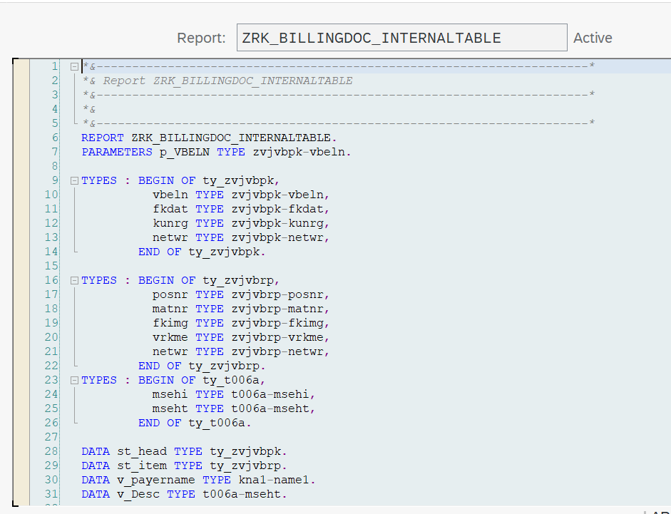

Assignmet6:Taking multiple inputs(document number) through select option. And displaying header and item data for given documents.  
  
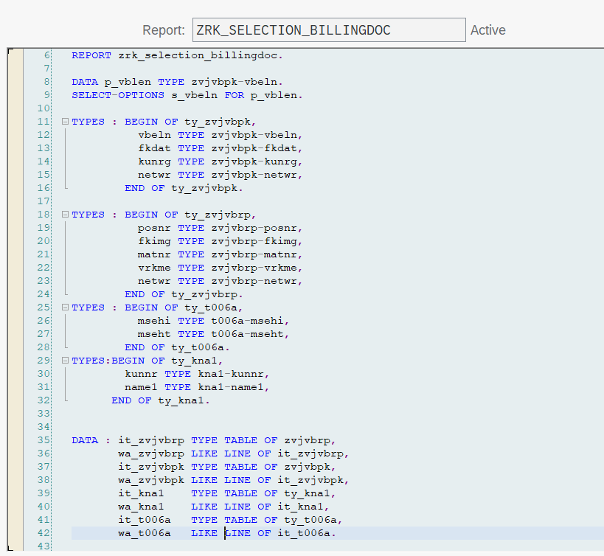

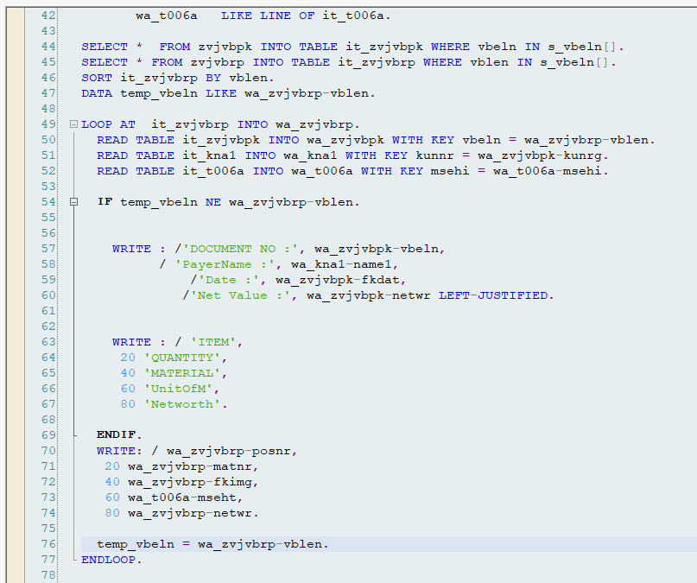



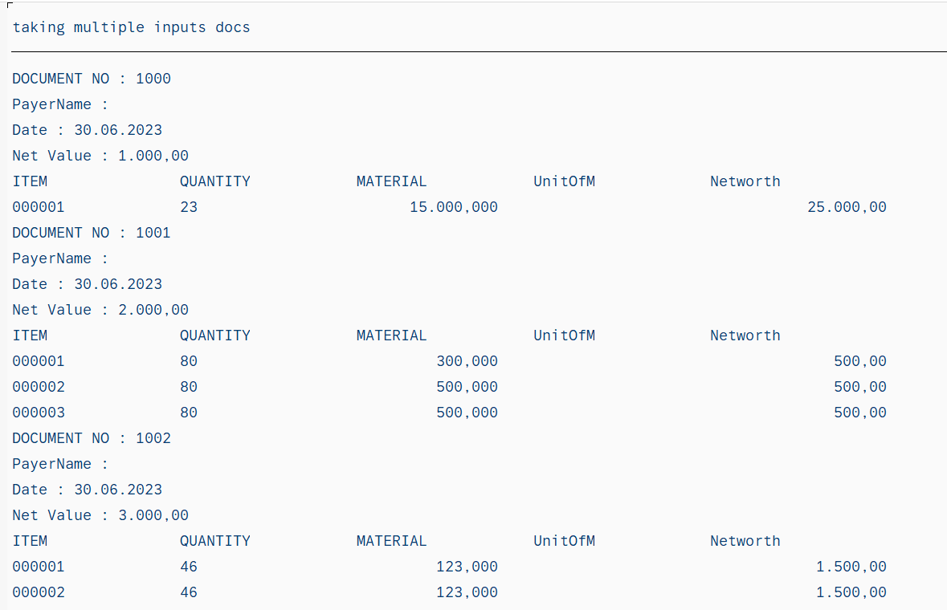

Assignment: 7 This below code includes 2 Rquirements. 1 is Printing sum of quantity and sum of net value.2nd is with Control statements.  
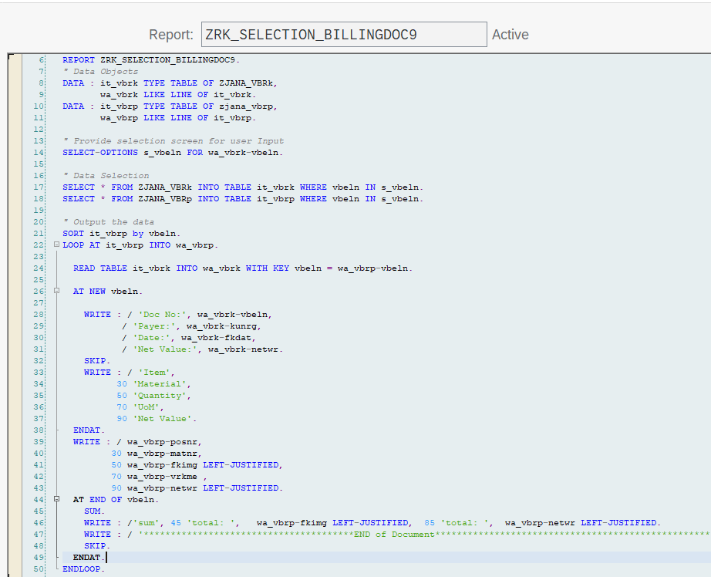

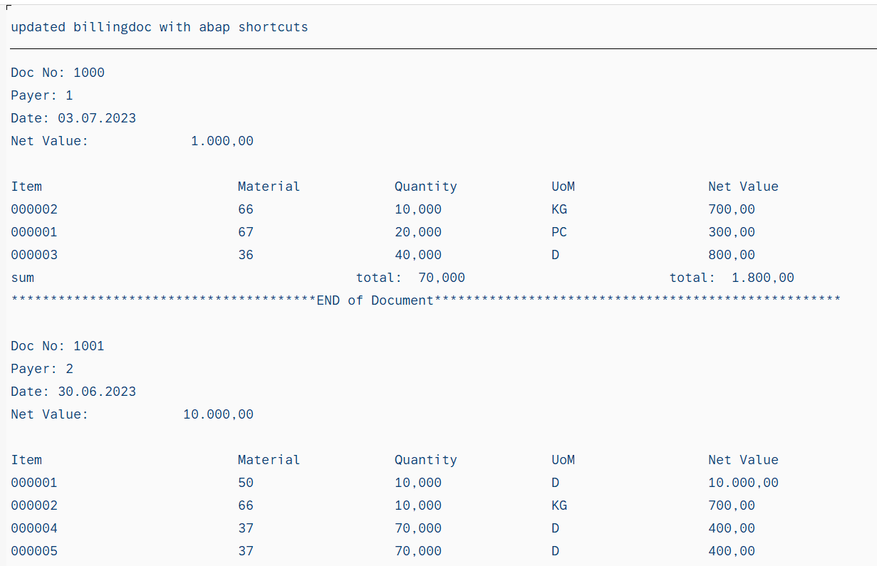

Assignment 8: Takes plant number as input and displays material, description of material, plant,storage location. Using parameter.

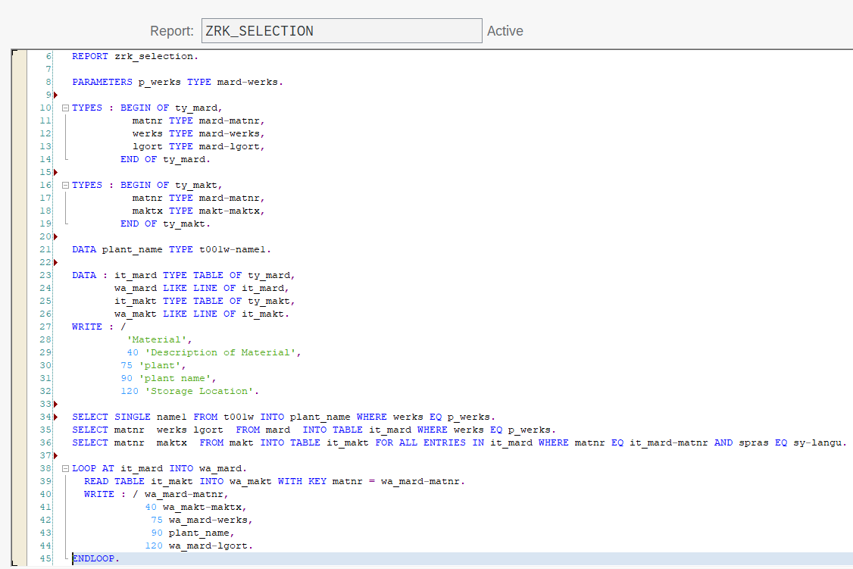

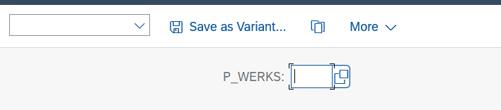

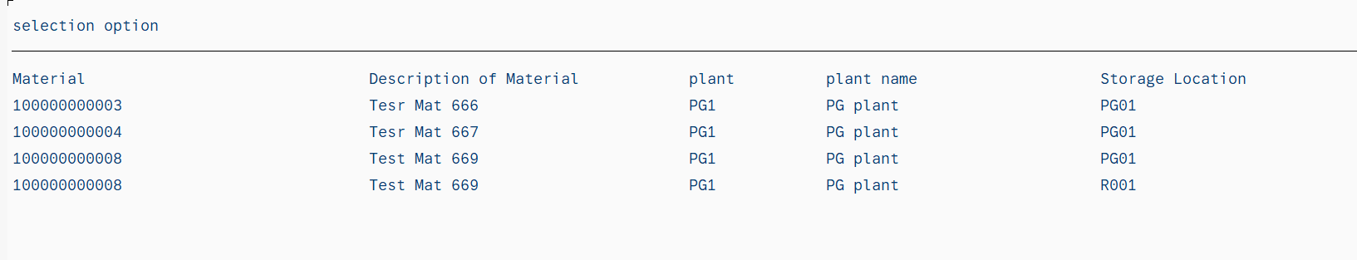

Assignment 9: Below program takes input Plant numbers and prints material, material description, plant ,plantname, storage location,. And for given 3 dangerous material(ATV112SLED,NTV22SLED, ATV925SLED) it will print in red colour. Using select-option

CONCEPTS: select-options, structure type,internal table, work area table, read internal table using READ, LOOP.

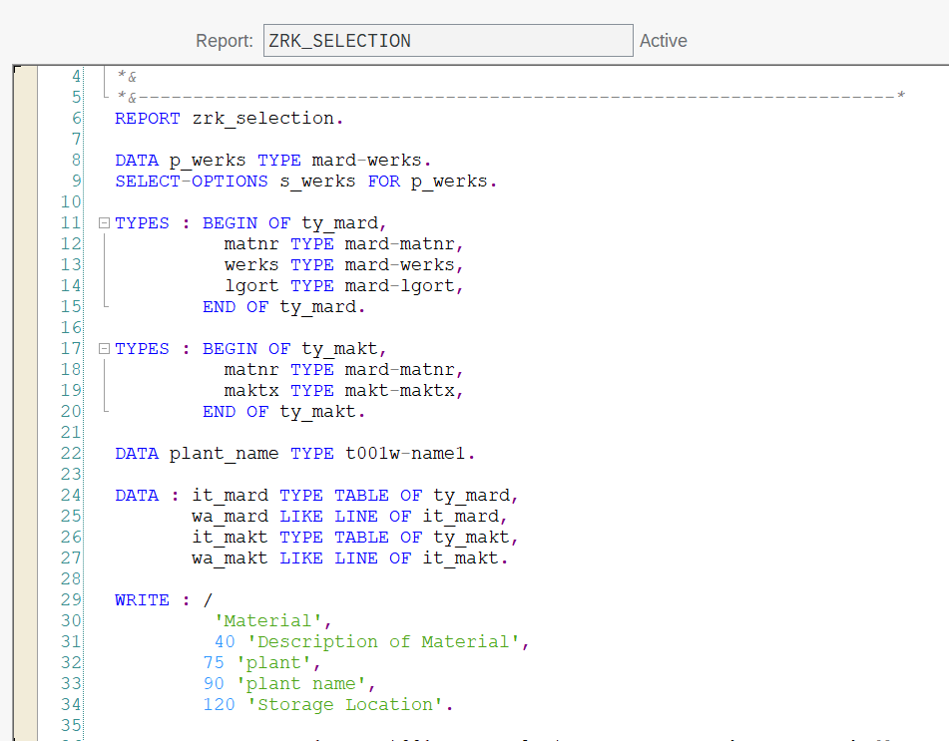

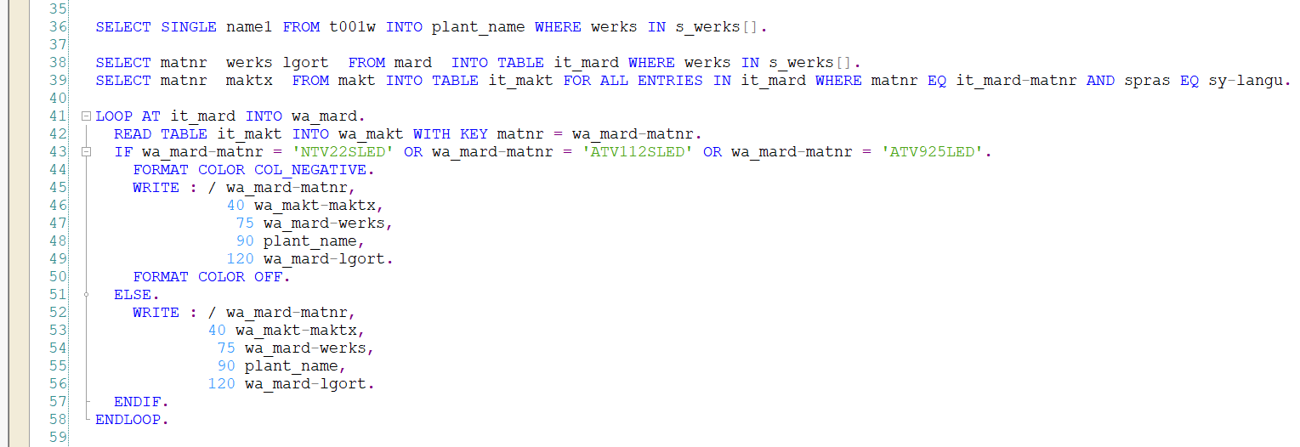

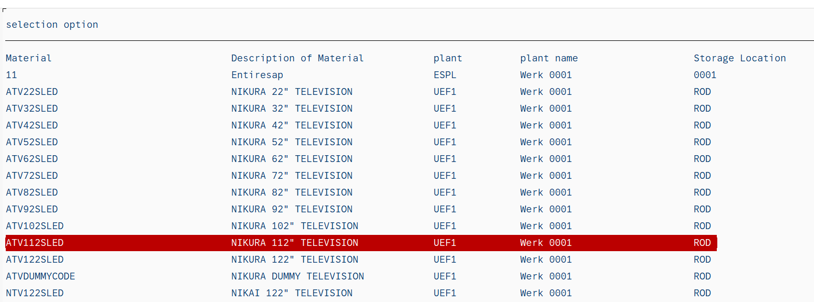

Assignment 10: IN ABOVE PROGRAM WE DEFINED DANGEROUS MATERIAL NUMBER IN CODE ITSELF

SO WE ARE MAKING IT DYNAMICALLY. we kept those dangerous material in separate table.

And compared.  And made color red for those details.

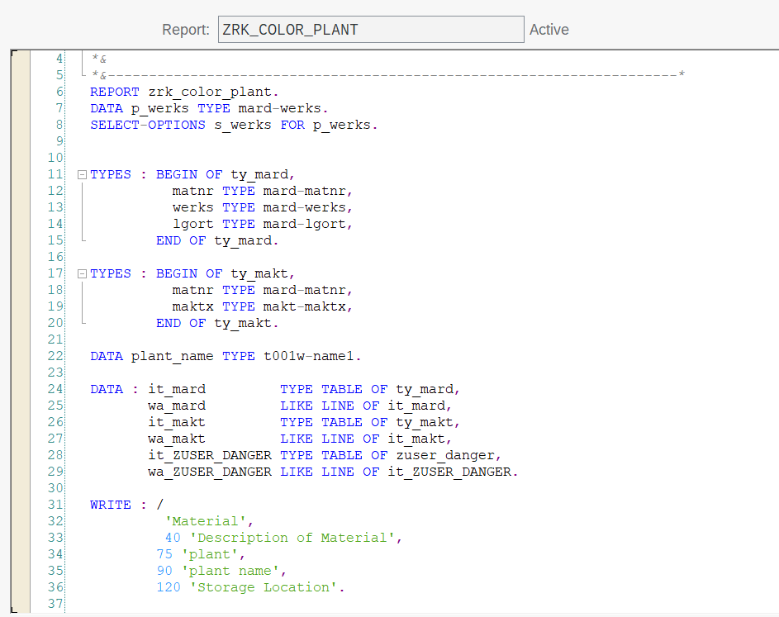

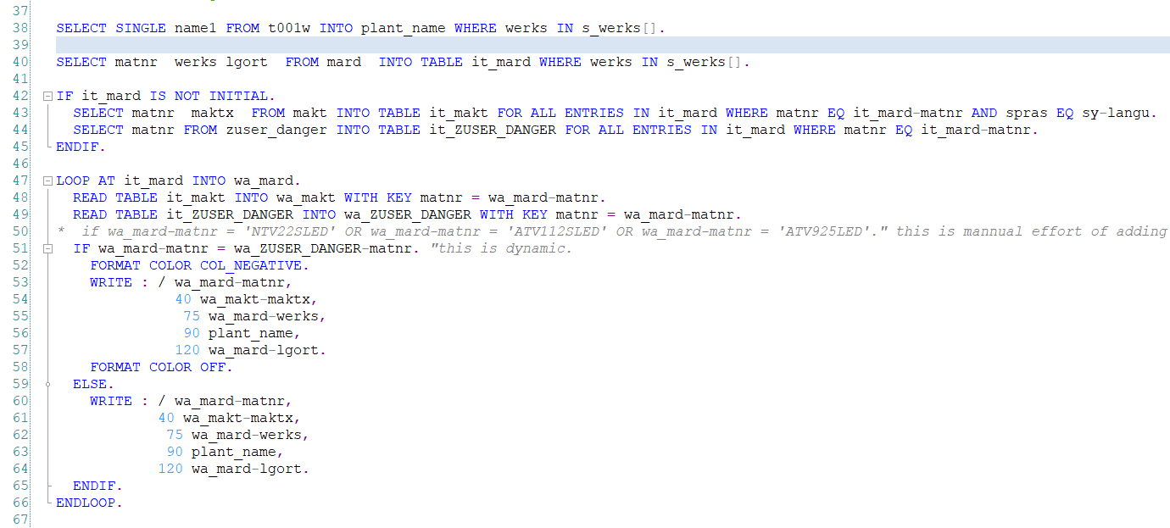

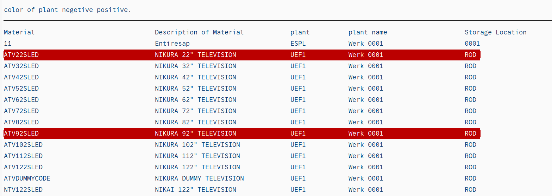

Assignment 11:  
Re modifying above code or more accurate code: my idea user can select exclude include through select-option and save the variant. Next time If he wants to add he can add in the variant.

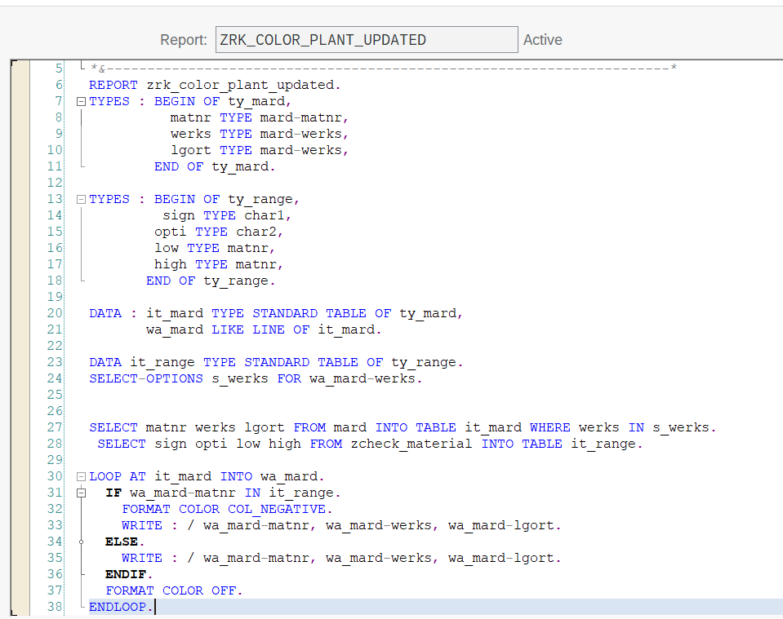

Assignment12:This code includes adding data to different types of internal table.Standard, sorted, hashed.  
  
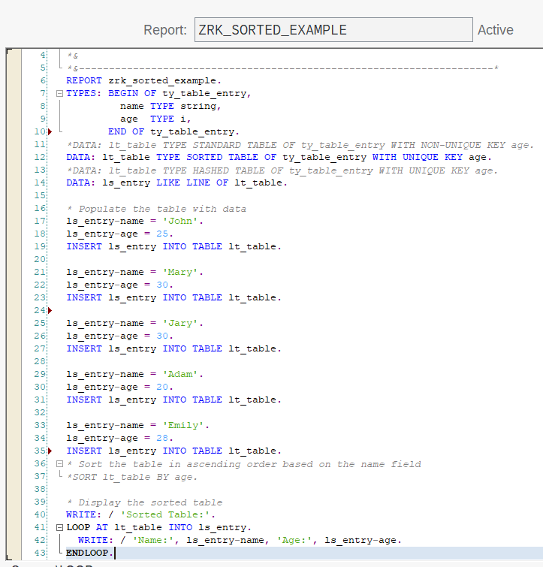

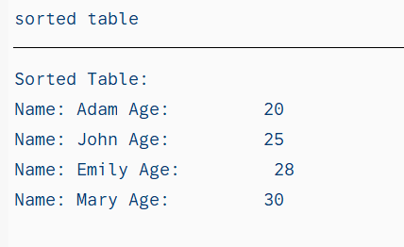

Assignment13: Subroutin created and called in the same program.  
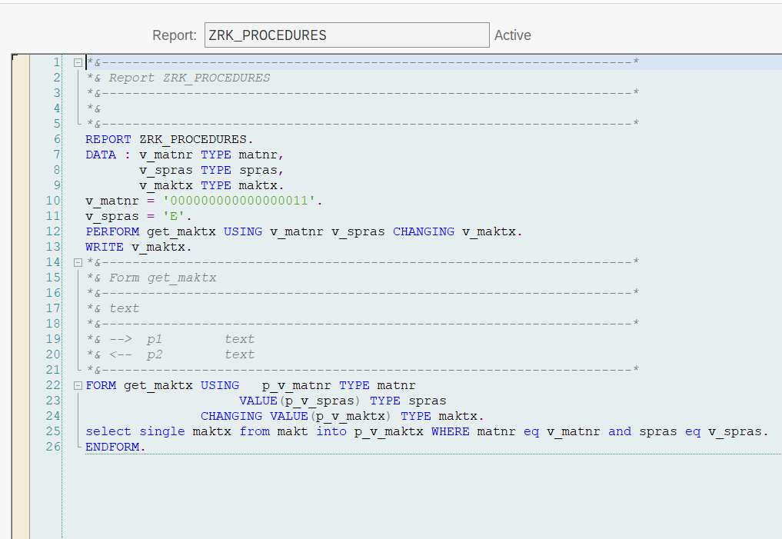

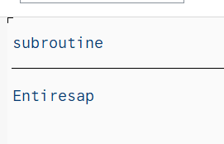

………………………………………………………………………………………………

Assignment 14 : Code Modularization, used Start-of-selection, End-of-selection, At user-command, At line-selection, Top-of-page, End-of-page, PF-status.  
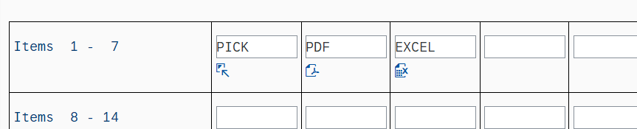

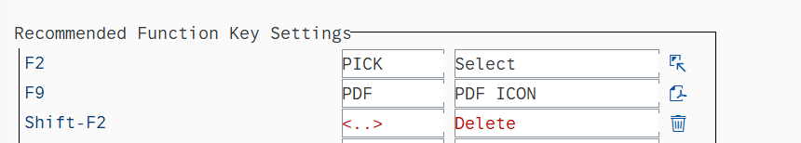

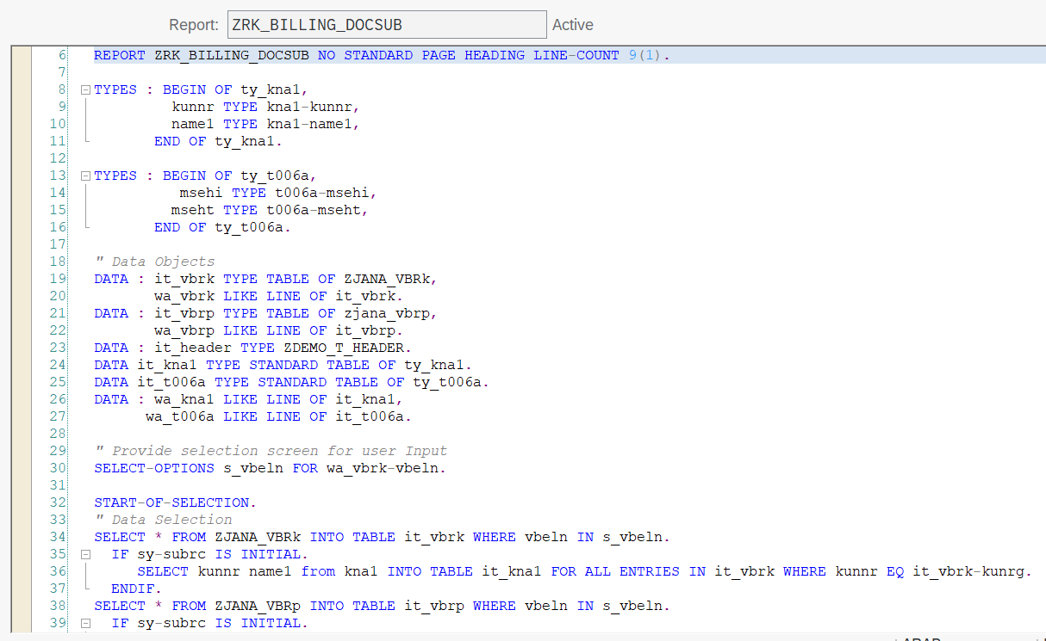

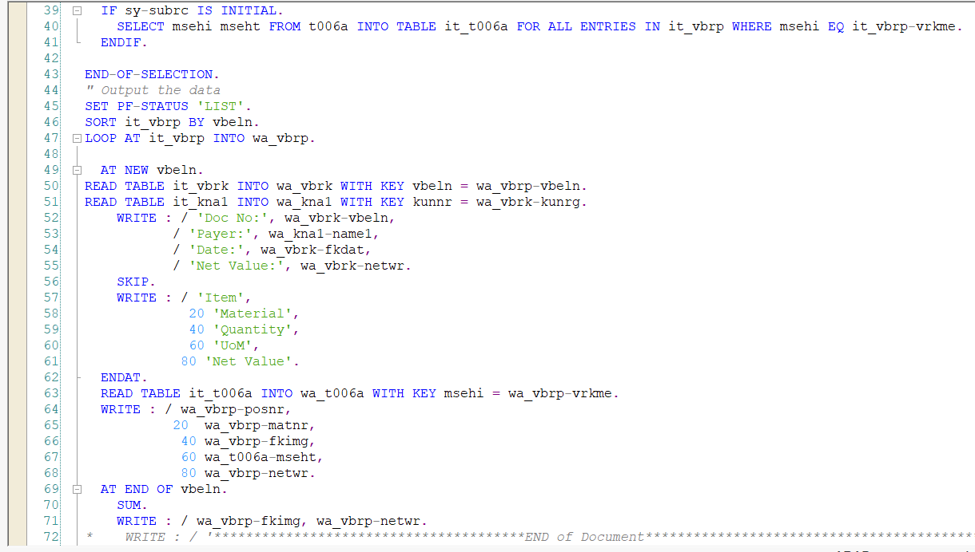

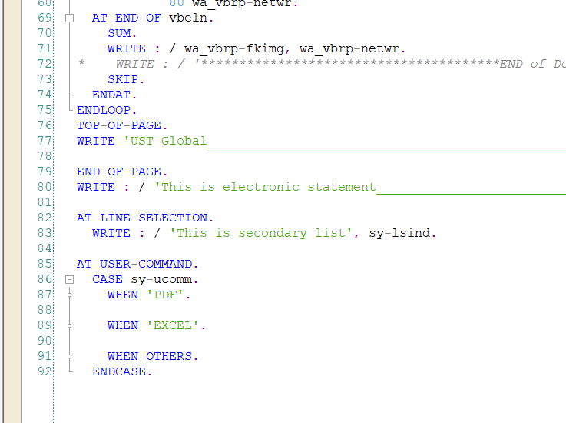

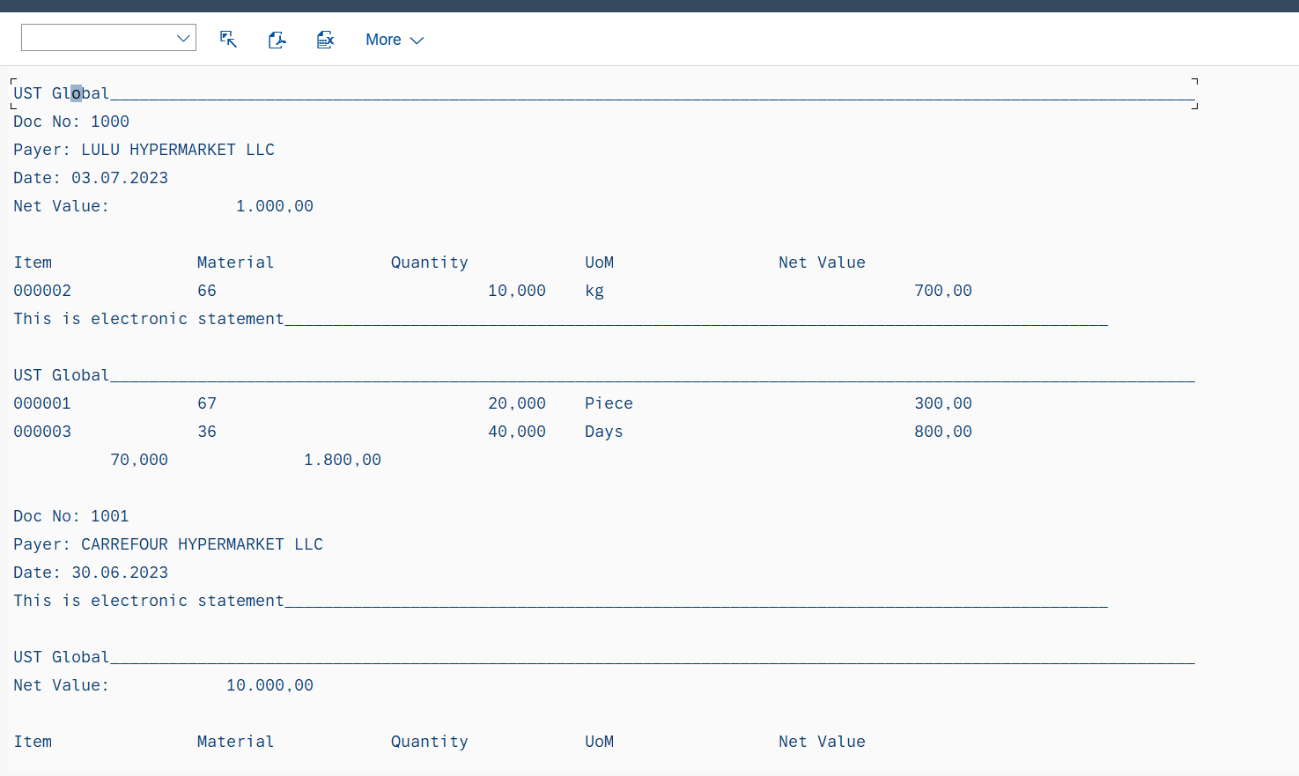

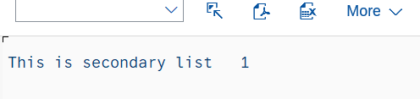

…………………………………………………………………………………………………

Assignment 15:  
In below code subroutine created in one program and called in another program.  
Below are subroutines, In these one is for getting header data,other one is getting item data, one more subroutine includes getting header and item data.

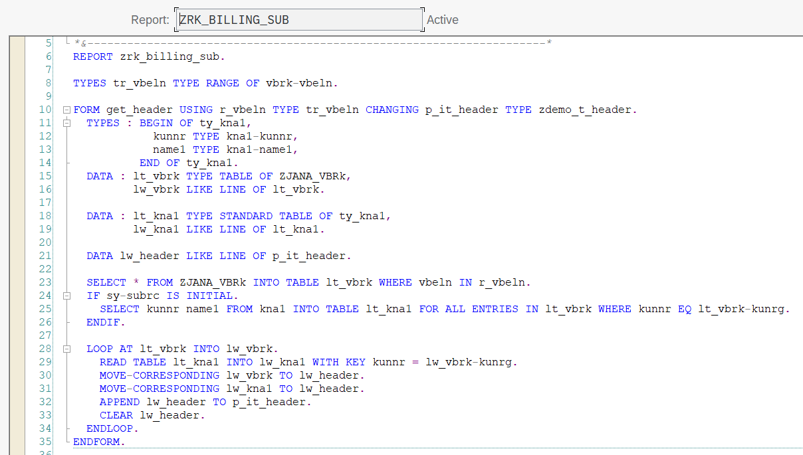

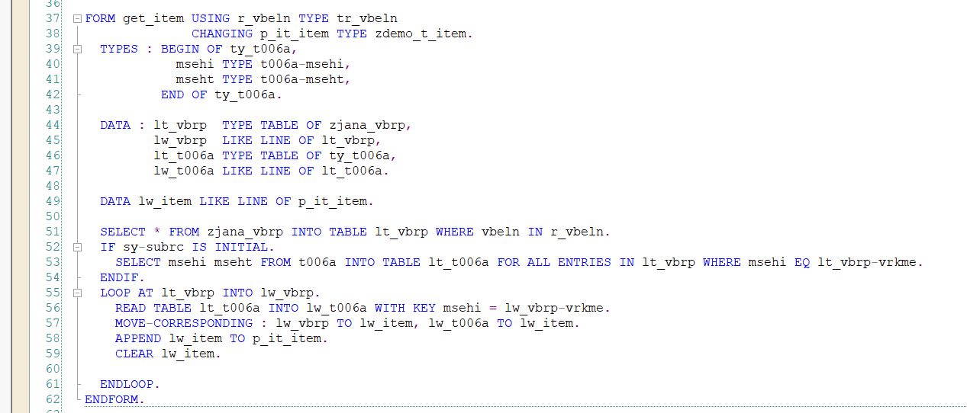

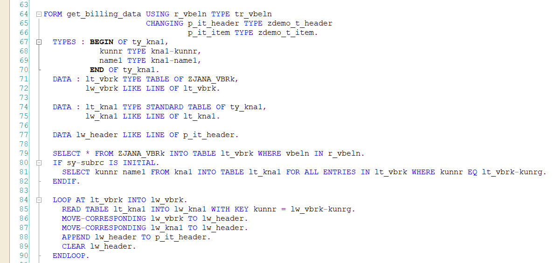

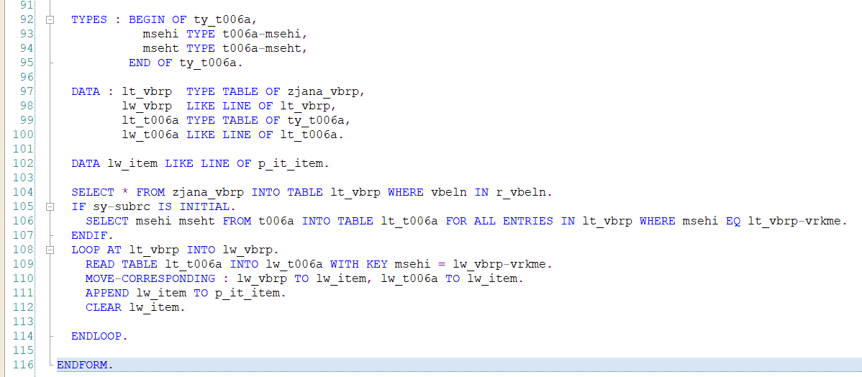

Called subroutine in below code:  
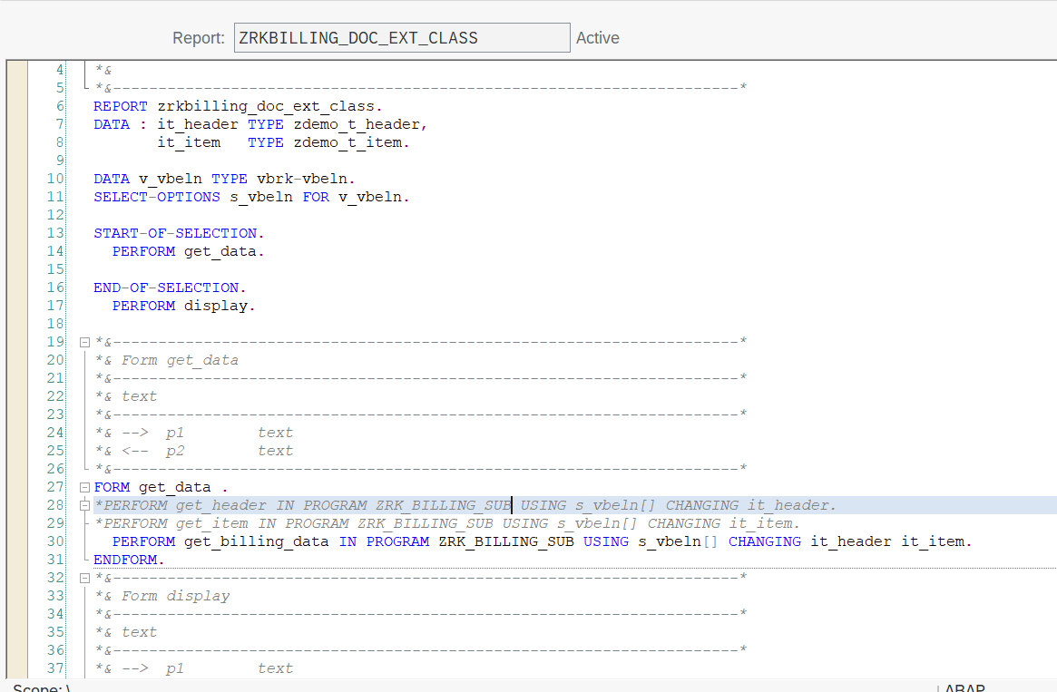

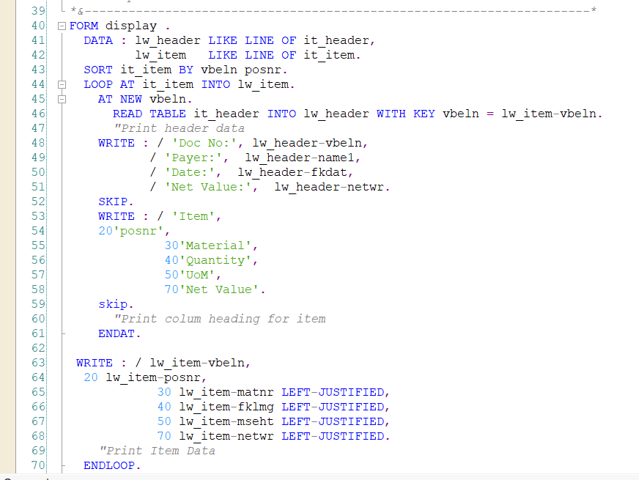  
  
Output:  
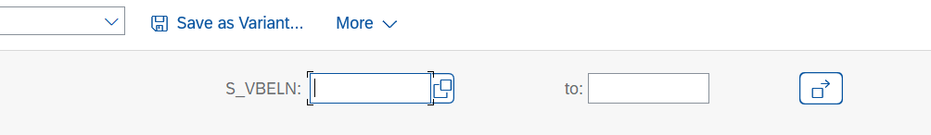

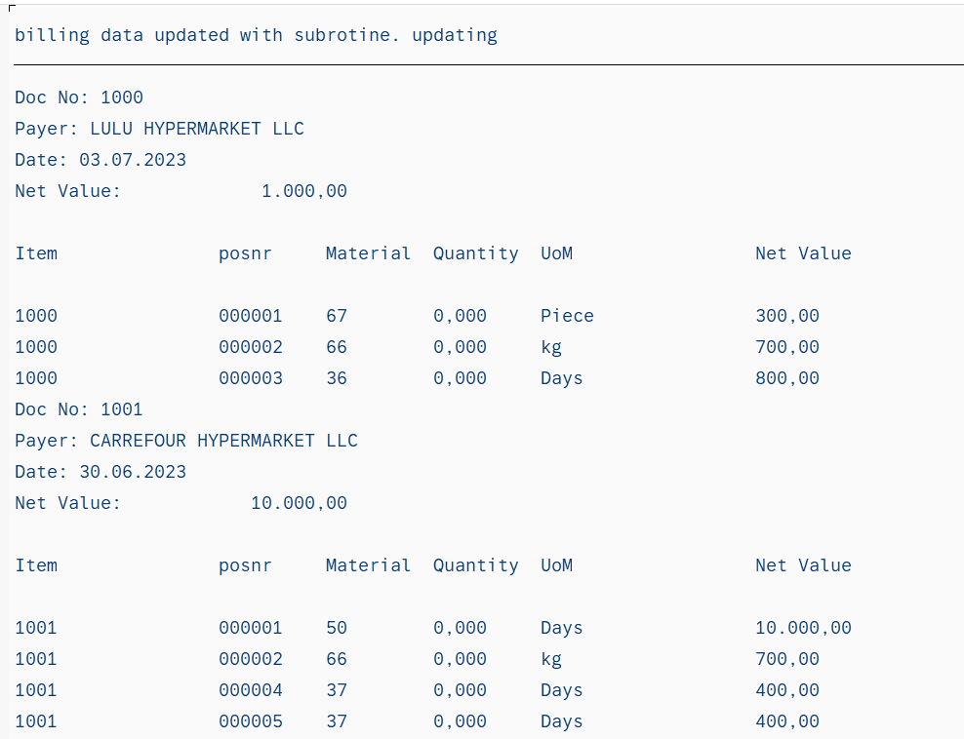

………………………………………………………………………………………………

Assignment 16: Function module.  
below are function modules created and called in our executable program.  
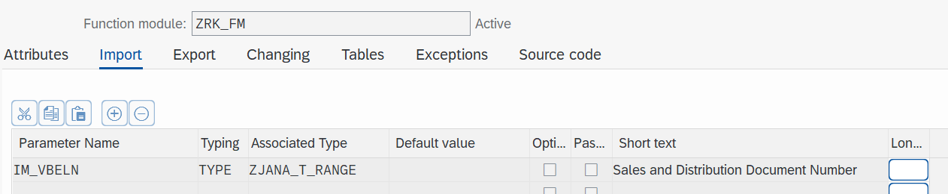

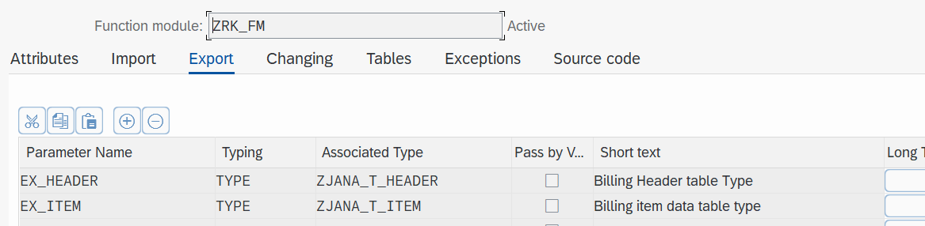

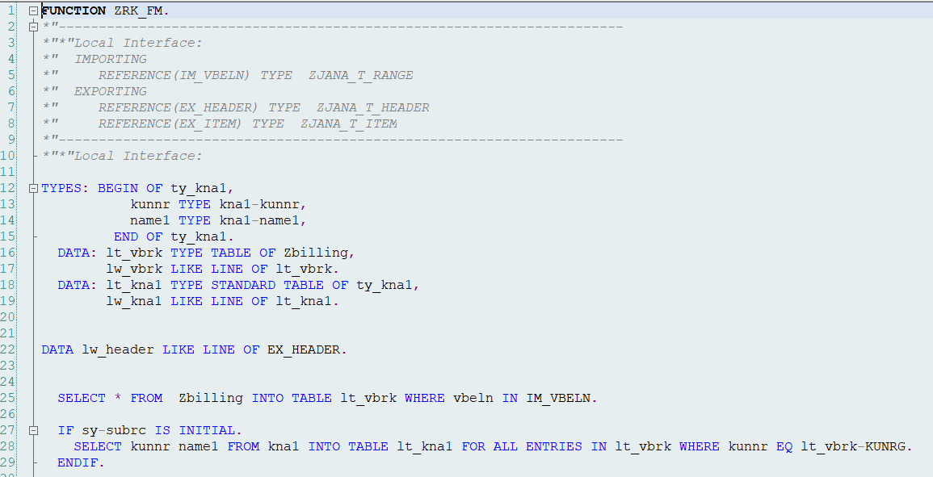

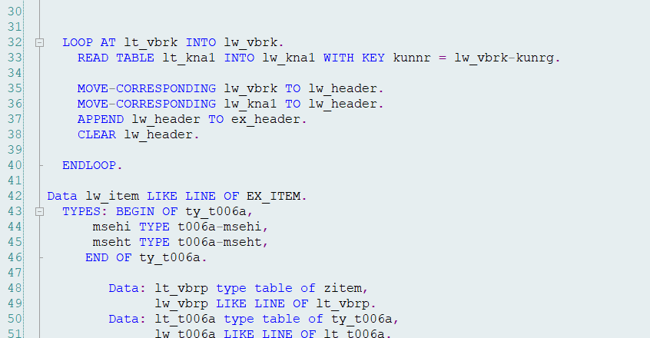

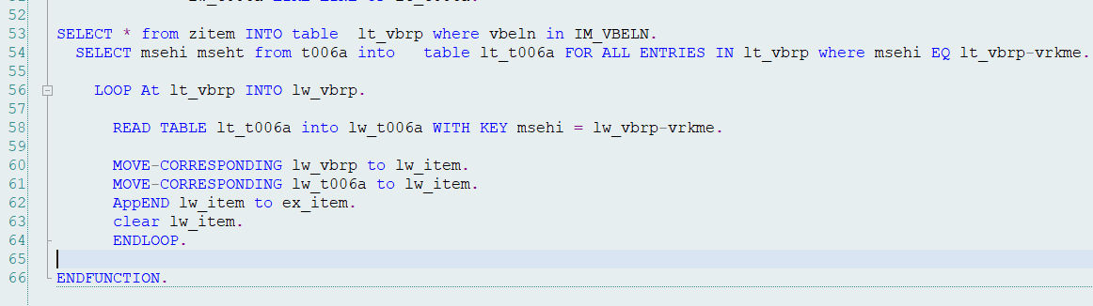

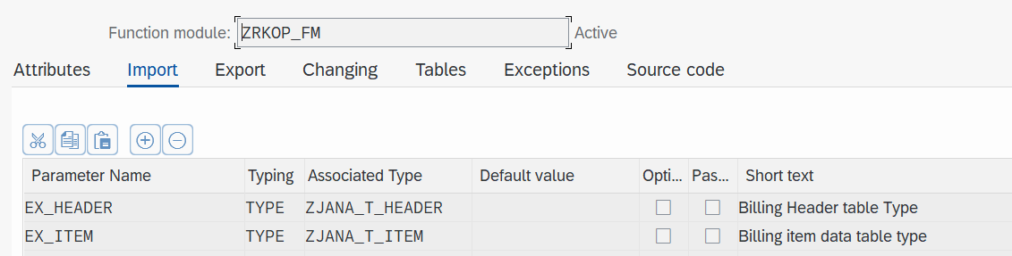

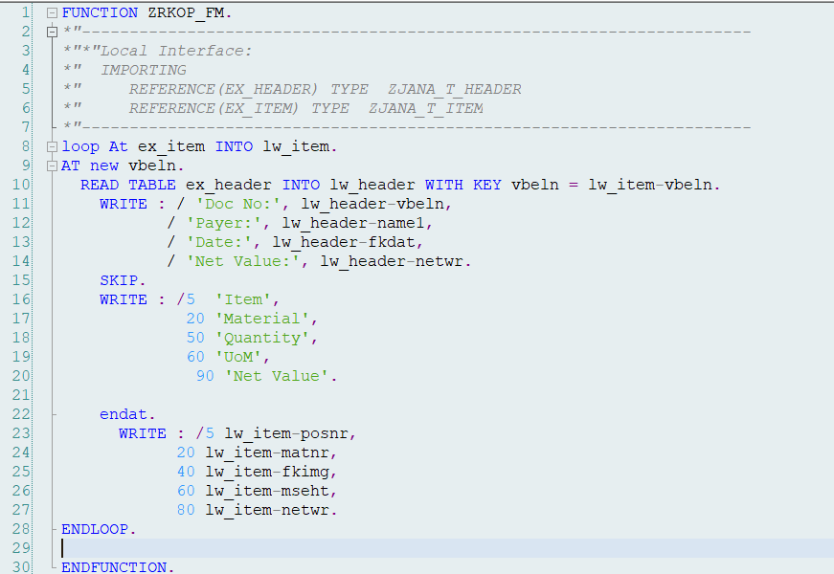

In below code we called function modules.  
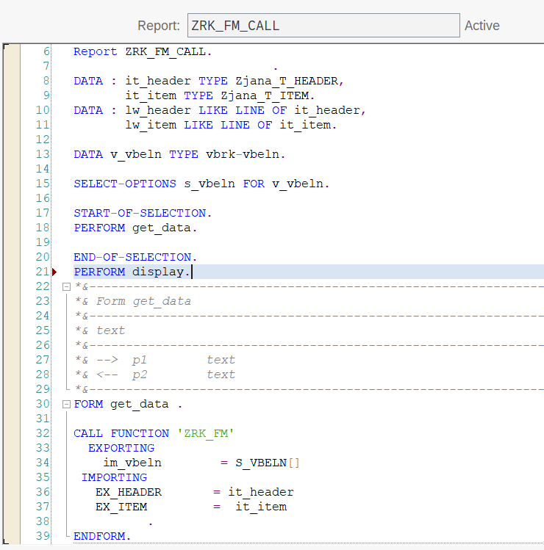

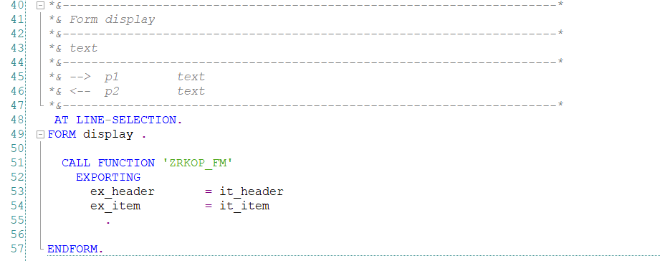

Output:



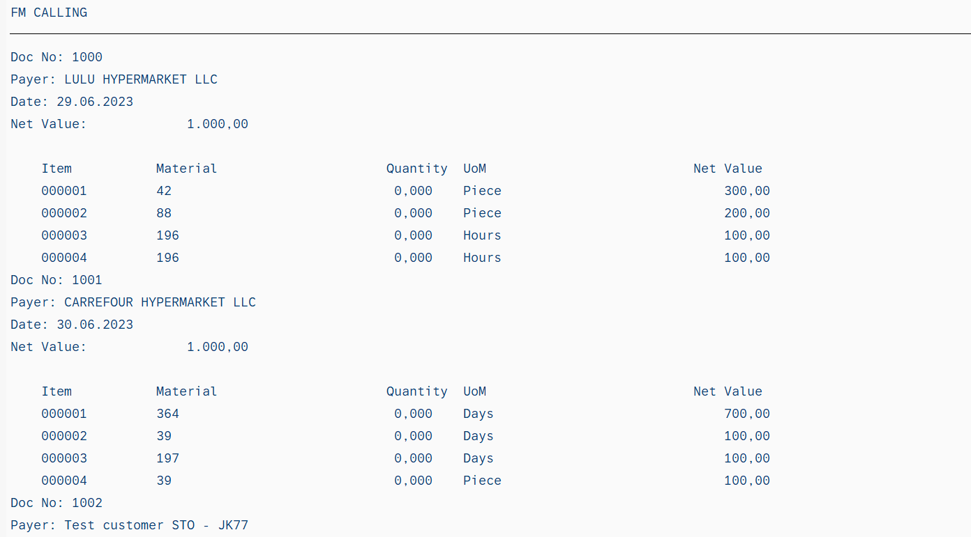

…………………………………………………………………………………………………..

Assignment 17: File upload using: 'GUI_UPLOAD'  
  
  
REPORT ZRK_FILE_UPLOAD.  
TYPES : BEGIN OF ty_file,  
 f1 TYPE char10,  
 f2 TYPE char10,  
 f3 TYPE char10,  
 END OF ty_file.  
  
DATA : it_file TYPE STANDARD TABLE OF ty_file,  
 wa_file LIKE LINE OF it_file.  
  
DATA v_file TYPE string.  
PARAMETERS p_file TYPE IBIPPARMS-PATH.*"string.*  
  
AT SELECTION-SCREEN ON VALUE-REQUEST FOR p_file.  
 CALL FUNCTION 'F4_FILENAME'  
 EXPORTING  
 PROGRAM_NAME = SYST-CPROG  
 DYNPRO_NUMBER = SYST-DYNNR  
 FIELD_NAME = 'P_FILE'  
 IMPORTING  
 FILE_NAME = p_file  
 .  
  
  
START-OF-SELECTION.  
v_file = p_file.  
CALL FUNCTION 'GUI_UPLOAD'  
 EXPORTING  
 filename = v_file  
 FILETYPE = 'ASC'  
 HAS_FIELD_SEPARATOR = 'X'  
*\* HEADER_LENGTH = 0*  
*\* READ_BY_LINE = 'X'*  
*\* DAT_MODE = ' '*  
*\* CODEPAGE = ' '*  
*\* IGNORE_CERR = ABAP_TRUE*  
*\* REPLACEMENT = '#'*  
*\* CHECK_BOM = ' '*  
*\* VIRUS_SCAN_PROFILE =*  
*\* NO_AUTH_CHECK = ' '*  
*\* IMPORTING*  
*\* FILELENGTH =*  
*\* HEADER =*  
 tables  
 data_tab = it_file  
*\* CHANGING*  
*\* ISSCANPERFORMED = ' '*  
 EXCEPTIONS  
 FILE_OPEN_ERROR = 1  
 FILE_READ_ERROR = 2  
 NO_BATCH = 3  
 GUI_REFUSE_FILETRANSFER = 4  
 INVALID_TYPE = 5  
 NO_AUTHORITY = 6  
 UNKNOWN_ERROR = 7  
 BAD_DATA_FORMAT = 8  
 HEADER_NOT_ALLOWED = 9  
 SEPARATOR_NOT_ALLOWED = 10  
 HEADER_TOO_LONG = 11  
 UNKNOWN_DP_ERROR = 12  
 ACCESS_DENIED = 13  
 DP_OUT_OF_MEMORY = 14  
 DISK_FULL = 15  
 DP_TIMEOUT = 16  
 OTHERS = 17  
 .  
IF sy-subrc <> 0.  
*\* Implement suitable error handling here*  
ENDIF.  
  
LOOP AT it_file INTO wa_file.  
WRITE : / wa_file-f1, wa_file-f2, wa_file-f3.  
ENDLOOP.  


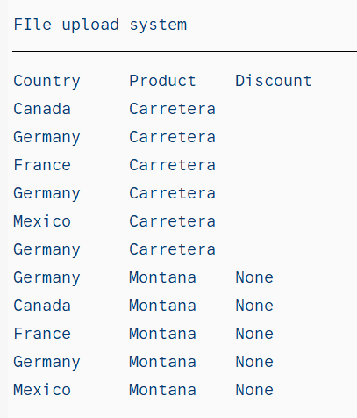

………………………………………………………………………………………………………

Assignment: CLASS ALV: Displaying material, material description, language using class ALV.  
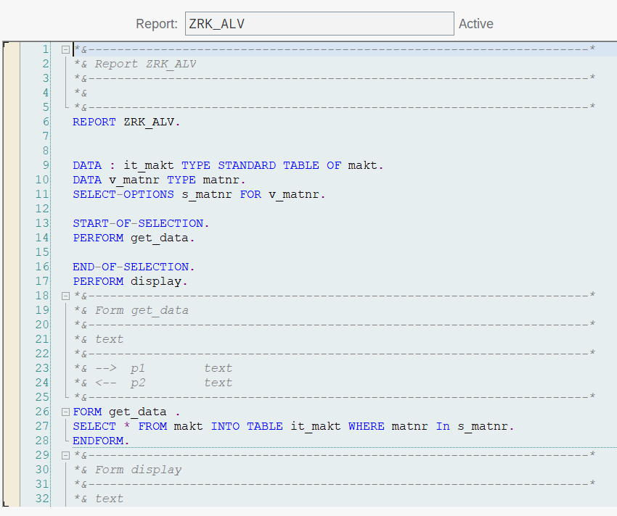

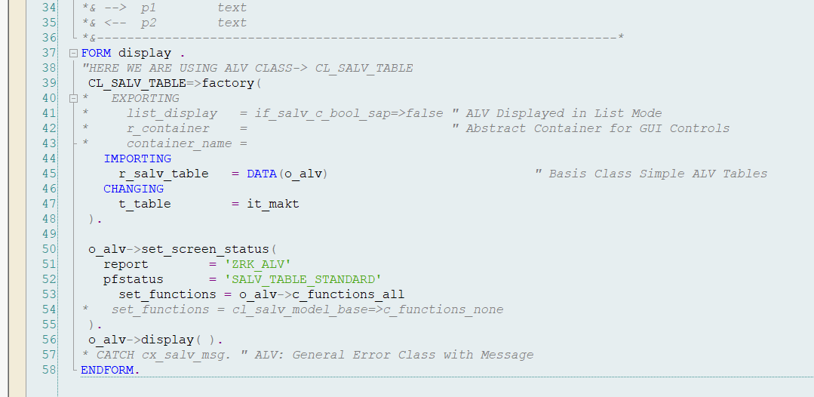



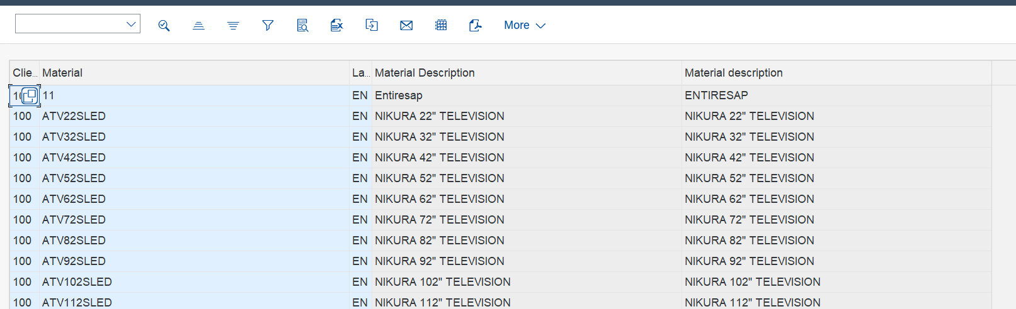

………………………………………………………………………………………………………

Function module ALV: Displaying material number, description, language using function module ALV.  
  
