Assignment: OPC UA Client Development and Data Logging.
GitHub Link: https://github.com/RohitKotekar21/Opc-Ua-Client-Logger
Objective
Design and implement an OPC UA Client that connects to a simulated OPC UA server, reads
dummy tags at regular intervals, and logs the data into hourly spreadsheets.

Prerequisites:
Before running the client, ensure the following software is installed and configured:
- Python 3.x: The core programming language used.
- python-opcua library: The protocol library for OPC UA communication.
- Unified Automation UA C++ Demo Server: Acts as the simulation server.
- Matrikon OPC UA Explorer: Used for manual tag verification and server browsing.

Installation & Setup:
Install Python Library: Open your terminal and run the following command:
pip install opcua

Start the Simulator:
- Open the UA C++ Demo Server.
- Ensure the server status is set to "Running".
- Note the endpoint (Host name) : opc.tcp://LAPTOP-LA2AESIK:48010
Verify Tags:
- Open Matrikon OPC UA Explorer.
- Connect to the server and browse to Root > Objects > Demo > Dynamic > Scalar.
- Ensure the tags are updating their values in real-time.

Configuration:
The source code is pre-configured with the following settings:
- Endpoint (Hostname): opc.tcp://LAPTOP-LA2AESIK:48010
- Polling Interval: 60 seconds (1 minute).
- Target Tags: 10 dynamic tags from the Demo.Dynamic.Scalar branch, including Double, Boolean, Int32, and String types.
Execution:
- Navigate to the folder containing the ```opc_logger.py``` script.

- Run the script via the command line:
python opc_logger.py
- The console will display real-time logs, and CSV files will be generated automatically in the same directory.

Troubleshooting:
- Connection Error: Verify that the server is running and the computer name in the endpoint is correct.
- Access Denied: Ensure the CSV output file is not open in Excel, as Excel locks the file and prevents the script from writing data.
- NaN/Error Values: Check the Matrikon Explorer to ensure the specific Node ID exists and is currently "Good."
Screenshots:
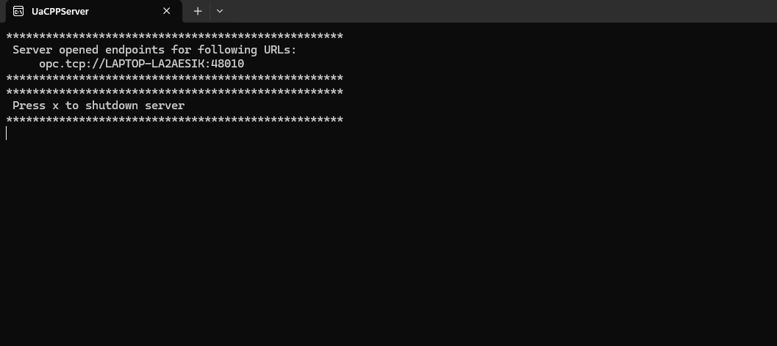
Fig 1. Checking the end points and Hostname.

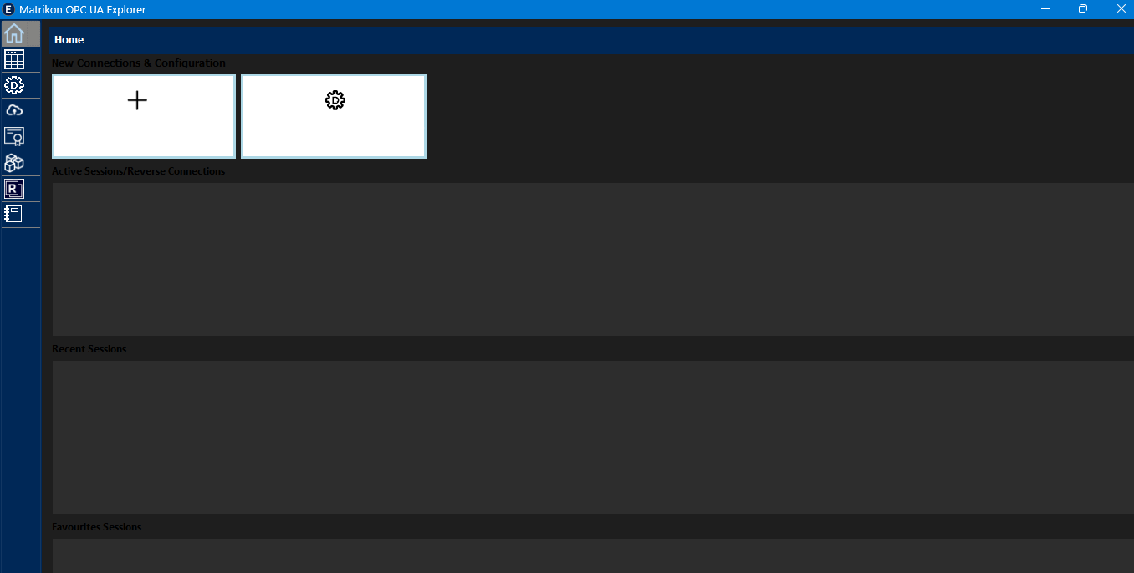
Fig 2. Connecting in the Matrikon.

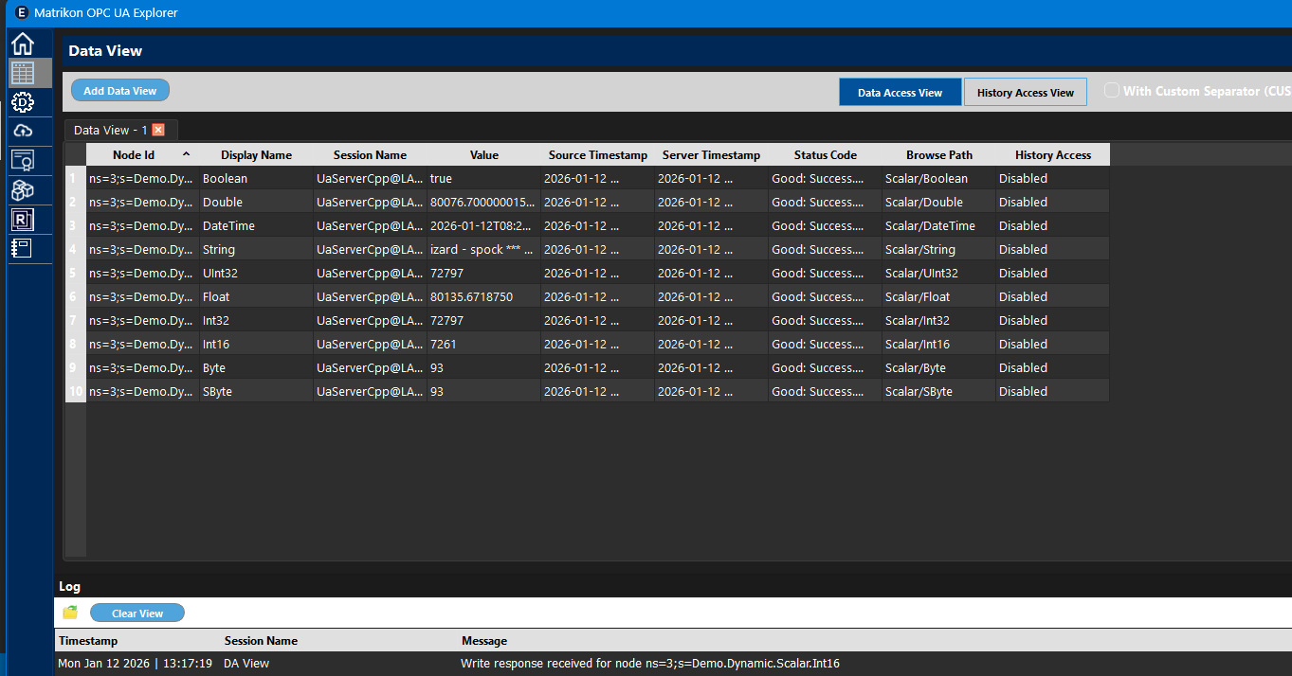
Fig 3. Reading the 10 Tags.
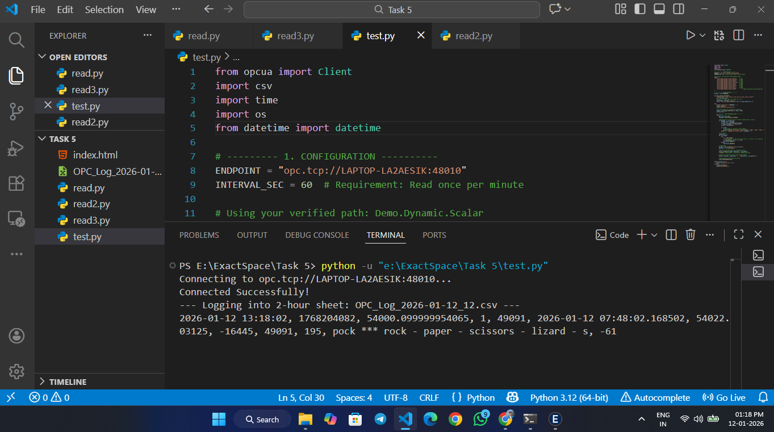
Fig 4. Connected successfully and loading the tags.

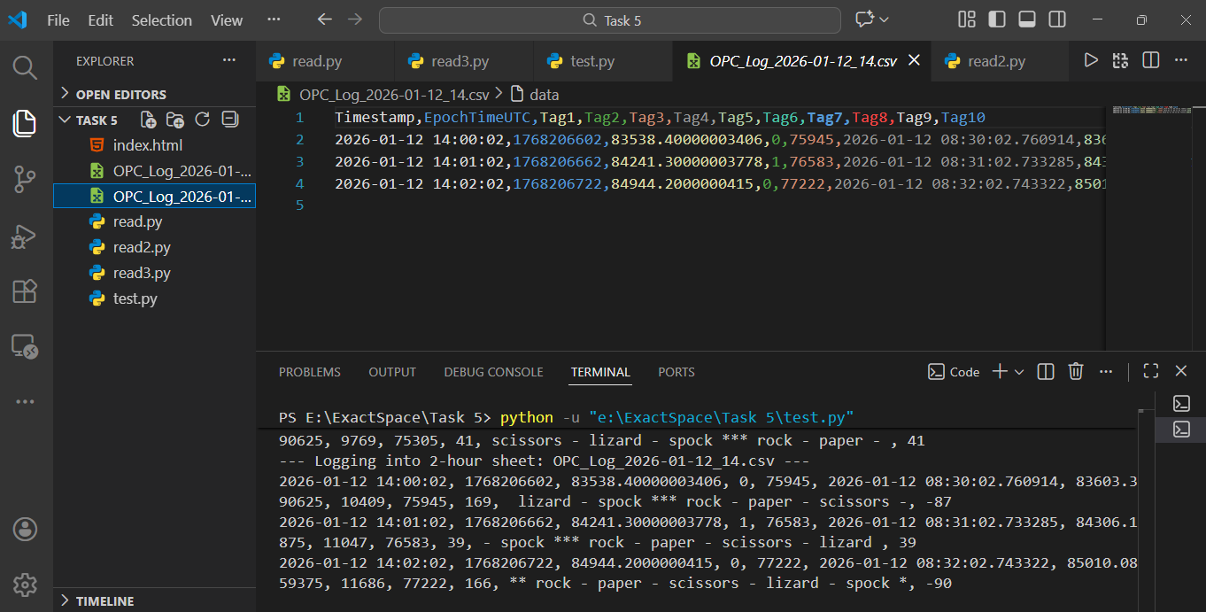
Fig 5. Saving the tags in the csv.

