 | Venkata Krishna  Rohit Chekuru | Email Id – v.chekuru@zensar.com  Ph: 9885523301  Location: Hyderabad  LinkedIn: |  | 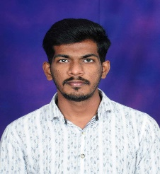

Summary | I have around 1 years of experience in IT development, I worked on technologies like HTML, CSS, JavaScript and AEM, possess excellent written and verbal communication skills. I am working with Zensar Technologies Limited as Software Engineer.

Education | - B Tech in Information Technology [2016-2020]

Core competencies/skills | Category | Primary skills | Secondary skills
Core competencies/skills | Domains | Banking, Insurance.
Core competencies/skills | Tools | VS Code, JIRA, GIT. | Notepad++
Core competencies/skills | Databases | MySQL
Core competencies/skills | Bug/Issue-Tracking System | JIRA
Core competencies/skills | Programming skills | Java Microservices,AEM,

Expertise | - Java Microservices, AEM.

Certifications

Awards

Experience Summary | - ROLE [2022 to 2023]  - HTML, CSS, JS,AEM.  - Deliver 1 projects, and got good words from higher management team and client.

PROFESSIONAL EXPERIENCE

Project – DotCoZa [Oct 2022- June 2023]

Role: Software engineer

Project Description: It’s a CMS kind of portal, we can manage website content through database as well frontend with zero downtime.

Key activities performed: Created reusable component with different-different variation.

Technology/Skills/Tools used
- Tools: Postman, JIRA, VS Code.
- Technologies: HTML, CSS, AEM.
- Skills: Front-End Developer.

