# Bike Sharing Prediction – Comparing Regression Models

## Authors:

Rohit Kumar Bandi Ravikumar

Rahul Prasad

Peter Prince

## Project Description:

BoomBikes, a US bike-sharing provider, experienced a significant decline in revenue due to the COVID-19 pandemic. To recover and improve future performance, the company aimed to understand the demand for shared bikes post-pandemic. They sought to identify the factors influencing bike demand to develop a strategic business plan.

## Business Goals:

1. Model the demand for shared bikes using available independent variables.

2. Help management understand how demand varies with different features.

3. Enable management to manipulate business strategies to meet demand and customer expectations.

## Equations:

• Total Users: cnt = Causal + Registered.

• Average Users Per Day: Average Users = $\frac{\sum{cnt}}{Number of days}$

## Dataset Overview:

Variables: Date, season, year, month, holiday, weekday, working day, weather situation, temperature, feeling temperature, humidity, wind speed, casual users, registered users, total users.

## Exploratory Data Analysis (EDA)

## 

## Model Building:

Model: A simple linear regression model was built to predict based on dependent variables.

Data Splitting: The dataset was split into training and test sets.

**Model Evaluation:**

Metrics:  
- RMSE: Root Mean Squared Error was calculated.  
- R-squared: R-squared value was computed to evaluate the fit of the model on the test set.

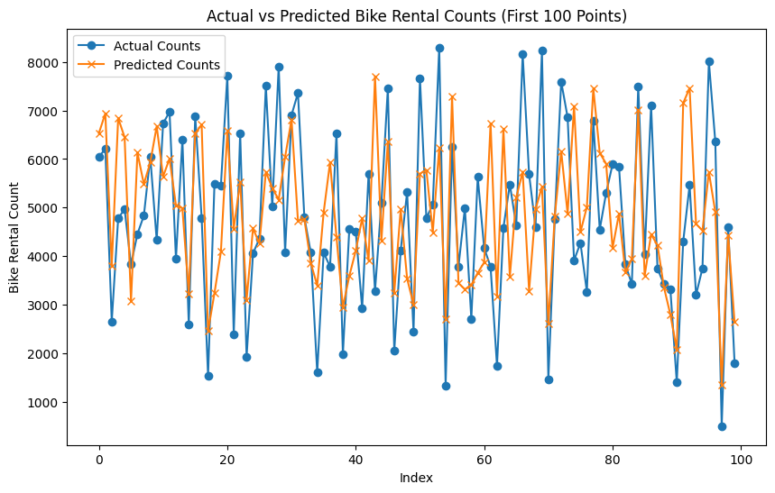

**Conclusion:**

* The developed model for predicting bike rentals identified humidity and wind speed as significant factors influencing rental counts. The analysis of residuals indicates that the model's errors are mostly random, suggesting a reliable model performance.