**RDBMS Lab Exercises**

**ER Model**

1. Draw an E-R diagram for the following application.
2. A training institute conducts up to 6 courses.
3. A course can have up to 30 students.
4. A student can enroll for a particular course only once. However a student can enroll for any number of courses. The date of enrollment of the course is also maintained.
5. A course is described by its *course-id*, title and duration, *course-*id being the primary key.
6. A student is described by *stud-id*, name and address (house number, street or area, town, dist , city state). The *stud-id* is the primary key.
7. There is no student who has not taken any course. There are however courses for which there are no students.
8. Draw an E-R diagram for the following application.
9. A company maintains details of its Employees like empId, name, date of birth)
10. Each Employee works for a single department.
11. There are two types of employee- Contract and Permanent. Contract employees work for a period of time and are given temporary id. They are paid in per day basis. Permanent employees are paid every month and they have permanent id.
12. Department is identified by deptId, name.
13. Each department has one of the employees as manager.
14. Company also needs the details of all the Employee’s Bank accounts.
15. Bank Account details are acctNumber, Type of account, Name of the Bank and Branch.
16. Draw an E-R diagram for the following application.
    1. A company has many rounds of recruitments each conducted by certain department (deptId, name).
    2. There is a list of applicants (appNo, name, qualification) whom these departments interview.
    3. After the interview, results (date of interview, score for each applicant) are prepared.
    4. The selected candidates are made Job Offers.
17. Translate the ER diagram of question 2 into relational tables. For the above tables identify (if any) Primary key, Composite key, Foreign key and Super Key.

5. Draw an ER diagram for a bus company with following specifications:

1. A Country Bus Company owns a number of busses.
2. Each bus is allocated to a particular route, although some routes may have several busses.
3. Each route passes through a number of towns.
4. One or more drivers are allocated to each stage of a route.
5. A stage corresponds to a journey through some or all of the towns on a route.
6. Some of the towns have a garage where busses are kept and each of the busses are identified by the registration number and can carry different numbers of passengers, since the vehicles vary in size and can be single or double-decked.
7. Each route is identified by a route number and information is available on the average number of passengers carried per day for each route.

6. Draw an ER diagram for application recording information about magazines, writers, and subscribers, including:

1. For each magazine, its name, its writers, its editor, and the cities to which it is delivered are to be maintained.
2. For each writer, their id, name is to be maintained. (Note: a writer can write for more than one magazine, but can only edit, at most, one magazine.)
3. For each subscriber, their name, favorite writers, city or residence, and what magazines they receive are to be maintained.
4. For all entities and relationships, select and specify keys.

**RDBMS Table Design**

1. Normalize the given table to 2NF and 3NF.

Happy Home Super market deals with groceries, household items, stationary products and gift items. They have announced a summer mela where, for every customer who holds a membership with Happy Home, any three items can be taken for free. The total price of the three items should be equal to or below Rs.1000. They record details of these free products given to their member customers in a table as below.

|  |  |  |  |  |  |  |  |  |  |  |  |  |
| --- | --- | --- | --- | --- | --- | --- | --- | --- | --- | --- | --- | --- |
| Invoice# | Member  ship# | Cust  name | Address | Item1 | Qty | Amt | Item2 | Qty | Amt | Item3 | Qty | Amt |

2. Normalize the given table ensuring no data loss and data redundancy.

|  |  |  |  |  |  |  |  |
| --- | --- | --- | --- | --- | --- | --- | --- |
| Emp_ID | Name | Dep_Name | Salary | | Course_Title | Date_Completed | |
| 100 | Margaret Simpson | Marketing | | 48000 | SPSS | | 6/19/200x  10/7/200x | |
| 140 | Alan Beeton | Accounting | | 52000 | Tax Acc | | 12/8/200x | |
| 110 | Chris Lucero | Info System | | 43000 | SPSS | | 1/12/200x  10/7/200x | |
| 190 | Lorenzo Davis | Finance | | 55000 | SPSS | | 6/16/200x | |
| 150 | Susan Martin | Marketing | | 42000 | JAVA | | 8/12/200x | |

**SQL Statements**

1. Create the following tables and insert data .

NOTE : input the date in oracle format.

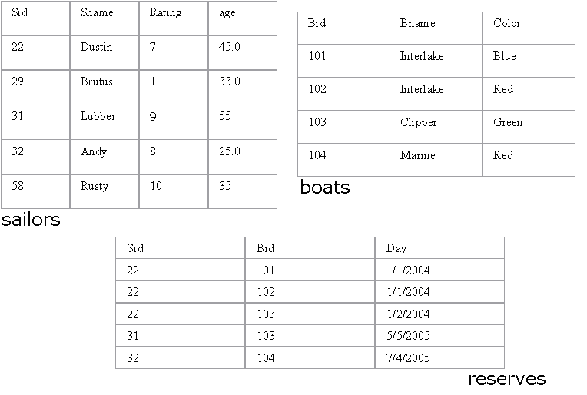

**Write SQL queries for the following:**

1. Find the names of sailors who have reserved a red boat.

2. Find the names of the Sailors who have reserved at least one boat

3. Compute increments for the ratings of persons who have sailed two different boats on the same day.

4. Find the ages of sailors whose name begins and ends with B and has at least 3 characters.

5. Find the names of sailors who have reserved a red and a green boat.

6. Find the sids of all sailors who have reserved red boats but not green boats.

7. Find the sailors with the highest rating

8. Find the name of the oldest sailor.

9. Count the number of different sailor names.

10. Find the no. of sailors who is eligible to vote for each rating level.

11. Find the no. of sailors who is eligible to vote for each rating level with at least

two such sailors.

12. Find the sid of the sailors who have sailed exactly one boat.

13. Find sailors who have not reserved any boats.

14. Find the Sailors who have reserved all the boats.

15. Find all the sailors older than Dustin.

16. Find all sailors whose ratings is greater than any others rating without using aggregates like MAX.

17. Find the sailors with 3rd highest ratings.

18. Find sids of the sailors who have reserved all the boats reserved by the sailor with sid =’31’.

19. List out all the sailors. For the sailors who have reserved some boats list out the boat’s bids also.

20. Assume that we have a table called customer.

|  |  |  |
| --- | --- | --- |
| CustID | Name | ReferredBy |
| 1 | Neeta Sayam |  |
| 2 | Dolly Dilly | 1 |
| 3 | Meena Kimi | 2 |

21. Find the names of all customers who are referred by others.

22. Find the names of all customers who have referred others.

23. Find the last three customer records inserted. (Refer the above Customer table)

1. Given a table ‘customer’.

|  |  |  |
| --- | --- | --- |
| CustID | Name | Age |
| 1 | Neeta Sayam | 32 |
| 2 | Dolly Dilly | 23 |
| 3 | Meena Kimi | 43 |

How will you get rows between the range x and y where x and y will be entered by the user?

1. Given three tables- sailors, boats and reserves. Sid, Bid and (Sid, Bid) are the primary keys of sailors, boats and reserves respectively. Sid and Bid are also the foreign keys of reserves which references Sid and Bid of sailors and boats relation respectively. No two sailors have same rating. The sname and bname of the sailors and boats table are cannot be null.



Queries:

1. Alter the Sailor table such that age is between 18 and 40.
2. Alter the Boats table such that color is Red, Blue or Green.
3. Assuming that all the tables are created as in 1, 2 and 3 alter the table (s) such that if a record from sailors table gets deleted, then the records corresponding to the same sailor also get deleted from reserves.
4. Drop primary key constraint from the reserves table.