- Create the following table and insert data :
EMP
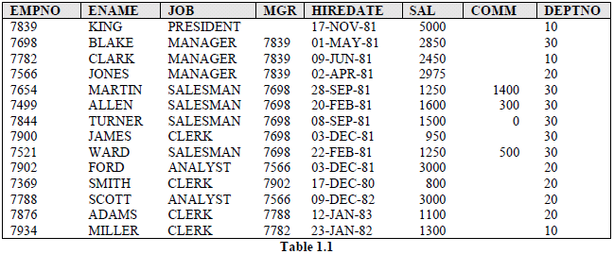

The table DEPT below contains data about different departments in an organization and
SALGRADE gives details of salaries for various grades. The table JOB_HISTORY stores
data about the job history of employees.

DEPT
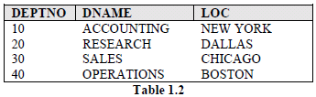

SALGRADE
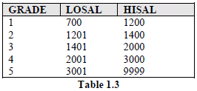
JOB_HISTORY
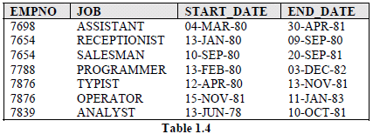

Relating Multiple Tables
Each table contains data that describes exactly one entity. For example, the EMP table
contains information about employees. Since data about different entities is stored in different
tables, it may be needed to combine two or more tables to answer a particular question. For
example, someone may want to know the location of the department where an employee
works. In this scenario, information is needed from both the EMP and DEPT table. An
RDBMS enables to relate the data in one table to the data in another table by using the foreign
keys.

Practice Basics

Simple Examples:
i. Selecting all columns from a table
ii. To select names of all jobs in a department, use
iii. To select all employees whose salary is greater than 2200.
iv. To display the name and department number of employees who were hired before 12th
v. To display the name and job of employees using literal character strings and
concatenation operators.

Select Statement Practice

1. Suppose there is need of annual salary along with emp name information
provided by emp table.
2. How to fetch monthly salary of each employee?
3. Select all record from emp table where deptno =10 & 30 or 40.
4. Select all record from emp table where deptno 30 and greater then 1500.
5. Select all record from emp where job not in SALESMAN or CLERK.
6. Select all record from emp with names 'BLAKE','SCOTT','KING'and'FORD'.
7. Select all records where Name starts with ‘S’ and its lenth is 6 char.
8. Select all records where Name may be any no of character,
but it should end with ‘R’.
9. Select emplyee name and thier MGR and also their salary.
10. select total Annual salery of all emps including their comm.
11. Select emp salary great then 3000 from dept 20 & 30.
12. Select all the employee group by deptno and sal in descending order.
13 Count of number of employees in department wise.
14. How to retrive record where sal between 1000 to 2000?
15. Select all records where dept no of both emp and dept table matches.
16. If there are two tables emp1 and emp2, and both have common record. How can I fetch all the recods but common records only once?
17. How to fetch only common records from two tables emp and emp1?
18. How can I retrive all records of emp1 those should not present in emp2?
19. Count the totalsa deptno wise where more than 2 employees exist.

20. How can I create an empty table emp1 with same structure as emp?

