**--Q1: The total number of order place**

**SELECT COUNT(order_id) AS total_orders**

**FROM orders;**

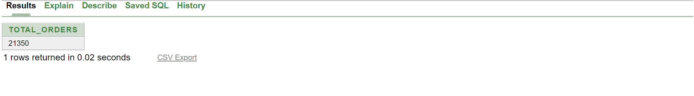

**-- Q2: The total revenue generated from pizza sales**

**SELECT SUM(od.quantity * p.price) AS total_revenue**

**FROM order_details od**

**JOIN pizzas p ON od.pizza_id = p.pizza_id**

**JOIN orders o ON od.order_id = o.order_id**

**JOIN pizza_types pt ON p.pizza_type_id = pt.pizza_type_id;**

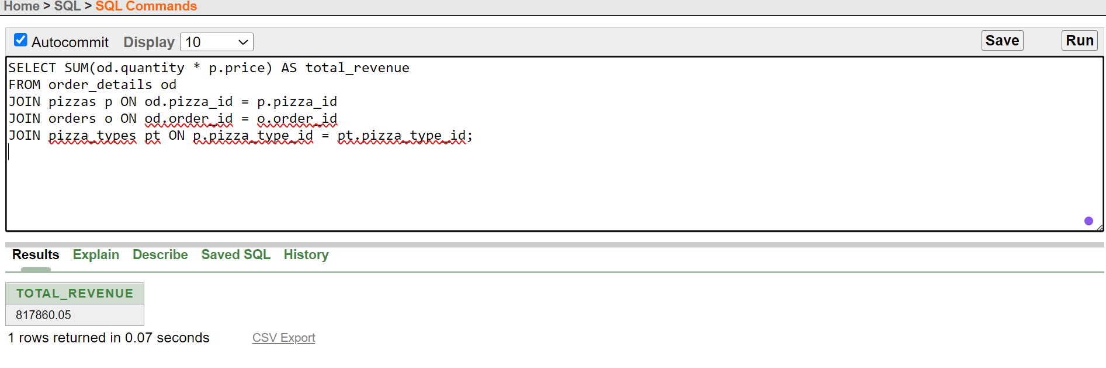

**-- Q3: The highest priced pizza.**

**SELECT pizza_id, price**

**FROM (**

**SELECT pizza_id, price**

**FROM pizzas**

**ORDER BY price DESC**

**)**

**WHERE ROWNUM = 1;**

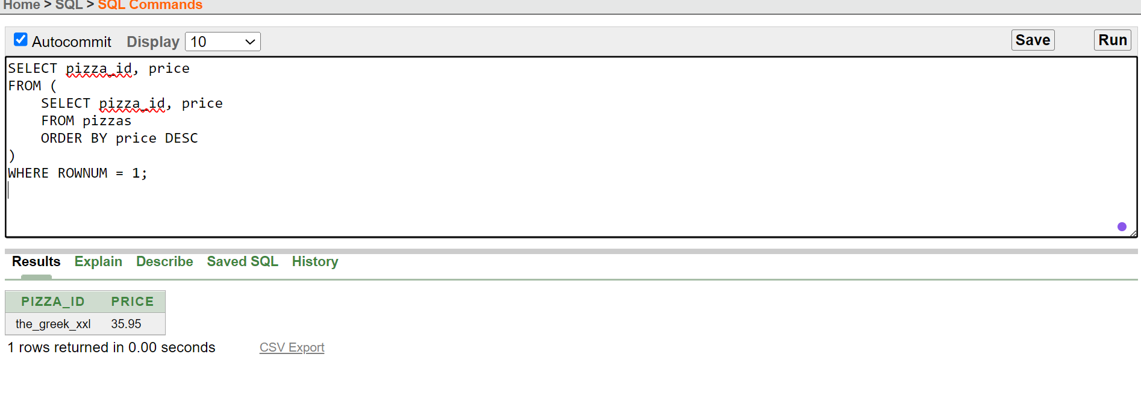

**-- Q4: The most common pizza size ordered.**

**SELECT order_size, order_count FROM (**

**SELECT p.order_size, COUNT(od.pizza_id) AS order_count**

**FROM order_details od**

**JOIN pizzas p ON od.pizza_id = p.pizza_id**

**GROUP BY p.order_size**

**ORDER BY order_count DESC**

**) WHERE ROWNUM = 1;**

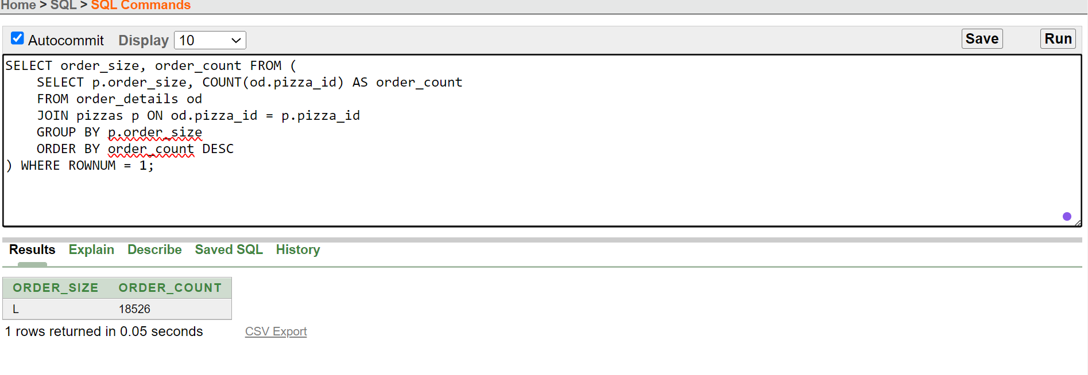

**-- Q5: The top 5 most ordered pizza types along their quantities.**

**pizzas p**

**SELECT category, order_count**

**FROM (**

**SELECT pt.category, COUNT(od.pizza_id) AS order_count**

**FROM order_details od**

**JOIN pizzas p ON od.pizza_id = p.pizza_id**

**JOIN pizza_types pt ON p.pizza_type_id = pt.pizza_type_id**

**GROUP BY pt.category**

**ORDER BY order_count DESC**

**) sub**

**WHERE ROWNUM <= 5;**

**-- Q6: The quantity of each pizza categories ordered.**

**SELECT pt.category, SUM(od.quantity) AS total_quantity**

**FROM order_details od**

**JOIN pizzas p ON od.pizza_id = p.pizza_id**

**JOIN pizza_types pt ON p.pizza_type_id = pt.pizza_type_id**

**GROUP BY pt.category;**

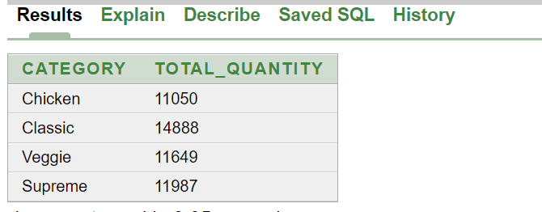

**-- Q7: The distribution of orders by hours of the day.**

**SELECT TO_CHAR(order_date, 'HH24') AS hour_of_day, COUNT(*) AS order_count**

**FROM orders**

**GROUP BY TO_CHAR(order_date, 'HH24')**

**ORDER BY hour_of_day;**

**-- Q8: The category-wise distribution of pizzas.**

**SELECT pt.category, COUNT(p.pizza_id) AS pizza_count**

**FROM pizzas p**

**JOIN pizza_types pt ON p.pizza_type_id = pt.pizza_type_id**

**GROUP BY pt.category**

**ORDER BY pizza_count DESC;**

**-- Q9: The average number of pizzas ordered per day.**

**SELECT order_date, SUM(quantity) AS total_pizzas**

**FROM order_details od**

**JOIN orders o ON od.order_id = o.order_id**

**GROUP BY order_date;**

**-- Q10: Top 3 most ordered pizza type base on revenue.**

**SELECT category, total_revenue**

**FROM (**

**SELECT pt.category, SUM(p.price * od.quantity) AS total_revenue**

**FROM order_details od**

**JOIN pizzas p ON od.pizza_id = p.pizza_id**

**JOIN pizza_types pt ON p.pizza_type_id = pt.pizza_type_id**

**GROUP BY pt.category**

**ORDER BY total_revenue DESC**

**)**

**WHERE ROWNUM <= 3;**

**-- Q11: The percentage contribution of each pizza type to revenue.**

**WITH RevenueByType AS (**

**SELECT pt.category,**

**SUM(p.price * od.quantity) AS total_revenue**

**FROM order_details od**

**JOIN pizzas p ON od.pizza_id = p.pizza_id**

**JOIN pizza_types pt ON p.pizza_type_id = pt.pizza_type_id**

**GROUP BY pt.category**

**),**

**TotalRevenue AS (**

**SELECT SUM(total_revenue) AS overall_revenue**

**FROM RevenueByType**

**)**

**SELECT rb.category,**

**rb.total_revenue,**

**(rb.total_revenue / tr.overall_revenue) * 100 AS percentage_contribution**

**FROM RevenueByType rb, TotalRevenue tr**

**ORDER BY percentage_contribution DESC;**

**-- Q12: The cumulative revenue generated over time.**

**SELECT order_date,**

**SUM(total_revenue) OVER (ORDER BY order_date) AS cumulative_revenue**

**FROM (**

**SELECT o.order_date,**

**SUM(od.quantity * p.price) AS total_revenue**

**FROM order_details od**

**JOIN pizzas p ON od.pizza_id = p.pizza_id**

**JOIN orders o ON od.order_id = o.order_id**

**GROUP BY o.order_date**

**) t**

**ORDER BY order_date;**

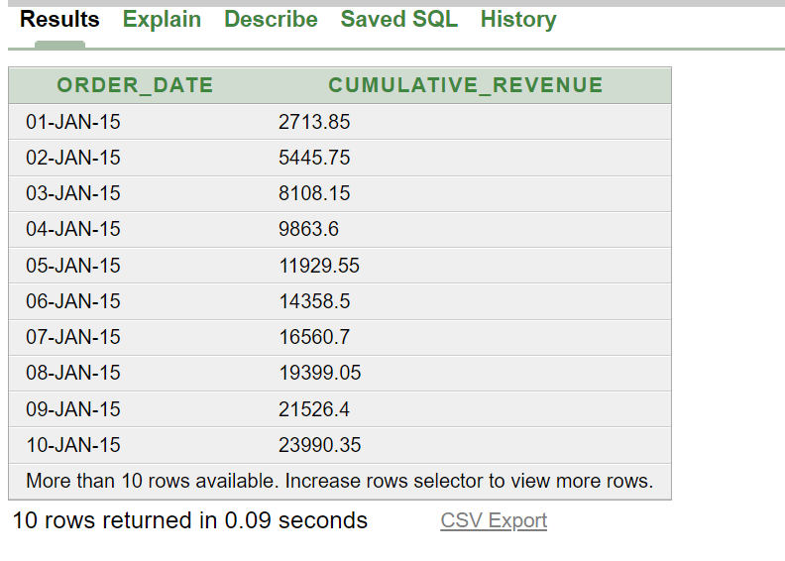

**-- Q13: The top 3 most ordered pizza type based on revenue for each pizza category.**

**WITH RevenueByType AS (**

**SELECT pt.category,**

**p.pizza_id,**

**SUM(p.price * od.quantity) AS total_revenue**

**FROM order_details od**

**JOIN pizzas p ON od.pizza_id = p.pizza_id**

**JOIN pizza_types pt ON p.pizza_type_id = pt.pizza_type_id**

**GROUP BY pt.category, p.pizza_id**

**),**

**RankedRevenue AS (**

**SELECT category,**

**pizza_id,**

**total_revenue,**

**RANK() OVER (PARTITION BY category ORDER BY total_revenue DESC) AS rank**

**FROM RevenueByType**

**)**

**SELECT category,**

**pizza_id,**

**total_revenue**

**FROM RankedRevenue**

**WHERE rank <= 3**

**ORDER BY category, rank;**

