**Questions**

1. If an IF neuron is fed very low current input, I would expect the frequency in spikes, or action potentials, to be much lower. I would assert the same for an LIF neuron, except due to the leakage of potential in this case, this difference in frequency will be slightly less pronounced given input current changes.
2. If an IF neuron is fed a larger current input, then I would expect the frequency in spikes, or action potentials, to be much higher. I would assert the same for an LIF neuron, except due to the leakage of potential in this case, this difference in frequency will be slightly less pronounced given input current changes.
3. The LIF neuron is inherently limited in that it is a highly simplified version of the biological neuron. Moreover, many aspects of neuronal dynamics are ignored under the LIF model. Mathematically speaking, given an input current for the model, it is integrated linearly into ascertaining the membrane potential, independently of the post-synaptic neuron. Also, after each spike, the membrane potential is reset to some value. As a result, no memory of previous spikes is kept, in contrast to what we know regarding the biological neuron.

**Programming**

1. I = 1.5 mOhms

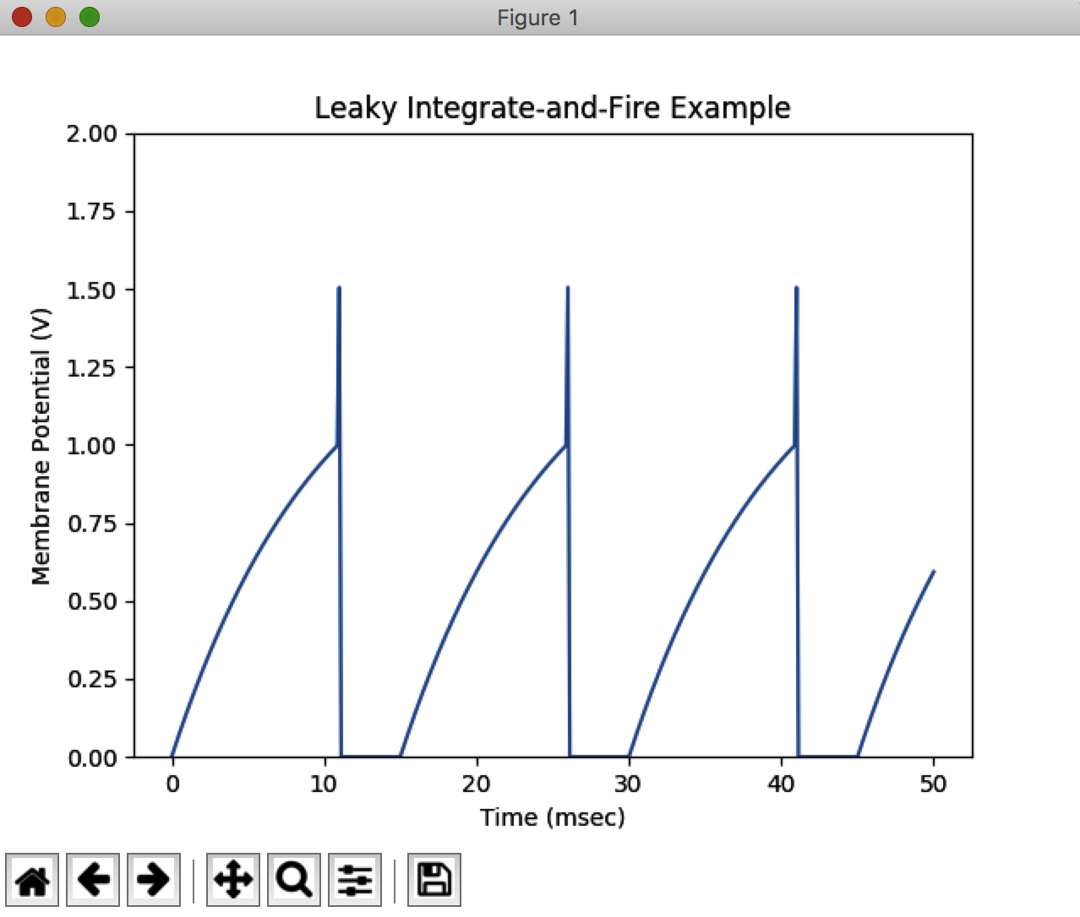

Figure 1. Simulation of an LIF Neuron with I = 1.5 mA

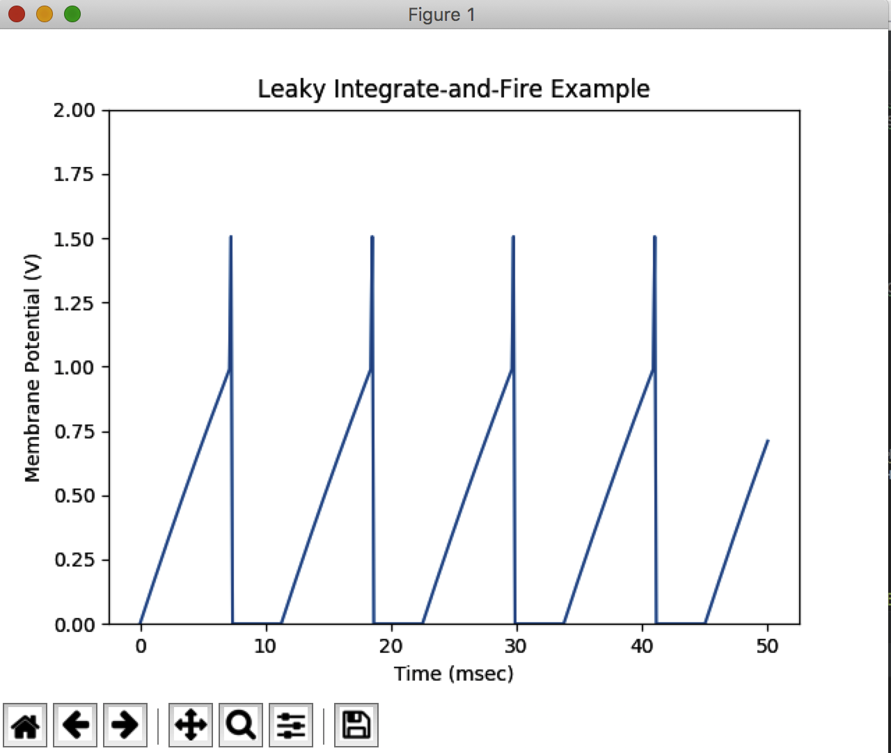

Figure 2. Another simulation of an LIF Neuron with I = 4.5 mA

1. 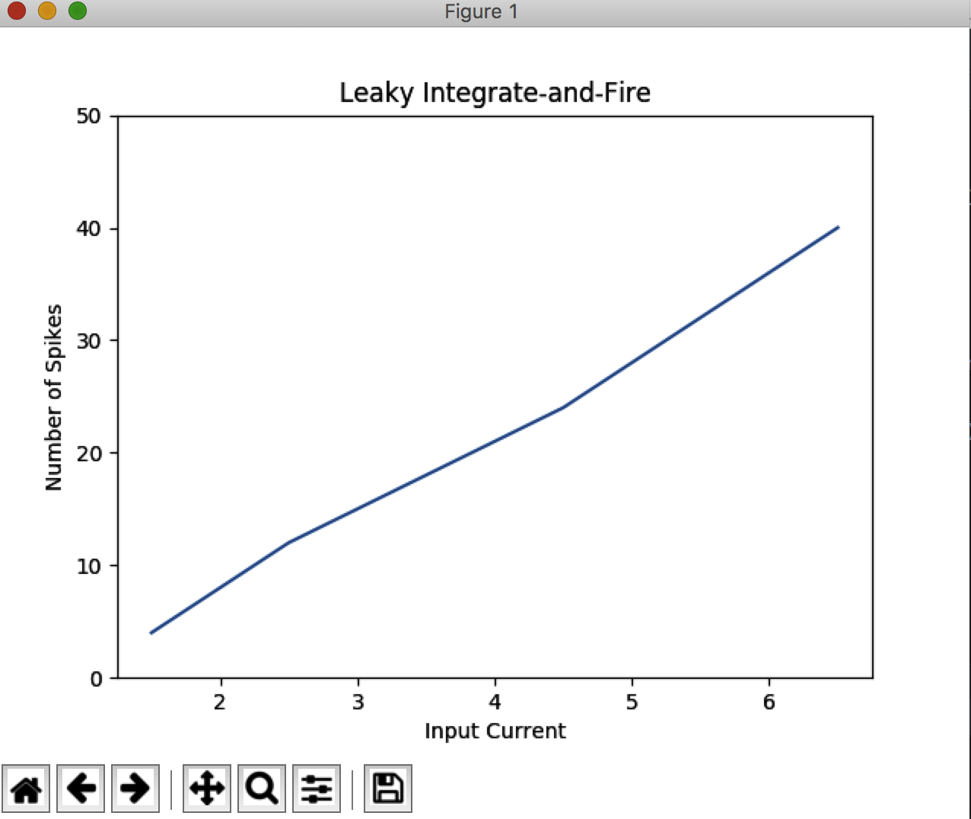

Figure 3. To show firing rate vs. input current, the number of spikes counted were tracked for 4 different input current levels: 1.5 mA, 2.5mA, 4.5mA, and 6.5mA. Clearly, as the input current level rises, the frequency of spikes seems to grow linearly in relation.

1. Clearly (from Figure 3), as the input current level rises, the frequency of spikes seems to grow linearly in relation. This is because, a higher current level would insinuate a stronger signal being received by the neuron’s dendrites, and a neuron is more likely to fire in response to a stronger signal. This is because there is greater probability that the potential change induced in the membrane will put the potential over the threshold for firing.
2. 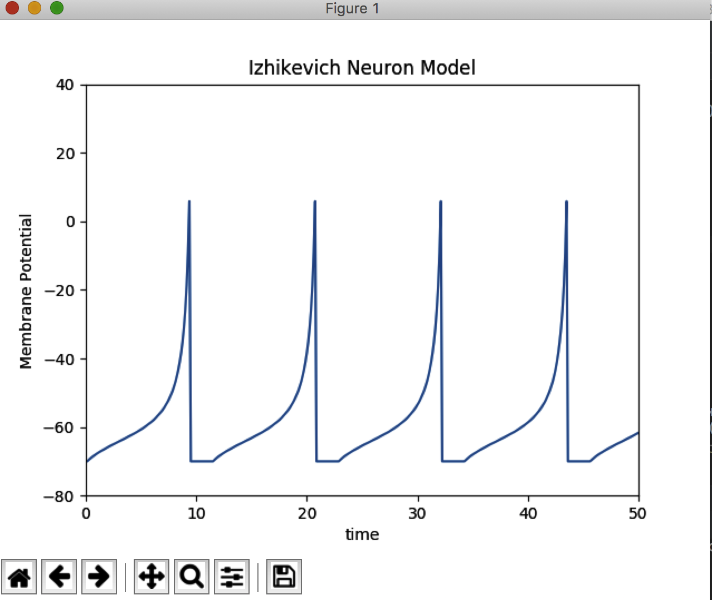

Figure 4. Given the constants used in the simulation for the Izhikevich Neuron Model, an input current of 17 mA was used to create the plot above. By changing the constants in the simulation, the model may depict more realistic quantities.

See next page for Hodgkin-Huxley Chart

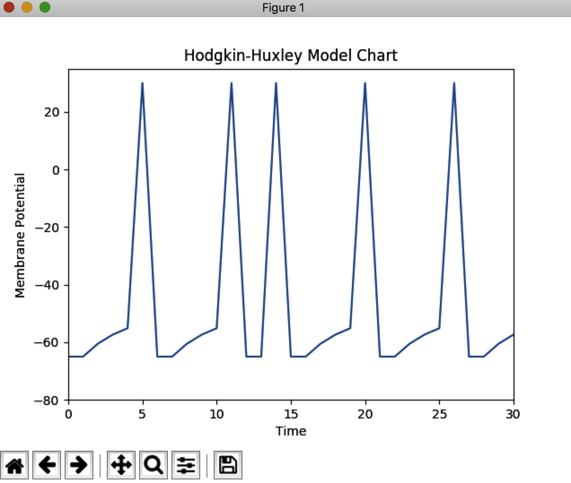

Figure 5. Given the constants used in the Hodgkin-Huxley simulation, as per the research paper, and input current of 10 mA in the time interval: [10, 15] (input current of 0 mA was used at all other times in simulation), membrane potential vs time is shown above.