

Table of Contents
Abstract 4
1. Introduction 5
2. Background 7
3. System Engineering Product Life Cycle 9
3.1 Problem Formulation 9
3.2 Concept Development 10
3.3 System Design 11
System Interface and User Interaction 12
3.4 Prototype Development 16
3.5 Testing and Evaluation 17
Sub-system Testing 17
Integration Testing 18
End-to-End System Testing 18
20
Automated Testing 21
Test Results and Observations 21
Testing Justification 22
3.6 Deployment and Maintenance Considerations 22
4. System Design and Architecture 23
4.1 Overview of the System 23
4.2 Sub-systems of the AI System 23
4.3 Data Flow 25
4.4 Design Justification 26
4.5 Project Structure and Implementation Organisation 28
5. AI Techniques 29
5.1 Logistic Regression (Baseline Model) 29
5.2 Random Forest (Ensemble Model) 30
5.3 XGBoost (Advanced Boosting Model) 31
5.4 Model Selection and Justification 32
6. Data Preprocessing 33
7. Model Training and Selection 36
8. Hybrid Prediction Approach 39
9. Evaluation Method 41
10. Results 43
11. Discussion 47
12. Deployment, Integration, and Maintenance Plan 49
APPENDICES 52
APPENDIX A – SAMPLE RISK REPORT 52
APPENDIX B – SYSTEM ARCHITECURE DIAGRAM 53
APPENDIX C – DATA FLOW DIAGRAM 54
APPENDIX D – AI USAGE DECLARATION 55
APPENDIX E - MODEL TEST RESULTS 56
APPENDIX F – SOFTWARE TOOLS USED 58
REFERENCES 61

Abstract
This project presents EduGuardian AI, an academic risk prediction and early intervention system designed to support university staff in identifying students at risk of failing during a teaching period. In many higher education environments, risk identification is often delayed until major assessments are completed, limiting the effectiveness of intervention strategies. This system addresses that limitation by providing early-stage predictions using partial academic performance data, enabling proactive and data-driven decision-making.
The system adopts a hybrid approach, combining machine learning techniques with a rule-based risk engine to balance predictive performance and interpretability. Three machine learning models - Logistic Regression, Random Forest, and XGBoost - are implemented and evaluated, with F1-score used as the primary metric due to class imbalance in academic datasets. The results demonstrate that ensemble and boosting methods outperform baseline models in predictive capability, while Logistic Regression provides strong interpretability. The hybrid integration further enhances system robustness by combining probabilistic predictions with deterministic academic rules.
EduGuardian AI is developed as a fully integrated AI system, incorporating a Flask-based dashboard, a structured database (SQLite), and an automated machine learning pipeline for data preprocessing, model training, and prediction. The system enables real-time interaction, allowing academic staff to input data, monitor cohort performance, and receive actionable risk classifications with recommended interventions.
The findings highlight that combining machine learning with domain-driven logic improves both reliability and usability of early warning systems. While the current implementation relies on publicly available datasets, the system establishes a scalable foundation for real-world deployment and integration with Learning Management Systems (LMS). Overall, this project demonstrates the importance of designing AI systems that are not only accurate but also interpretable, practical, and aligned with real-world academic workflows (Albreiki et al., 2021; Chen & Zhai, 2023).

1. Introduction
In modern higher education environments, identifying students who are at risk of academic failure remains a persistent challenge. Traditionally, academic risk is only recognised after students have performed poorly in major assessments such as midterm tests or final examinations. By this stage, opportunities for meaningful intervention are significantly reduced, limiting the ability of academic staff to support students effectively. This issue is particularly critical in trimester-based systems, where compressed timelines further restrict the window for corrective action.
With the widespread adoption of Learning Management Systems (LMS), universities now have access to large volumes of student performance data, including quiz results, assignment scores, and engagement metrics. This presents an opportunity to shift from a reactive approach to a more proactive and data-driven model of academic support. Machine learning and predictive analytics have emerged as powerful tools for analysing such data, enabling early identification of patterns associated with academic risk (Albreiki et al., 2021). However, many existing approaches focus primarily on predictive accuracy while overlooking the importance of interpretability and integration within real-world workflows.
This project introduces EduGuardian AI, an academic risk prediction and early intervention system designed to address these limitations. The system aims to provide early-stage predictions using partial semester data, allowing academic staff to identify at-risk students before final outcomes are determined. Unlike traditional systems that rely solely on static thresholds or black-box models, EduGuardian AI adopts a hybrid approach, combining machine learning models with a rule-based risk engine. This design enhances both predictive capability and transparency, ensuring that the system produces results that are not only accurate but also understandable and actionable.
A key objective of this project is to develop a complete AI system rather than a standalone predictive model, following the System Engineering Product Life Cycle (SEPLC). The system integrates multiple components, including data preprocessing, model training and evaluation, database management, and a user-facing dashboard built using Flask. By embedding the AI component within a broader system architecture, the solution supports real-time interaction and aligns with practical academic workflows.
The significance of this work lies in its focus on early intervention and decision support. By providing continuous monitoring of student performance and generating interpretable risk indicators, the system enables academic staff to take timely action, improving student outcomes and retention. Furthermore, the project demonstrates how combining machine learning with domain-specific logic can enhance the effectiveness and usability of AI systems in educational contexts (Chen & Zhai, 2023).

2. Background
Student performance prediction has been widely studied within the fields of learning analytics and educational data mining, with numerous approaches proposed to identify students at risk of academic failure. Traditional methods often rely on statistical analysis and simple threshold-based rules, such as identifying students with low average scores. While these approaches are easy to implement, they lack the ability to capture complex relationships between multiple performance indicators and are therefore limited in predictive capability (Albreiki et al., 2021).
With the advancement of machine learning, more sophisticated techniques have been introduced to improve prediction accuracy. Commonly used models include Logistic Regression, Decision Trees, Random Forest, and more recently, boosting algorithms such as XGBoost. Logistic Regression is frequently used as a baseline model due to its simplicity and interpretability, allowing stakeholders to understand how input features influence predictions. However, its linear nature restricts its ability to model complex, non-linear relationships present in real-world educational data (Chen & Zhai, 2023).
Ensemble methods such as Random Forest address this limitation by combining multiple decision trees to capture non-linear patterns and feature interactions. This improves predictive performance and robustness, particularly when dealing with noisy or heterogeneous datasets. Similarly, XGBoost, a gradient boosting algorithm, has gained popularity for its ability to achieve high accuracy by iteratively correcting prediction errors, making it highly effective for structured datasets such as student performance records (Salah et al., 2020).
Despite these advancements, several limitations remain in existing approaches. First, many studies focus primarily on maximising predictive accuracy, often at the expense of interpretability. In educational contexts, this presents a challenge, as academic staff require clear explanations of predictions in order to make informed decisions. Systems that operate as “black boxes” may achieve high performance but are less likely to be trusted or adopted in practice (Albreiki et al., 2021).
Second, a significant number of models are trained using complete semester data, which reduces their effectiveness for early-stage prediction. In real-world scenarios, only partial data is available during the initial weeks of a teaching period, making it necessary to design systems that can operate effectively under incomplete information. Early prediction is crucial, as it enables timely intervention before student performance declines further (Chen & Zhai, 2023).
To address these challenges, recent research has explored the integration of hybrid approaches, combining machine learning with rule-based or domain-driven systems. Such approaches aim to balance predictive performance with interpretability by leveraging both data-driven insights and structured academic knowledge. This project builds upon this idea by developing a hybrid academic risk prediction system that integrates machine learning models with a rule-based risk engine, providing both accurate predictions and explainable outputs.
In addition, unlike many existing studies that focus solely on model development, this project adopts a system engineering perspective, treating the solution as a complete AI system rather than an isolated algorithm. This includes the integration of data preprocessing, model training, prediction, and user interaction within a unified workflow. By doing so, the system is designed not only to achieve predictive performance but also to support practical deployment and real-world usage in educational environments.

3. System Engineering Product Life Cycle
The development of EduGuardian AI follows a structured System Engineering Product Life Cycle (SEPLC), which ensures that the system is designed as a complete and integrated solution rather than a standalone machine learning model. This approach is particularly important for AI systems, where performance alone is not sufficient; usability, interpretability, and integration within a workflow are equally critical. (Patterson, 1999)

In this project, the lifecycle was not treated as a purely theoretical framework, but as a practical guide that influenced how the system was progressively developed from a simple prototype into a fully functioning application. Each stage of the lifecycle contributed to refining the system’s functionality, improving its reliability, and ensuring that it aligns with real-world academic use cases.

3.1 Problem Formulation
The first stage of the lifecycle focused on clearly defining the problem domain and understanding the operational challenges faced by academic institutions. The core issue identified is the delayed detection of at-risk students, where academic performance concerns are typically recognised only after major assessments have been completed. This reactive approach limits the effectiveness of intervention strategies and reduces the ability of academic staff to support students in a timely manner.
The problem is further complicated by the nature of academic environments, where decisions must be made using incomplete and evolving data. Early in the semester, only partial information such as quiz scores and initial assignments is available, making prediction inherently uncertain. Therefore, the system must be capable of generating meaningful insights under conditions of limited data, while maintaining a balance between predictive accuracy and reliability. (Chen, 2023)
To address this, academic risk prediction is formulated not as a single classification task, but as a continuous monitoring problem, where student performance is analysed progressively over time. This formulation ensures that the system remains aligned with real-world academic workflows and supports ongoing decision-making rather than one-time predictions.

3.2 Concept Development
Following problem formulation, multiple solution approaches were explored to determine the most suitable design for the system. Initial considerations included purely rule-based systems, which rely on predefined thresholds, and fully data-driven machine learning models. While rule-based systems offer transparency, they lack the ability to capture complex relationships in data. Conversely, machine learning models provide strong predictive capability but often suffer from reduced interpretability, particularly in educational contexts where decisions must be explainable.
To overcome these limitations, a hybrid concept was developed, combining machine learning with a rule-based risk engine. In this design, the machine learning component is responsible for identifying patterns in historical data and generating probabilistic predictions, while the rule-based component incorporates domain knowledge, such as assessment weightings and performance trends, to provide interpretable insights.
This hybrid approach was selected because it ensures that the system is both predictive and explainable, which is critical for adoption in real-world academic environments. It also allows the system to function effectively even when data is limited, as the rule-based component can operate independently of the machine learning model when necessary. (Shao, 2022)

3.3 System Design
The system was designed using a modular architecture to separate different functional responsibilities. This design decision was made to improve maintainability and to allow individual components to be developed and tested independently. The architecture follows a layered approach, where each layer interacts with others through clearly defined interfaces.
The design emphasises the integration of the AI component within a broader system. Rather than treating the machine learning model as the central focus, the system positions it as one part of a larger workflow that includes data input, processing, storage, and user interaction. This ensures that the system can be used in a practical setting, where predictions must be generated, interpreted, and acted upon by users.
Another important consideration in the design was reproducibility. The system is structured in such a way that all processes, including data preprocessing, model training, and prediction, can be repeated consistently. This is achieved through the use of saved models, standardised preprocessing steps, and controlled workflows. (Khalill, 2018)

System Interface and User Interaction
The EduGuardian AI system is implemented as a web-based application with a graphical user interface (GUI) developed using Flask. The interface is designed to support two primary user roles: academic staff and students. Each role is provided with a dedicated portal, ensuring that the system aligns with real-world academic workflows and maintains clear separation of responsibilities.
Staff Dashboard
The staff portal serves as the primary control interface for academic staff. Upon logging in, users are presented with a central dashboard that provides an overview of system activity and cohort status. Initially, before the model is executed, the dashboard displays placeholder values; however, once predictions are generated, it reflects key indicators such as the number of students in each risk category.
The staff interface includes multiple functional tabs. The “Units” section allows staff to create, view, edit, activate, or deactivate academic units. Unit configuration includes defining assessment structures such as quiz counts, assignment weightings, and pass thresholds. This flexibility allows the system to adapt to different course structures.
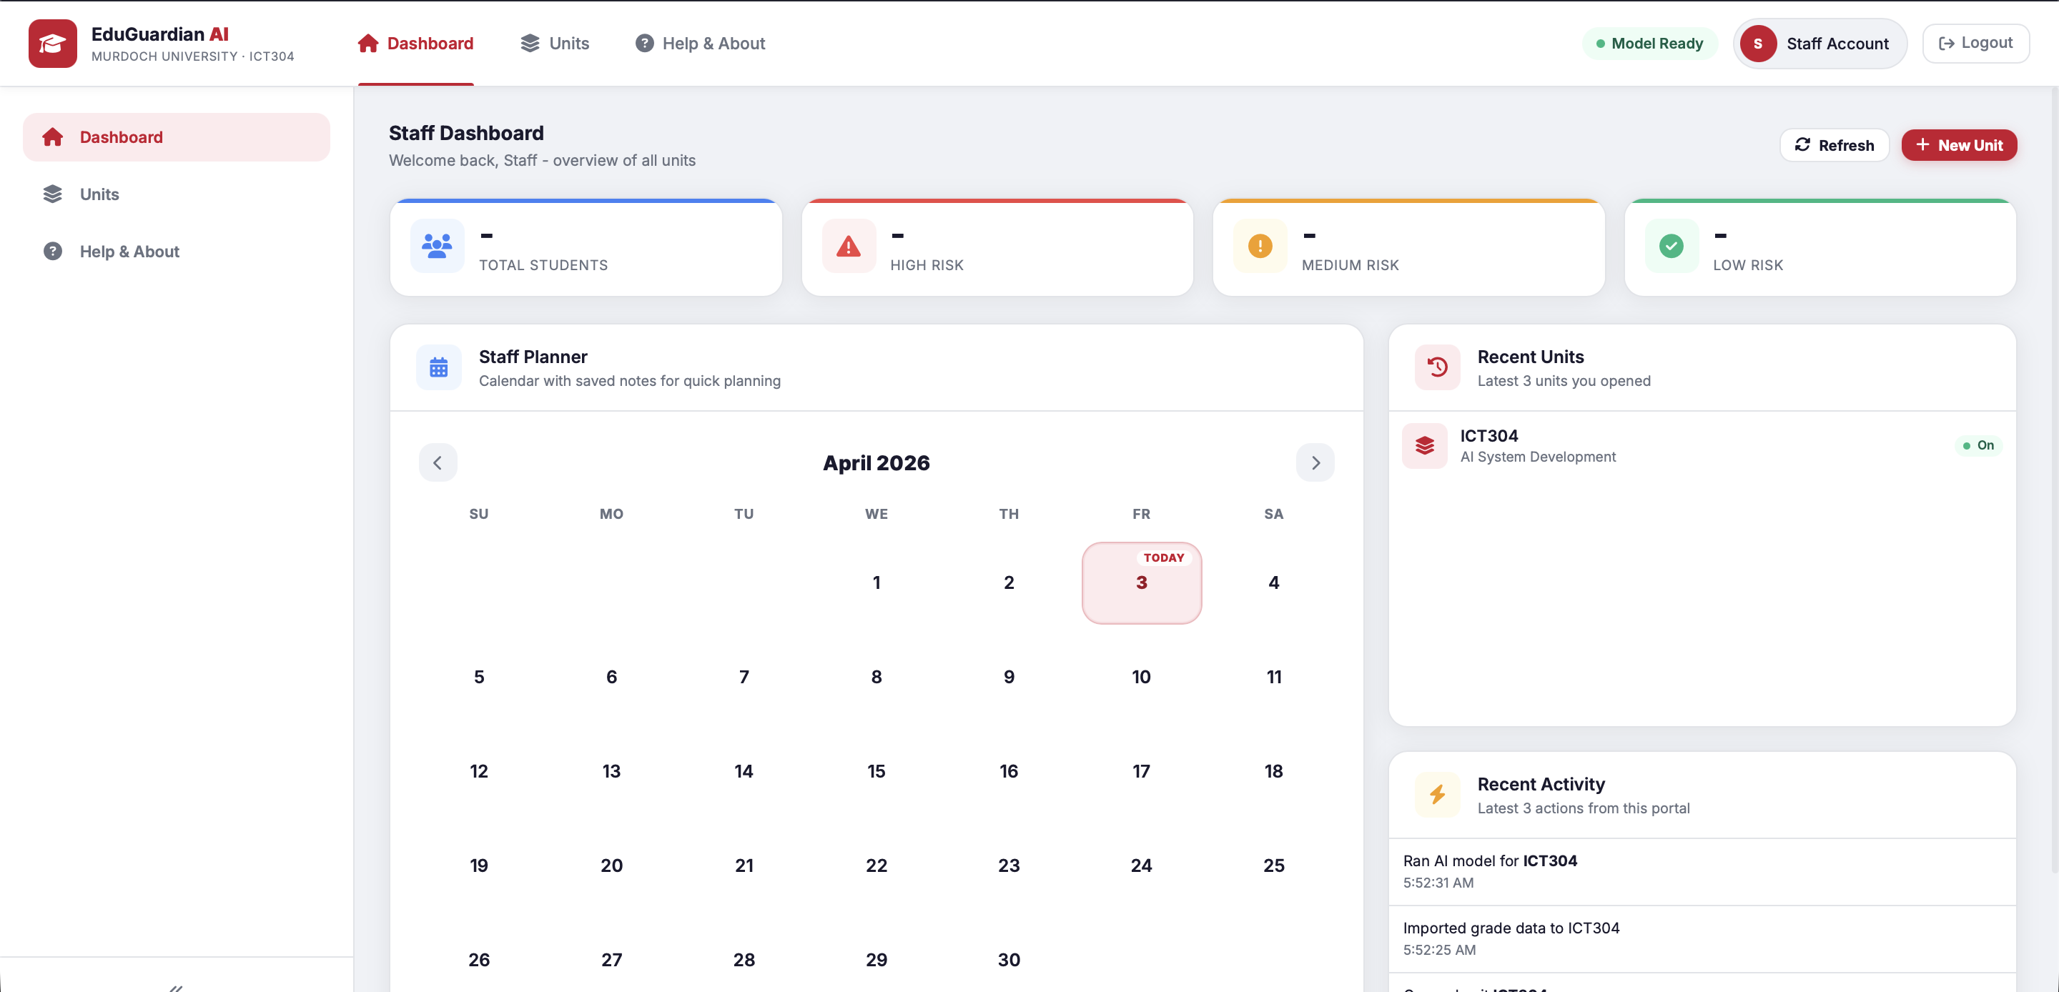

Within each unit, the system provides a “Manage Students” interface where staff can add students manually or import student data through CSV files. Similarly, student performance data, including quiz and assignment scores, can be uploaded in bulk. This design supports scalability and reduces manual data entry effort.
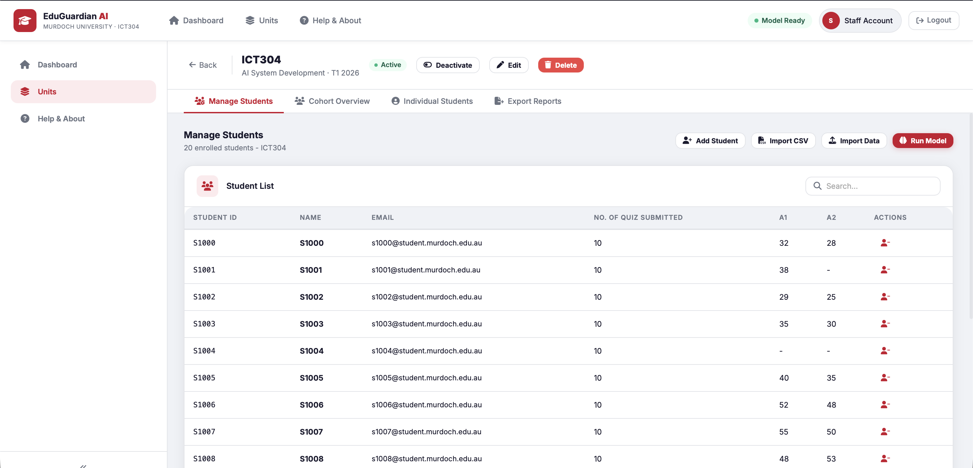
A key feature of the staff interface is the ability to execute the AI model directly from the dashboard. By selecting the “Run Model” option, staff can initiate the hybrid prediction process. The system allows configuration of parameters such as machine learning weight, deterministic weight, and risk thresholds before execution, providing control over how predictions are generated.
Following model execution, the interface transitions to a “Cohort Overview” dashboard. This view presents a summary of the entire student cohort, including the number of students classified as low, medium, and high risk. Visual elements such as charts and tables are used to improve interpretability. Staff can filter students by risk level and examine detailed attributes including quiz averages, assignment scores, performance trends (e.g., improving or declining), and machine learning probability scores.

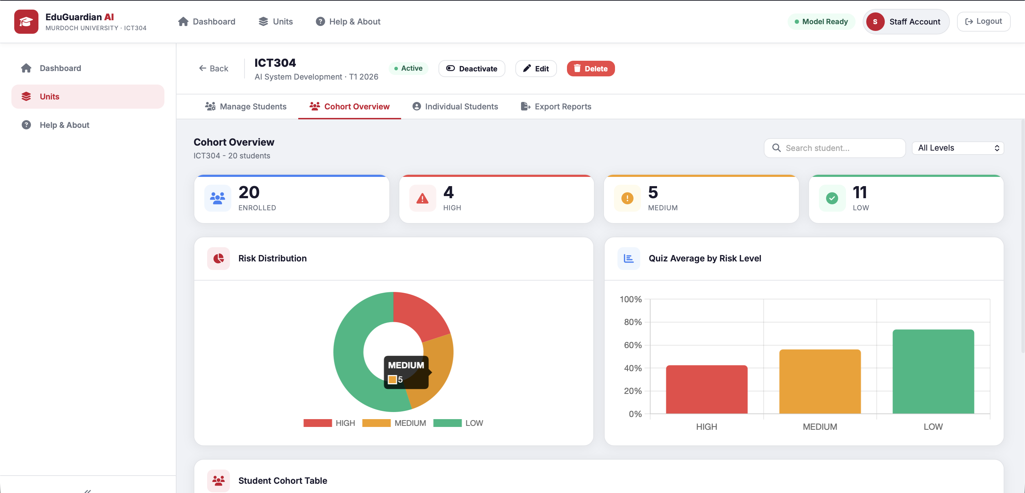
In addition, the system supports export functionality, allowing staff to generate reports in formats such as PDF, CSV, and JSON. This enables further analysis and supports auditability of predictions.

Student Dashboard
The student portal provides a personalised, read-only interface that allows individual users to monitor their academic performance and risk status. After logging in, students can view their enrolled units and access relevant performance data associated with each unit.
Unlike the staff interface, students do not have permission to modify or upload academic data. All performance inputs, including quiz and assignment scores, are managed exclusively by academic staff. The submit button allows the students to view the grades submitted by the academic staff but does not allow submission from students. This design ensures data integrity and prevents inconsistencies within the system.
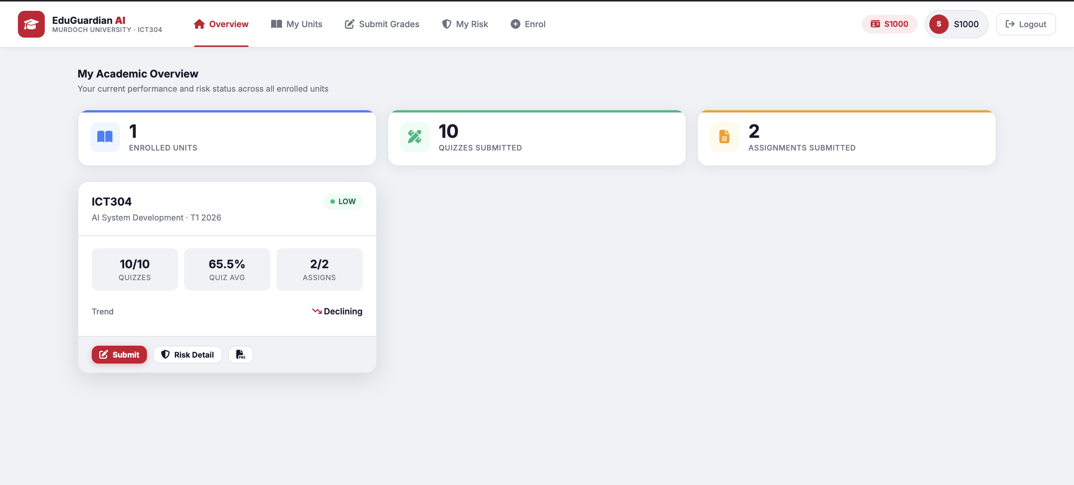
A central feature of the student dashboard is the ability to view individual risk predictions. Students are presented with their current risk classification (low, medium, or high), along with supporting information derived from the hybrid prediction model. This includes key indicators such as performance trends and overall academic standing.

In addition, students can generate and download their individual risk reports, which provide a structured summary of their predicted outcomes and supporting factors. These reports enable students to better understand their academic progress and take appropriate actions where necessary.
Overall, the student interface is designed to provide transparency and awareness without granting data manipulation capabilities, reinforcing the system’s role as a decision-support and monitoring tool rather than a data entry platform for students.

3.4 Prototype Development
The initial prototype developed in Assignment 1 focused on demonstrating the feasibility of the core AI functionality. It included a basic implementation of quiz trend analysis and machine learning classification using a limited number of features. Interaction with the system was performed through a command-line interface, and the output was presented in a simple textual format.
While the prototype successfully demonstrated the key concepts, it lacked several important aspects required for a complete system. These included user interaction, data persistence, integration of multiple components, and automated workflows.
In the final project, the system was significantly expanded to address these limitations. A web-based dashboard was introduced to provide a user-friendly interface, allowing staff to manage units, input student data, and view results. A database was integrated to store all relevant information, ensuring persistence and enabling repeated use of the system. The AI pipeline was extended to include preprocessing, training, and prediction modules, which operate automatically as part of the workflow.
This progression from a simple prototype to a fully integrated system demonstrates the application of system engineering principles in developing a practical AI solution.
The transition from the prototype to the final system represents a significant advancement in both system functionality and integration. While the initial prototype focused on validating the feasibility of the AI components through a command-line interface, the final system extends this into a fully integrated web-based application.
Key improvements include the introduction of a graphical user interface, database integration for persistent data storage, role-based user interaction, and an automated machine learning pipeline. These enhancements transform the system from a proof-of-concept into a deployable decision-support tool, aligning with the later stages of the System Engineering Product Life Cycle such as system integration, deployment readiness, and user interaction design.

3.5 Testing and Evaluation
Testing is a critical component in the development of EduGuardian AI, as it ensures that both individual components and the overall system function correctly, reliably, and consistently. Given that the system integrates multiple sub-systems including data preprocessing, machine learning models, rule-based logic, and a web interface it is essential to validate each component independently as well as the system as a whole.
The testing strategy adopted in this project follows a multi-level approach, consisting of sub-system testing, integration testing, and end-to-end system testing. This approach aligns with system engineering principles, where each layer of the system is verified before validating the complete workflow. (Riccio, 2020)

Sub-system Testing
At the sub-system level, individual components of the AI pipeline were tested in isolation to ensure correctness of their functionality.
The preprocessing module was tested to verify that data from multiple datasets is correctly cleaned, transformed, and aligned into a unified feature structure. This includes validating that missing values are handled appropriately, target variables are correctly encoded, and class imbalance is addressed through SMOTE. Ensuring correctness at this stage is important because any preprocessing errors would directly affect the performance of the machine learning models.
The rule-based risk engine was tested to confirm that it correctly identifies performance trends and calculates risk scores based on predefined academic rules. For example, test cases were designed to simulate declining quiz performance or consistently low assignment scores, ensuring that the system assigns appropriate risk levels in each scenario.
The machine learning module was tested to ensure that models are trained correctly, predictions are generated without errors, and saved artifacts such as models and scalers can be loaded and reused. Additional checks were performed to ensure that the system handles missing model files gracefully by retraining when necessary.

Integration Testing
Following sub-system validation, integration testing was conducted to ensure that the different components of the system interact correctly. This stage focuses on verifying the flow of data between modules and ensuring that outputs from one component are correctly used as inputs for the next.
In particular, the interaction between the database, preprocessing module, and prediction engine was tested to confirm that:
- Student data is correctly retrieved from the database
- Preprocessing is applied consistently during both training and prediction
- Predictions are generated and stored without errors

End-to-End System Testing
End-to-end testing was performed to validate the system as a complete application from the user’s perspective. This involved simulating real usage scenarios, including:
- User login and authentication
- Unit creation and configuration
- Student enrolment
- Input of quiz and assignment data
- Execution of the prediction pipeline
- Display of risk results on the dashboard
This stage ensures that the system functions correctly in a real-world workflow and that all components operate together seamlessly.
To further validate the robustness of the system, multiple test scenarios were designed to simulate different academic performance conditions. These scenarios ensure that the system behaves correctly under a range of realistic and edge-case inputs.
Test cases included scenarios where students exhibited consistently low performance, high performance, mixed performance trends, and partial data availability. For example, datasets containing only high-risk students were used to verify that the system correctly classifies all inputs as at risk, while datasets with only high-performing students ensured that false positives are minimised.
Additional tests were conducted using partial inputs, such as quiz-only data, to evaluate the system’s ability to make early-stage predictions. These scenarios reflect real-world conditions where complete assessment data may not be available.

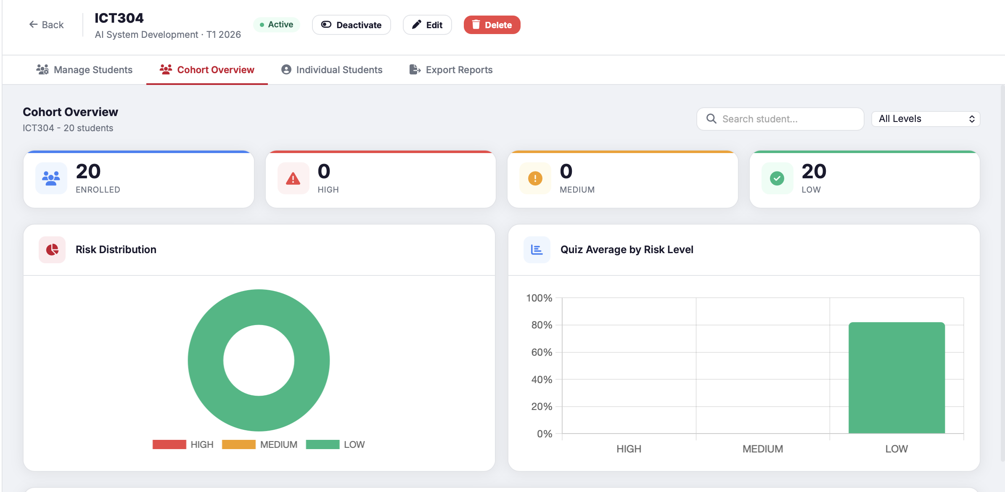
1. Testing using dataset containing only low risk students
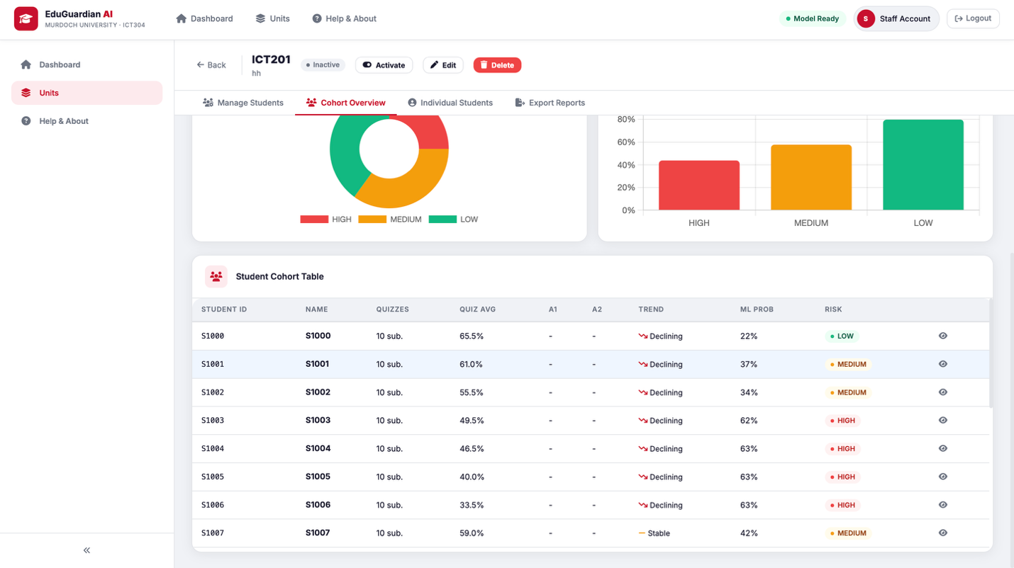
2. Testing using only quiz and no assignment grades

(SEE APPENDICES E FOR MORE TESTING RESULTS)

Automated Testing
To improve reliability and reproducibility, automated tests were implemented for key components of the system. These tests are designed to validate core functionality and ensure that changes to the code do not introduce errors.
The automated tests cover:
- Data preprocessing functions
- Risk engine calculations
- Machine learning prediction logic
By running these tests, it is possible to quickly verify that the system behaves as expected under different conditions. This is particularly useful during development and debugging, as it allows issues to be identified early.

Test Results and Observations
The results of testing indicate that the system performs reliably across different components. The preprocessing module successfully standardises data from multiple sources, while the machine learning models generate consistent predictions when provided with valid input. The rule-based engine correctly identifies performance trends and produces interpretable risk scores.
Integration testing confirmed that data flows correctly through the system, with no major issues observed in the interaction between components. End-to-end testing demonstrated that the system can be used effectively through the dashboard, with predictions generated and displayed in real time.
Some minor limitations were observed during testing, particularly related to dataset inconsistencies and the handling of incomplete input data. However, these issues were managed through preprocessing and validation steps, ensuring that the system remains stable.

Testing Justification
The multi-level testing approach adopted in this project ensures that both individual components and the overall system are thoroughly validated. By combining sub-system testing, integration testing, and end-to-end testing, the system is evaluated from both a technical and user perspective.
This approach is particularly important for AI systems, where errors can propagate across components if not detected early. By validating each stage of the pipeline, the system achieves a higher level of reliability and robustness. (Riccio, 2020)

3.6 Deployment and Maintenance Considerations
Although the system is developed as a prototype, considerations for deployment and maintenance were incorporated into the design. The system is structured in a way that allows it to be deployed on a local server, with the possibility of extending it to a cloud-based environment in the future.
Model persistence is achieved using joblib, which allows trained models to be saved and reused without retraining. This improves efficiency and ensures consistency in predictions. The use of a database also supports long-term usage by storing historical data and prediction results.
From a maintenance perspective, the modular design allows individual components to be updated without affecting the entire system. For example, new machine learning models can be introduced, or preprocessing techniques can be improved, without requiring significant changes to the user interface or database.
Future improvements may include integration with learning management systems such as Moodle, enhanced security mechanisms, and the use of real institutional data to improve model performance.

4. System Design and Architecture

4.1 Overview of the System
EduGuardian AI is designed as a layered system that integrates multiple components into a single workflow. The system enables academic staff to input student performance data, run predictive analysis, and receive risk assessments in real time.
At a high level, the system consists of a presentation layer, which handles user interaction through a web-based dashboard; an application layer, which manages business logic and API communication; a data layer, which stores all relevant information; and an AI processing layer, which performs data preprocessing, model training, and prediction. These layers work together to ensure that the system functions as a cohesive unit.

4.2 Sub-systems of the AI System
The system is composed of several sub-systems, each responsible for a specific function within the overall architecture. These sub-systems are designed to interact with each other while maintaining a clear separation of responsibilities.
The user interface provides the entry point for interaction with the system. It allows staff to log in, configure units, enrol students, and input assessment data. The interface is designed to be intuitive, ensuring that users can operate the system without requiring technical expertise.
The authentication system manages access control and ensures that only authorised users can interact with the system. While the current implementation is simplified for the purpose of the prototype, it demonstrates the importance of security in real-world applications.
The database system serves as the central repository for all data, including user information, unit configurations, student enrolments, assessment results, and prediction outputs. By storing this data persistently, the system supports repeated usage and enables historical analysis.
The data processing module prepares raw data for machine learning. This involves cleaning inconsistent values, aligning features across multiple datasets, handling missing data, and applying techniques such as SMOTE to address class imbalance. Proper preprocessing is essential, as the quality of input data directly affects the performance of the models.
The machine learning module is responsible for training and selecting predictive models. Multiple models are evaluated, and the best-performing one is selected based on F1-score, which is more appropriate for imbalanced classification problems such as academic risk prediction.
The prediction engine applies the trained model to new data, generating probability scores that indicate the likelihood of a student being at risk. These probabilities are then interpreted and used to classify students into risk categories.
In addition to the machine learning component, a rule-based risk engine is used to analyse performance trends. This component evaluates changes in quiz scores and other assessment data to identify patterns that may indicate academic decline. The inclusion of this component improves interpretability and provides additional context for the predictions.
The hybrid decision module combines the outputs of the machine learning model and the rule-based engine. By integrating these two approaches, the system produces a final risk score that is both data-driven and explainable.
Finally, the reporting system presents the results to the user in a meaningful way. This includes risk levels, probability scores, and recommended actions, which help academic staff make informed decisions.

4.3 Data Flow
The system follows a structured data flow that ensures all components are interconnected and operate as part of a continuous pipeline rather than isolated modules. This design is important because it allows the system to process data efficiently while maintaining consistency across different stages of the workflow.
When a user inputs student data through the dashboard, the information is first validated and stored in the database. This step ensures that all data is persistently recorded and can be reused for future analysis or auditing purposes. Storing the data at an early stage also enables the system to maintain a history of student performance, which is useful for tracking trends over time.
Once the data is stored, it is retrieved by the preprocessing module. At this stage, the data is cleaned, transformed, and aligned with the feature schema required by the machine learning models. This includes handling missing values, applying scaling, and ensuring consistency across all input variables. Proper preprocessing is essential, as it directly influences the reliability of the predictions generated later in the pipeline.
After preprocessing, the data is passed to the machine learning module, where the trained model generates a probability score indicating the likelihood of a student being at risk. At the same time, the rule-based risk engine analyses performance trends, such as declining quiz results or low assignment scores, to produce a separate deterministic risk score.
These two outputs are then combined by the hybrid decision module, which applies a weighted approach to produce the final risk assessment. This integration ensures that the prediction benefits from both data-driven insights and domain-specific reasoning.
The overall data flow can be summarised as:
- User input → database storage
- Database → preprocessing module
- Preprocessed data → ML model + rule-based engine
- Combined outputs → final risk score
- Results → dashboard display and database storage
The final result is displayed on the dashboard and stored in the database, allowing it to be accessed later for reporting, monitoring, or further analysis. This structured flow ensures that the system operates as a cohesive pipeline, where each component contributes to the overall functionality in a coordinated manner.

4.4 Design Justification
The design of EduGuardian AI reflects a deliberate balance between technical performance and practical usability. While machine learning models form the core predictive component, the system is designed as a complete application that supports real-world usage by academic staff.
One of the key design decisions was the adoption of a modular architecture. By separating the system into distinct components such as the user interface, database, preprocessing module, machine learning model, and risk engine the system becomes easier to maintain and extend. This modularity allows individual components to be updated or improved without requiring changes to the entire system. For example, a new machine learning model can be introduced without affecting the user interface or database structure.
Another important aspect of the design is the use of a hybrid prediction approach. Purely machine learning-based systems often achieve good predictive performance but may lack interpretability. In contrast, rule-based systems are easier to understand but may not capture complex patterns in data. By combining both approaches, the system benefits from the strengths of each method, resulting in improved accuracy and greater transparency.
The inclusion of a web-based interface further enhances the usability of the system. Academic staff can interact with the system through a dashboard without needing technical knowledge of machine learning or programming. This ensures that the system can be realistically adopted in an educational environment.
The use of a database provides persistence, allowing data to be stored and reused across sessions. This supports long-term monitoring of student performance and enables the system to function as a continuous decision-support tool rather than a one-time prediction model.
Key design considerations include:
- Modularity for maintainability and scalability
- Hybrid approach for accuracy and interpretability
- Web-based interface for accessibility and usability
- Database integration for persistence and reproducibility
Overall, the design demonstrates the application of system engineering principles in developing an AI solution that is not only technically effective but also practical and usable in a real-world academic context. Rather than focusing solely on model performance, the system emphasises integration, usability, and reliability, which are essential for real-world deployment.

4.5 Project Structure and Implementation Organisation
The system is organised using a modular folder structure to clearly separate different components of the application. This organisation improves maintainability, readability, and scalability of the system.
The project is divided into several key directories based on functionality. The data directory contains both raw datasets and processed data generated during preprocessing. Multiple datasets are used in this project, including student grading data, performance datasets, and the OULAD dataset. Processed outputs such as merged training data and SMOTE-balanced datasets are stored separately to ensure reproducibility of experiments.
The models directory stores all trained machine learning artifacts, including the selected model, feature scaler, and evaluation metrics. Saving these components allows the system to reuse trained models without retraining, improving efficiency and ensuring consistent predictions.
The src directory contains the core AI pipeline. This includes data preprocessing, model training, evaluation, prediction logic, and the rule-based risk engine. Separating these components ensures that the machine learning logic remains independent of the user interface and database layers.
The database directory manages all data storage operations using SQLite. It includes scripts for creating database tables, handling data operations, and seeding initial data for testing and demonstration purposes.
The app directory implements the web application using Flask. It contains the application configuration, authentication system, route handling, and service layer that connects the dashboard with the AI pipeline. HTML templates for the user interface are also stored within this directory.
Additional directories such as tests and reports support system validation and output generation. The test directory contains automated tests for different components, while the reports directory stores generated risk reports for analysis.
This structured organisation reflects the system engineering approach adopted in this project. By separating concerns into distinct modules, the system becomes easier to develop, test, and extend. It also ensures that each component can be modified independently without affecting the overall functionality of the system.

5. AI Techniques
The core functionality of EduGuardian AI is driven by its ability to predict academic risk using machine learning techniques while maintaining a balance between predictive performance, interpretability, and reliability. Rather than relying on a single algorithm, this project adopts a comparative modelling approach, where multiple machine learning techniques are implemented, evaluated, and analysed before selecting the most suitable model for deployment. This approach ensures that model selection is not arbitrary, but instead based on empirical performance and alignment with the problem domain.
Three machine learning techniques were selected for this project: Logistic Regression, Random Forest, and XGBoost. These models were chosen because they represent different levels of complexity and learning capability, allowing for a comprehensive comparison between linear, ensemble, and boosting-based approaches. This selection reflects common practices in student performance prediction research, where multiple models are evaluated to identify the most effective technique for a given dataset (Albreiki et al., 2021).

5.1 Logistic Regression (Baseline Model)
Logistic Regression was implemented as the baseline model due to its simplicity, efficiency, and high level of interpretability. It is a probabilistic classification algorithm that models the relationship between input features and the likelihood of a binary outcome using a linear decision boundary. In the context of this project, Logistic Regression estimates the probability that a student belongs to the at-risk class, defined as those likely to fail the unit.
One of the primary advantages of Logistic Regression is its transparency. The model provides coefficients that indicate the influence of each feature on the prediction, making it easier for academic staff to understand how factors such as quiz averages and assignment performance contribute to risk. This interpretability is particularly important in educational settings, where decisions must be explainable and justifiable.
However, the model assumes a linear relationship between input features and the output, which limits its ability to capture complex, non-linear interactions present in real-world academic data. Student performance is often influenced by multiple interacting factors, and such relationships may not be adequately represented by a linear model. Despite this limitation, Logistic Regression serves as an essential benchmark, providing a reference point against which more complex models can be evaluated (Chen & Zhai, 2023).

5.2 Random Forest (Ensemble Model)
To address the limitations of linear models, Random Forest was implemented as a more advanced machine learning technique capable of modelling non-linear relationships. Random Forest is an ensemble learning method that constructs multiple decision trees and aggregates their predictions to produce a final output. This approach reduces overfitting and improves generalisation by averaging the results of multiple models.
In the context of academic risk prediction, Random Forest is particularly effective because it can capture interactions between features that are not explicitly defined. For example, it can identify threshold-based behaviours, such as a significant increase in risk when both quiz and assignment scores fall below certain levels. This ability to model complex patterns makes Random Forest well-suited for real-world datasets, where relationships between variables are rarely linear.
Another advantage of Random Forest is its robustness to noise and variability in the data. Since the model is based on multiple trees trained on different subsets of data, it is less sensitive to outliers and inconsistencies. Additionally, the model provides measures of feature importance, offering a degree of interpretability that, while not as direct as Logistic Regression, still allows insights into which factors contribute most to predictions (Breiman, 2001).
However, Random Forest introduces increased computational complexity and reduced transparency compared to simpler models. While it improves predictive performance, the decision-making process is less intuitive, which may limit its direct interpretability for non-technical users.

5.3 XGBoost (Advanced Boosting Model)
XGBoost was implemented as the most advanced model in this project, representing a state-of-the-art gradient boosting approach. Unlike Random Forest, which builds trees independently, XGBoost constructs trees sequentially, with each new tree learning from the errors of the previous ones. This iterative refinement allows the model to achieve high predictive accuracy, particularly in structured datasets.
In this project, XGBoost demonstrated strong performance due to its ability to capture complex patterns and optimise prediction errors effectively. It incorporates regularisation techniques that help prevent overfitting, making it suitable for datasets with varying levels of noise and feature interactions. These characteristics make XGBoost one of the most widely used algorithms in predictive modelling tasks (Salah et al., 2020).
Despite its advantages, XGBoost comes with increased model complexity and reduced interpretability. The sequential nature of boosting and the combination of multiple trees make it difficult to directly explain individual predictions. In educational contexts, this lack of transparency can be a limitation, as stakeholders often require clear reasoning behind predictions.

5.4 Model Selection and Justification
The selection of the final model was based on a structured evaluation process using multiple performance metrics, including accuracy, precision, recall, and F1-score. However, F1-score was chosen as the primary evaluation metric, as it provides a balanced measure of performance in classification problems with class imbalance.
In academic datasets, the number of students who are at risk is typically smaller than those who are not. In such cases, accuracy alone can be misleading, as a model may achieve high accuracy by predominantly predicting the majority class. This would result in poor detection of at-risk students, which contradicts the primary objective of the system.
The F1-score addresses this issue by combining precision and recall into a single metric. Precision ensures that students identified as at risk are likely to be correctly classified, while recall ensures that actual at-risk students are not missed. In the context of early intervention systems, recall is particularly important, as failing to identify a struggling student may result in missed opportunities for support. At the same time, maintaining reasonable precision is necessary to avoid overwhelming academic staff with false positives.
Based on this evaluation framework, the selected model represents the best balance between predictive performance and suitability for the problem domain. However, rather than relying solely on the chosen machine learning model, the system integrates it within a hybrid prediction framework, combining its output with a rule-based risk engine. This ensures that the final prediction is both data-driven and interpretable, enhancing the overall reliability and usability of the system.

Model | Strength | Weakness | Role
Logistic Regression | Interpretable | Linear only | Baseline
Random Forest | Non-linear | Less transparent | Main model
XGBoost | High accuracy | Complex | Best performer

6. Data Preprocessing
Data preprocessing is a critical stage in the development of machine learning systems, as the quality and consistency of input data directly influence model performance and reliability. In the context of EduGuardian AI, preprocessing was particularly challenging due to the integration of multiple datasets with differing structures, formats, and feature definitions. To ensure that the data could be effectively used for model training and prediction, a comprehensive preprocessing pipeline was developed to transform heterogeneous data into a unified and consistent representation.
The datasets used in this project include the Students Grading Dataset, Student Performance datasets, and the Open University Learning Analytics Dataset (OULAD). These datasets were selected to provide a diverse range of academic performance indicators, including assessment scores and engagement-related features. However, each dataset was originally structured differently, requiring significant transformation before they could be combined into a single machine learning pipeline. This highlights a common challenge in real-world AI systems, where data is often collected from multiple sources and must be standardised before analysis (Khalil et al., 2018).
The first stage of preprocessing involved data cleaning, which ensured that the datasets were free from inconsistencies and errors. This included handling missing values, removing irrelevant or redundant attributes, and ensuring that all features followed a consistent format. Missing values were addressed through a combination of simple imputation techniques and exclusion of incomplete records where appropriate. This step is essential, as incomplete or noisy data can significantly degrade model performance and lead to unreliable predictions (Albreiki et al., 2021).
Following data cleaning, feature alignment and transformation were performed to create a unified schema across all datasets. Since each dataset used different naming conventions and measured different aspects of student performance, it was necessary to map these features into a common set of variables. The resulting feature set includes key indicators such as quiz averages, assignment performance, and participation-related metrics. This alignment process ensures that all input data is consistent and compatible with the machine learning models, enabling meaningful comparison and prediction.
A major challenge encountered during preprocessing was the presence of class imbalance, where the number of students classified as at risk (failure cases) is significantly smaller than those not at risk. In such cases, machine learning models tend to be biased towards the majority class, resulting in poor detection of at-risk students. To address this issue, the Synthetic Minority Oversampling Technique (SMOTE) was applied to the training data. SMOTE generates synthetic examples of the minority class by interpolating between existing samples, allowing the model to learn more balanced decision boundaries and improving its ability to detect rare but important cases (Chawla et al., 2002).
In addition, feature scaling was applied using standardisation to ensure that all input variables contribute equally to the model. Without scaling, features with larger numerical ranges may dominate the learning process, particularly in algorithms such as Logistic Regression, which are sensitive to feature magnitude. Standardisation transforms the data to have a mean of zero and a standard deviation of one, improving convergence during training and enhancing model stability (Pedregosa et al., 2011).
The preprocessing pipeline also supports reproducibility and consistency by ensuring that the same transformations applied during training are also applied during prediction. This is particularly important in deployed systems, where inconsistencies between training and inference data can lead to incorrect results.
Overall, the preprocessing stage ensures that the data used in EduGuardian AI is clean, consistent, and suitable for machine learning, forming a reliable foundation for subsequent model training and prediction. By addressing issues such as data inconsistency, feature misalignment, and class imbalance, the preprocessing pipeline significantly improves the robustness and effectiveness of the system.

7. Model Training and Selection
The model training process in EduGuardian AI was designed to ensure fair, consistent, and reproducible comparisonbetween multiple machine learning algorithms. Given the objective of identifying at-risk students accurately while maintaining reliability, the training pipeline was carefully structured to evaluate each model under identical conditions and minimise bias in performance comparison.
The dataset was initially divided into training and testing subsets, typically using an 80:20 split, to evaluate the generalisation capability of the models on unseen data. This separation ensures that model performance is not overestimated due to overfitting on the training data. In addition to this, stratified sampling was applied during the split to preserve the distribution of the target classes (at-risk vs non-risk), which is particularly important in imbalanced classification problems.
To further improve the robustness of the evaluation, k-fold cross-validation was applied on the training dataset. In this approach, the training data is divided into multiple subsets, and the model is trained and validated across different folds. This reduces the dependency on a single train-test split and provides a more reliable estimate of model performance. Cross-validation is especially valuable in educational datasets, where variability in student performance can lead to fluctuations in results across different samples.
All models were trained using a consistent preprocessing pipeline, including feature scaling and class imbalance handling through SMOTE. Ensuring that each model receives the same input representation is critical for fair comparison, as differences in preprocessing can significantly influence model performance.
To optimise model performance, hyperparameter tuning was performed using grid search. This process systematically evaluates different combinations of hyperparameters to identify the configuration that yields the best performance. For example, in the Random Forest model, parameters such as the number of trees, maximum tree depth, and minimum samples per split were tuned. Similarly, for XGBoost, parameters such as learning rate, number of estimators, and maximum depth were adjusted to balance model complexity and generalisation. This optimisation step is essential to ensure that each model operates at its best capacity rather than relying on default configurations.
Following training, the models were evaluated using multiple performance metrics, including precision, recall, F1-score, and ROC-AUC. While each of these metrics provides useful insights, F1-score was selected as the primary evaluation criterion due to the imbalanced nature of the dataset. In academic risk prediction, the minority class (students at risk of failure) is of greater importance, and relying solely on accuracy could lead to misleading conclusions.
F1-score provides a balanced measure by combining precision and recall. Precision reflects how many of the predicted at-risk students are actually at risk, while recall measures how many of the actual at-risk students are correctly identified. In this context, recall is particularly important, as failing to identify a struggling student may result in missed opportunities for intervention. At the same time, maintaining reasonable precision ensures that academic staff are not overwhelmed by excessive false positives. Therefore, prioritising F1-score aligns with the system’s goal of supporting effective early intervention.
The evaluation results indicated that more complex models such as Random Forest and XGBoost generally outperformed Logistic Regression in terms of predictive capability, particularly in capturing non-linear relationships within the data. However, despite their superior performance, the final system does not rely exclusively on a single machine learning model. Instead, the selected model is integrated within a hybrid prediction framework, where its output is combined with a rule-based risk engine.
This design decision was motivated by the need to balance accuracy and interpretability. While advanced models such as XGBoost can achieve high predictive performance, their internal decision-making processes are less transparent. In contrast, the rule-based component provides clear and explainable reasoning based on academic performance trends. By combining these two approaches, the system ensures that predictions are both data-driven and interpretable, making them more useful for academic staff.
Once the optimal model was selected, it was persisted using joblib, allowing it to be stored and reused for future predictions without retraining. This improves computational efficiency and ensures consistency across different system executions. Model persistence also supports deployment, as it enables the system to operate in real time without requiring repeated training processes.
Overall, the training and selection process reflects a systematic and well-justified approach, ensuring that the chosen model is not only accurate but also suitable for integration within a real-world decision-support system

8. Hybrid Prediction Approach

One of the key contributions of EduGuardian AI is the implementation of a hybrid prediction approach, which integrates machine learning predictions with a deterministic, rule-based risk engine. Rather than relying solely on a single predictive model, the system combines data-driven learning with domain-specific reasoning to produce outcomes that are both accurate and interpretable. This design addresses a fundamental limitation in many predictive systems, where high-performing models often lack transparency, reducing their practical usability in decision-making environments.
The machine learning component of the system is responsible for generating a probabilistic risk score, representing the likelihood that a student is at risk of failing. This probability is derived from patterns learned during training, where the model identifies relationships between input features such as quiz averages, assignment performance, and engagement indicators. The strength of this approach lies in its ability to capture complex and non-linear relationships within the data, enabling the detection of subtle patterns that may not be immediately observable through manual analysis (Chen & Zhai, 2023).
However, despite their predictive capability, machine learning models often function as black-box systems, where the reasoning behind predictions is not easily interpretable. In educational contexts, this presents a significant limitation, as academic staff require clear and justifiable explanations before taking action. To address this issue, a rule-based risk engine is incorporated alongside the machine learning model.
The rule-based component evaluates student performance using predefined academic logic derived from domain knowledge. This includes analysing quiz performance trends, identifying whether scores are improving, stable, or declining over time, and assessing assignment performance relative to expected benchmarks. For example, a consistent decline in quiz scores or performance below a defined threshold contributes to an increased risk score. Unlike machine learning models, this component produces deterministic outputs that can be directly explained and traced back to observable student behaviour.
The final prediction is generated through a weighted fusion mechanism, where the outputs of the machine learning model and the rule-based engine are combined into a single risk score. This approach ensures that neither component dominates the decision-making process. Instead, the system balances the strengths of both methods, leveraging the predictive power of machine learning while retaining the interpretability of rule-based reasoning. The weighting mechanism can be adjusted to prioritise different aspects of prediction, allowing flexibility depending on the application context.
This hybrid design significantly improves the robustness of the system. In scenarios where machine learning predictions may be uncertain, such as when limited data is available early in the semester, the rule-based component provides stable and meaningful insights based on observable trends. Conversely, the machine learning model enhances the system’s ability to detect complex patterns that may not be captured by predefined rules. This complementary interaction reduces the risk of over-reliance on a single method and improves overall prediction reliability.
Another major advantage of the hybrid approach is its contribution to interpretability and trustworthiness. The rule-based component provides clear reasoning for each prediction, enabling academic staff to understand why a student has been classified as at risk. This transparency is critical in educational environments, where decisions must be explainable and defensible. By combining interpretable logic with data-driven predictions, the system supports informed decision-making while maintaining user confidence.
Furthermore, the hybrid approach aligns with system engineering principles by integrating multiple analytical components into a cohesive framework. Rather than treating machine learning as a standalone solution, it is embedded within a broader decision-support system that incorporates domain knowledge and practical considerations. This ensures that the system is not only technically effective but also operationally relevant.
The final risk score is calculated using a weighted fusion of the machine learning probability output and the rule-based risk score. The default configuration applies a weight of approximately 0.55 to the machine learning prediction and 0.45 to the rule-based component.
This approach ensures that predictions are both data-driven and interpretable, allowing academic staff to understand the reasoning behind each classification.
Overall, the hybrid prediction approach enables EduGuardian AI to achieve a balance between accuracy, interpretability, and practical usability, making it well-suited for real-world academic applications where both predictive performance and transparency are essential.

9. Evaluation Method

The evaluation of EduGuardian AI was designed to assess not only the predictive performance of the machine learning models, but also the effectiveness of the system as a complete decision-support tool. Since the primary objective of the system is to identify at-risk students as early as possible, the evaluation goes beyond simple accuracy measures and focuses on how well the system supports timely and reliable intervention.
A major challenge in this problem is class imbalance, where the number of students who are not at risk significantly exceeds the number of students who are at risk. In such scenarios, accuracy alone is not a reliable indicator of performance. A model may achieve high accuracy simply by predicting the majority class, while failing to correctly identify students who actually require support. This would defeat the purpose of the system.
To address this issue, the F1-score was selected as the primary evaluation metric. The F1-score provides a balanced measure of performance by combining precision and recall into a single value. Precision reflects how many of the students predicted as at risk are actually at risk, while recall measures how many of the truly at-risk students are successfully identified by the model.
In the context of academic risk prediction, recall is particularly important. Missing a student who is genuinely at risk can result in a lost opportunity for early intervention, which is one of the main goals of the system. However, precision cannot be ignored, as a large number of false positives may lead to unnecessary interventions and increased workload for academic staff. The F1-score ensures that both aspects are considered, making it more suitable than accuracy for this problem.
Key evaluation considerations include:
- Prioritising detection of at-risk students (recall)
- Maintaining reasonable precision to avoid excessive false alerts
- Balancing both using F1-score as the main metric
To further improve the reliability of the evaluation, cross-validation was applied during model training. This technique involves dividing the dataset into multiple subsets and training the model on different combinations of these subsets. By evaluating the model across multiple splits, cross-validation provides a more robust estimate of performance and reduces the likelihood of overfitting to a specific dataset.
In addition to quantitative evaluation, the system was also assessed from a system-level perspective. This includes evaluating how predictions are generated within the workflow, how results are presented to users, and whether the outputs are meaningful and actionable. For example, the usefulness of risk classifications and recommended actions was considered as part of the evaluation process.
This broader evaluation approach reflects the system engineering perspective adopted in this project. Rather than focusing solely on model performance, the evaluation considers the effectiveness of the entire system, including its ability to support decision-making in a real-world academic environment. This ensures that the system is not only technically accurate but also practical and usable.

10. Results

The results of the model evaluation demonstrate clear differences in predictive performance across the implemented algorithms, highlighting the impact of model complexity and learning capability on academic risk prediction. The comparative analysis provides valuable insights into how different techniques handle the characteristics of educational datasets, particularly in the presence of non-linear relationships and class imbalance.
Logistic Regression exhibited comparatively lower performance across most evaluation metrics. This outcome is consistent with expectations, as the model relies on a linear relationship between input features and the target variable. In the context of academic performance prediction, relationships between factors such as quiz scores, assignment results, and student engagement are inherently complex and influenced by multiple interacting variables. As a result, Logistic Regression was limited in its ability to capture these patterns effectively. Nevertheless, it remains a useful baseline model due to its interpretability, providing a transparent reference point for understanding how individual features contribute to predictions.
Random Forest demonstrated a noticeable improvement in performance compared to Logistic Regression. Its ensemble-based structure enables it to model non-linear relationships and interactions between features more effectively, leading to improved predictive capability. In addition, Random Forest showed consistent performance across different validation folds, indicating strong generalisation ability. This stability is particularly important in educational applications, as it suggests that the model can perform reliably across different cohorts of students rather than being overly dependent on a specific dataset. The ability of Random Forest to handle variability and noise further contributes to its suitability for this problem domain.
Among the evaluated models, Random Forest achieved the highest overall predictive performance (see Figure 10.1 ). This is clearly supported by the ROC curve analysis, where Random Forest attained the highest Area Under Curve (AUC) score of approximately 0.9876, outperforming both XGBoost and Logistic Regression. This indicates a superior ability to distinguish between at-risk and not-at-risk students across different classification thresholds.
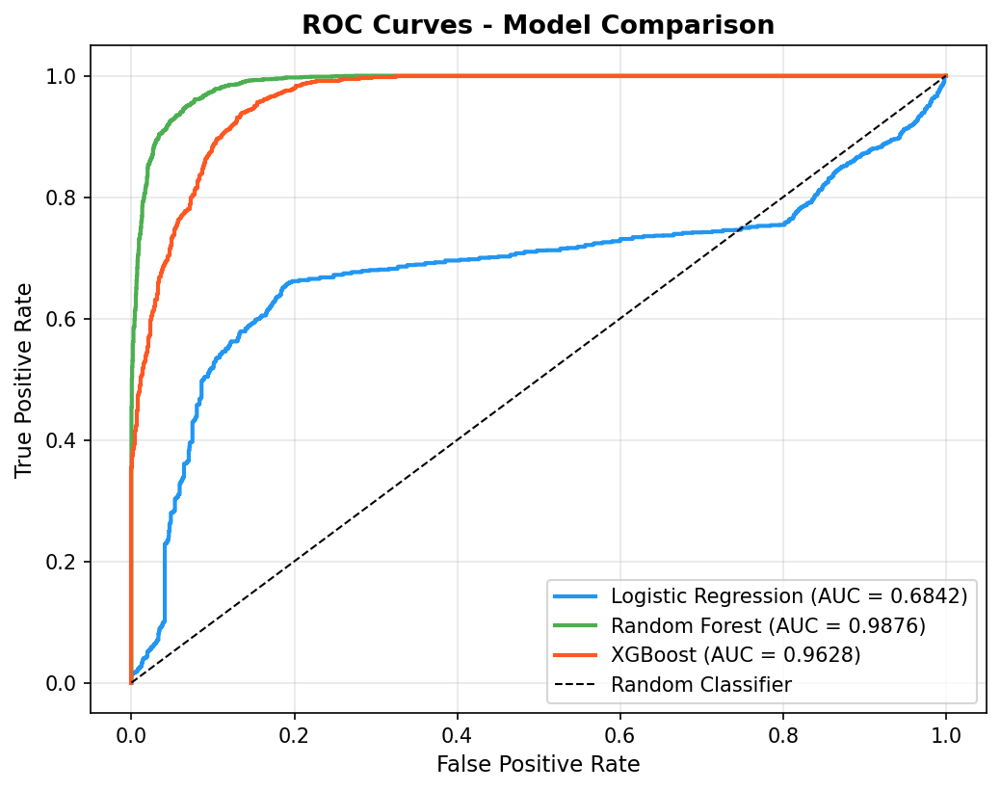

Figure 10.1 ROC Curve Analysis of all three models
The confusion matrix (see figure 10.2 ) further reinforces this observation. Random Forest demonstrated significantly lower false negatives compared to the other models, which is a critical factor in academic risk prediction. Minimising false negatives ensures that at-risk students are not incorrectly classified as safe, thereby reducing the likelihood of missed intervention opportunities. This makes Random Forest particularly well-suited for early warning systems where recall for the at-risk class is highly important.
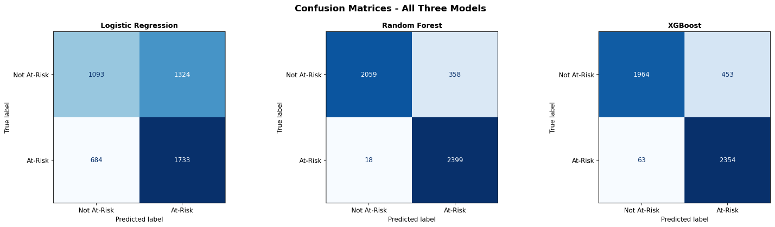
Figure 10.2 Confusion matrix comparison

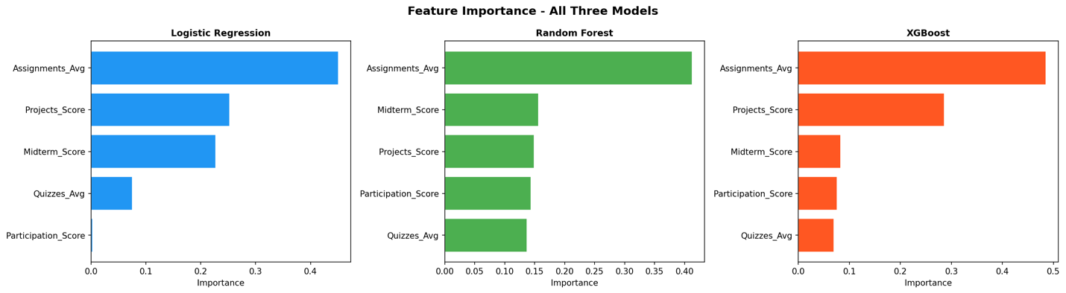
Figure 10.3 Feature importance comparison

XGBoost also performed strongly, achieving an AUC score of approximately 0.9628 and demonstrating high predictive capability. Its gradient boosting mechanism allows it to capture complex feature interactions effectively. However, while its performance is competitive, it is slightly lower than Random Forest in this implementation, particularly in terms of recall for the at-risk class. Additionally, XGBoost introduces increased model complexity, which may reduce interpretability in practical applications.
The comparative results indicate that Random Forest provides the best balance between predictive performance, robustness, and interpretability. Logistic Regression remains valuable as a baseline model due to its transparency, but its performance is limited by its inability to capture non-linear relationships present in the dataset.
These findings highlight that model selection should not be based solely on theoretical expectations, but rather on empirical evaluation using appropriate metrics such as AUC, recall, and F1-score. In this project, Random Forest emerged as the most effective model for the given dataset and problem context.
The results also highlight the significant impact of preprocessing techniques on model performance. In particular, addressing class imbalance through SMOTE played a crucial role in improving the model’s ability to detect at-risk students. Prior to balancing, the models tended to favour the majority class, resulting in low recall for the minority class. After applying SMOTE, there was a noticeable improvement in recall and F1-score, indicating a more balanced and effective classification. Similarly, feature scaling contributed to more stable model training, particularly for algorithms sensitive to feature magnitude.
Overall, the results demonstrate that EduGuardian AI is capable of identifying at-risk students with a reasonable level of accuracy, especially considering the limitations associated with publicly available datasets. The combination of multiple machine learning models, a robust preprocessing pipeline, and a hybrid decision mechanism contributes to the overall effectiveness of the system. These findings support the suitability of the proposed approach for early-stage academic risk prediction and highlight its potential for further improvement through the use of real-world institutional data.

11. Discussion
The results of this project demonstrate that it is feasible to develop an effective academic risk prediction system by integrating machine learning techniques with domain-driven logic. The system not only achieves reasonable predictive performance but also reflects a broader understanding of how AI systems must be designed to function effectively within real-world environments. A detailed analysis of the system reveals several strengths as well as important limitations that provide direction for future improvement.
One of the most significant strengths of the system lies in its hybrid prediction approach, which combines machine learning outputs with a rule-based risk engine. This design addresses a critical limitation in many predictive systems, where high accuracy is often achieved at the expense of interpretability. In educational contexts, predictions must be explainable in order to support informed decision-making by academic staff. The rule-based component enhances transparency by providing clear reasoning based on observable student performance trends, while the machine learning component captures complex patterns that are not easily represented through predefined rules. The combination of these approaches ensures that the system is both analytically powerful and practically usable.
Another important strength is the development of the system as a complete, integrated solution rather than a standalone model. Many machine learning projects focus primarily on algorithm performance without considering how the model will be used in practice. In contrast, EduGuardian AI incorporates multiple components, including data preprocessing, model training, database management, and a user-facing dashboard. This integration reflects a system engineering perspective and enhances the applicability of the solution in real-world academic environments. The inclusion of a web-based interface further improves accessibility, allowing non-technical users to interact with the system effectively.
Despite these strengths, several limitations were identified during the development and evaluation of the system. One of the primary challenges relates to the use of multiple datasets with differing structures and feature definitions. While combining datasets increases feature diversity and provides a richer representation of student performance, it also introduces inconsistencies that require extensive preprocessing. Differences in feature availability and measurement standards necessitate assumptions and approximations, which may affect the overall reliability of the model.
Another limitation is the reliance on publicly available datasets, which may not fully represent the behaviour and characteristics of students within a specific institutional context. Educational environments vary significantly in terms of assessment structures, student demographics, and engagement patterns. As a result, models trained on generic datasets may not generalise perfectly to real-world applications. This highlights the importance of incorporating institution-specific data in future work to improve model relevance and predictive accuracy (Chen & Zhai, 2023).
In addition, the current system is implemented as a prototype and therefore uses relatively simple infrastructure, including a lightweight database and basic system configuration. While this is sufficient for demonstrating functionality, a production-level system would require more advanced features such as secure authentication mechanisms, role-based access control, and scalable database solutions. These aspects are essential for ensuring data privacy, system security, and long-term maintainability in real-world deployments.
The evaluation also highlights the importance of preprocessing and feature engineering in determining model performance. Techniques such as class imbalance handling and feature alignment played a crucial role in improving predictive capability, reinforcing the idea that model performance is heavily dependent on data quality rather than algorithm choice alone.
Looking forward, several opportunities exist to enhance the system further. Incorporating real Learning Management System (LMS) data would significantly improve model accuracy and contextual relevance. Expanding the feature set to include engagement metrics, such as login frequency and time spent on learning activities, could provide additional predictive power. Improvements to the user interface could enhance usability and user experience, making the system more accessible to academic staff. Furthermore, deploying the system on a cloud-based platform would enable scalability and support integration with existing institutional systems.
Overall, this project demonstrates a comprehensive understanding of the challenges involved in developing AI systems for real-world applications. By combining multiple techniques and adopting a system engineering approach, EduGuardian AI provides a balanced solution that addresses both technical and practical considerations. While there are areas for improvement, the system establishes a strong foundation for future development and highlights the potential of hybrid AI approaches in educational decision-support systems.

12. Deployment, Integration, and Maintenance Plan
The system has been designed with deployment and integration considerations in mind, even though it is currently implemented as a prototype. Rather than focusing solely on model development, the system is structured as a complete application that can be executed in a real-world environment with minimal modification. This reflects a system engineering approach, where the goal is to ensure that the solution is not only functional but also deployable and maintainable.
The application is built using the Flask framework, which enables it to run as a web server on a local machine. This allows the system to be accessed through a browser, providing an intuitive interface for academic staff. Due to the lightweight nature of Flask, the system can also be deployed to cloud platforms with relatively minor changes, making it suitable for future scaling.
From a data storage perspective, the system uses SQLite as its database. This provides a simple and portable solution for managing user data, student records, and prediction results. While SQLite is sufficient for a prototype, it may not be suitable for large-scale deployment. In a production environment, it can be replaced with more robust database systems such as PostgreSQL or MySQL to handle higher data volumes and concurrent users.
The machine learning component is designed for efficient reuse through model persistence. Trained models are saved using joblib, allowing them to be loaded quickly during prediction without the need for retraining. This significantly reduces computational overhead and ensures consistent results across different runs of the system.
Key deployment features of the system include:
- Web-based interface accessible via browser
- Lightweight backend using Flask
- Persistent storage using SQLite
- Reusable trained models stored as joblib files
In terms of integration, the system has the potential to connect with existing Learning Management Systems (LMS) such as Moodle. This would allow student data, such as quiz scores and assignment results, to be automatically imported into the system. Automating data collection would reduce manual input, improve efficiency, and enable real-time monitoring of student performance.
Maintenance of the system involves updating the machine learning models as new data becomes available. Over time, student behaviour and assessment patterns may change, which can affect model performance. Regular retraining ensures that the system remains accurate and relevant. The modular design of the system makes this process straightforward, as individual components such as the preprocessing module or model training pipeline can be updated independently.
Maintenance activities include:
- Periodic model retraining with new data
- Updating preprocessing steps if new features are introduced
- Monitoring system performance and prediction accuracy
In a real-world deployment, additional considerations would need to be addressed, particularly in relation to security and data privacy. This includes implementing secure authentication mechanisms, encrypting sensitive data, and ensuring compliance with institutional data protection policies. User access control would also need to be strengthened to ensure that only authorised personnel can access student information.
Overall, the system provides a strong foundation for deployment in an academic environment. While further improvements are required for production use, the current design demonstrates how an AI system can be integrated into existing workflows and extended for real-world applications.

APPENDICES

APPENDIX A – SAMPLE RISK REPORT




APPENDIX B – SYSTEM ARCHITECURE DIAGRAM

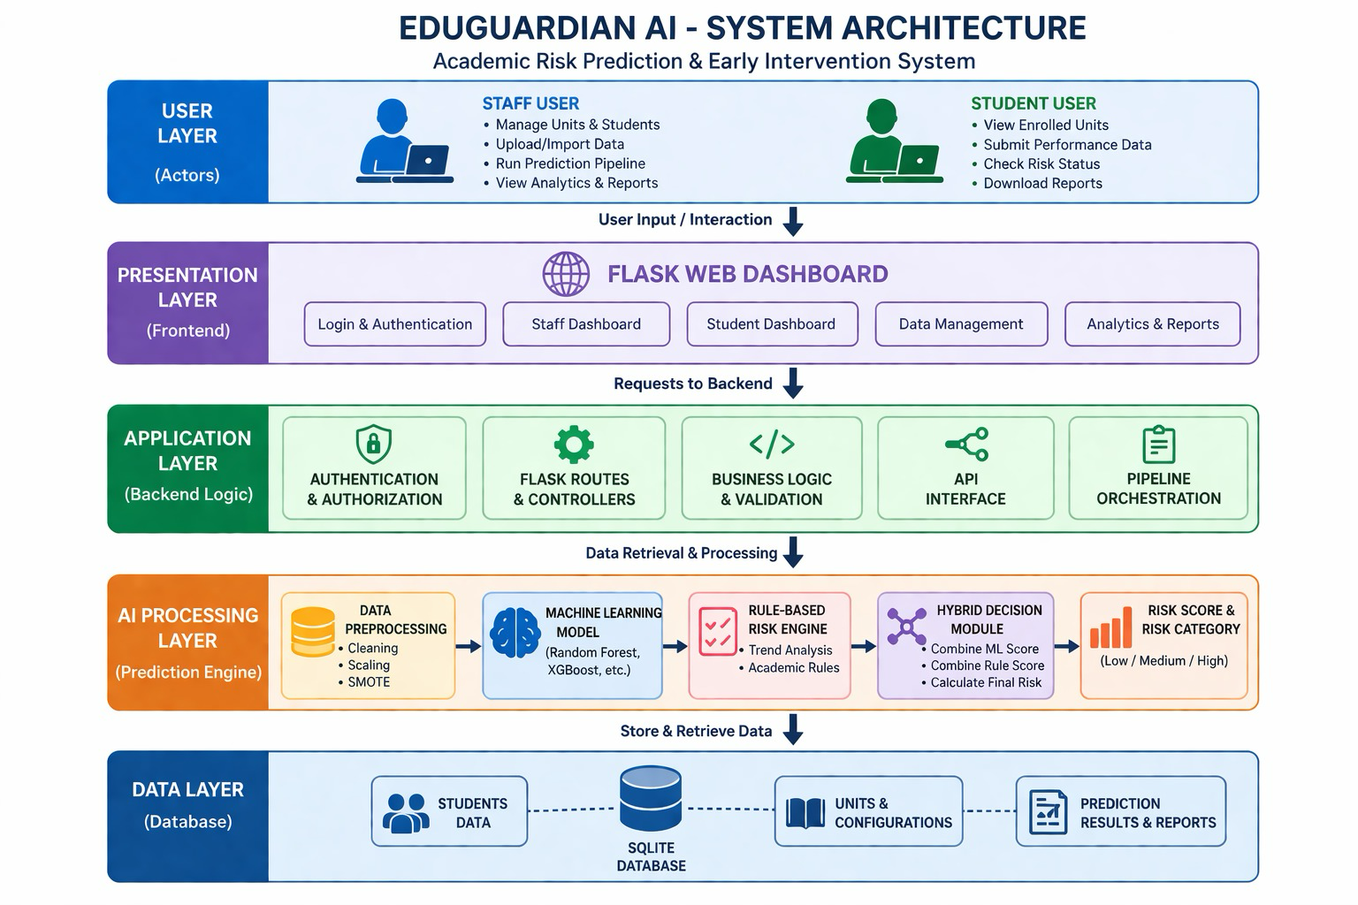

APPENDIX C – DATA FLOW DIAGRAM

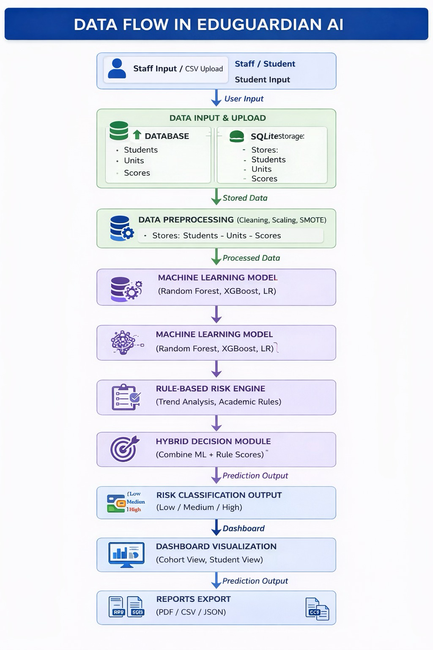

APPENDIX D – AI USAGE DECLARATION

This project made use of generative AI tools, including ChatGPT, to assist in the development and refinement of the report. The AI tool was used primarily for:
- Improving clarity and structure of written content
- Rephrasing technical explanations
- Assisting with grammar and language refinement
- Providing guidance on report organisation and formatting
All technical design, system implementation, model development, and evaluation were completed independently by the authors. The use of AI tools did not replace original work but was used as a support tool to enhance presentation and readability.
All outputs generated using AI were reviewed, validated, and modified where necessary to ensure accuracy and alignment with the actual system implementation.

APPENDIX E - MODEL TEST RESULTS

- Testing AI system with dataset containing all high risk students
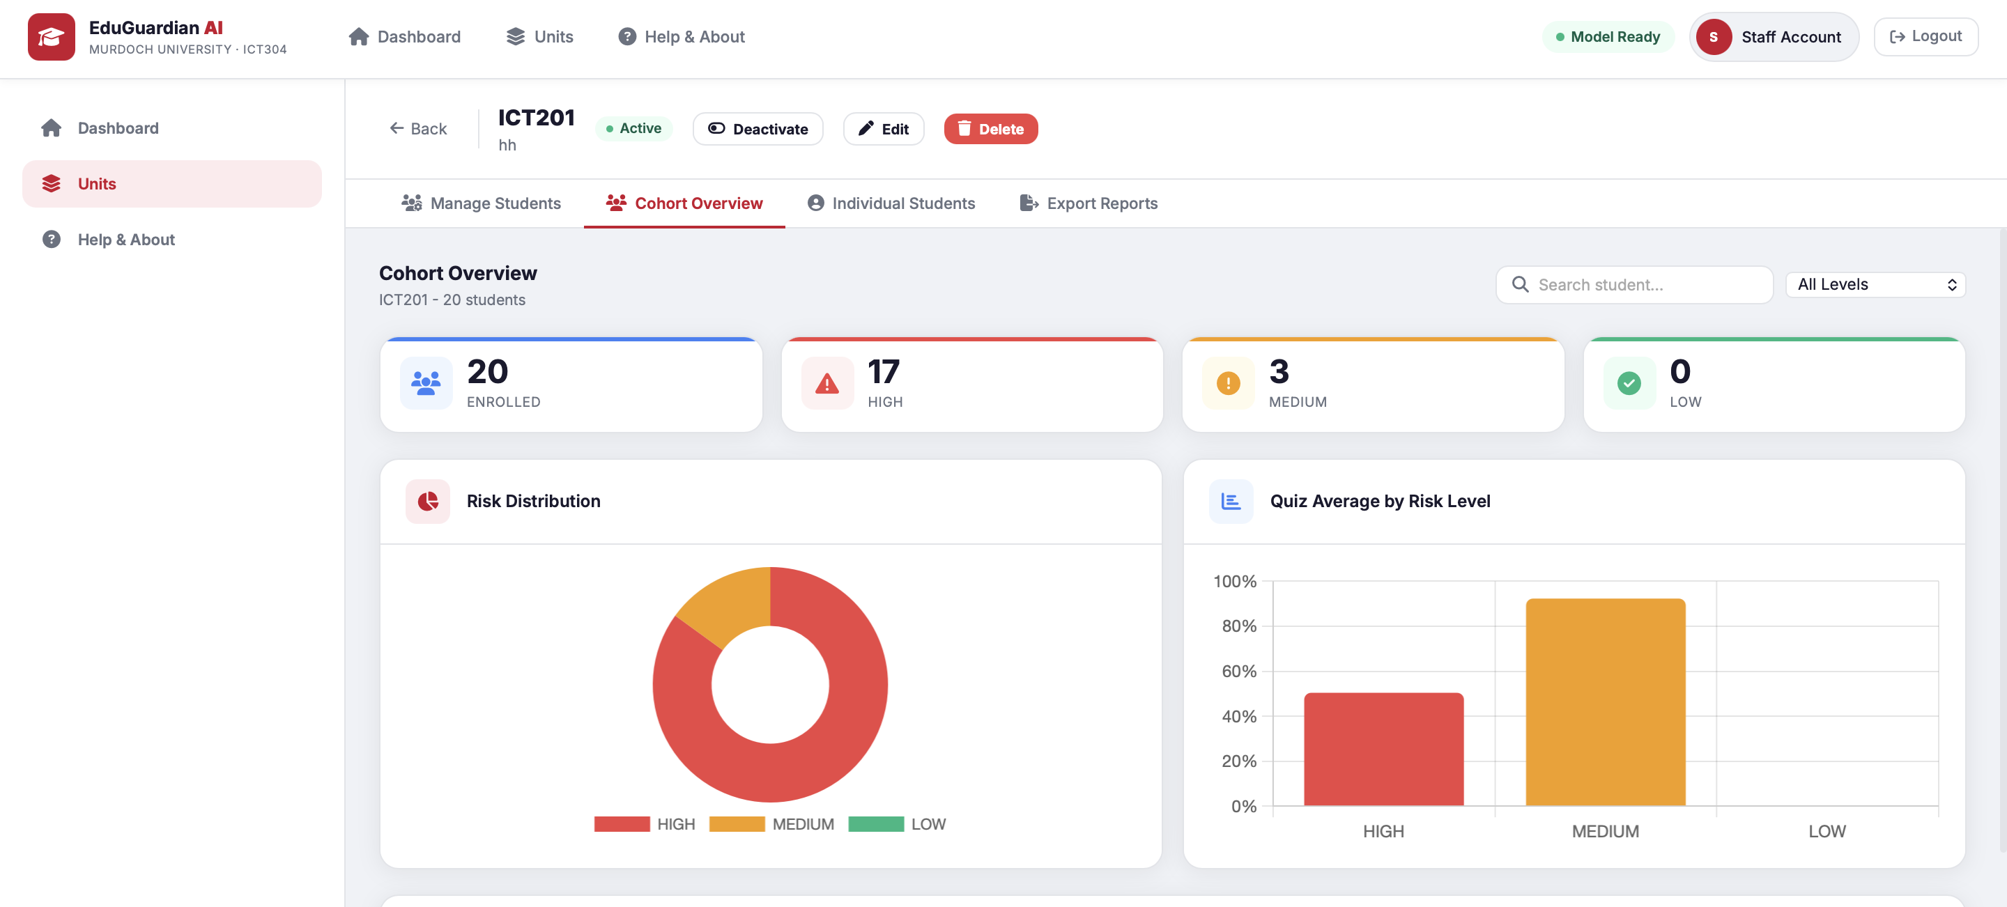

- Testing AI system with dataset containing only 3 quiz scores
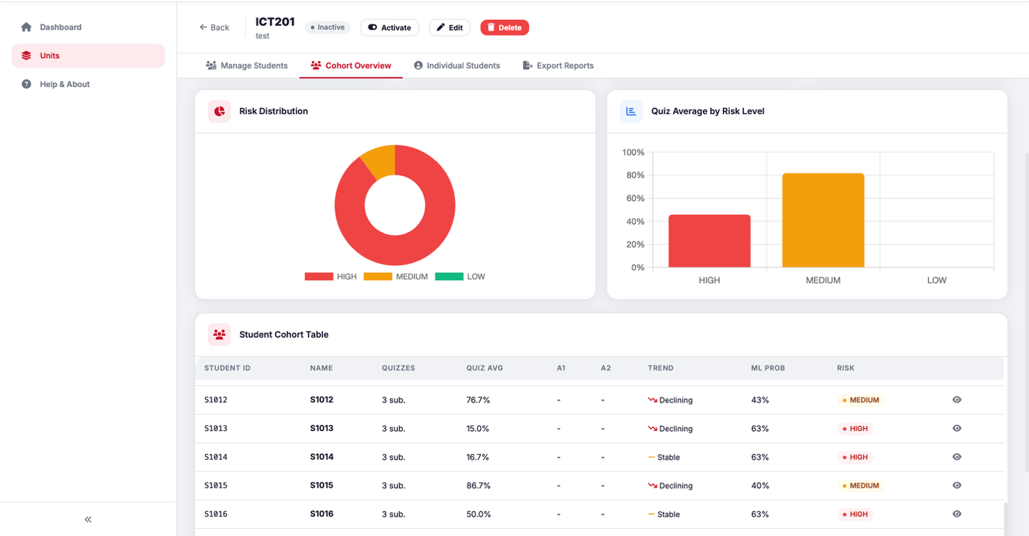

- Testing using dataset containing mixed risk students

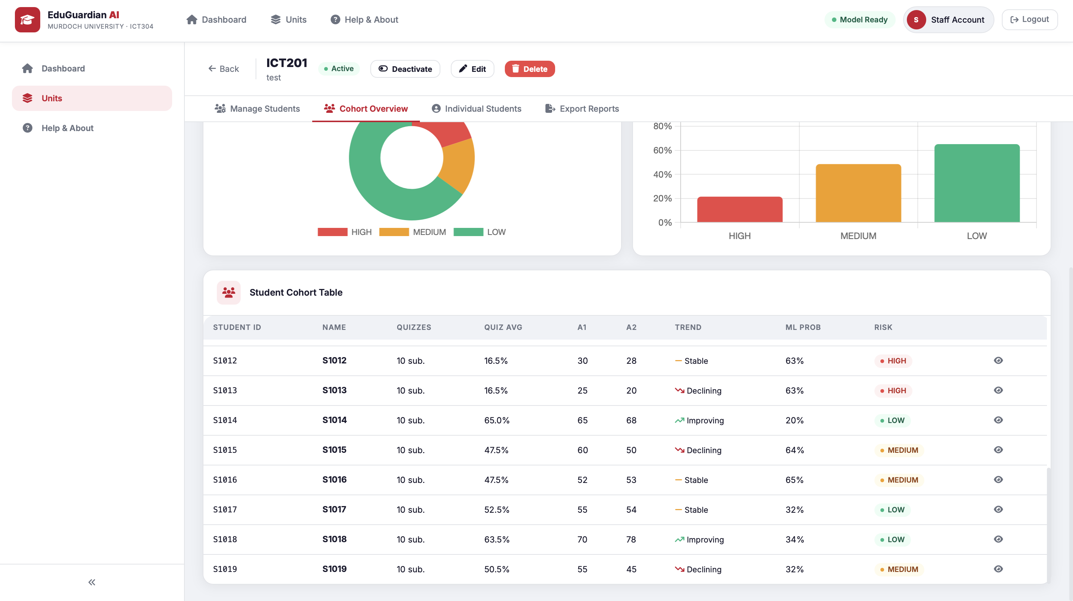

APPENDIX F – SOFTWARE TOOLS USED

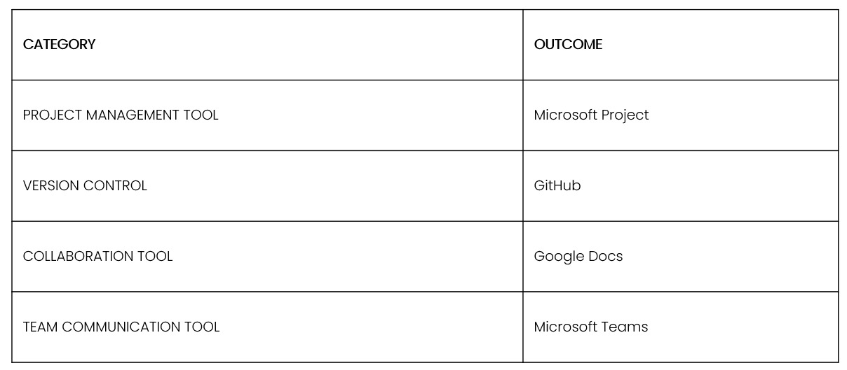

Project Management Tool – Microsoft Project
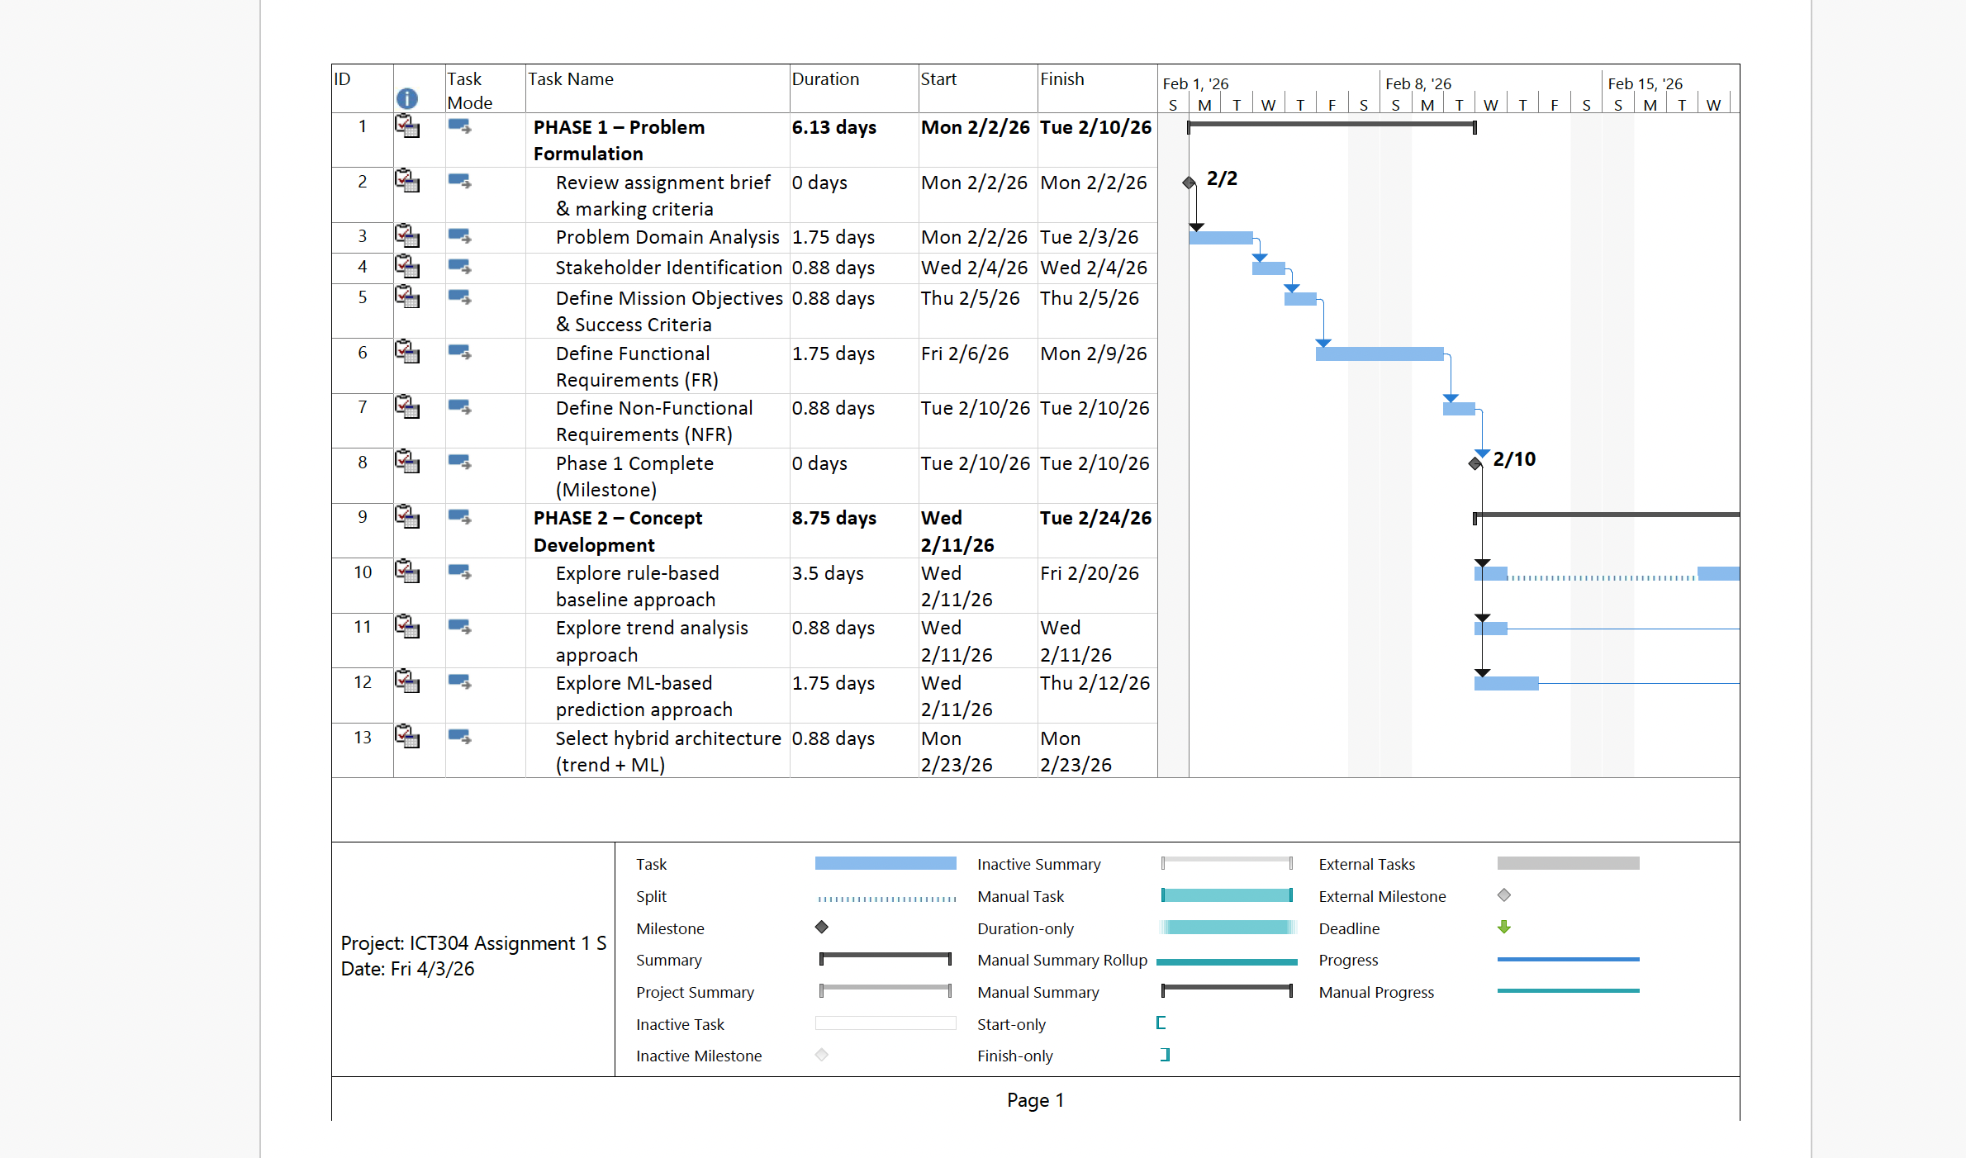

Team communication tool – Microsoft Teams


Collaboration tool – Google Docs


Version control – github
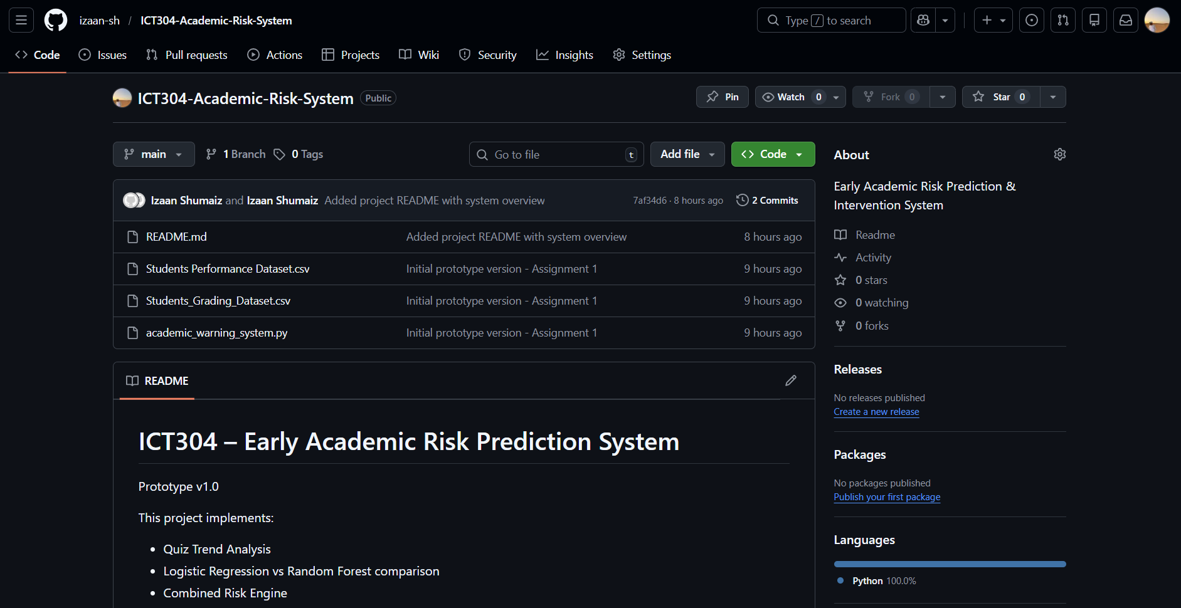

REFERENCES
Albreiki, B., Zaki, N., & Alashwal, H. (2021). A systematic literature review of student performance prediction using machine learning techniques. Education Sciences, 11(9), 552.
https://doi.org/10.3390/educsci11090552
Chen, Y., & Zhai, L. (2023). A comparative study on student performance prediction using machine learning. Education and Information Technologies, 28(9), 12039–12057.
https://doai.org/10.1007/s10639-023-11614-3
Shao, H., Shi, L., Lin, Y., & Fonseca, V. (2022). Using modern risk engines and machine learning/artificial intelligence to predict diabetes complications: a focus on the BRAVO model. Journal of Diabetes and its Complications, 36(11), 108316
Salah Hashim, A., Akeel Awadh, W., & Khalaf Hamoud, A. (2020, November). Student performance prediction model based on supervised machine learning algorithms. In IOP conference series: materials science and engineering (Vol. 928, No. 3, p. 032019). IOP Publishing.
Khalil, M. K., Hawkins, H. G., Crespo, L. M., & Buggy, J. (2018). The design and development of prediction models for maximizing students’ academic achievement. Medical Science Educator, 28(1), 111-117.

Riccio, V., Jahangirova, G., Stocco, A., Humbatova, N., Weiss, M., & Tonella, P. (2020). Testing machine learning based systems: a systematic mapping. Empirical Software Engineering, 25(6), 5193-5254
Breiman, L. (2001).Random forests. xMachine Learning, 45(1), 5–32. https://doi.org/10.1023/A:1010933404324

