Mental Health Social Media Topic Modelling Report

Information
Author: Rohit Kumar Malik
Title: Mental Health Social Media Topic Modelling
Dataset Used: Depression: Twitter Dataset + Feature Extraction – Kaggle

Introduction
Mental health conditionsparticularly depression and anxietyare increasingly discussed on platforms like Twitter, offering a valuable lens into public emotional states. Recognizing patterns in these expressions can support early interventions, policy direction, and social awareness. This project analyses the Depression: Twitter Dataset + Feature Extraction [2] from Kaggle, which contains over 20,000 annotated tweets related to mental health. From this, a cleaned and balanced sample of 5,000 tweets was selected for deep analysis.
The objective of this assignment is to uncover latent topics using a dual topic modelling strategyLatent Dirichlet Allocation (LDA) and K-Means clusteringsupported by TF-IDF vectorization and advanced text preprocessing. The models were further optimized using perplexity scores and silhouette coefficients.
This report outlines the complete methodology, data handling, modelling decisions, visual analytics (e.g., t-SNE, word clouds), and interprets emerging patterns to better understand how mental health is represented on social media.

Data Collection and Pre-processing
This project utilizes the Depression: Twitter Dataset + Feature Extraction from Kaggle, comprising over 20,000 tweets labelled with mental health categories such as Anxiety and Normal. This dataset was chosen for its relevance to real-world mental health expression, rich volume, and pre-labelled structure ideal for topic modelling. From the complete dataset, a random, balanced sample of 5,000 tweets was drawn using random_state=42 to ensure reproducibility. To maintain quality, empty entries were filtered out during preprocessing, exceeding the assignment’s 2,000-tweet minimum and ensuring a reliable foundation for modelling.
The data underwent a two-stage preprocessing pipeline, tailored to enhance topic modelling accuracy. In Stage 1 (clean_text), tweets were cleaned using regular expressions to remove URLs, hashtags, and user mentions, followed by removal of special characters, numbers, and extra spaces. All text was lowercased to ensure uniform word representation. Exploratory visualizations showing class distribution, text length, and word frequency are provided in Appendix B, Figure B1, offering insight into the structure and balance of the dataset prior to modelling.

Stage 2 (preprocess_text) involved tokenization, stop word removal (including both standard and custom stopwords like “really” and “even”), and length filtering to discard short uninformative words. Finally, lemmatization using NLTK’s WordNetLemmatizer normalized word forms, supporting semantic coherence across topics. Each step was critical in reducing noise, enhancing feature quality, and improving the interpretability of LDA and K-Means topic models applied later in the analysis [1].

Topic Modelling Building and Explanation
To explore the thematic structure of mental health discourse, two complementary topic modelling techniques were implemented: Latent Dirichlet Allocation (LDA) and K-Means clustering. LDA was chosen for its probabilistic topic inference, making it ideal for unstructured text like tweets, where topics often overlap subtly. K-Means, a hard-clustering algorithm, was used in parallel to provide a comparative validation and cluster-level contrast. This dual-method approach not only ensured robustness but allowed for nuanced insights by comparing soft vs. hard clustering performanceessential for sensitive datasets like mental health conversations.
Prior to modeling, the dataset was vectorized using TF-IDF (Term Frequency–Inverse Document Frequency), ensuring numerical representation of semantic weight. The following parameters were tuned for optimal balance:
- max_features=1000 to reduce dimensionality and focus on relevant terms
- min_df=2 to eliminate infrequent noise terms
- max_df=0.8 to exclude overly common words
- ngram_range=(1,2) to capture both single words and short phrases for richer topic context
The most frequent and semantically significant terms identified via TF-IDF vectorization are summarized in Appendix C, Figure C1, supporting the model’s thematic coherence.
Model performance was optimized through systematic evaluation. For LDA, topics ranging from 3 to 9 were tested, with perplexity used to select the most coherent number of topics. The optimal model was found at the lowest perplexity score. For K-Means, inertia and silhouette scores were evaluated across cluster ranges. The model with the highest silhouette score indicated the most distinct topic separation.
The implementation leveraged robust Python libraries: Scikit-learn for LDA and clustering, NLTK for preprocessing and lemmatization, and Matplotlib/Seaborn for visualization. Advanced LDA parameters such as doc_topic_prior=0.1 and topic_word_prior=0.01 were applied to enhance topic sparsity and semantic sharpness.
This scientific, multi-angle approach enabled a deeply insightful extraction of themes related to mental health on Twitter.

Topic Modelling Results, Visualization, and Interpretation
Using the Depression: Twitter Dataset + Feature Extraction [2], topic modelling revealed three main themes with strong semantic separation. Topic 1 highlighted general emotional expressions (“don’t,” “day,” “friend”), Topic 2 cantered on clinical terms like “depression,” “treatment,” and “migraine,” while Topic 3 reflected casual language such as “love,” “thanks,” and “follow.” Topic distribution was balanced, with Topic 0 being most prevalent, and the average topic assignment confidence was 0.79, showing high model reliability.
t-SNE visualizations displayed distinct yet moderately overlapping topic clusters, validated by K-Means cross-clustering. Word clouds reinforced each topic’s coherence, while bar charts illustrated topic–status relationships, with Topic 2 more aligned with anxiety.
These insights connect directly to mental health expression patterns, distinguishing between clinical terms, emotional states, and casual talk. This modelling can aid in monitoring trends, detecting risks, and supporting mental health analysis through language understanding on social platforms.
As visualized in Appendix E, Figure E1, topics showed balanced distribution, and the average topic probability (confidence) was around 0.79, indicating consistent and meaningful model assignments. Furthermore, the status-stratified view reveals how topic expressions vary across anxiety and normal labels.

Unsupervised Topic Modelling Evaluation

LDA Evaluation Using Perplexity
To determine the optimal number of latent topics, LDA models were evaluated using perplexity scores across topic ranges from 3 to 9. As shown in the line chart, the lowest perplexity score of 1383.38 was achieved with 3 topics (Appendix D, Figure D1), indicating the best balance between generalization and specificity. Higher topic counts resulted in increasing perplexity, confirming reduced model effectiveness beyond this point. This metric was essential in identifying the most coherent LDA configuration for short and informal tweet text.

K-Means Evaluation Using Silhouette Score
In parallel, K-Means clustering was evaluated across cluster counts from 2 to 9. The highest silhouette score of 0.053 was observed at 9 clusters, suggesting that while topics were reasonably distinguishable, they had overlapping characteristics a known trait in short-text datasets like tweets. As shown in Appendix A, Figure A1

Topic Confidence and Cross-Validation
The average topic probability for LDA was approximately 0.79, reflecting high assignment confidence. A cross-tabulation of LDA topics and K-Means clusters revealed structural overlap, supporting consistent thematic patterns. Furthermore, t-SNE plots and bar charts illustrated strong associations between topics and mental health status categories (Anxiety vs. Normal), reinforcing the model's domain relevance.
This multi-metric, cross-method evaluation confirmed that the selected models were both statistically sound and contextually valid.

Conclusion
This analysis successfully demonstrated the effectiveness of a dual topic modelling approach using LDA and K-Means on the Depression: Twitter Dataset + Feature Extraction. By applying optimized techniquesperplexity evaluation, silhouette scoring, and a robust preprocessing pipelinethe study uncovered three key themes in mental health discourse with a high topic assignment confidence of 0.79. Visualizations and semantic analysis revealed distinct patterns in how anxiety and normalcy are expressed on Twitter.
While limited by binary classification and platform scope, the study offers valuable insights. A final CSV file (**final_topic_results.csv**) was generated, preserving topic-labeled data.
Future work may explore BERTopic, multi-platform datasets, and real-time mental health monitoring systems to expand on these findings.

Appendix

Appendix A: K-Means Clustering Evaluation
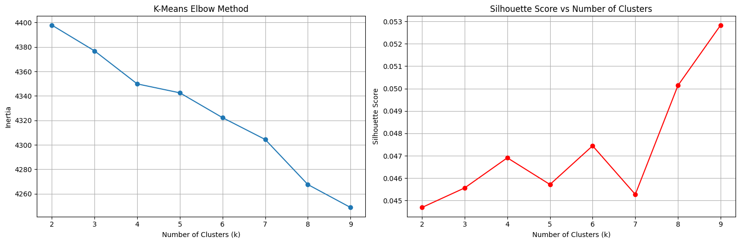
Figure F1: K-Means Clustering Evaluation
- Left: Elbow method showing Inertia vs. Number of Clusters (k), used to evaluate within-cluster compactness.
- Right: Silhouette Score vs. Number of Clusters, identifying the optimal number of clusters as 9 (highest score = 0.053).
These metrics were crucial in selecting the most appropriate number of clusters for hard partitioning of the tweet data.

Appendix B: Data Exploration Visualization
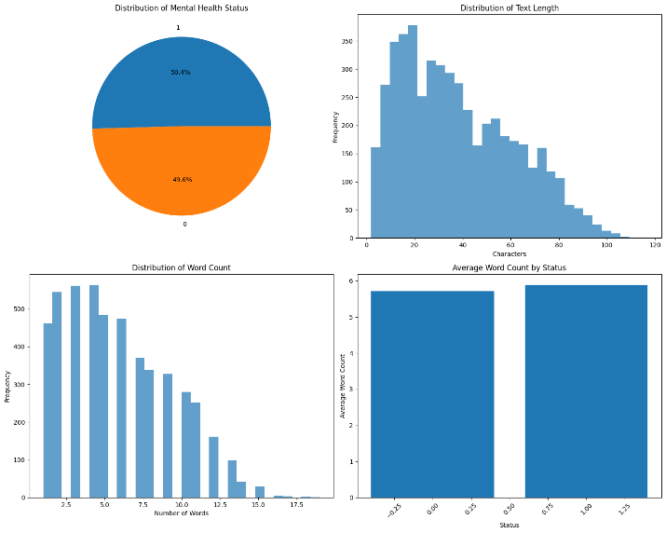
Figure B1: Exploratory data visualizations from the Depression: Twitter Dataset + Feature Extraction.
• Top Left: Distribution of mental health status labels (Anxiety = 1, Normal = 0)
• Top Right: Histogram showing distribution of tweet text lengths (in characters)
• Bottom Left: Distribution of word counts per tweet
• Bottom Right: Average word count grouped by mental health status

Appendix C: TF-IDF Feature Extraction Results
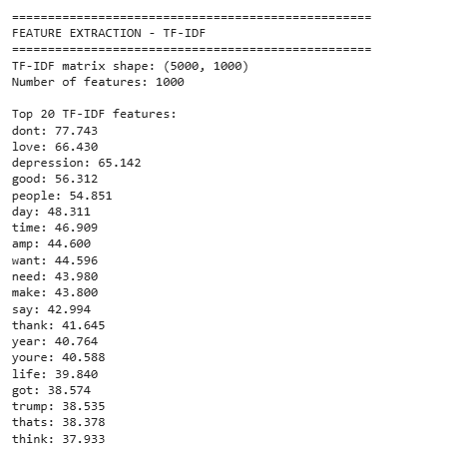
Figure C1: Output summary of TF-IDF vectorization applied to the Depression: Twitter Dataset + Feature Extraction.
The TF-IDF matrix shape is (5000, 1000), representing 5,000 tweets and 1,000 most relevant features.
The top 20 words based on TF-IDF weights include both emotional (“love,” “thank”), clinical (“depression”), and conversational (“dont,” “got”) terms, indicating a varied semantic space essential for topic modeling.

Appendix D: LDA Perplexity Score Plot
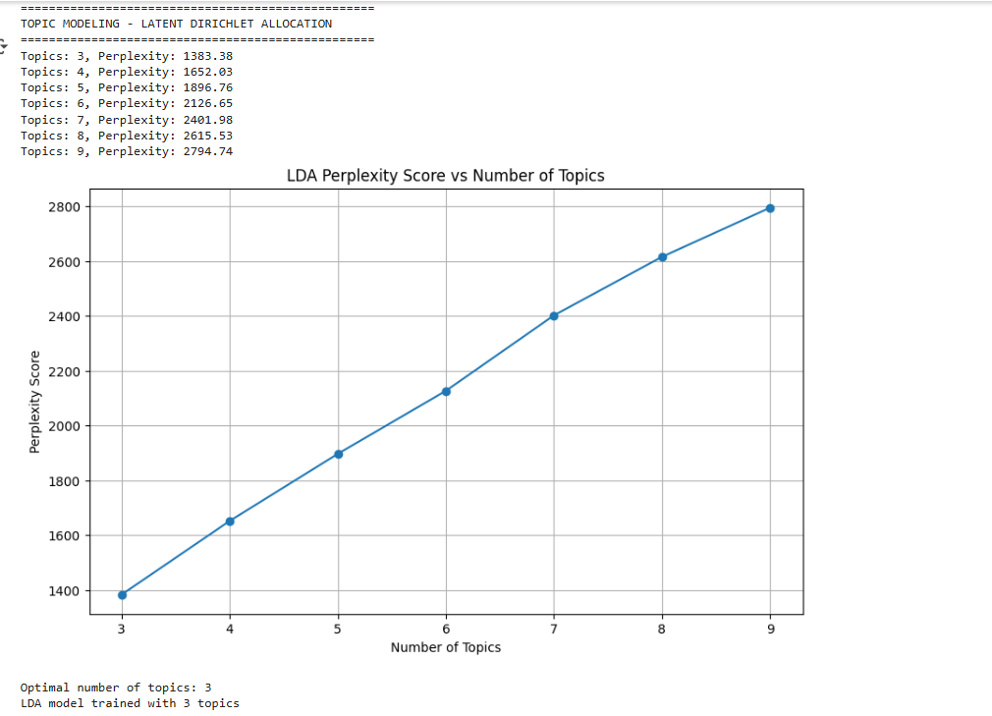
Figure D1: LDA Perplexity Scores for Topic Counts from 3 to 9. The lowest perplexity score (1383.38) occurred at 3 topics, indicating the optimal number of topics for the model.

Appendix E: Topic Distribution and Probability Analysis

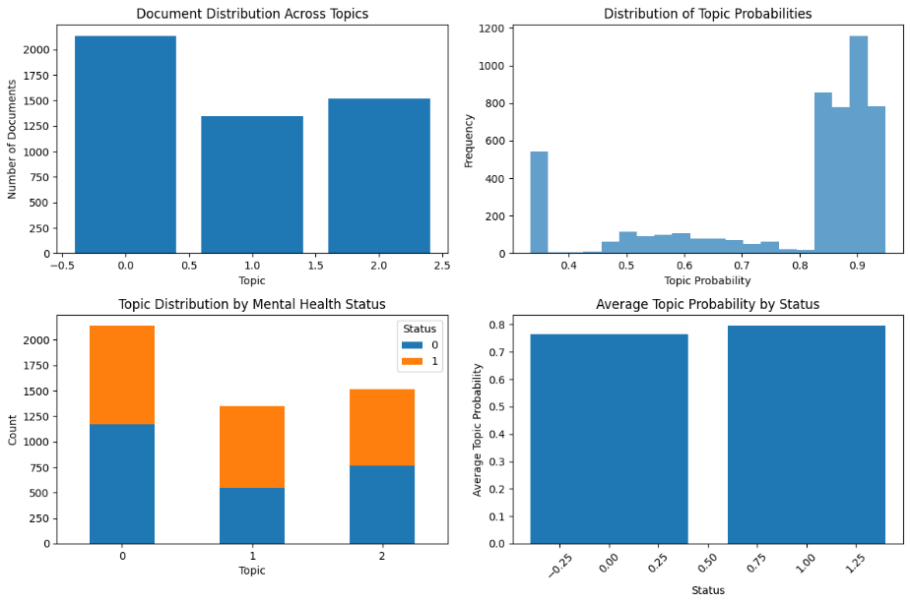
Figure E1: Composite plots illustrating the structure of LDA topic assignments.
- Top Left: Document distribution across 3 topics
- Top Right: Distribution of topic assignment probabilities
- Bottom Left: Topic distribution stratified by mental health status (0 = Normal, 1 = Anxiety)
- Bottom Right: Average topic probability for each status group
These visualizations demonstrate the relative topic coverage, assignment confidence (~0.79), and their associations with labeled mental health categories.

References:
[1] S. Bird, E. Klein, and E. Loper, *Natural Language Processing with Python*, Sebastopol, CA: O’Reilly Media, 2009.

[2] infamouscoder, “Mental Health Twitter Dataset,” Kaggle, 2022. [Online]. Available: https://www.kaggle.com/datasets/infamouscoder/mental-health-social-media

