Report
Of
AI-ML VIRTUAL INTERNSHIP
(Google AI-ML Domain — AICTE–EduSkills Virtual Internship Program)

Submitted To
School of Computer Science and Engineering
IILM University, Greater Noida, U.P.
In partial fulfilment of the requirement of degree of
B.Tech (Artificial Intelligence (AI) and Data Science)

By
Student ID: STU68a727280e58b1755785000
Name of Student: ROHIT MAURYA
ROLL-NO:CS-2341404
Batch: 2026-27

CANDIDATE'S DECLARATION
I, Rohit Maurya, do hereby declare that the internship report titled “AI-ML Virtual Internship” has been completed by me to fulfil the requirement for the award of the degree of Bachelor of Technology in Artificial Intelligence (AI) and Data Science at IILM University, Greater Noida. All the references used have been duly quoted, and I have not taken as such any material from any other source without acknowledgement.
I affirm that this report is my own work and has not been submitted to any other institute for any other degree/diploma requirement, and I shall be solely responsible for any kind of copyright violation in this regard.
The report presents the learning, technical concepts, activities, and outcomes associated with the 10-week AI-ML Virtual Internship undertaken in the Google AI-ML domain through the AICTE–EduSkills Virtual Internship Program during January 2026 to March 2026. The information presented has been prepared based on the internship materials, learning activities, and supporting documents available to me, including the official offer letter and completion certificate.
I understand that any false or misleading information presented in this report may affect its academic validity.
Signature: ____________________
Student Name: Rohit Maurya
Roll No. / Student ID: CS-2341404
Date: 19-08-2026

ACKNOWLEDGEMENT
I would like to express my sincere gratitude to IILM University, Greater Noida, for providing me the opportunity to undertake this internship as part of my B.Tech (Artificial Intelligence (AI) and Data Science) academic journey.
I am thankful to EduSkills and the AICTE–EduSkills Virtual Internship Program for the opportunity to participate in the 10-week AI-ML Virtual Internship in the Google AI-ML domain. The internship provided structured learning and practical exposure to important areas of artificial intelligence and machine learning.
I am grateful for the learning opportunities provided throughout the internship, particularly in areas such as neural networks with TensorFlow, object detection, product image search, and image classification. The week-wise structure helped in developing a systematic understanding of these concepts.
I would also like to express my appreciation to the faculty members and mentors of IILM University who supported and guided me throughout my academic and internship journey. Their guidance and encouragement helped me approach the technical topics with greater interest and discipline. I am also thankful for their aspiring guidance, valuable constructive criticism, and friendly advice during this work.
I express my gratitude to my parents for their blessings, and I thank everyone who contributed directly or indirectly to the successful completion of this internship and the preparation of this report.
Signature: ____________________
Student Name: Rohit Maurya
Roll No. / Student ID:CS-2341404

INTERNSHIP COMPLETION CERTIFICATE
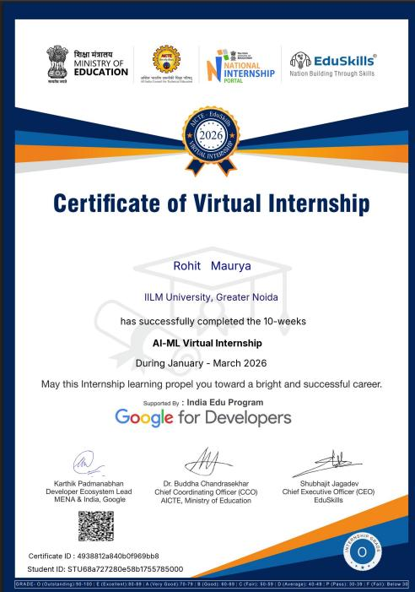
Official Internship Certificate — AI-ML Virtual Internship (Certificate ID: 4938812a840b0f969bb8)

CHAPTER 4: PROJECT DESCRIPTION
4.1 Introduction
Artificial Intelligence (AI) is an important area of computer science that focuses on developing systems capable of performing tasks that normally require intelligent human behaviour. Machine Learning (ML) is a major area within AI in which computational models learn patterns from data and use those patterns to perform specific tasks.
AI and ML have applications in areas such as image recognition, classification, object detection, search systems, and mobile applications. These technologies have also contributed to the development of modern computer-vision systems.
Computer vision is an area of artificial intelligence concerned with enabling computer systems to process and understand visual information such as images and camera feeds. Important computer-vision tasks include image classification and object detection. Image classification determines the category of an image, whereas object detection identifies objects within an image. These concepts form important parts of the technical curriculum covered during the internship.
The AICTE–EduSkills Virtual Internship Program provided a structured 10-week AI-ML learning program in the Google AI-ML domain. According to the official offer letter, the internship was scheduled from January 2026 to March 2026 and included structured learning, weekly assessments, project documentation or assignments where required, and final assessment requirements. The curriculum covered neural networks with TensorFlow, object detection, custom object detection, product image search, and image classification, providing exposure to different areas of AI and computer vision through a week-wise learning structure.
4.2 Organization Profile
The AICTE–EduSkills Virtual Internship Program is a structured internship program designed to provide students with industry-relevant learning and practical exposure in a specific subject area. It is jointly supported by the Ministry of Education, the All India Council for Technical Education (AICTE) through its National Internship Portal, and EduSkills, with the AI-ML domain curriculum developed under the India Edu Program in association with Google for Developers.
According to the official internship offer letter, the program was conducted as a 10-week virtual internship in the Google AI-ML domain. The internship was organized into weekly modules beginning with neural networks using TensorFlow, followed by object detection, custom object detection, product image search, and image classification, with the final weeks dedicated to assessment and credential validation. The internship also included weekly assessments, while certain modules required project documentation and assignments, with the final grade based on overall performance across these components.
Particular | Details
Program | AICTE–EduSkills Virtual Internship Program
Internship Domain | Google AI-ML
Internship Type | Virtual
Duration | 10 Weeks
Period | January 2026 – March 2026
Institute | IILM University, Greater Noida
Branch | B.Tech (Artificial Intelligence (AI) and Data Science)
Student | Rohit Maurya
Table 4.1: Internship Details (as stated in the official offer letter)
Major Areas Covered
- Neural Networks with TensorFlow
- Object Detection
- Custom Object Detection
- Product Image Search
- Image Classification
- Assessment and Credential Validation
4.3 Problem Statement
Modern computer-vision and AI-based applications require practitioners who understand not only theoretical machine-learning concepts but also their practical implementation using industry-standard frameworks. Students often have limited structured exposure to end-to-end AI/ML workflows — ranging from neural-network fundamentals to object detection, visual product search, and image classification — that are widely used in real-world mobile and web applications.
The AI-ML Virtual Internship was undertaken to address this gap by providing a structured, week-wise curriculum, developed for the Google AI-ML domain and delivered through the AICTE–EduSkills Virtual Internship Program, that introduces learners to these concepts in a progressive, hands-on, and assessment-driven manner.
4.4 Project Objectives
Based on the documented internship curriculum, the major learning objectives were:
1. To understand machine learning fundamentals — To develop an understanding of fundamental machine-learning concepts and their application in AI-based systems.
2. To learn neural networks using TensorFlow — To understand neural networks and use TensorFlow for developing neural-network-based solutions, as covered in the first week of the internship.
3. To understand computer vision concepts — To gain knowledge of computer-vision tasks involving images and visual information, particularly image recognition, object detection, and image classification.
4. To understand object detection — To learn the fundamentals of object detection and the use of pretrained object detectors.
5. To learn custom object detection — To understand how custom object-detection models can be trained using TensorFlow Lite and the TensorFlow Lite Model Maker library.
6. To understand product image search — To learn how object detection can be used for product image search and how visual-search functionality can be developed for mobile applications.
7. To understand image classification — To learn about custom image-classification models and the process of improving image-classification capabilities.
8. To gain structured practical exposure — To follow a week-wise learning structure involving assessments and, where required, project documentation and assignments.
9. To evaluate learning through assessments — To complete the assessment requirements of the internship, including the final assessment and credential validation.
4.5 Scope of the Project
The scope of the internship was defined by the official week-wise curriculum of the AICTE–EduSkills AI-ML Virtual Internship Program in the Google AI-ML domain. It covered neural networks with TensorFlow, object detection, custom object detection, product image search (including on-device detection, static images, live camera feeds, and backend integration), and image classification, concluding with assessment and final credential validation.
The internship was oriented toward conceptual and applied learning within a virtual, self-paced environment rather than the deployment of a production system. Accordingly, the scope did not extend to building or deploying a full production-grade application; it was limited to the guided modules, assessments, and documentation available through the official program.
4.6 Technologies and Tools Used
Technology / Concept | Description | Internship Relevance
TensorFlow | A framework used for developing machine-learning and neural-network solutions. | Week 1 — programming neural networks with TensorFlow.
Neural Networks | Computational models used for learning patterns from data. | Covered during the first week of the internship.
Convolutional Neural Networks (CNNs) | Neural-network architectures used for image-related tasks. | Included in the image recognition and classification pathway.
TensorFlow Lite | A technology used for deploying ML models in lightweight environments. | Used in the custom object-detection module.
TensorFlow Lite Model Maker | A library used for creating custom machine-learning models. | Used for custom object-detection model training.
Object Detection | A computer-vision task used to identify objects in visual data. | Covered during Weeks 2 and 3.
Product Image Search | A visual-search approach involving product images and object detection. | Covered during Weeks 4–6.
Image Classification | A computer-vision task that assigns images to categories. | Covered during Weeks 7–8.
Android / Mobile Integration | Integration of visual AI capabilities into mobile applications. | Mentioned in the object-detection and product-image-search modules.
Table 4.2: Major Technologies and Concepts (based on the documented weekly curriculum)
Relationship Between the Technologies
The internship curriculum progresses from fundamental AI/ML concepts toward computer-vision applications:
Neural Networks & TensorFlow
↓
Object Detection
↓
Custom Object Detection with TensorFlow Lite
↓
Product Image Search
↓
Image Classification
4.7 System Architecture
The overall learning architecture of the internship followed a staged pipeline that moved from foundational concepts to applied, assessment-based learning. Each stage built upon the technical skills developed in the preceding stage, as illustrated below.
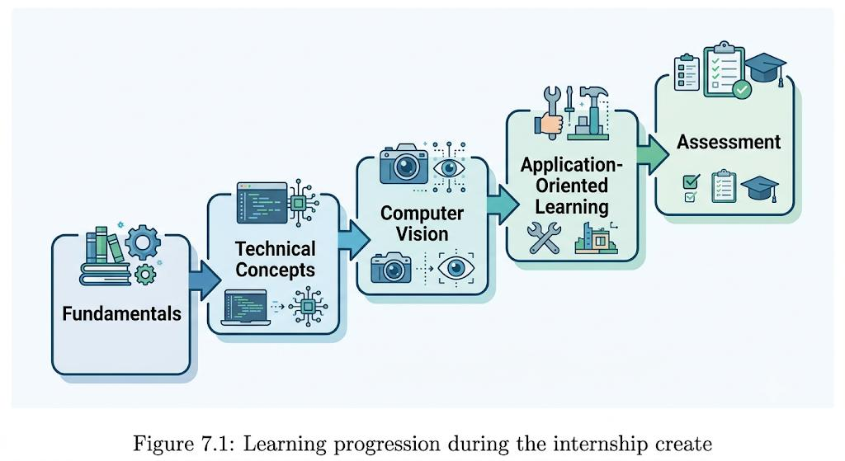
Figure 4.1: Overall learning architecture / progression of the internship
At the application level, the computer-vision modules (object detection, product image search, and image classification) followed a common conceptual data flow: an input image or camera frame is passed through a trained model, the model performs identification or classification, and the result is returned to the mobile application. This pattern, illustrated for object detection below, was reused with variations across the product-image-search and image-classification modules.
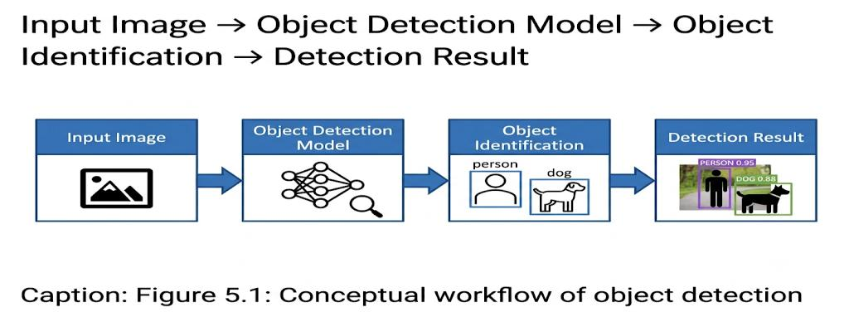
Figure 4.2: Conceptual workflow of object detection (Input Image → Object Detection Model → Object Identification → Detection Result)
4.8 Methodology
The internship followed a week-wise methodology in which each module introduced a specific concept, built upon the previous week's learning, and was reinforced through weekly assessments. The methodology followed across the 10 weeks is summarised below.
4.8.1 Week 1 — Programming Neural Networks with TensorFlow
The first week focused on programming neural networks with TensorFlow. The module introduced the fundamentals of machine learning and neural networks and provided an understanding of how these concepts can be applied to computer-vision problems, introducing convolutional neural networks (CNNs) for advanced image recognition and classification.
- Fundamentals of machine learning
- Neural networks
- TensorFlow
- Convolutional Neural Networks (CNNs)
- Image recognition and classification
4.8.2 Week 2 — Getting Started with Object Detection
The second week focused on the fundamentals of object detection, an important computer-vision task concerned with identifying objects within visual data. The module introduced the integration of a pretrained object detector into a mobile application.
- Fundamentals of object detection
- Pretrained object detectors
- Object detection in visual data
- Mobile application integration
4.8.3 Week 3 — Custom Object Detection
The third week extended the concepts introduced in Week 2 and focused on training custom object-detection models using TensorFlow Lite and the TensorFlow Lite Model Maker library.
- Custom object detection
- TensorFlow Lite
- TensorFlow Lite Model Maker
- Training custom object-detection models
4.8.4 Weeks 4–5 — Product Image Search
Week 4 introduced product image search — building a product image-search feature for a mobile application using on-device object detection to identify objects and support visual-search functionality. Week 5 continued this pathway, focusing on detecting objects in static images and live camera feeds on Android to develop a visual product-search experience.
- Product image search
- On-device object detection
- Static image processing
- Live camera feeds
- Android integration
4.8.5 Week 6 — Product Image Search Backend
The sixth week extended the visual-search functionality through a backend component, involving building and calling a product image-search backend from a mobile application to enhance the product-search feature introduced in the previous modules.
Mobile Application
↓
Image / Search Request
↓
Product Image Search Backend
↓
Search Processing
↓
Product Search Result
4.8.6 Weeks 7–8 — Image Classification
Week 7 introduced the development of custom image-classification models, where image classification is the computer-vision task of assigning an image to a particular category. Week 8 continued this module, focusing on creating a custom image classifier and integrating it into an application.
- Custom image-classification models
- Image-based categorization
- Custom image classifier
- Application integration
4.8.7 Weeks 9–10 — Assessment and Final Credential Validation
The ninth week was dedicated to assessment, providing an evaluation stage following completion of the earlier learning modules. The internship offer letter states that the program included weekly assessments to track progress and understanding, with certain modules also requiring project documentation and assignments. The final grade was based on overall performance, including weekly assessments, project submissions, and the final test.
The tenth and final week was dedicated to Final Credential Validation — the concluding stage of the 10-week structure. According to the offer letter, successful completion of the required steps and assessments was necessary for receiving the Virtual Internship Certificate.
4.8.8 Assessment and Observations
The internship followed a structured evaluation process requiring completion of weekly assessments to track progress and understanding, with certain modules also requiring the submission of project documentation and assignments. The official internship documents do not provide a record of specific personal challenges faced by the student; accordingly, no personal difficulty is claimed here. The technical areas covered in the curriculum — including neural-network concepts, TensorFlow, object-detection workflows, custom object detection, TensorFlow Lite, visual product-search workflows, image-classification models, and application integration — generally require careful and sustained study.
4.9 Expected Outcomes
The AI-ML Virtual Internship provided a structured learning pathway covering important concepts and technologies related to Artificial Intelligence, Machine Learning, and Computer Vision. The major expected learning outcomes were:
1. Neural Networks and TensorFlow — An understanding of neural networks and their relationship with TensorFlow through the first week's learning module.
2. Computer Vision — Exposure to computer-vision concepts through image recognition, object detection, product image search, and image classification.
3. Object Detection — Understanding of the fundamentals of object detection and the concept of using pretrained object detectors.
4. Custom Object Detection — Knowledge of custom object-detection models using TensorFlow Lite and TensorFlow Lite Model Maker.
5. Product Image Search — Knowledge of product image search using on-device object detection, static images, live camera feeds, and backend integration.
6. Image Classification — Understanding of custom image-classification models and integration of a custom image classifier into an application.
Overall Learning Outcome
The week-wise structure provided a progression from fundamental concepts toward more application-oriented AI and computer-vision topics:
Neural Networks
↓
TensorFlow
↓
Object Detection
↓
Custom Object Detection
↓
Product Image Search
↓
Image Classification
Future Scope
The concepts covered during the internship provide a foundation for further learning in computer-vision applications, more advanced visual-search systems, mobile and edge AI using TensorFlow Lite, advanced image classification, and advanced object detection. Continued practice with machine-learning frameworks, computer-vision techniques, and model development can help build deeper technical capabilities in AI and machine learning, in line with the internship's aim of strengthening industry-relevant skills and confidence in the subject area.
Conclusion
Overall, the AICTE–EduSkills Virtual Internship Program provided a structured 10-week learning experience in the Google AI-ML domain, progressing from neural networks and TensorFlow to object detection, custom object detection, product image search (including backend integration), and image classification, supported by weekly assessments, project documentation where required, a final assessment, and final credential validation. The internship established a foundation for further learning in machine learning, deep learning, object detection, image classification, visual search, and mobile/edge AI.
4.10 Certificates of Completion and Other Communication / Mail Proof
The Official Internship Certificate (Certificate ID: 4938812a840b0f969bb8; Student ID: STU68a727280e58b1755785000), jointly issued by the Ministry of Education, AICTE, the National Internship Portal, and EduSkills, confirming successful completion of the 10-week AI-ML Virtual Internship (January–March 2026) in the Google AI-ML domain, is presented in the Internship Completion Certificate chapter of this report.
No additional offer-letter or e-mail communication proof was available in the source records at the time of preparing this report. Copies of the offer letter and any related communication, where available, should be attached here to complete this section.

CHAPTER 5: BIBLIOGRAPHY / REFERENCES
Official Internship Documents
1. AICTE–EduSkills Virtual Internship Program, Internship Offer Letter, Internship Domain: Google AI-ML, January 2026 – March 2026.
2. AI-ML Virtual Internship Certificate, AICTE–EduSkills Virtual Internship Program, Certificate ID: 4938812a840b0f969bb8.
Technical References
3. TensorFlow Documentation — Official documentation for TensorFlow and machine-learning concepts.
4. TensorFlow Lite Documentation — Official documentation related to lightweight machine-learning model deployment.
5. TensorFlow Lite Model Maker Documentation — Official documentation related to creating and customizing machine-learning models.

