**Git Assessment**

Objective: The goal of this assignment is to help you get familiar with basic Git commands and workflows, which are commonly used in real-world software development.

1. Create New Repository. (Using the cloning method)

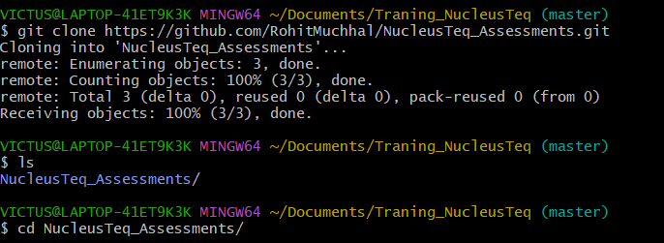

#We can also use “git init” and then move it to remote.

2. Create a New File.

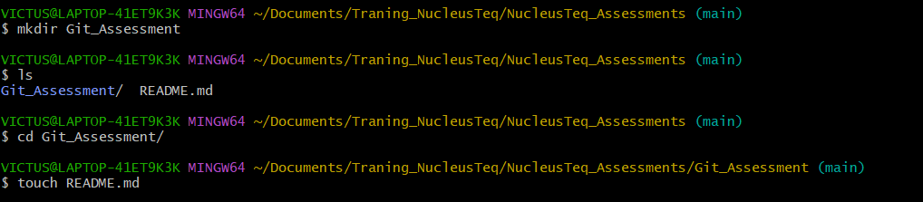

3. Create a Branch.

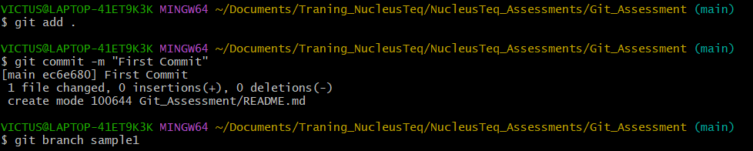

4. Make Changes in the New Branch.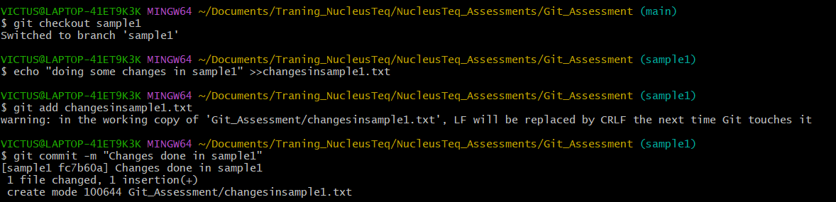

5. Create Another Branch (Optional)

This is a new way to directly create and also switch to the new branch



6. Merge Branches.

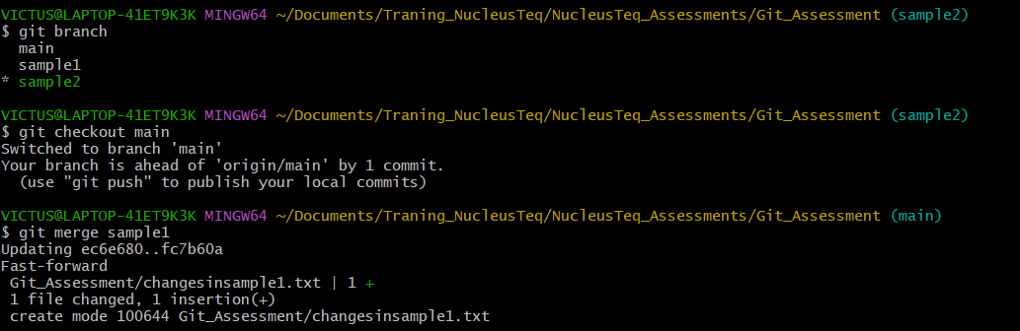

7. Pull Changes from Remote.



8. View Git Log and History.

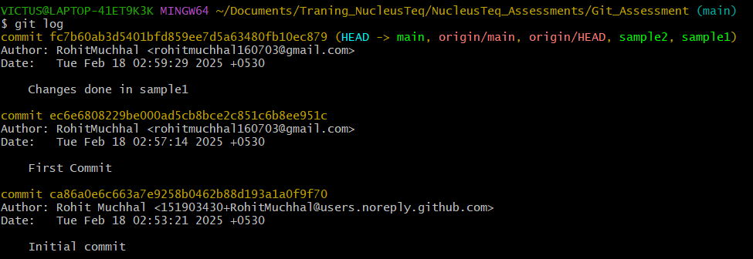

9. Git Status and Staging

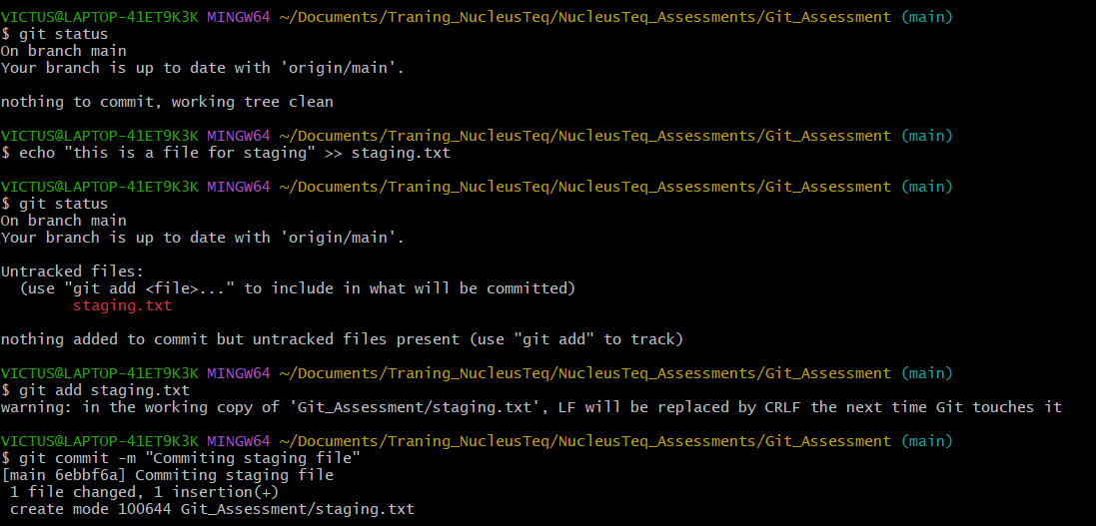

10. Revert and Reset

