N.Rohit

Cse A

BL.EN.U4CSE22040

1)Write a python function that takes a text document as input and returns a dict containing the frequency of each word in document.

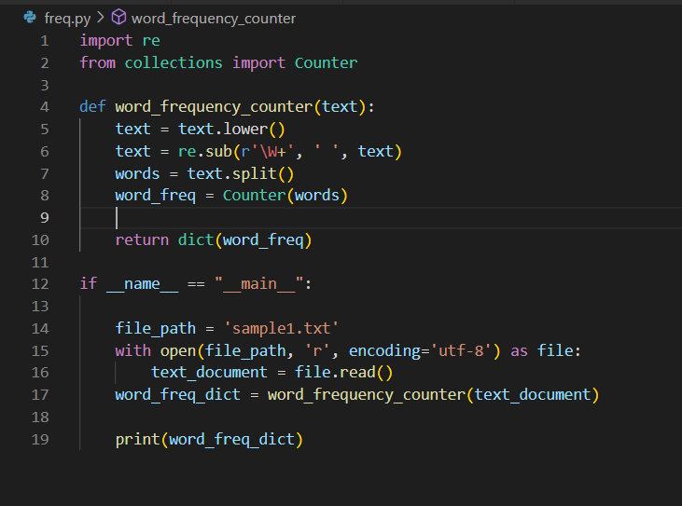

output:

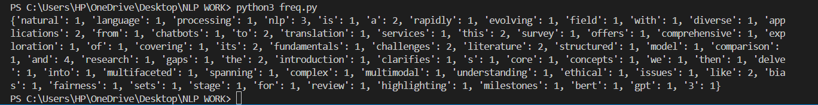

2)write a function to Clean and tokenize the given text, removing punctuation and coverting words into lowercase

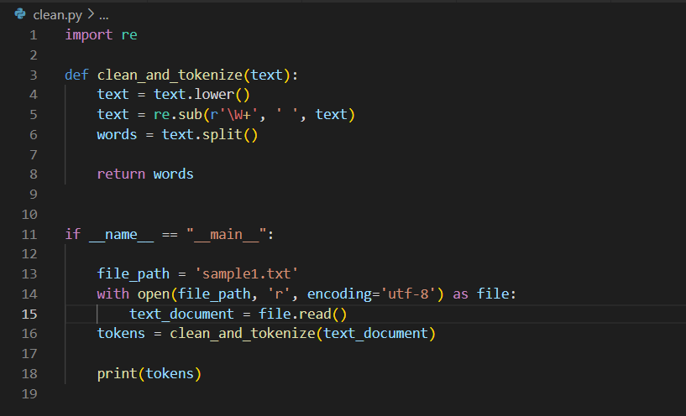

Output:

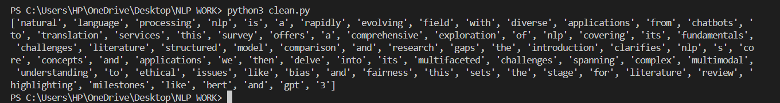

3)Develop a function that removes stop words of a given sentence.

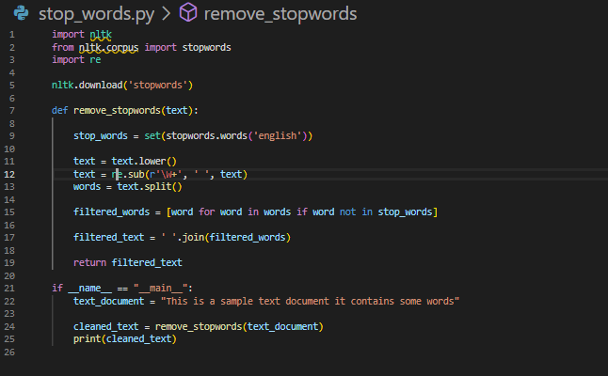

Output:

