Sentinel-2 MultiSpectral Imager data have effectively detected chlorophyll-a, a proxy for algal biomass, in large bodies of water, but few studies have shown the applicability in small (<10 km2) reservoirs, which are critically important for [aquatic species](https://www.sciencedirect.com/topics/agricultural-and-biological-sciences/aquatic-species), [drinking water](https://www.sciencedirect.com/topics/earth-and-planetary-sciences/potable-water), irrigation, cultural activities, and recreation.

This study provides a test of the use of Sentinel-2 imagery in Google Earth Engine for algal bloom detection in two small freshwater reservoirs in northern California, [USA](https://www.sciencedirect.com/topics/earth-and-planetary-sciences/united-states-of-america), from October 2015 to December 2020.

[Normalized Difference Vegetation Index](https://www.sciencedirect.com/topics/earth-and-planetary-sciences/normalized-difference-vegetation-index) (NDVI), Normalized Difference Chlorophyll Index (NDCI), B8AB4, and B3B2 - to retrieve chlorophyll-a data for algal bloom identification in two highly dynamic freshwater systems.

NDCI, which leverages the red-edge wavelength, most accurately identified chlorophyll-a across all study sites (highest adjusted R2 = 0.84, lowest [RMSE](https://www.sciencedirect.com/topics/earth-and-planetary-sciences/root-mean-square-error) = 0.02 µg/l), followed by NDVI.

In general, algae appeared to be highest in the spring and summer months, with the highest peaks observed in 2019 at Copco among all spectral indices,

These data included chl-a concentrations and levels of microcystin, an acute liver toxin ([Rastogi et al., 2014](https://www.sciencedirect.com/science/article/pii/S1470160X2200512X?ref=pdf_download&fr=RR-2&rr=7e14e5b13d1b8549" \l "b0370)), that were measured in water samples collected at 0.5 m depth

33 sentinal -2 A images

 We used this regression equation because of the non-linear relationship between the [spectral reflectance](https://www.sciencedirect.com/topics/earth-and-planetary-sciences/spectral-reflectance) and chl-a values

y = index + chl-a + chl-a2 + chl-a3

as per understanding y = spectral reflectance at sensor

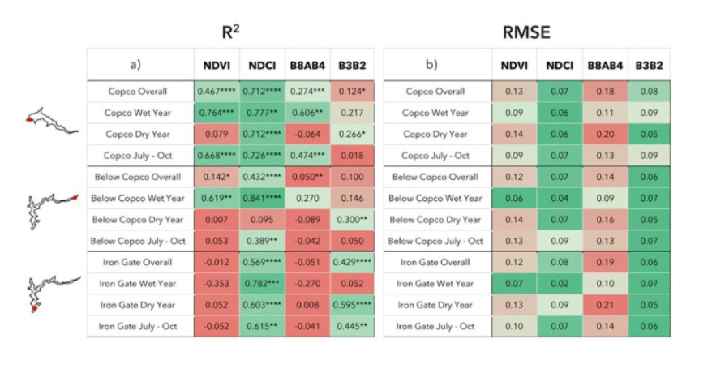

index calculated as per correction and calculated based on surface reflectance

chl -a = dependent parameter

Ref paper - <https://www.mdpi.com/2073-4441/10/8/1020>

e^chl-a = a = a1 +a2(index) +a3(index)^2+a4(index)^3

As algal blooms can appear and vanish within hours ([Lee et al., 2005](https://www.sciencedirect.com/science/article/pii/S1470160X2200512X?ref=pdf_download&fr=RR-2&rr=7e14e5b13d1b8549" \l "b0265)), it is preferable to gather data on an hourly or daily timescale.

Algal bloom satellite detection could also be improved by harmonizing imagery from Sentinel-2 and Sentinel-3 (and potentially with high-resolution Planet imagery (3–5 m)) to leverage the distinct spatial, temporal, and [spectral resolution](https://www.sciencedirect.com/topics/earth-and-planetary-sciences/spectral-resolution) from each mission

Totalponds = 55(44(train) +11 test) + 5 using, coinciding

Band values are taken from centroid of pond (not averaged)

Why to take middle pixel, any mathematical model to check that.

Data is from same pond

Scalable work on satellite

Salinity affects

More data for brute force

DE,

Model design

cluster of ponds with similar property (so multiple model)

Needs to be done in terms of coding

geojson.io>**API**> template csv (cord)+ geo-json(cord) python>**API**> master csv (cord info) > GEE give SAR(centroid band value) data > final csv >**API**> SVR model

Steps:

1. Algae estimation using process-based model -> required light intensity and temperature of pond.([Link](https://www.sciencedirect.com/science/article/abs/pii/S2211926418306672))

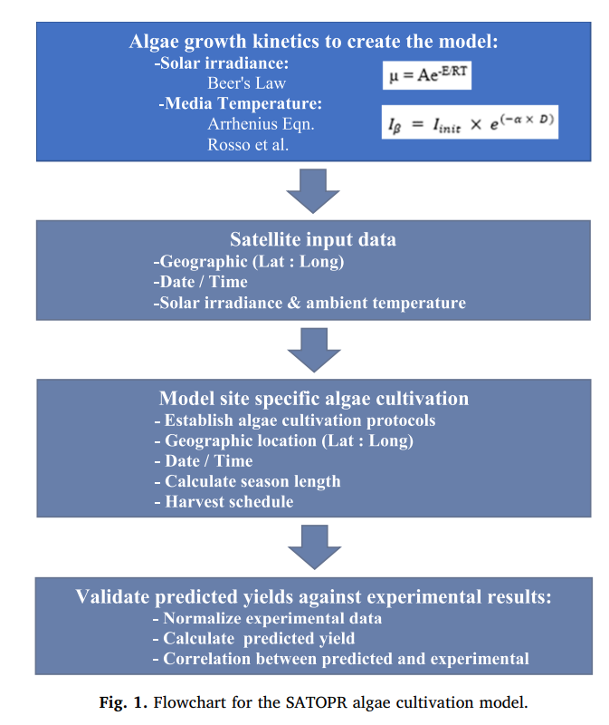



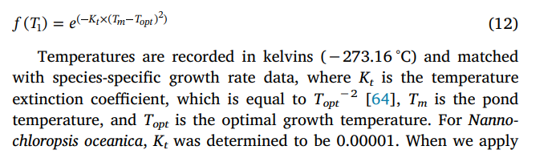

One more method for f(t)

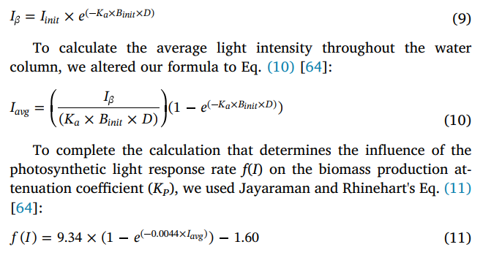

1. Establishing relation between Algae and WQ parameters
   1. Blue team have a lead on it (found good relation in them)
2. Estimation of temperature of pond using sentinels 3 data(cant resolution is too low)
3. Estimation of temperature using sen2 data in combination with landsat 8 data([Link](https://www.researchgate.net/publication/368517297_Estimation_of_land_surface_temperature_in_agricultural_lands_using_Sentinel_2_images_A_case_study_for_sunflower_fields)) can give temp with MODIS downscaling with sen2 data