**Water Quality Management**

1. Need of atmospheric correction in sen 2 data
2. Can use different satellite data
3. GT analysis with justification and its effects on input and commodity
4. water + satellite data interaction
5. Very less data points
6. Another issue of coincidence (NEED TO BE RESOLVED SO ALL DATA POINTS CAN BE USED)
7. identification of Nature of problems

**Identification of Nature of problem:**

What we have:  
 Input = [CoastalAerosol,Blue,Green,Red, RedEdge1,RedEdge2,RedEdge3,NIR,NarrowNIR,WaterVapour,SWIR1,SWIR2]

Output required:  
 output = [pH,Salinity,Carbonate ,BiCarbonate,Alkalinity,Hardness,Calcium,Magnesium,Ammonia]

**PH =** The pH of the pond water is indicative of its fertility or potential productivity. Water with pH ranging from 7.5 to 9.0 are generally regarded as suitable for shrimp production. The growth of shrimps is retarded if pH falls below 5.0. Water with low pH can be corrected by adding lime to neutralize the acidity.

**Salinity =** Younger shrimps appear to tolerate a wider fluctuation of salinity than the adults. Average required (27–32 ppt)

**Need of atmospheric correction in Sen 2 data**

The Level-2A processing includes a Scene Classification and an Atmospheric Correction applied to Top-Of-Atmosphere (TOA) Level-1C orthoimage products. Level-2A main output is an orthoimage atmospherically corrected, Surface Reflectance product.

Please be aware that "Surface Reflectance (SR)" is a new term that has been introduced to replace the former one: "Bottom of Atmosphere (BOA) reflectance." [Link](https://sentinels.copernicus.eu/web/sentinel/user-guides/sentinel-2-msi/processing-levels/level-2)

So, we don’t need to do atmospheric correction if we are using sen2-A images.

But other atmospheric correction needs to perform(not heighlighted one).

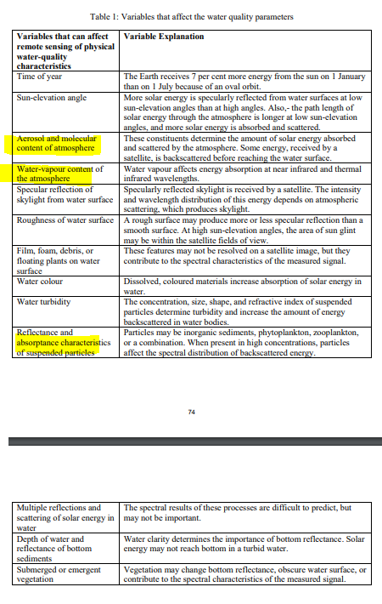

**Can we use different satellite data.**

**Indices for WQA:**

For PH

Paper - [link](https://www.indexdatabase.de/db/i-single.php?id=90)

SIPI - [link](https://www.indexdatabase.de/db/i-single.php?id=90)

For Classification of Ponds (form artificial and other water bodies), can refer this paper - [Link](https://www.mdpi.com/2072-4292/14/14/3306)   
 used sentinel data, also talked about the aquaculture and cultivation.

Remark – Not useful because of the for our data showing very correlation ph – 0.01 and salinity – 0.38

**Interpolation of sentinel’s data for remove days of difference issue to add the data point for model:**

Assumption is in those intermediate dates no external manmade factor added bias in Water quality   
Approaches are Kriging and interpolation based on the GT.