**SOLVING SIMULTANEOUS LINEAR EQUATION USING OP-AMP**

**AIM:**

To Solve two Simultaneous Linear equations using Op-Amp 741.

**Materials Required:**

|  |  |  |  |
| --- | --- | --- | --- |
| Sl. No. | Equipments and Components Required | Range / Specification | Quantity |
| 1 | Regulated Power Supply | (0-30)V | 1 |
| 2 | CRO | (0-20)MHz | 1 |
| 3 | Function Generator |  | 1 |
| 4 | IC 741 |  | 1 |
| 5 | Resistors |  |  |
| 6 | Breadboard |  | 1 |
| 7 | Multimeter |  | 1 |
| 8 | Connecting wires |  | As required |

**THEORY:**

**INVERTING AMPLIFIER:**

The inverting amplifier is shown in Fig. 1. The input signal drives the invertinginput of the op-amp through resistor *R*1. The op-amp has an open-loop gain of A, so thatthe output signal is much larger than the error voltage. Because of the phase inversion,the output signal is 180˚out-of-phase with the input signal. This means that the feedbacksignal opposes the input signal and the feedback is negative or degenerative.The output voltage is given by,

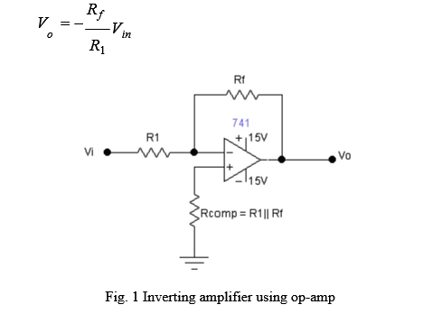

**SOLVING SIMULTANEOUS LINEAR EQUATION:**

For two equations:

Equation 1: Ax + By = C

Equation 2: Dx - Ey = F

**From Equation 1 we can write x = C/A – (B/A)y**

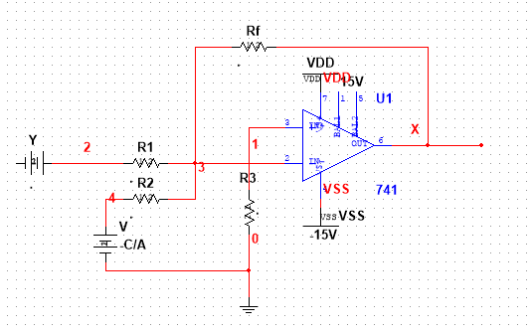

R2 = Rf

Rf/R1 = B/A

R3 = R1||Rf

V = - C/A

Hence Output is X = -(-C/A + (B/A)y) = C/A – (B/A)y

**From Equation 2 we can write y = -(F/E) + (D/F)x**

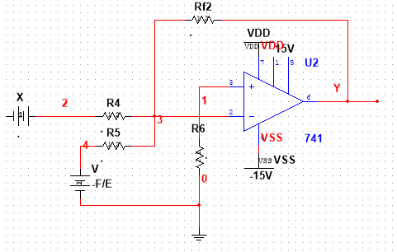

R5 = Rf2

Rf2/R4 = D/F

R6 = R4||Rf2

V = - F/E

Hence Output is Y **=** -(-(F/E) + (D/F)x) = **=** (F/E) - (D/F)x

Here the output y is inverted to -y.

Hence an inverting amplifier is required to invert negative Y to positive Y to be fed back into The First Equation.

**Final Circuit:**

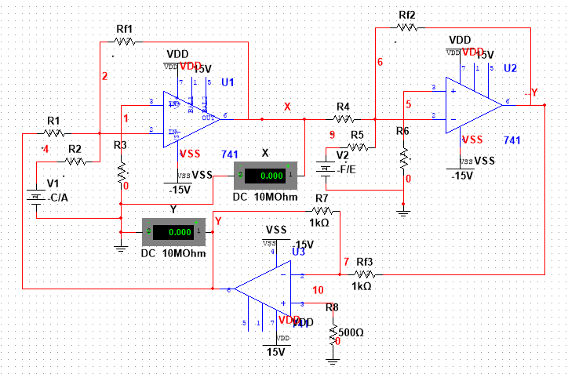

**Note:**

An inverting amplifier is required only when both equations have different signs.

Ex: For the equations

1: Ax + By = C

2: Dx + Ey = F

An Additional inverting amplifier is not needed.

**PROCEDURE:**

1. Write Simultaneous Equation and form x,y equations.
2. Find If an additional Amplifier is needed.
3. Design Circuit based on first two steps.

**TABULAR COLUMN:**

|  |  |  |
| --- | --- | --- |
|  | Theoretical | Practical |
| X |  |  |
| Y |  |  |

**RESULT**:

Thus, the Simultaneous Linear Equations were solved using inverting amplifier circuits and verified with the theoretical values.