GRADIENT SEARCH ALGORITHM

STEP 1:

Select finite number of far field sample points in the region and compute the gain.

STEP 2:

Set the cost function as:

F = $Σ{\left(G\left(desired\right)-G\left(achieved\right)\right)}^{2}$

STEP 5:

Repeat process by choosing new point as initial point until F is saturated.

STEP 4:

To determine desired distance between 2 successive points, compute:

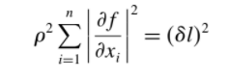

STEP 3:

To find local minimum,

Use starting solution as . To decrease function, compute:

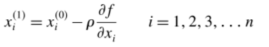

ARRAY SYNTHESIS USING GSA

STEP 1:

Array pattern is determined for N element array with $Δx$ spacing:

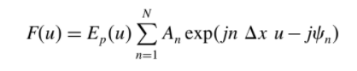



STEP 5:

The cost function is set as:

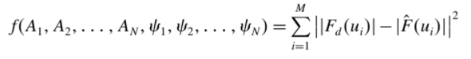

STEP 4:

M discrete points are selected on the far field pattern to obtain desired beam.

$$Δu=\frac{2π}{a}$$

STEP 3:

Desired shape is considered as . It is determined using Parseval’s theorem:

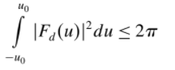

Upper limit for for is $\sqrt{\frac{π}{u_{0}}}$

STEP 2:

The array pattern is normalized.

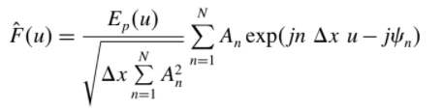

STEP 6:

Real and imaginary parts of excitation coefficients are considered as independent variables and starting solution is considered as uniform phase distribution and excitation.

Partial derivatives of the function are computed and process is repeated till desired pattern is obtained.

PHASE ONLY OPTIMIZATION

* Ampltitude distribution is predetermined.
* Cost function is same as before:



(N phases i.e N independent variables)

CONTOUR BEAM:

STEP 1:

u and v coordinated are determined:



STEP 3:

Far field pattern is normalized w.r.t input power of 4 $π$:

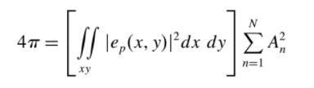

STEP 2:

The far field pattern is determined:

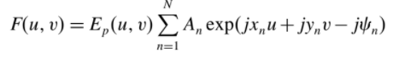

STEP 6:

To estimate expected gain, GAP is determined.

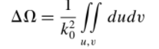

The lowest gain can be estimated

using the GAP number and 

STEP 5:

To reduce large amount of computation, N is reduced to K $×L$.

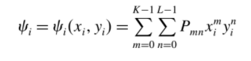

STEP 4:

Set cost function as:

